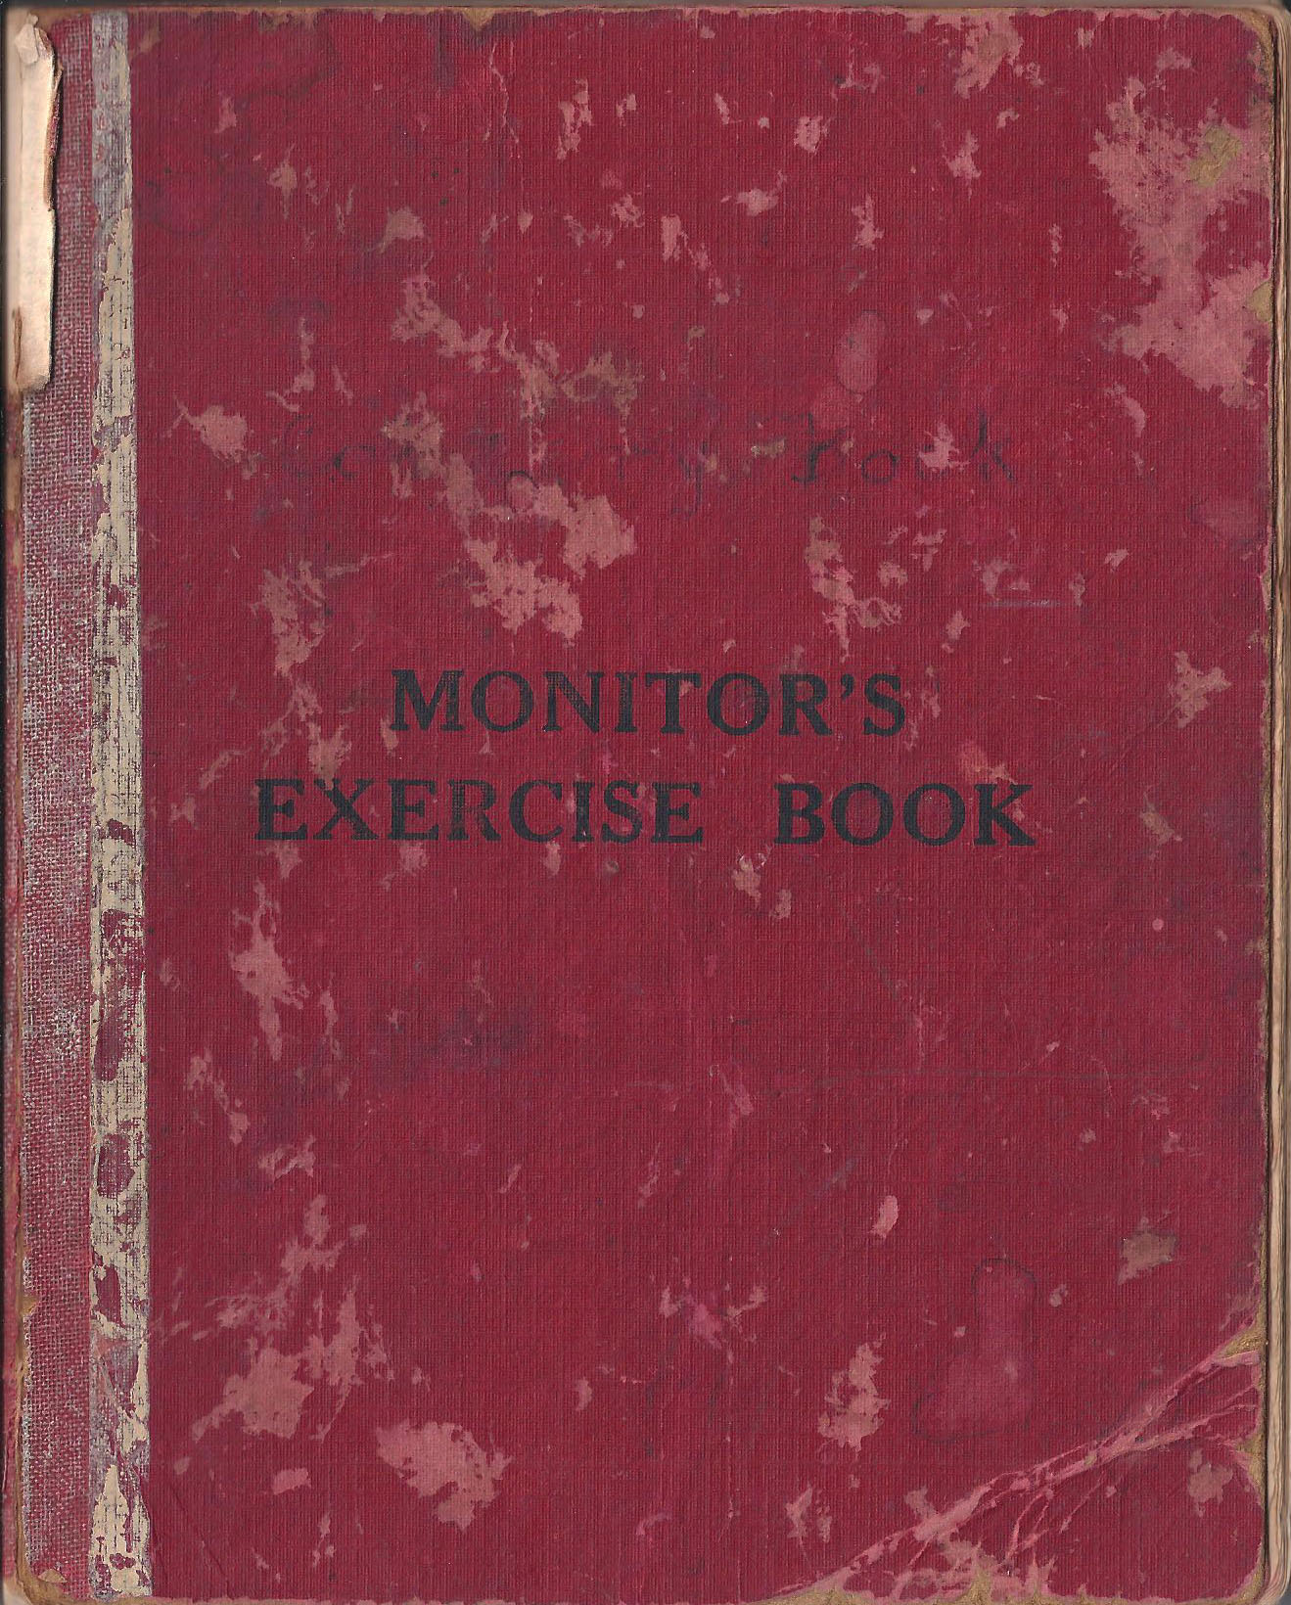

Cookery Book

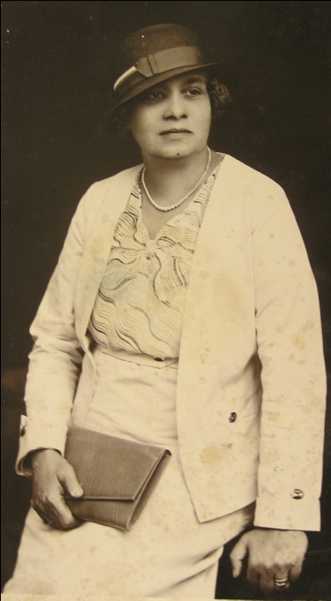

Introduction

Ada Henrietta Ferdinands, my grandmother, was born in 1883, the sixth of the fourteen children of Frederick William Ferdinands and Henrietta Jansz, a Sri Lankan Dutch Burgher. Dutch Burghers are the descendants of employees of the Dutch East India Company (VOC) who chose to remain in Sri Lanka when the British took over government of the country.

She married Lawrence Isidore Michael de la Harpe on 12th March, 1833. She was his second wife. They had two children, Celia Helen, my mother, born 27th March, 1922, and Ian Frederick, born 18th February, 1925.

Celia married Alphonsus Gerard Godfrey van Reyk on 23rd November, 1946. Celia and Gerry had four children of whom I was the third, born 30th November, 1952.

There are two unusual features of Ada’s Cookery Book for me. The recipes follow each other closely with no space for additions and little for revisions: they are ordered into categories; there is an index; there are no pasted in recipes from
others; all of which usually characterize domestic cookbooks. When I asked my mum about it she said that Ada probably at some stage got all her recipe cards and notes together ordered like published cookbooks she would have seen and then wrote the book we now have. Mum thinks she did this late in the 1930’s or early 1940’s. Why Ada chose to do this remains Ada’s secret.

The other thing that struck me when I looked closely at Ada’s recipes was that they are largely European in origin – soups, roasts, chops, savoury and sweet sauces, flour based cakes. I’d go so far as to identify them as British, with the occasional Dutch (frikadells, broeder) and Portuguese (bol-de-coku). The Sri Lankan dishes are few. When I asked my mum why this might be so she pointed out that most of our meals were prepared by our Singhalese cook who would turn out general run of curries, pahis, badungs and so on with which she was familiar. The recipes that are in Ada’s book are the European dishes she would prepare herself or supervise our cook in preparing, and the Sri Lankan dishes that are in the book are specialties those Ada would also prepare herself or closely supervise – lampraya for example.
Ada’s recipes end at page 110. When Ada died, the book passed on to mum. Some of the pages show where mum adapted her favourites, particularly adaptations for the methods and produce of her Australian kitchen. For example, mum found that Australian eggs were larger than those in Sri Lanka and made adjustments to the number of eggs used in the Christmas cake. Mum also then began collecting her own recipes and the book from here becomes a more standard domestic cookbook with recipes clipped from magazines and newspapers pasted in, hand-written entries from mum, a few in a handwriting that is not hers and I don’t recognise as dad’s. I haven’t transcribed these – that’s a whole other project.

A glossary of some ingredients, measures and terms

B onions Bombay Red onions
an old cultivar
brinjal aubergine/ eggplant
cajunats cashew nut
chundu a cupful, or a condensed milk tinful
chow chow choko/chayote fruit, Sechium edule
coduwa koduwa, barramundi
Cook’s Joy a brand of refined coconut oil
curry stuffs any of a mixture of spices used for curries in the rest of the recipes in the book
drumsticks a long podded vegetable, Moringa oleifera
ekel a straw from a broom
endura dill seeds
Goroka a souring agent, dried segments of Garcinia gummi-gutta
hal-masso halmassas, dried sprats
inellas innala, a small indigenous yam, literally ‘wart yam’ Solenostemon rotundifolius

junk a Dutch Burgher idiomatic term for a chunk, as far as I can tell anyway
karallos karalla, a small flat bony fish usually only for soup
k/carapincha curry leaves, Murraya koenigii
katuwallo katuwalla, an eel-like fish
maha-duru caraway
old stuff sherry
“Padre” curry named for its use of “old stuff” which is sherry, with the joke in the title being that this supposedly is the only way the priest could get away with drinking alcohol
rampa pandanus leaf
ruling semolina flour
serai lemongrass
shoeflower red hibiscus
sudu-duru cumin
wineglass a small liqueur/sherry glass

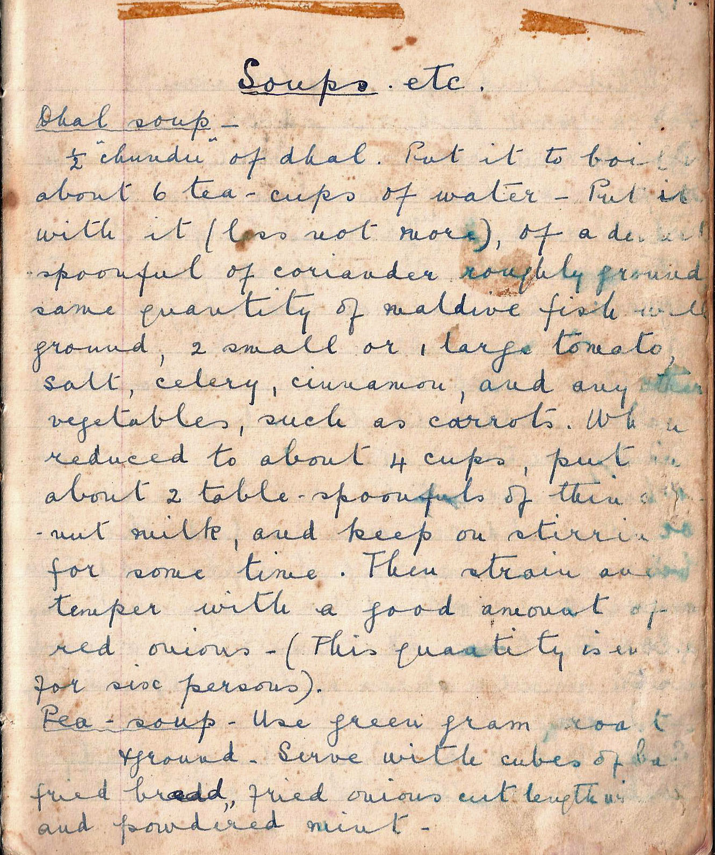

Soups etc.

Dhal Soup
½ chundu of dhal. Put it to boil in about 6 tea-cups of water. Put in with it (less not more) of a dessert spoonful of coriander roughly ground, same quantity of Maldive fish well ground, 2 small or 1 large tomato, salt, celery, cinnamon, and any other vegetables, such as carrot. When reduced to about 4 cups, put in about 2 tablespoonfuls of thin coconut milk, and keep stirring for some time. Then strain and temper with a good amount of red onions. (This quantity is enough for six persons).

Pea Soup
Use green gram, roasted and ground. Serve with cubes of fried bread, fried onions cut lengthwise and powdered mint.

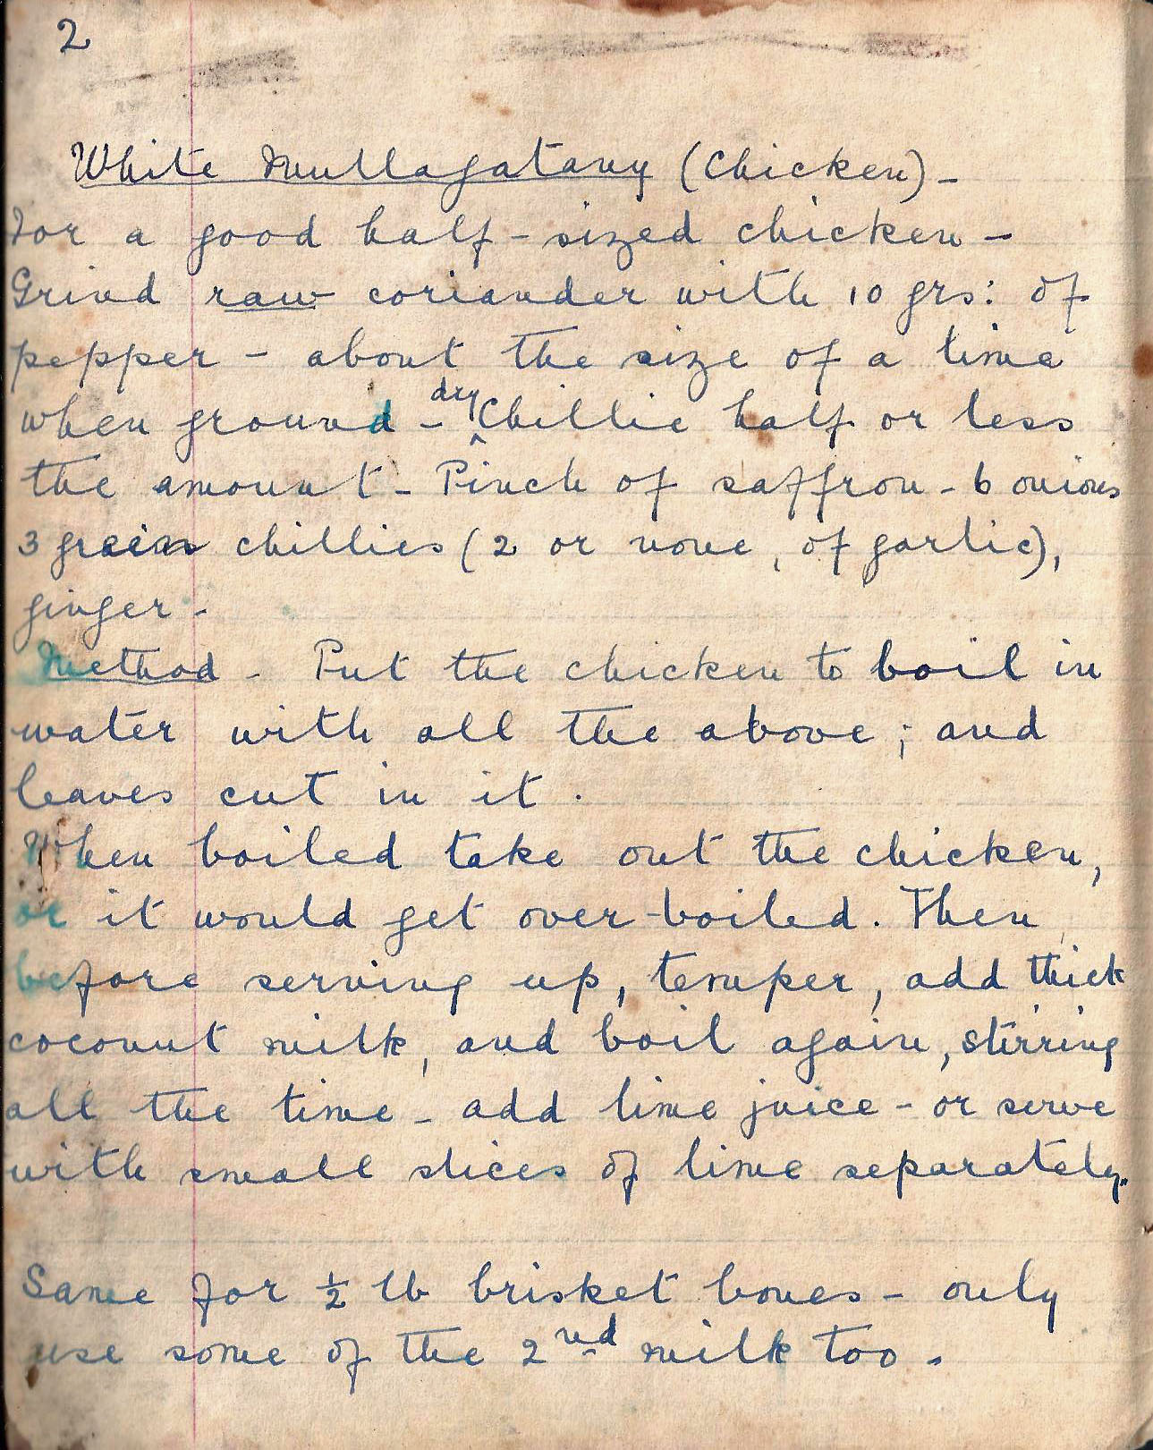

White Mulligatawny (Chicken)
For a good half-sized chicken - Grind raw coriander with 10 grams of pepper to about the size of a lime when ground - dry chilli, half or less the amount, Pinch of saffron - 6 onions, 3 green chillies (2 or more of garlic) ginger.

Method. Put the chicken to boil in water with all the above; and leaves cut in it.

When boiled take out the chicken, or it would get over-boiled. Then before serving up, temper, add thick coconut milk, and boil again, stirring all the time. Add lime juice, or serve with small slices of lime separately.

Same for ½ lb brisket bones, only use some of the 2nd milk (of coconut) too.

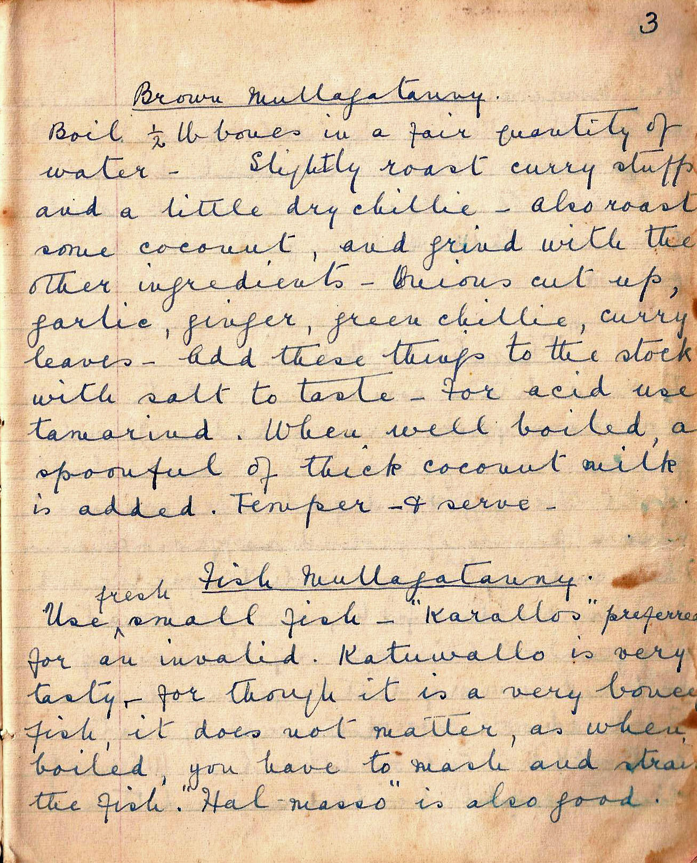

Brown Mulligatawny
Boil ½ lb bones in a fair quantity of water. Slightly roast curry stuffs and a little bit of dry chilli. Also roast some coconut, and grind with the other ingredients. Onions cut up, garlic, ginger, green chilli, curry leaves. Add these things to the stock with salt to taste. For acid use tamarind. When well boiled, a spoonful of thick coconut milk is added. Temper and serve.

Fish Mulligatawny
Use fresh small fish – karallos preferred for an invalid. Katuwallos is very tasty, for though it is a very bony fish it does not matter, as when boiled, you have to mash and strain the fish. Hal-masso is also good.

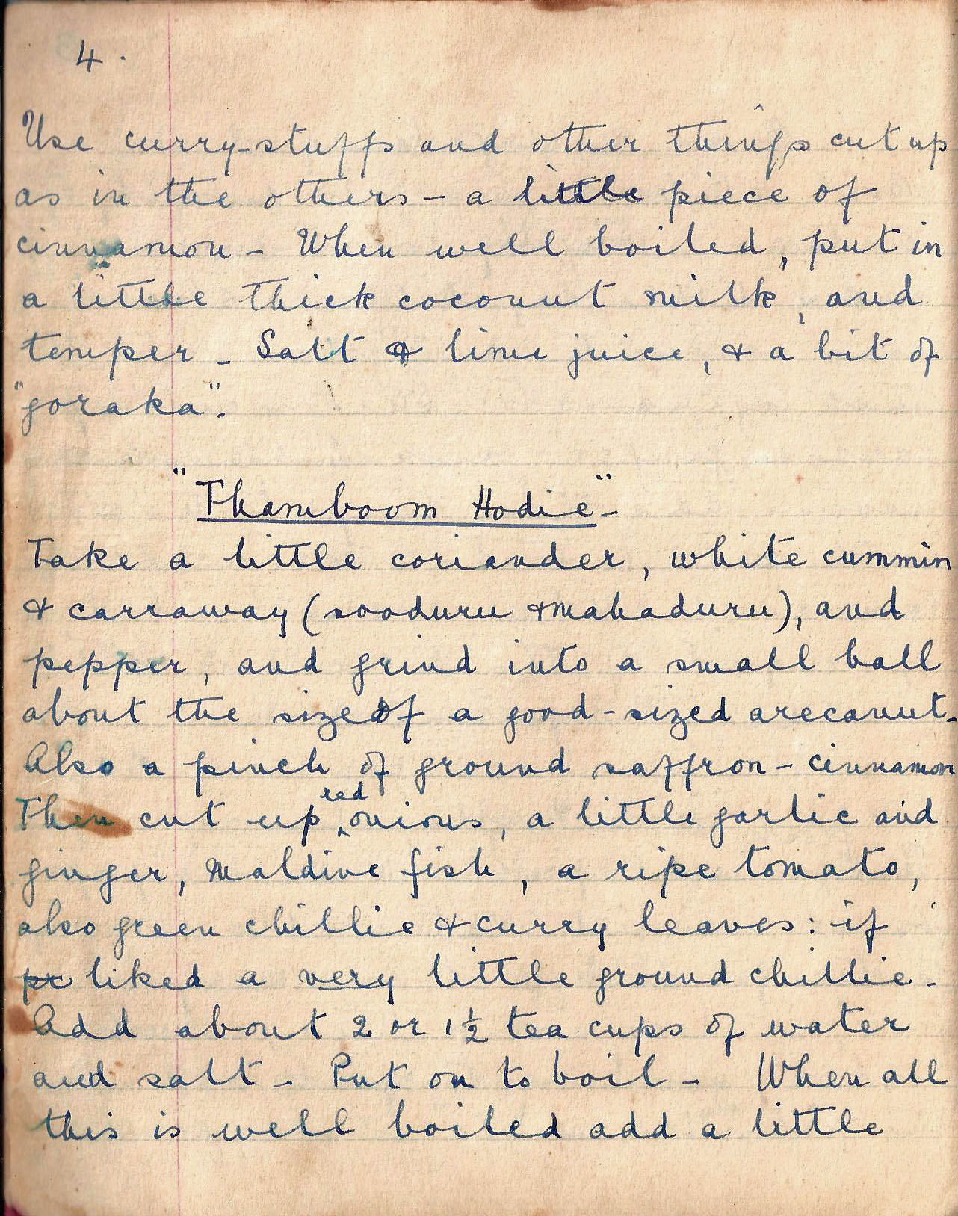

Use curry stuffs and other things cut up as in the others. A little piece of cinnamon. When boiled, put in a little thick coconut milk, and temper. Salt and lime juice and a bit of goraka.

Thamboom Hodie
Take a little coriander, white cumin and caraway (sooduru and mahaduru), and pepper, and grind into a small ball about the size of a good-sized areca nut. Also a pinch of ground saffron.Cinnamon. Then cut up red onions, a little garlic and ginger, Maldive fish, a ripe tomato, also green chilli and curry leaves: if liked a very little ground chilli. Add about 2 or 1½ tea cups of water and salt. Put on to boil. When all this is well boiled add a little
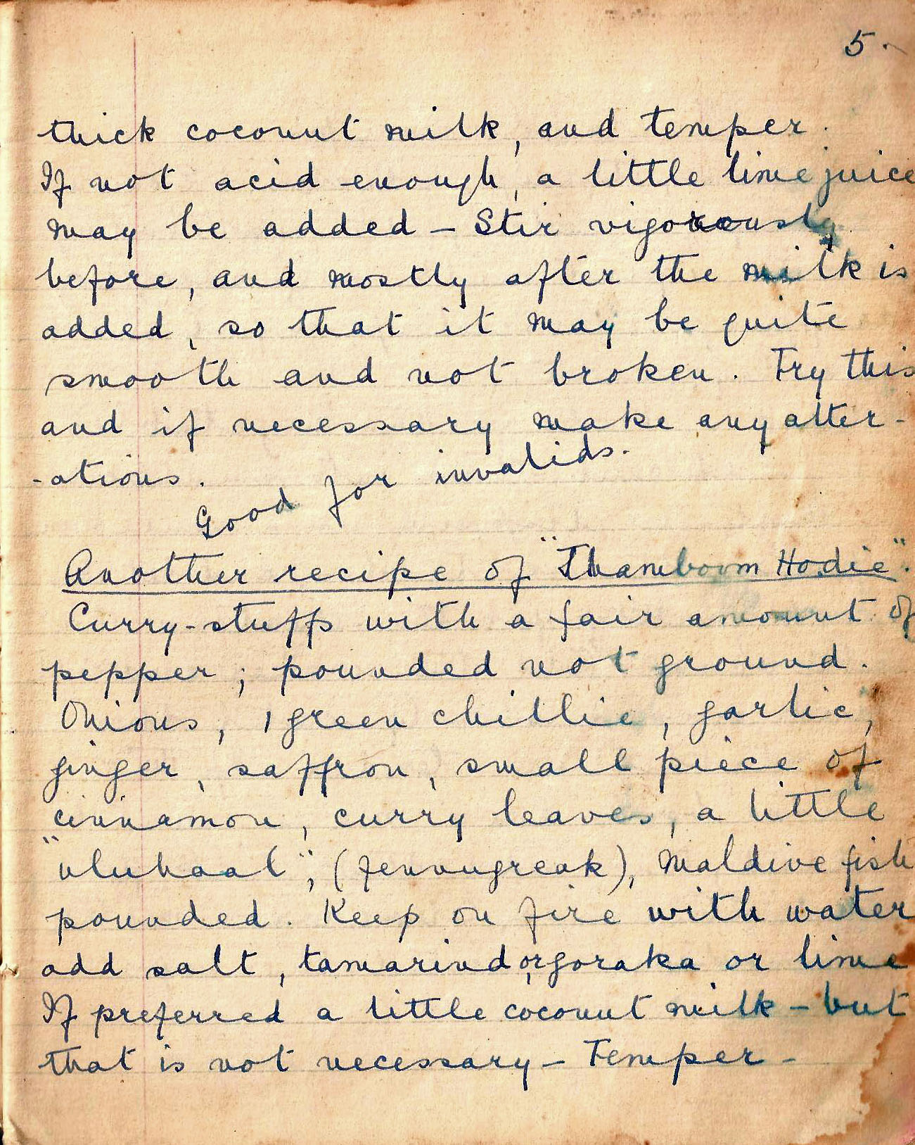

thick coconut milk, and temper. If not acid enough, a little lime juice may be added. Stir vigorously before, and mostly after the milk is added, so that it may be quite smooth and not broken. Try this and if necessary make any alterations.

Another recipe of Thamboom Hodie
Curry-stuffs with a fair amount of pepper, pounded not ground. Onions, green chillies, garlic, ginger, saffron, small piece of cinnamon, curry leaves, a little uluhall (fenugreek), Maldive fish pounded. Keep on fire with water. Add salt, tamarind or goraka or lime. If preferred a little coconut milk, but that is not necessary. Temper.

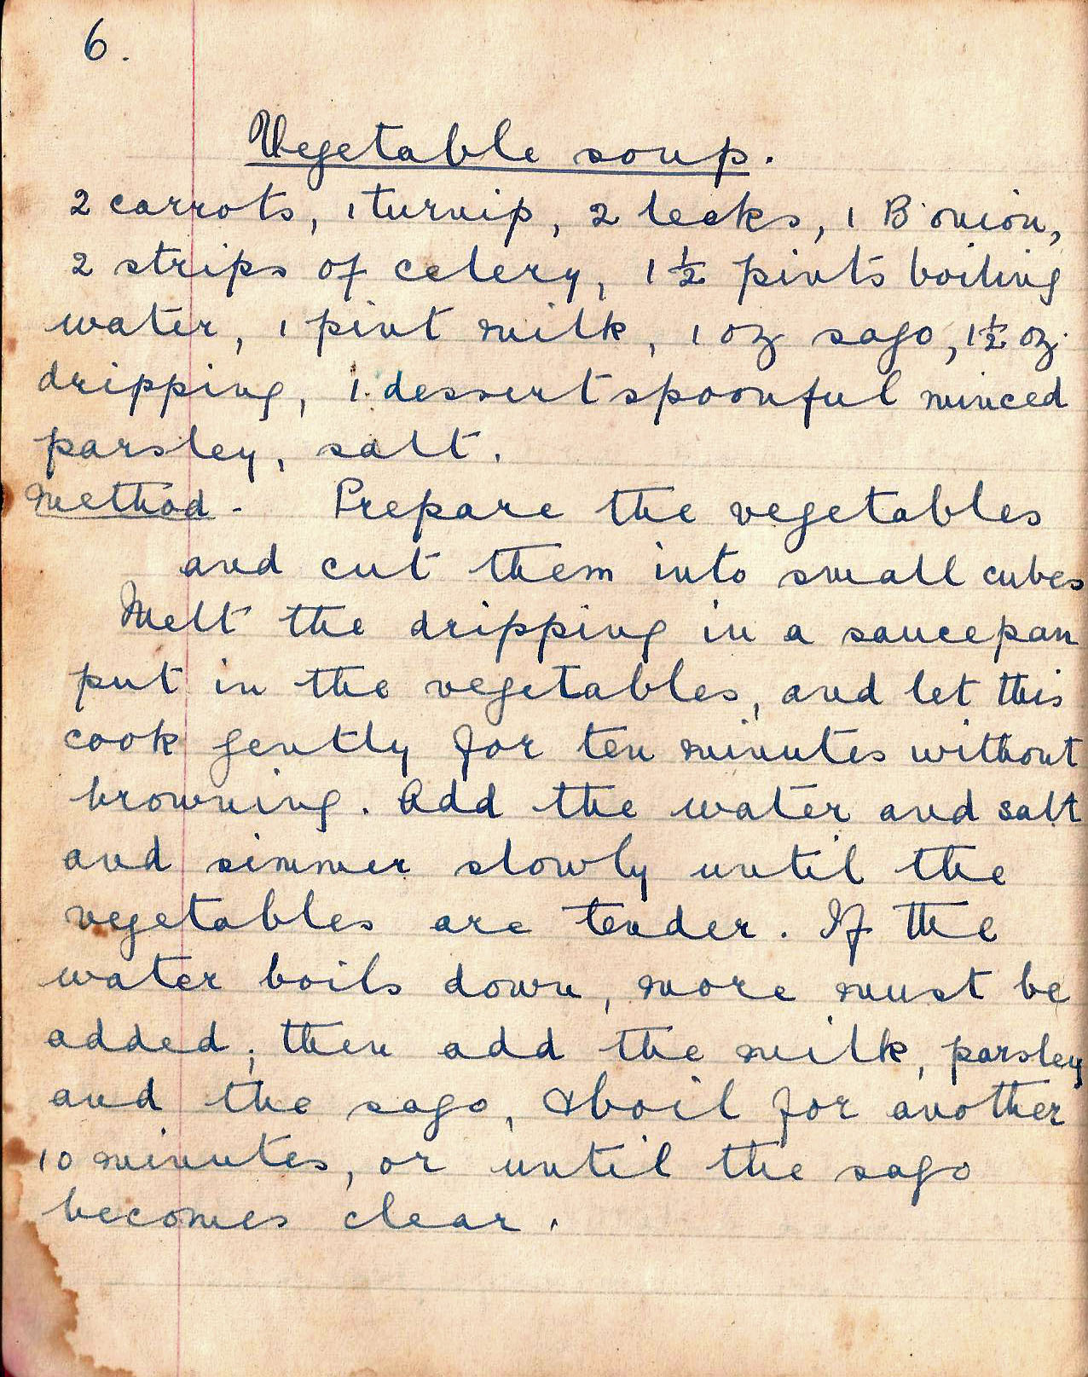

Vegetable Soup
2 carrots, 1 turnip, 2 leeks, 1 B onion, 2 strips of celery, 1 ½ pints boiling water, 1 pint milk , 1 oz sago, 1 ½ ozs dripping, 1 dessertspoonful minced parsley, salt

Method. Prepare the vegetables and cut them into small cubes. Melt the dripping in a sauce pan put in the vegetables and let this cook gently for ten minutes without browning. Add the water and salt and simmer slowly until the vegetables are tender. If the water boils down, more must be added; then add the milk, parsley and the sago and boil for another ten minutes, or until the sago becomes clear.

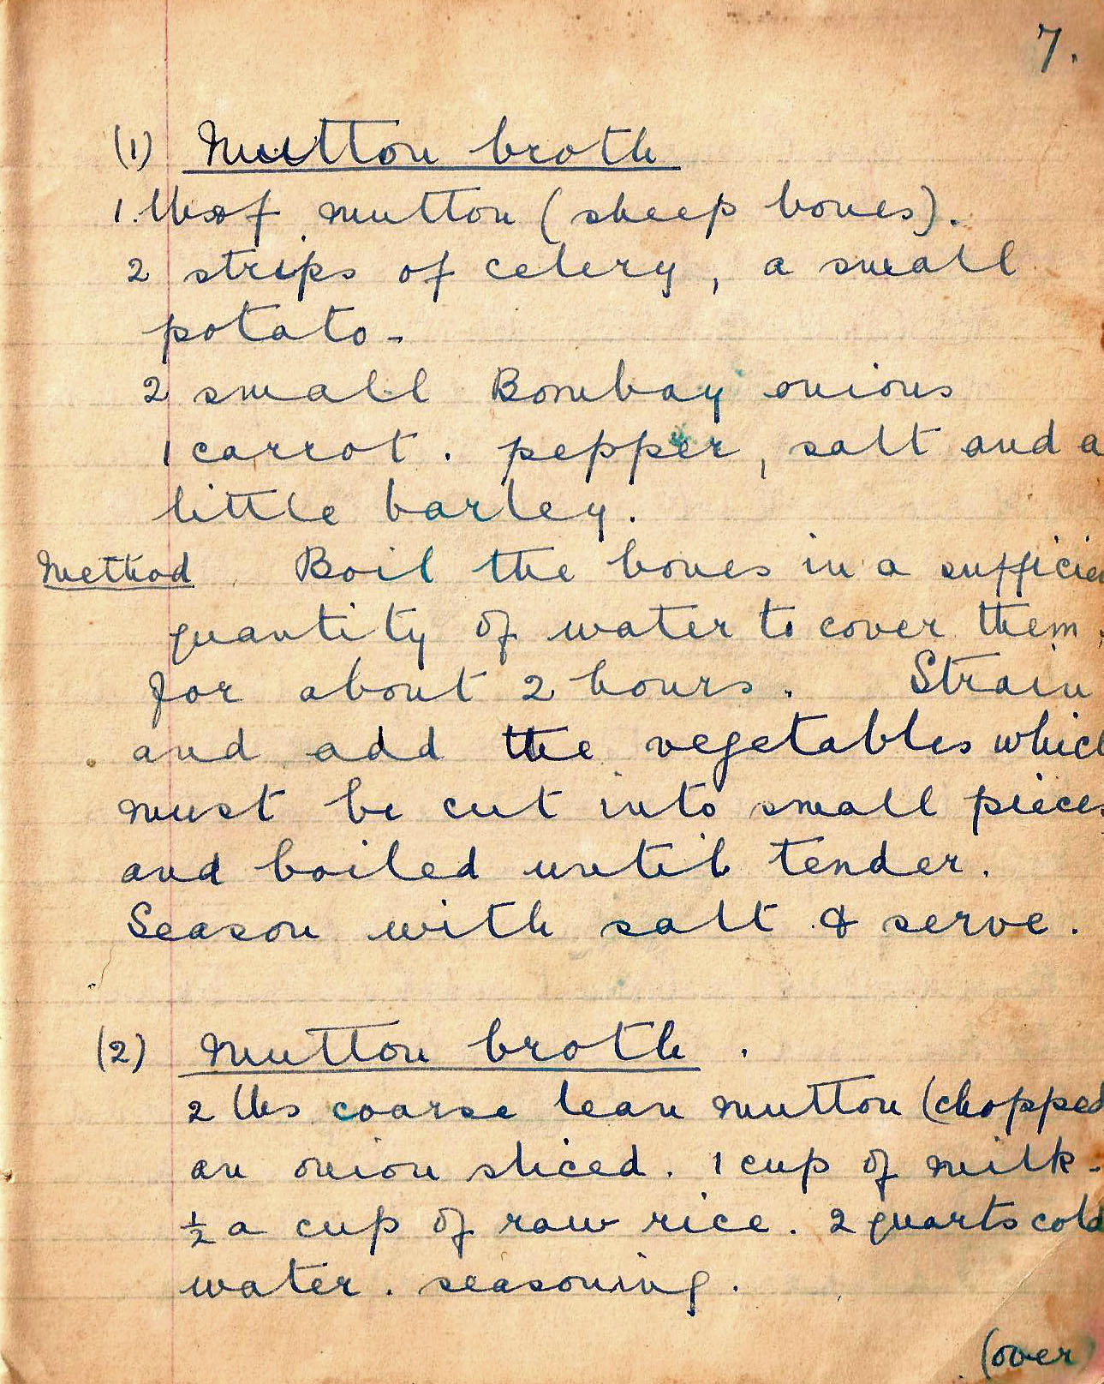

(1) Mutton Broth
1 tbsp mutton (sheep bones), 2 strips of celery, a small potato
2 small Bombay onions, 1 carrot, pepper, salt
and a little barley

Method Boil the bones in a sufficient quantity of water to cover them, for about 2 hours. Strain and add the vegetables which must be cut into small pieces and boiled until tender. Season with salt and serve.

(2) Mutton Broth
2 lbs coarse lean mutton (chopped), an onion sliced, 1 cup of milk, ½ a cup of raw rice. 2 quarts cold water, seasoning

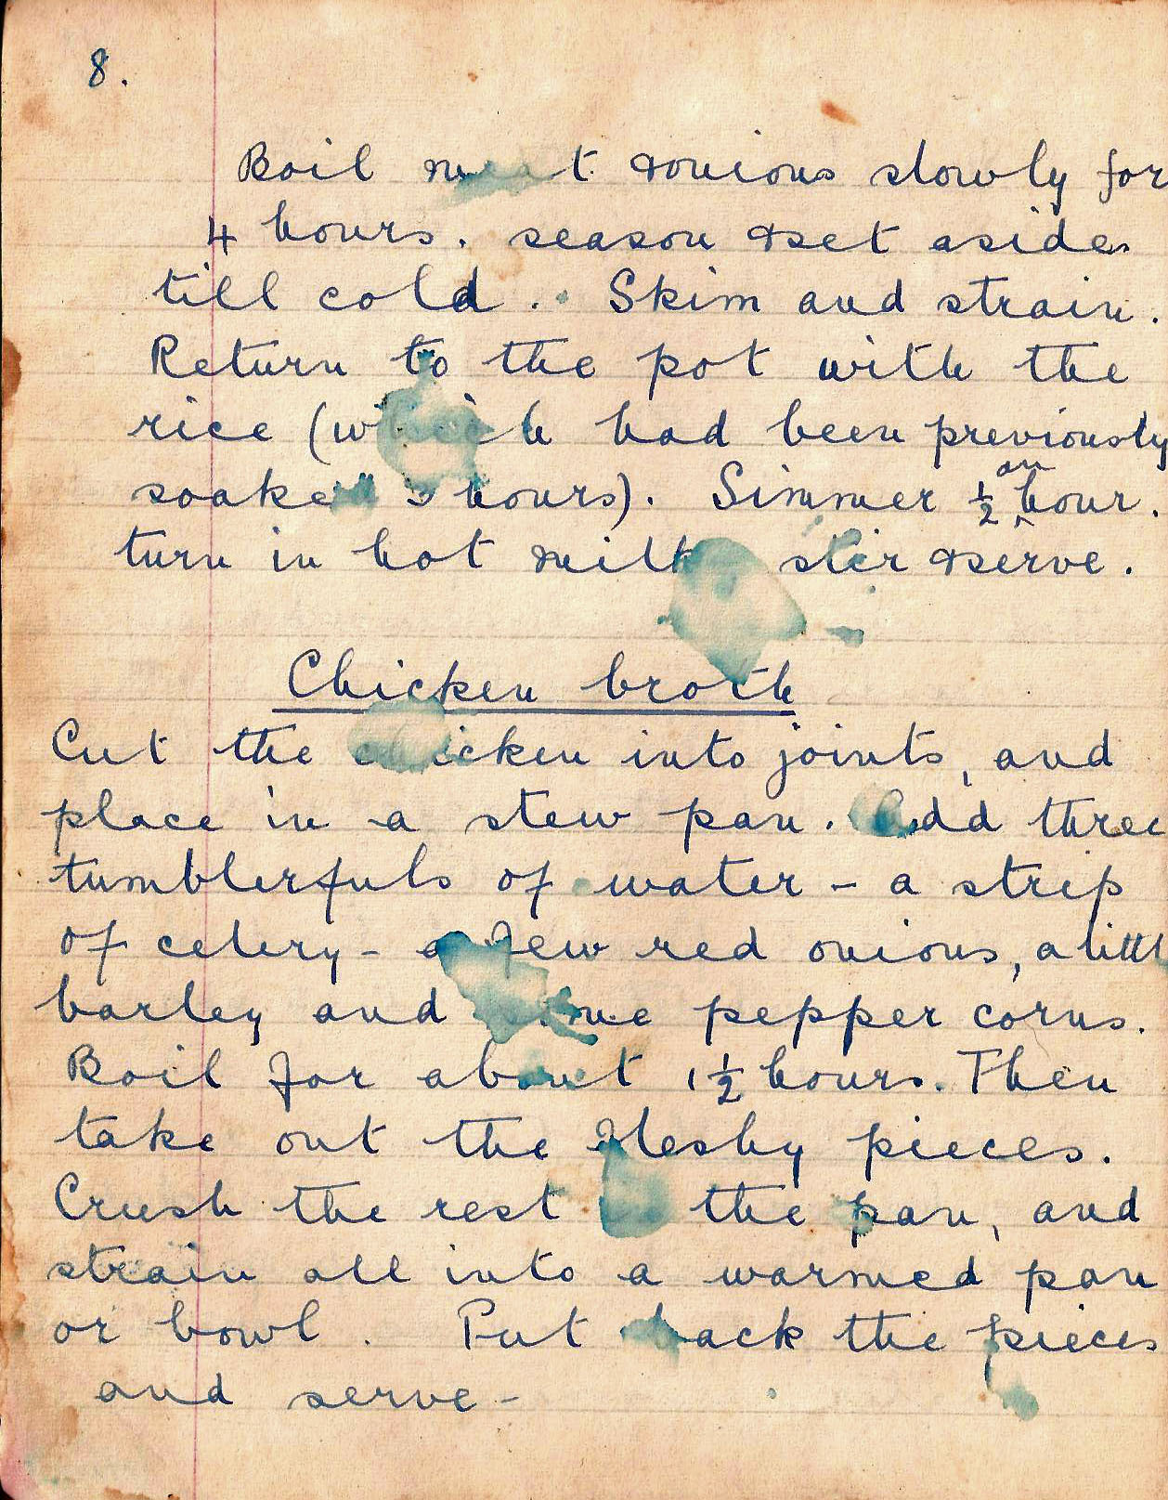

Boil meat onions slowly for 4 hours. season and set aside till cold. Skim and strain. Return to the pot with the rice (which had been previously soaked 3 hours). Simmer ½ an hour. turn in hot milk and serve.

Chicken broth
Cut the chicken into joints and place in a stew pan. Add three tumblersful of water, a strip of celery, a few red onions, a little barley and five pepper corns. Boil for about 1½ hours. Then take out the fleshy pieces. Crush the rest in the pan, and strain all into a warmed pan or bowl. Put back the pieces and serve.

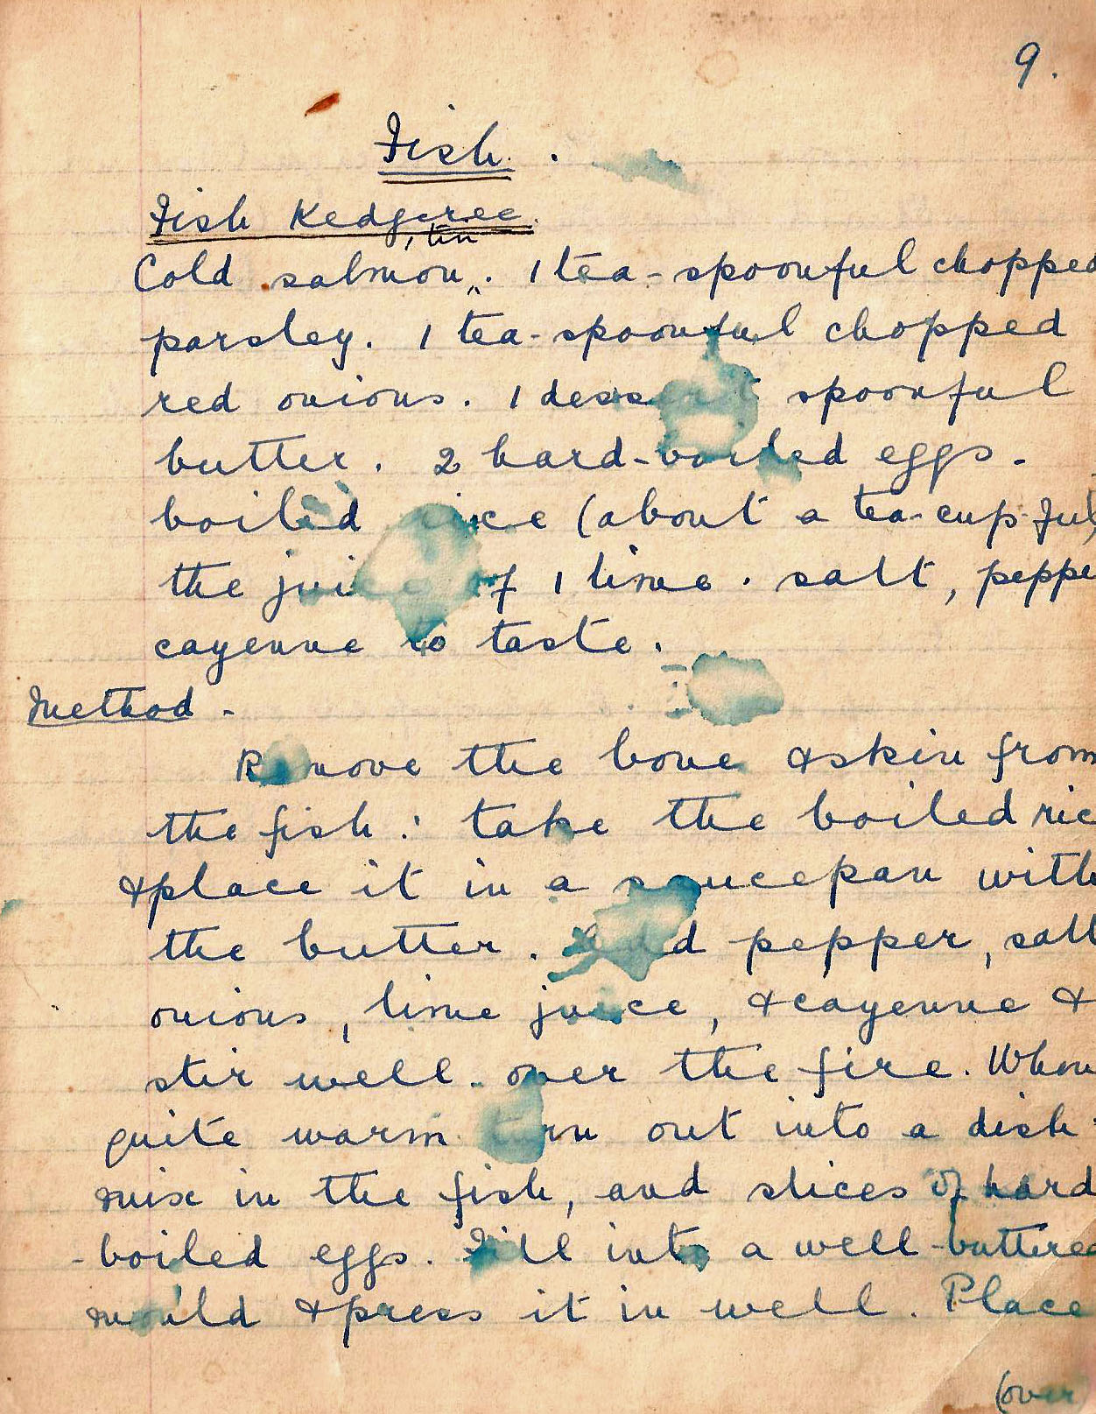

Fish

Fish Kedgeree
Cold salmon (1 tin). 1 tsp chopped parsley. 1 teaspoomful chopped red onions. 1 dessrtspoonful butter. 2 hard-boiled eggs.
boiled rice (about a tea-cup full). juice of 1 lime. salt, pepper, cayenne to taste.

Method. Remove the bone and skin from the fish. Take the boiled rice and place in a sauce pan with the butter. Add pepper, salt, onions, lime juice, and cayenne and stir well over the fire. When quite warm turn out into a dish. Mix in the fish, and slices of hard boiled eggs. Fill into a well-buttered mould and press it in well. Place

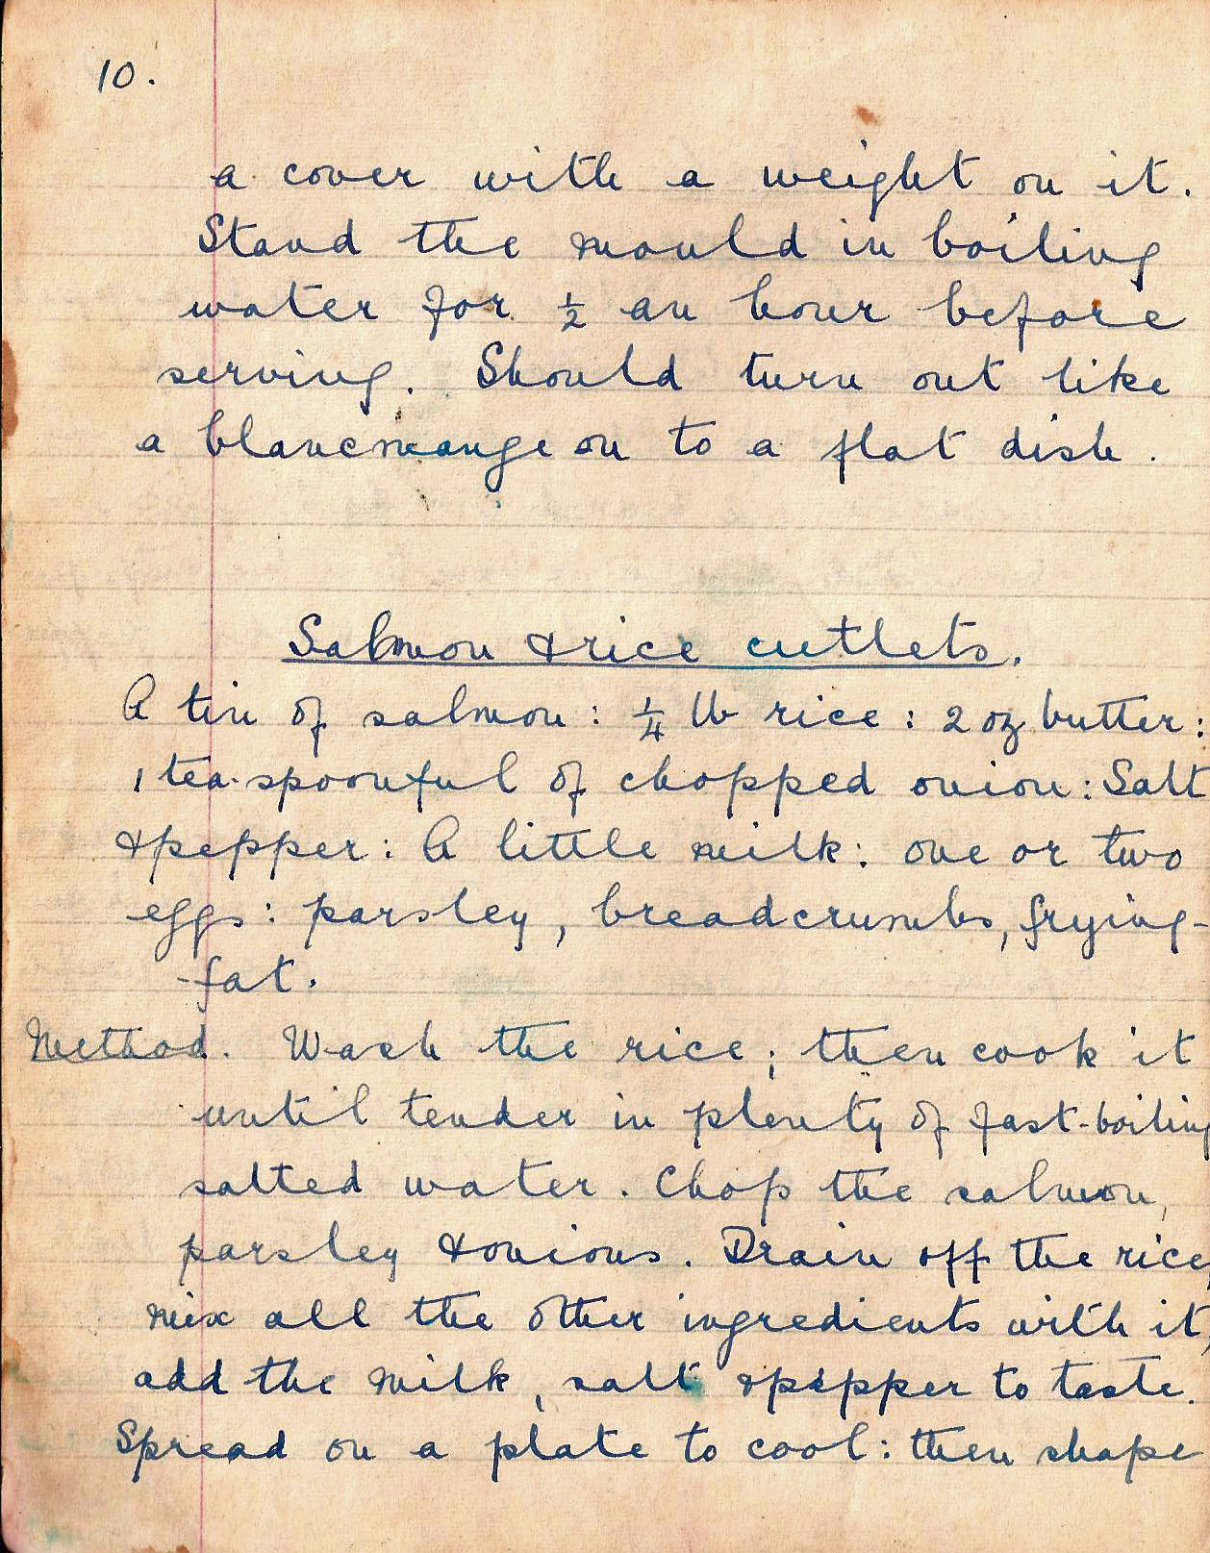

a cover with a weight on it. Stand the mould in boiling water for ½ an hour before serving. Should turn out like a blancmange on to a flat dish.

Salmon and rice cutlets
A tin of salmon: ¼ lb rice: 2 oz butter: 1 tsp of chopped onion: salt and pepper: A little milk
one or two eggs: parsley, breadcrumbs, frying fat.

Method. Wash the rice; then cook it until tender in plenty of fast-boiling salted water. Chop the salmon, parsley, onions. Drain off the rice, mix all the other ingredients with it, add the milk, salt and pepper to taste. Spread on a plate to cool: then shape

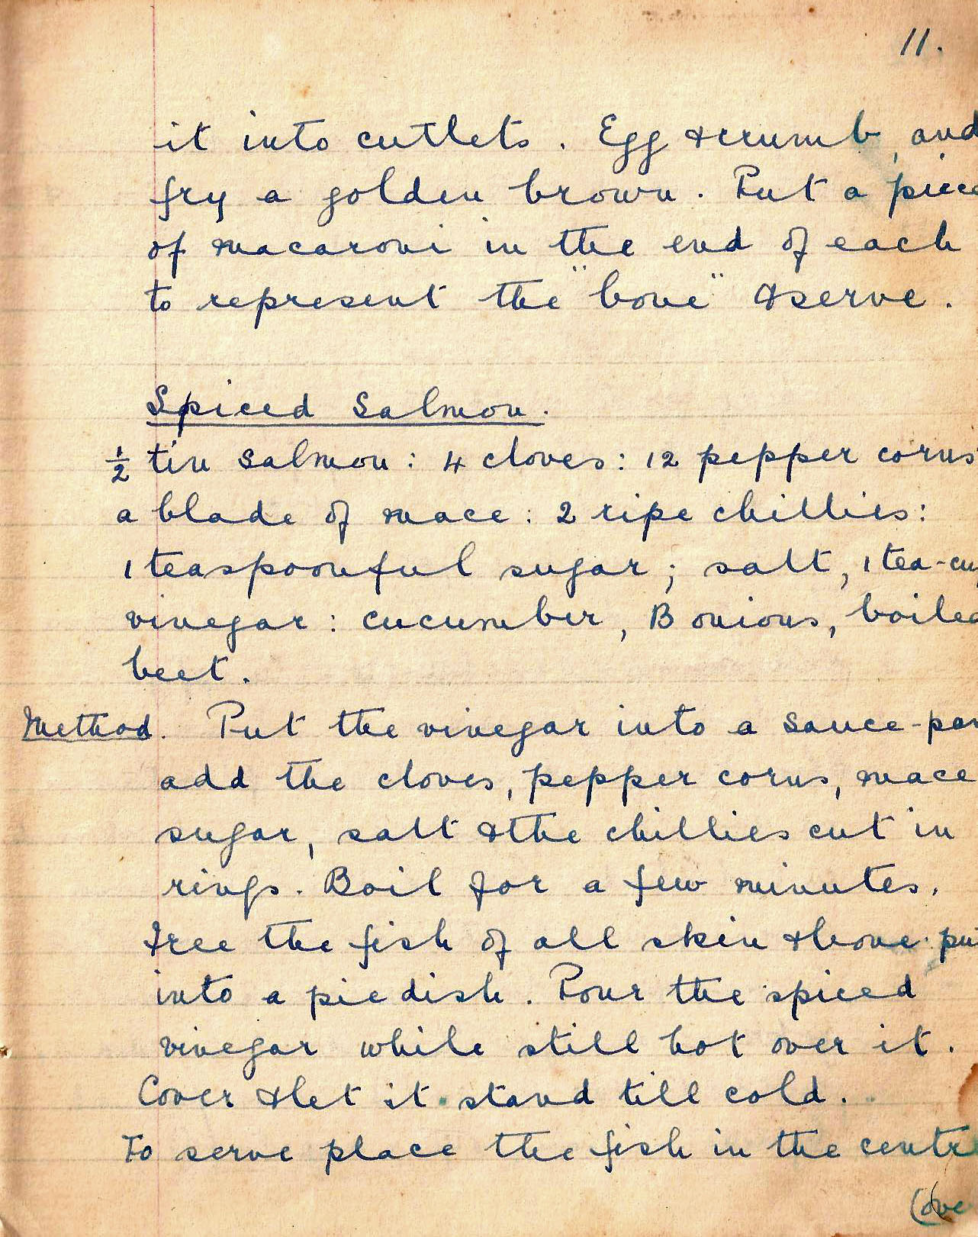

it into cutlet. Egg and crumb and fry a golden brown. Put a piece of macaroni in the end of each to represent the “bone” and serve.

Spiced salmon
½ tin salmon: 4 cloves: 12 peppercorns: a blade of mace: 2 ripe chillies: 1 teaspoonful sugar; salt, 1 tea cup vinegar: cucumber, Bombay onions
boiled beet.

Method. Put the vinegar into a sauce pan, add the cloves, peppercorns, mace, sugar, salt and the chillies cut in rings. Boil for a few minutes. Free the fish of all skin and bone, put into a pie dish. Pour the spiced vinegar while still hot over it. Cover and let it stand till cold. To serve place the fish in the centre

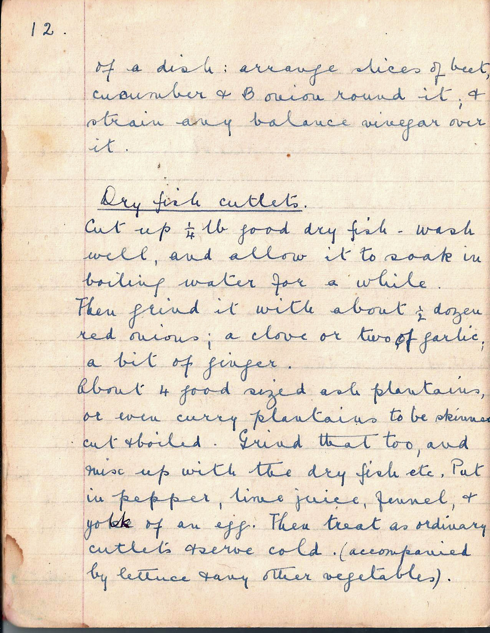

of a dish: arrange slices of beet, cucumber and Bombay onion round it and strain any balance vinegar over it.

Dry fish cutlets
Cut up ¼ lb good dry fish – wash well, and allow it to soak in boiling water for a while. Then grind it with about ½ dozen red onions, a clove or two of garlic, a bit of ginger.
About four good sized ash plantains or even curry plantain to be skinned, cut and boiled. Grind that too, and mix up with the dry fish etc. Put in pepper, lime juice, fennel and yolk of an egg. Then treat as ordinary cutlets and serve cold (accompanied by lettuce and any other vegetables).

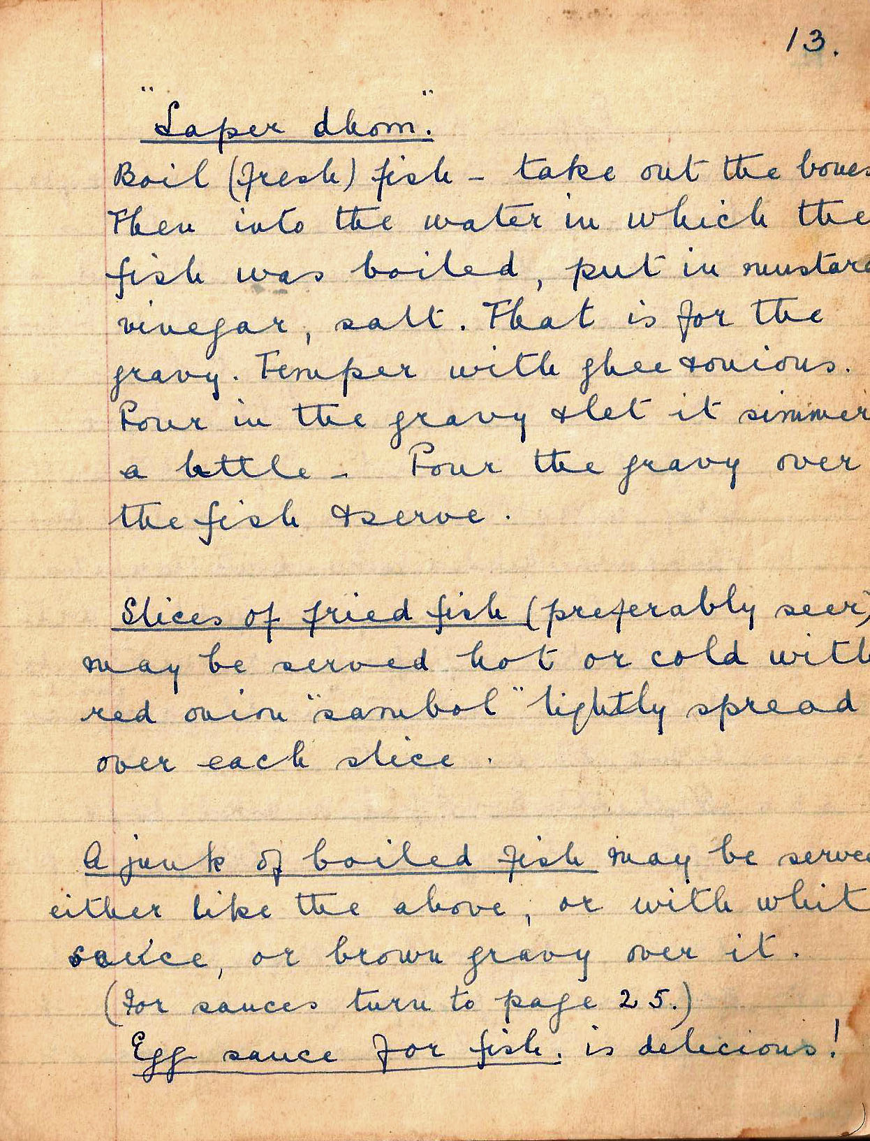

“Saper dhom”
Boil (fresh) fish. Take out the bones. Then into the water in which the fish was boiled, put in mustard, vinegar, salt. That is for the gravy. Temper with ghee onions. Pour in the gravy and let it simmer a little. Pour the gravy over the fish and serve.

Slices of fried fish (preferably seer) maybe served hot or cold with red onion sambol lightly spread over each fish.

A junk of boiled fish may be served either like the above or with white sauce, or brown gravy over it.
(For sauces turn to page 25.)

Egg sauce for fish is delicious!

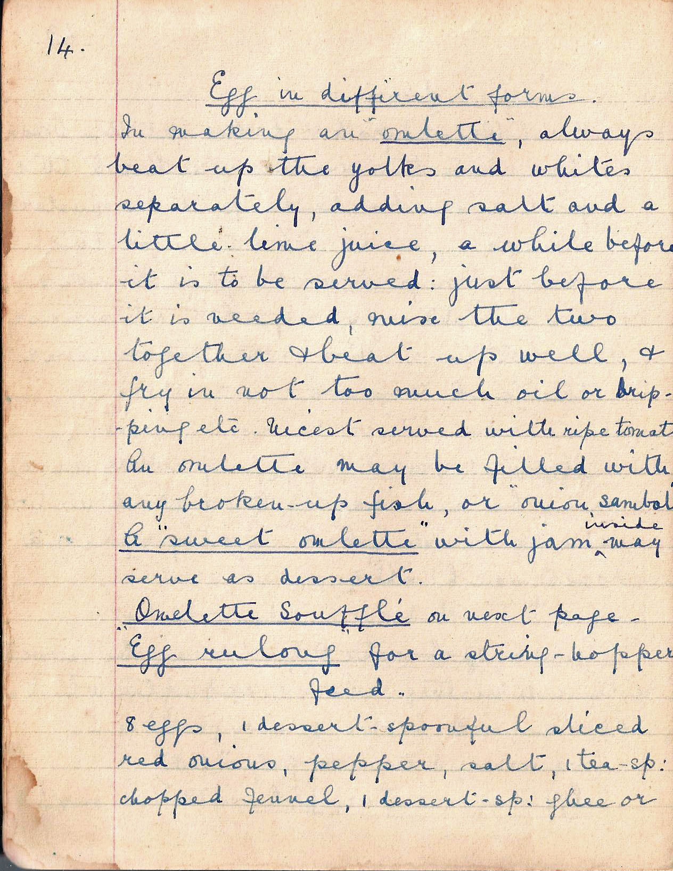

Egg in different forms

In making an omelette, always beat up the yolks and whites separately, adding salt and a little lime juice, a while before it is to be served. Just before it is needed, mix the two together and beat up well, and fry in not too much oil or dripping etc. Nicest served with ripe tomatoes. An omelette may be filled with any broken-up fish, or onion sambol.

A “sweet omelette” with jam inside may be served as dessert.
Omelette Soufflé on next page.

Egg rulang for a string hopper feed.
8 eggs 1 dessertspoonful sliced red onions, pepper, salt, 1 tsp chopped fennel, 1 dessert spoon ghee or
.
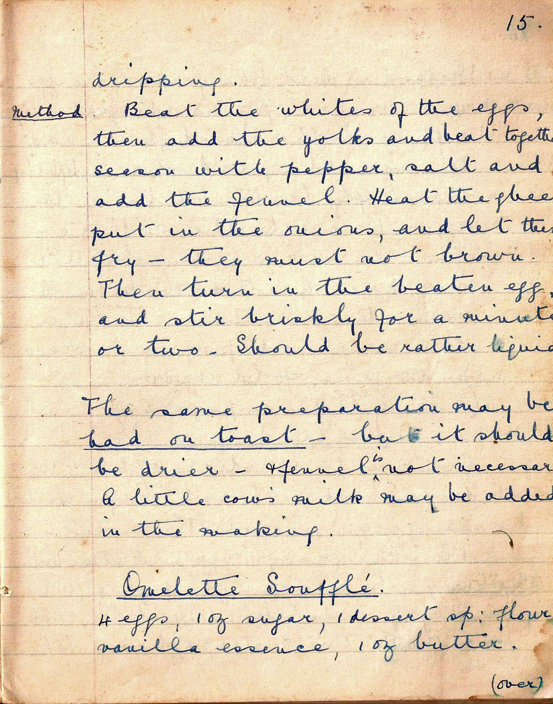

dripping.

Method. Beat the whites of the eggs, then add the yolks and beat together. Season with pepper, salt and add the fennel. Heat the ghee and put in the onions, and let them fry – they must not brown. Then turn in the beaten egg, and stir briskly for a minute or two. Should be rather liquid.

The same preparation may be had on toast – but it should be drier – and the fennel is not necessary. A little cow’s milk may be added in the making.

Omeletté Souffle
4 eggs, 1 oz sugar, 1 dessertspoonful , flour, vanilla essence, 1 oz butter.

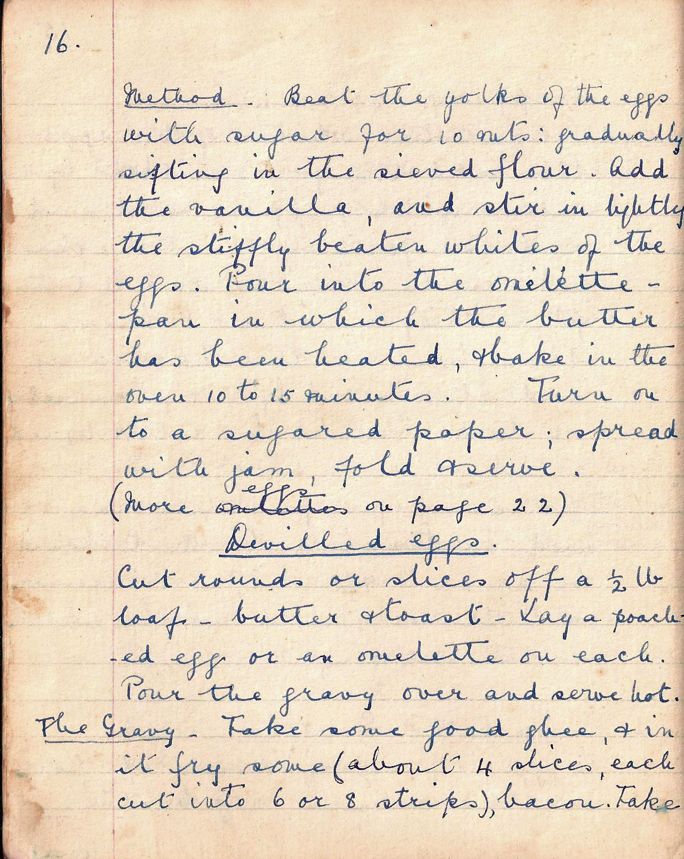

Method. Beat the yolks of the eggs with sugar for 10 mins. Gradually sifting in the sieved flour. Add the vanilla, and stir in lightly the stiffly beaten whites of the eggs. Pour into the omelette pan in which the butter was heated, and bake in the oven for 10 to 15 mins. Turn on to a sugared paper; spread with jam, fold and serve.
(More eggs on page 22)

Devilled eggs
Cut rounds or slices off a ½ lb loaf . Butter and toast . Lay a poached egg or an omelette on each. Pour the gravy over and serve hot.

The Gravy. Take some good ghee, and in it fry some (about 4 slices, each cut into 6 or 8 strips) bacon.
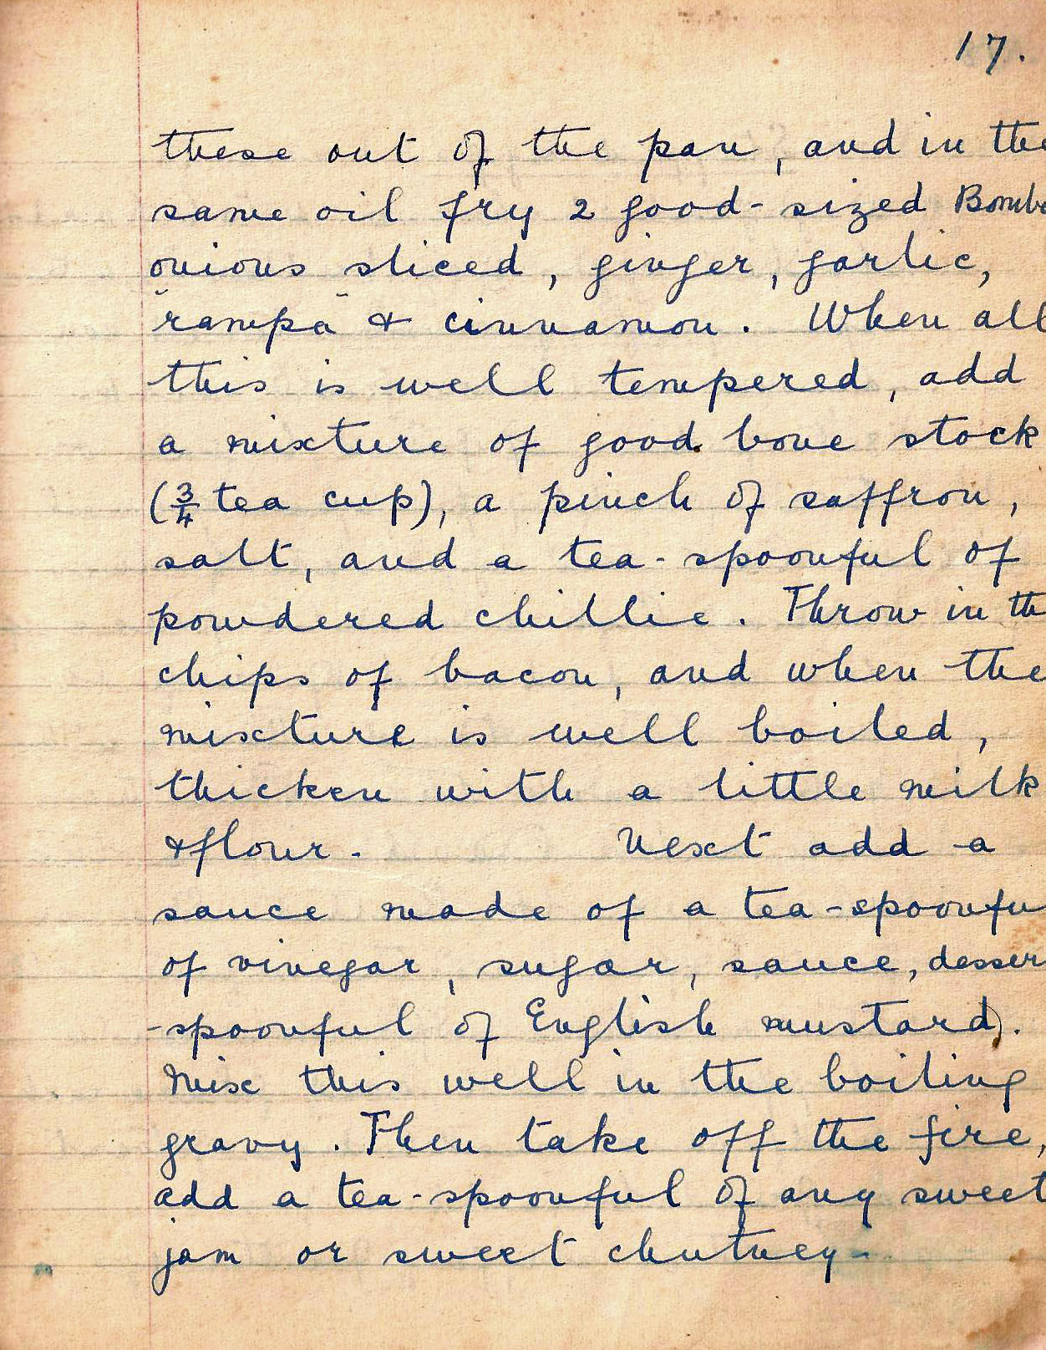

these out of the pan, and in the same oil fry 2 good-sized Bombay onions sliced, ginger, garlic, rampa and cinnamon. When all this is well tempered, add a mixture of good bone stock (3/4 tea cup), a pinch of saffron, salt, and a teaspoonful of powdered chilli. Throw in the chips of bacon, and when the mixture is well-boiled, thicken with a little milk flour.

Next add a sauce made of a teaspoonful of vinegar, sugar, sauce, dessert spoonful of English mustard. Mix this well in the boiling gravy. Then take off the fire, add a teaspoonful of any sweet jam or sweet chutney.

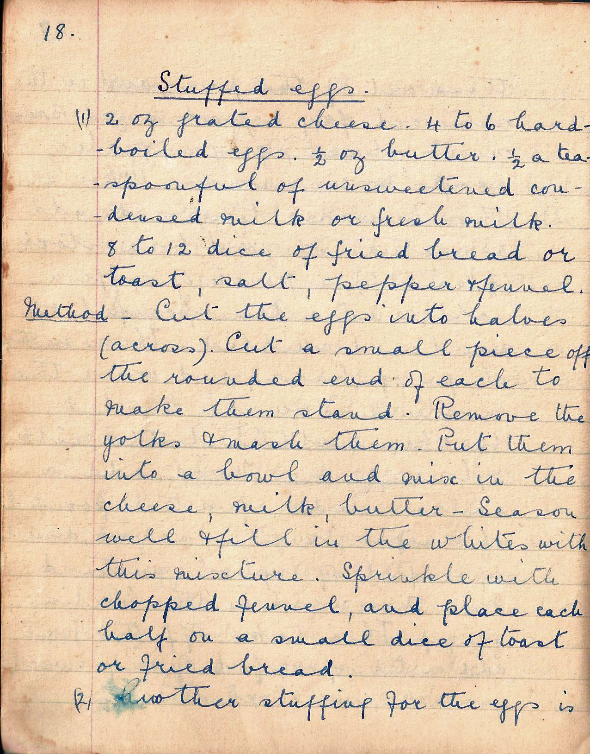

Stuffed eggs
(1) 2 oz grated cheese.4 to 6 hard-boiled eggs..½ oz butter ½ a teaspoonful of unsweetened condensed milk or fresh milk.
8 to 12 dice of fried bread or toast, salt, pepper, fennel

Method. Cut the eggs into halves (across). Cut a small piece of the rounded end of each to make them stand. Remove them into a bowl and mix in the cheese, milk, butter . Season well and fill in the whites with this mixture. Sprinkle with chopped fennel, and place each half on a small dice of toast or fried bread.

(2) Another stuffing for the eggs is

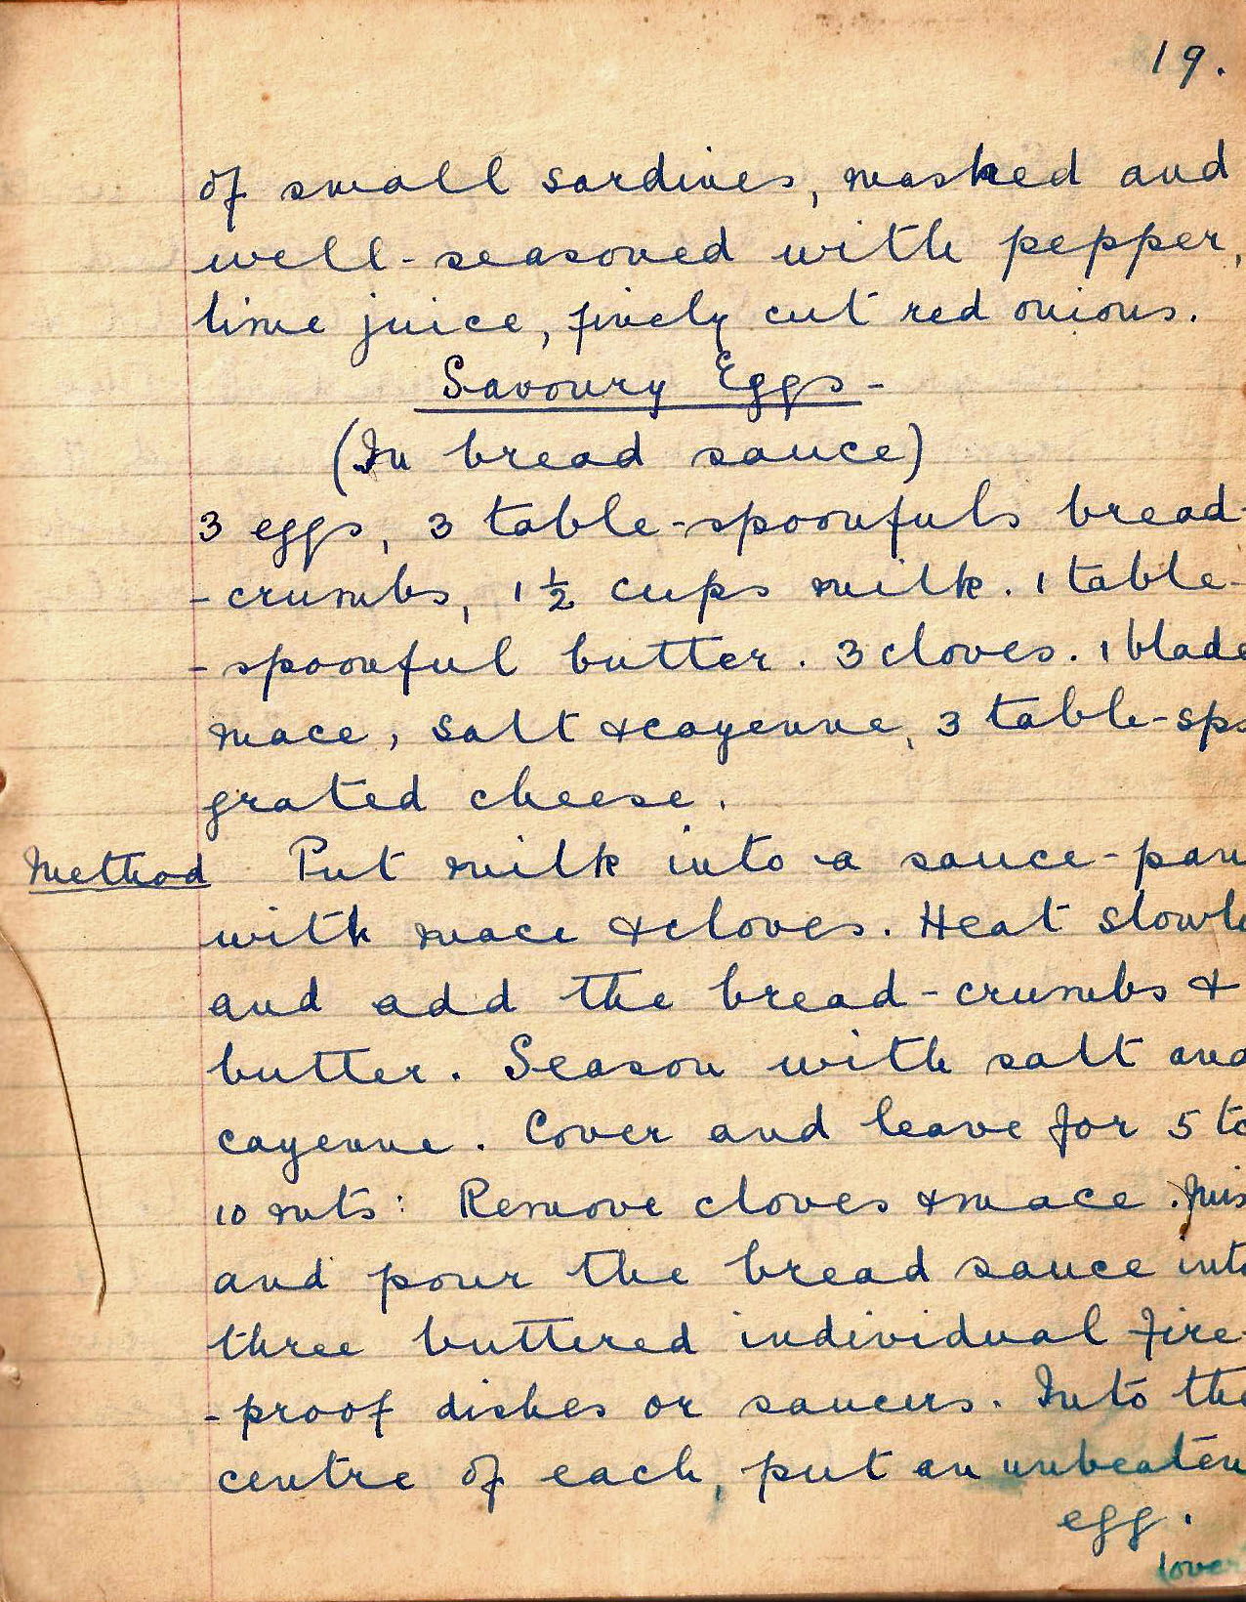

of small sardines, mashed and well-seasoned with pepper, lime juice, finely cut red onions.

Savoury eggs
(In bread sauce)
3 eggs, 3 tablespoonful bread crumbs, 1 ½ cups milk, 1 tablespoonful butter. 3 cloves. 1 blade mace. salt and cayenne, 3 tbsp grated cheese

Put milk into a sauce pan with mace and cloves. Heat slowly and add the bread crumbs and butter. Season with salt and cayenne. Cover and leave for 5 to 10 mins. Remove cloves and mace. Mix and pour the bread sauce into three buttered individual fire-proof dishes or saucers. Into the centre of each put an unbeaten egg.

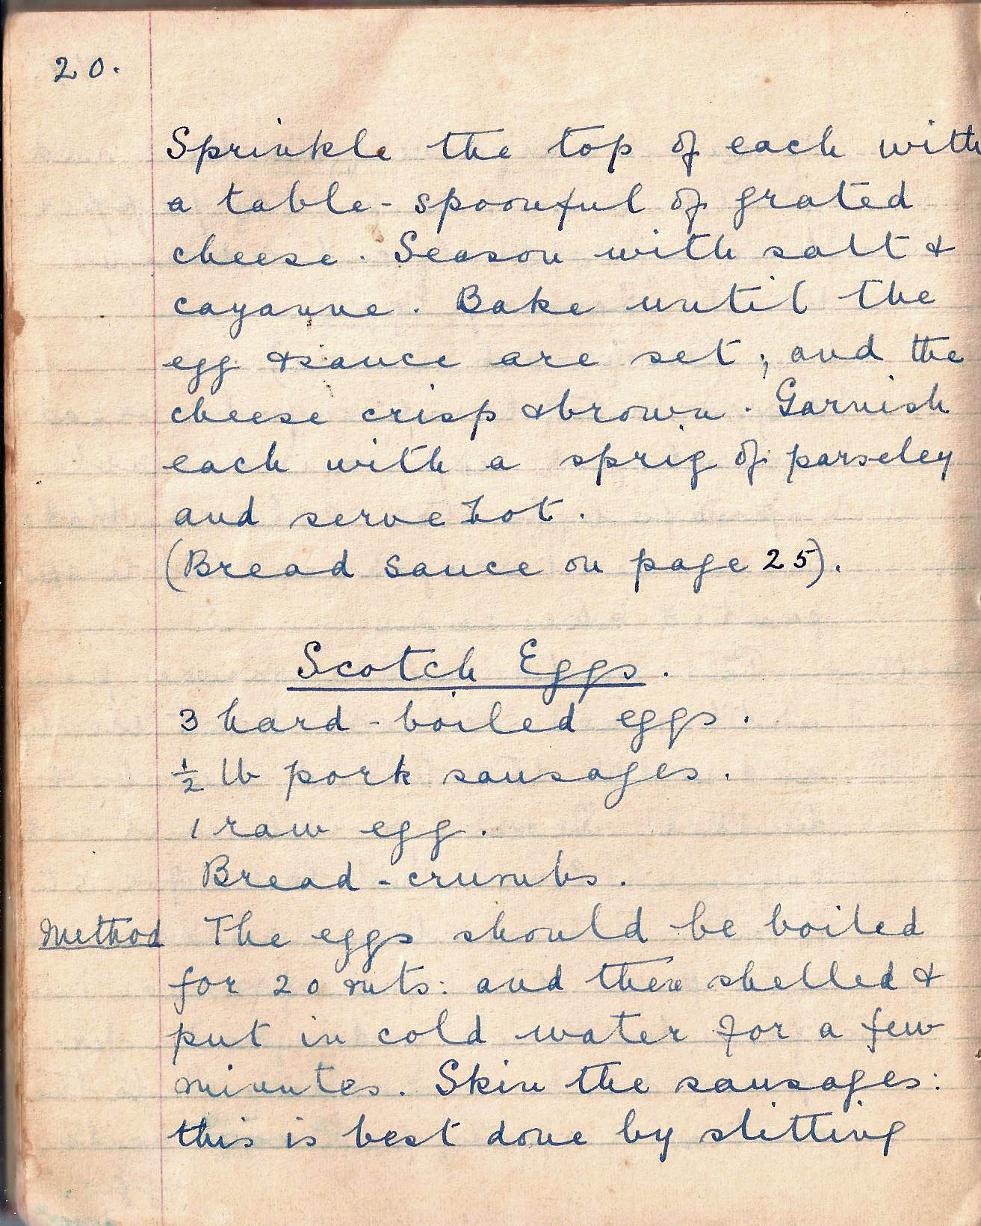.

Sprinkle the top of each with a tablespoonful of grated cheese. Season with salt and cayenne. Bake until the egg and the sauce are set; and the cheese crisp and brown. Garnish each with a sprig of parsley and serve hot.
Bread sauce on page 25)

Scotch eggs
3 hard boiled eggs
½ lb pork sausages
1 raw egg
Bread crumbs

Method The eggs should be boiled for 20 mins and then shelled and put in cold water for a few minutes. Skin the sausages: this is best done by slitting

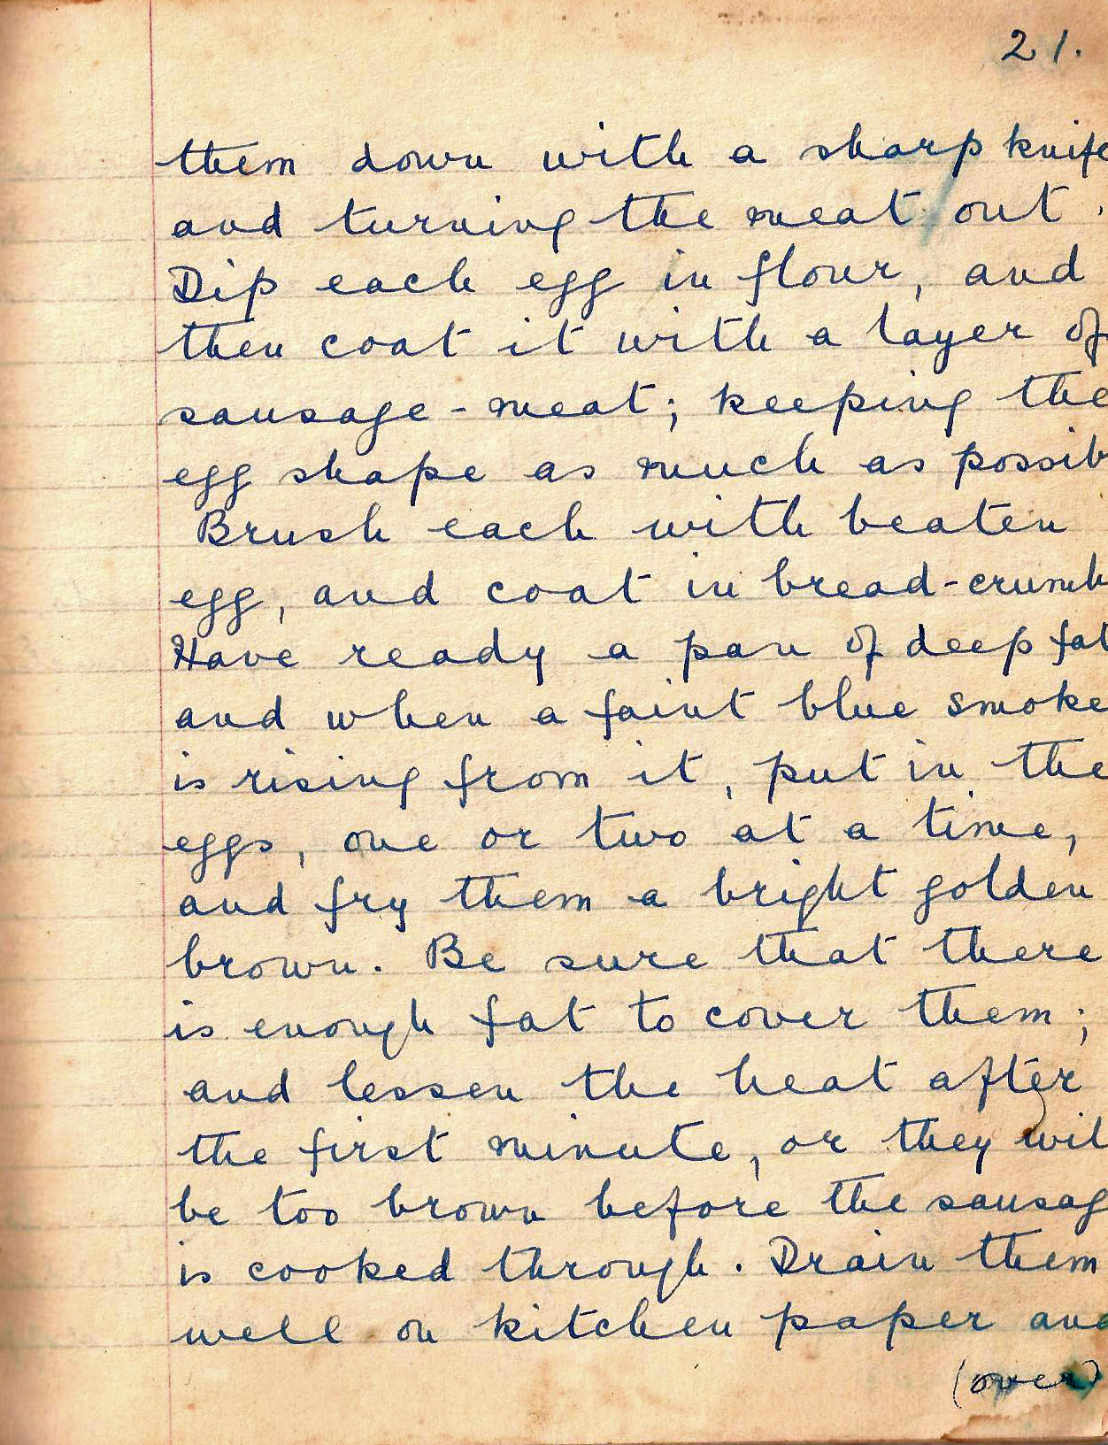

them down with a sharp knife and turning the meat out. Dip each egg in flour, and then coat with a layer of sausage meat; keeping the egg shape as much as possible. Brush each with beaten egg, and coat in bread crumbs. Have ready a pan of deep fat and when a faint blue smoke is rising from it, put in the eggs, one or two at a time, and fry them a bright golden brown. Be sure that there is enough fat to cover them: and lessen the heat after the first minute, or they will be too brown before the sausage is cooked through. Drain them well on kitchen paper and

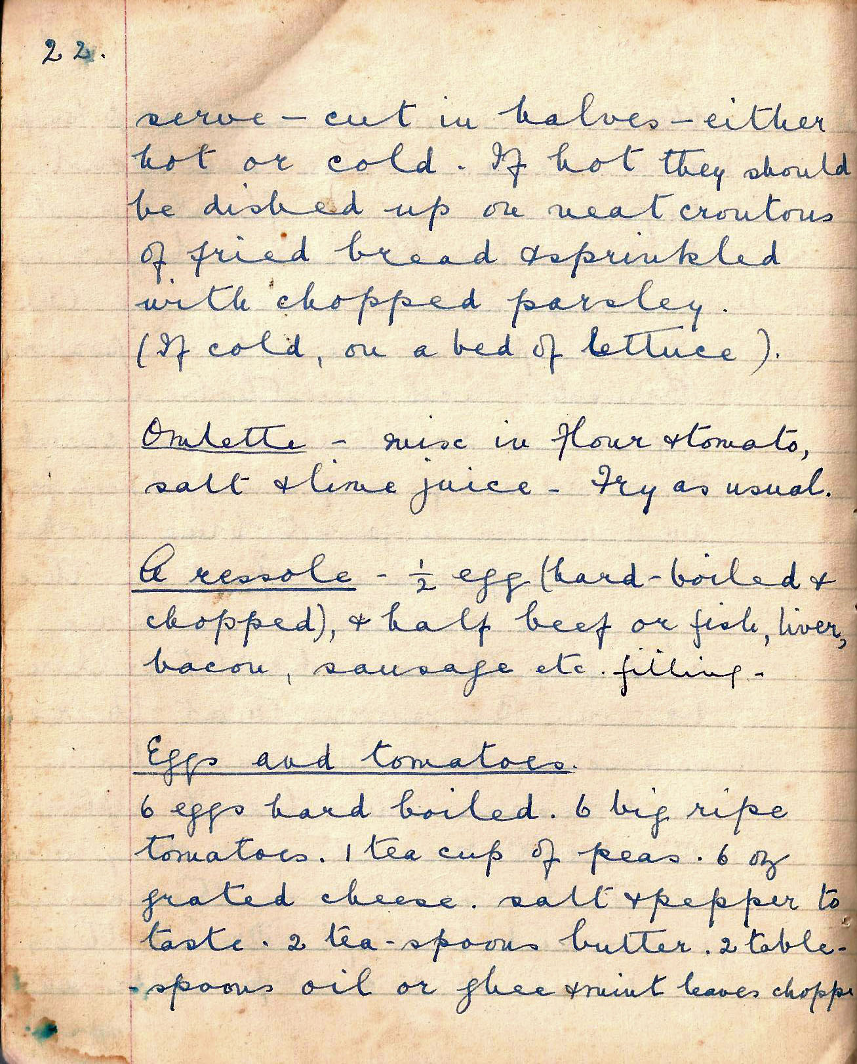

- cut in halves – either hot or cold. If hot they should be dished up on neat croutons of fried bread and sprinkled with chopped parsley. (If cold, on a bed of lettuce).

Omelette – mix in flour and tomato, salt and lime juice. Fry as usual.

A rissole – ½ egg (hard boiled and chopped) and half beef or fish, liver, bacon, sausage etc filling.

Eggs and tomatoes
6 eggs hard boiled. 6 big ripe tomatoes. 1 tea cup of peas. 6 oz grated cheese
salt and pepper to taste. 2 tablespoons butter 2 tbsp oil or ghee, mint leaves chopped

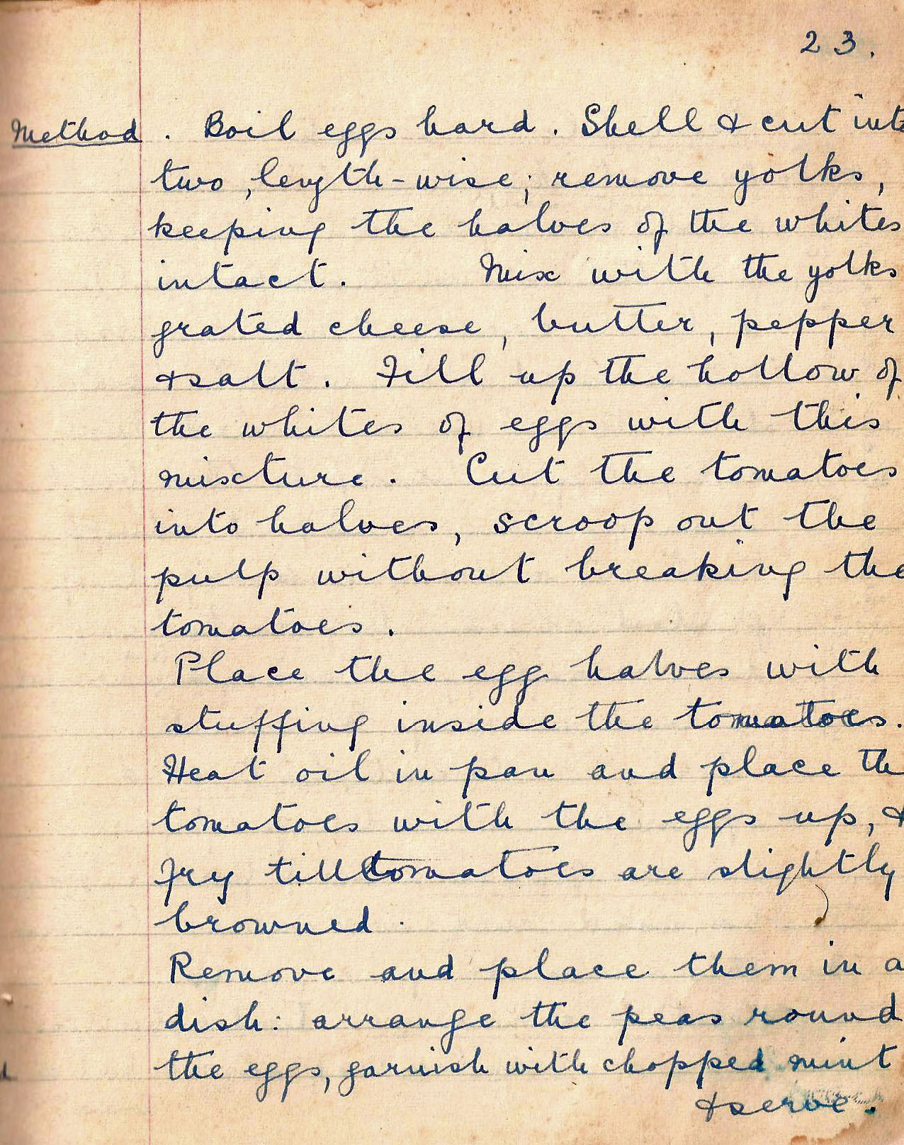

Method. Boil eggs hard. Shell and cut into two, length-wise; remove yolks, keeping the halves of the whites intact. Mix with the yolks grated cheese, butter, pepper and salt. Fill up the hollow of the whites of eggs with this mixture. Cut the tomatoes into halves, scoop out the pulp without breaking the tomatoes.

Place the egg halves with stuffing inside the tomatoes. Heat oil in pan and place the tomatoes with the eggs up and fry till the tomatoes are slightly browned.

Remove and place them in a dish: arrange the peas round the eggs, garnish with chopped mint and serve.

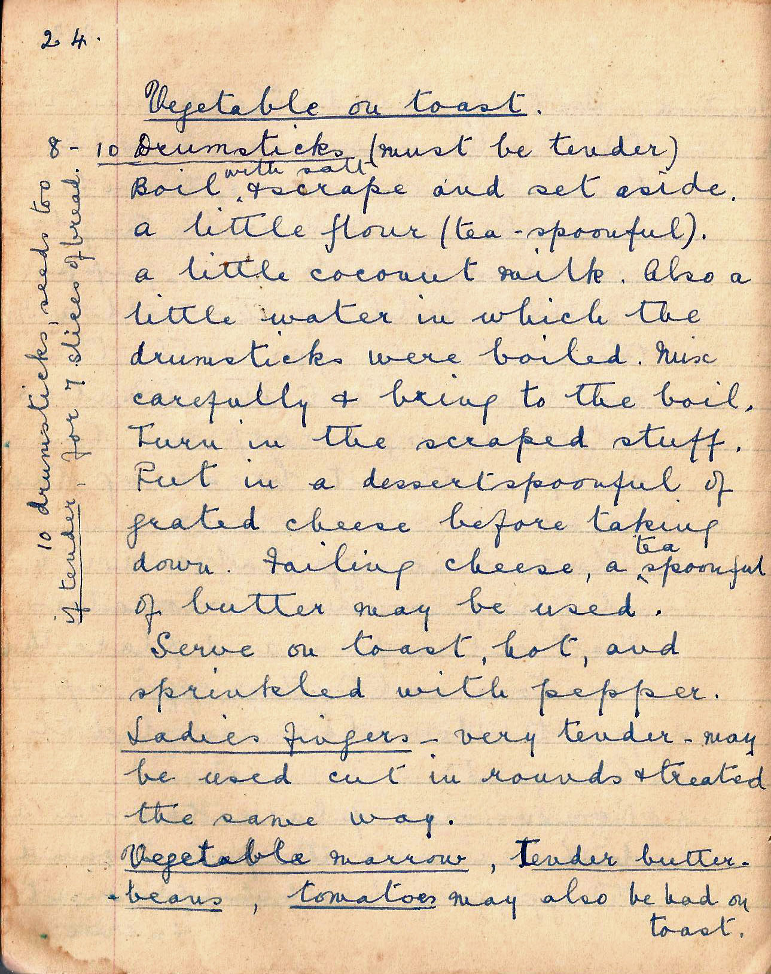

Vegetable on toast
8 – 10 Drumsticks (must be tender). Boil with salt and scrape and set aside. A little flour (teaspoonful). a little coconut milk. Also a little water in which the drumsticks were boiled. Mix carefully and bring to the boil. Turn in the scraped stuff. Put in a dessertspoonful of grated cheese before taking down. Failing cheese, a teaspoonful of butter may be used. Serve on toast, hot, and sprinkled with pepper.
10 drumsticks, seeds too, if tender 7 slices of bread.

Ladies fingers very tender may be used cut in rounds and treated the same way.

Vegetable marrow, tender butter beans, tomatoes may also be had on toast.

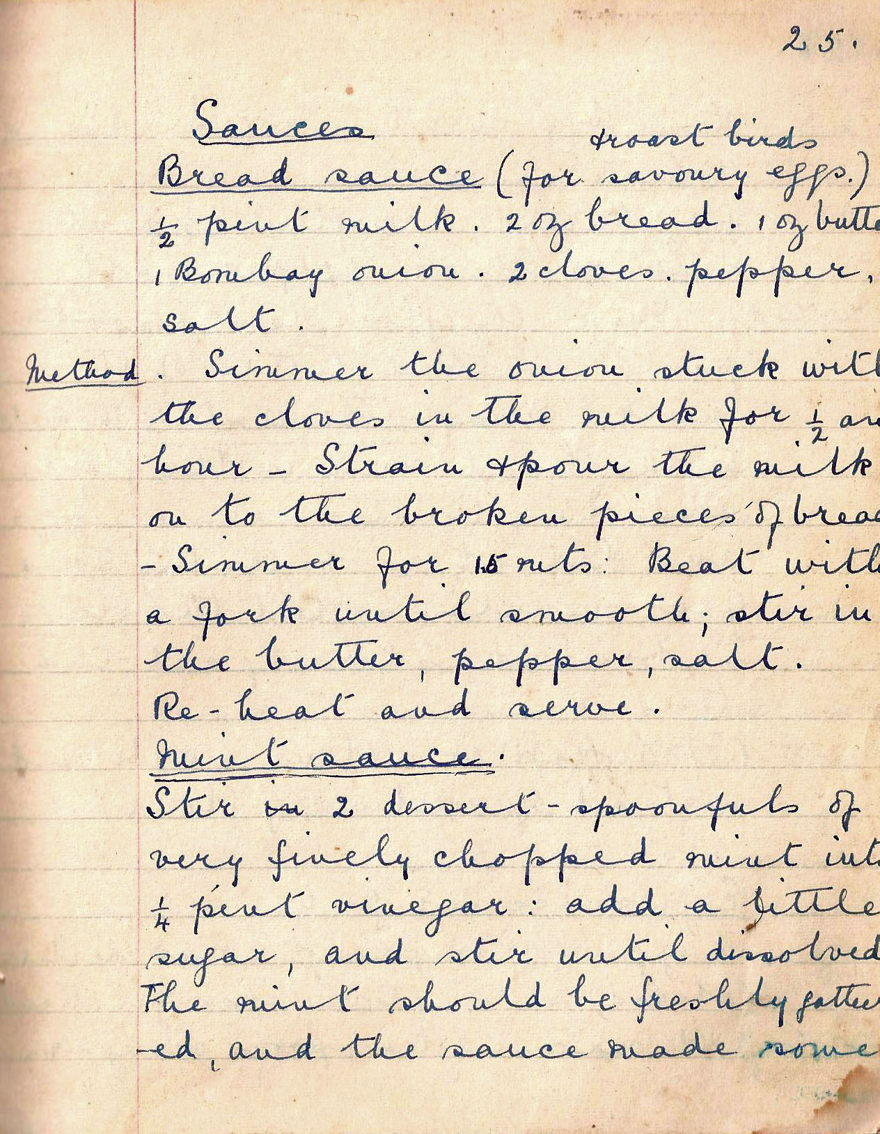

Sauces

Bread sauce (for savoury eggs and roast birds)
½ pint milk. 2 oz bread. 1 oz butter. 1 Bombay onion, 2 cloves. pepper and salt.

Simmer the onion stuck with the cloves in the milk for ½ an hour. Strain and pour the milk on to the broken pieces of bread. Simmer for 15 mins. Beat with a fork until smooth; stir in the butter, pepper, salt. Re-heat and serve.

Mint sauce
Stir 2 dessertspoonfuls of very finely chopped mint into ¼ pint vinegar: add a little sugar, and stir until dissolved. The mint should be freshly gathered and the sauce made some

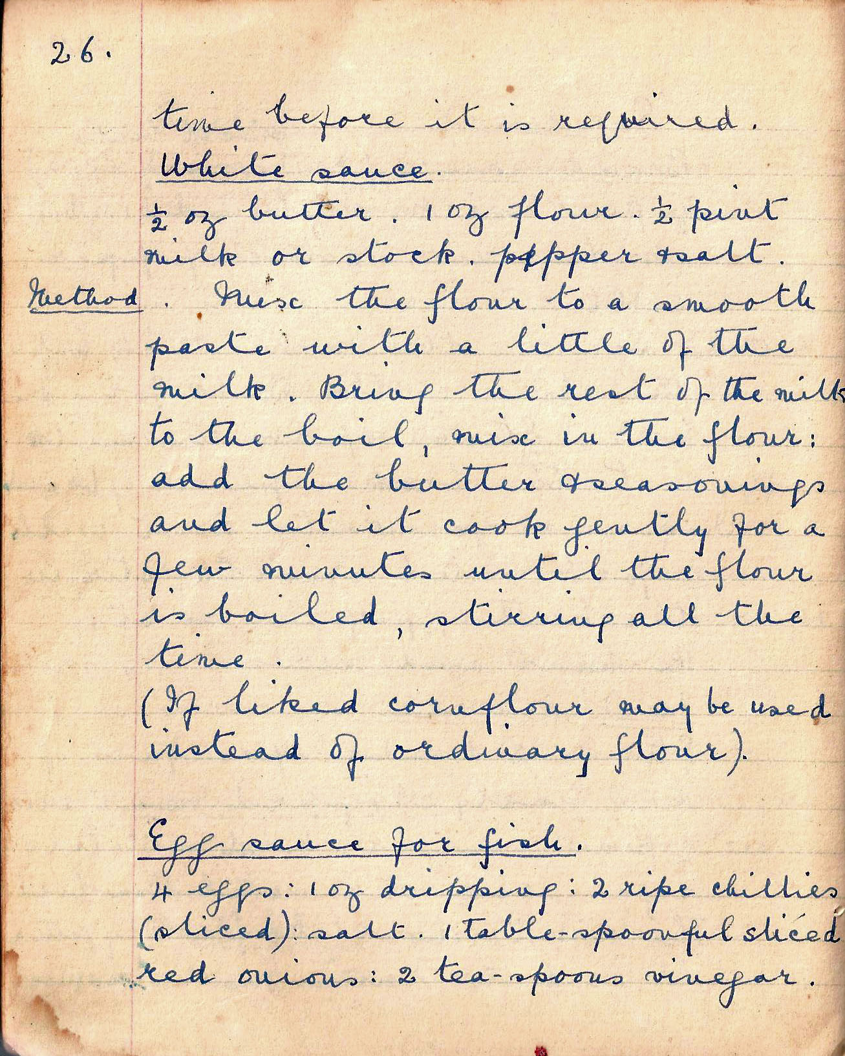

time before it is required.

White Sauce
½ ox butter. 1 oz flour. ½ pint milk or stock.
pepper and salt

Method. Mix the flour to a smooth paste with a little of the milk. Bring the rest of the milk to the boil, mix in the flour. Add the butter and seasonings and let it cook gently for a few minutes until the flour is boiled, stirring all the time.
(If liked cornflour may be used instead of ordinary flour)

Egg sauce for fish
4 eggs : 1 oz dripping: 2 ripe chillies (sliced)
Salt, 1 tablespoonful sliced red onions:
2 tsp vinegar.

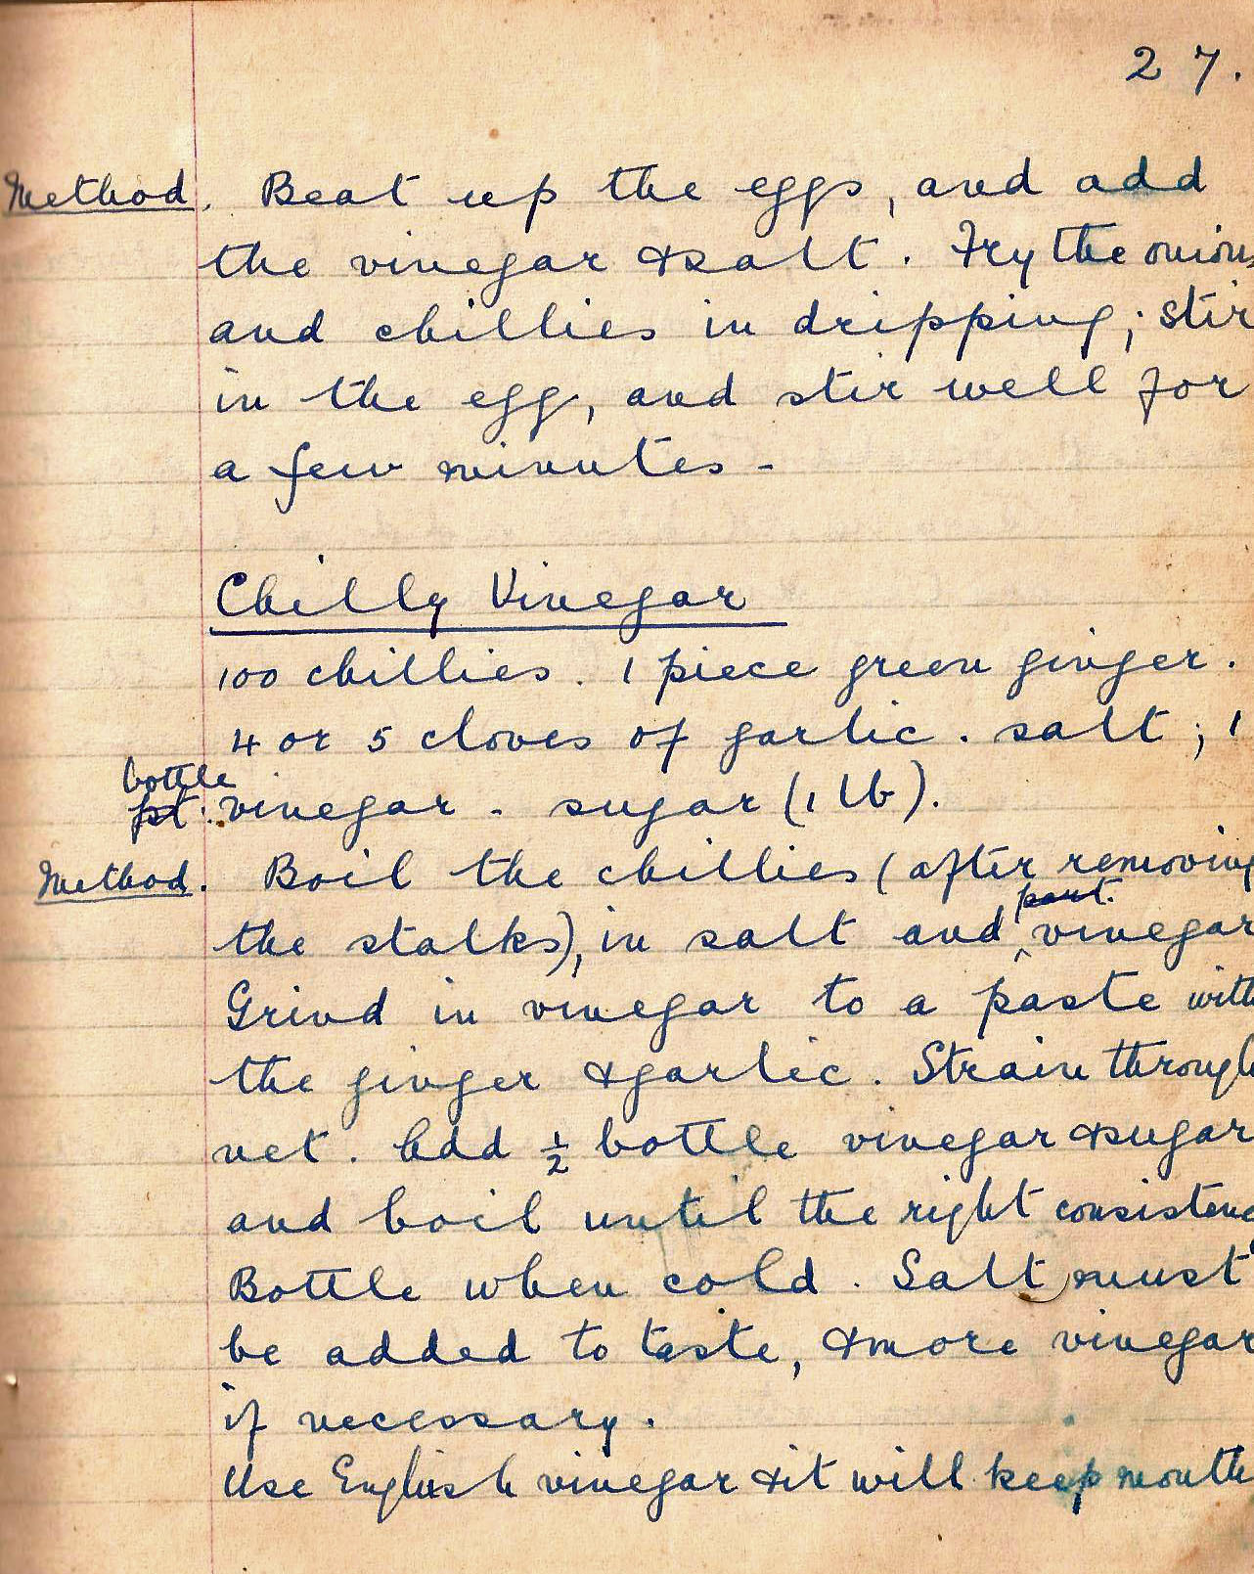

Method. Beat up the eggs, and add the vinegar and salt. Fry the onions and chillies in dripping; stir in the egg, and stir well for a few minutes.

Chilli Vinegar
100 chillies. 1 piece green ginger. 4 or 5 cloves of garlic. Salt, 1 bottle of vinegar - sugar 1 lb.

Method. Boil the chillies (after removing the stalks), in salt and vinegar. Grind the vinegar to a paste with the ginger and garlic. Strain through net. Add ½ bottle vinegar and sugar and boil until the right consistency. Bottle when cold. Salt must be added to taste and more vinegar if necessary.

Use English vinegar and it will keep months.

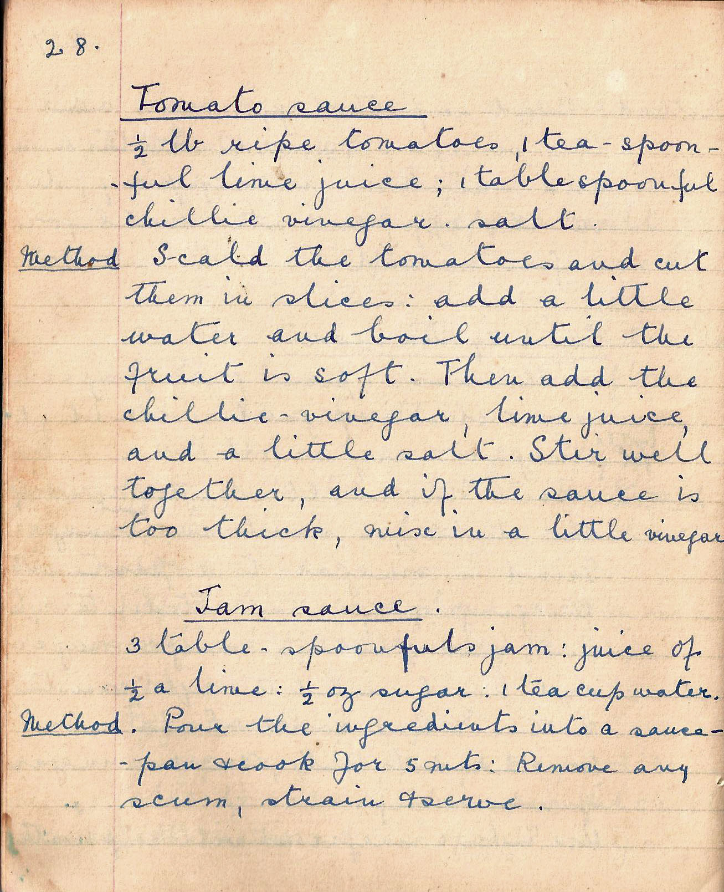

Tomato sauce
½ lb ripe tomatoes, 1 teaspoonful lime juice: 1 tbsp chillie vinegar.
salt

Method Scald the tomatoes and cut them in slices: add a little water and boil until the fruit is soft. Then add the chilli vinegar, lime juice, and a little salt. Stir well together, and if the sauce is too thick, mix in a little vinegar.

Jam sauce
3 tablespoonfuls jam: juice of ½ a lime: ½ oz sugar: 1 tea cup water

Method. Pour the ingredients into a sauce pan and cook for 5 mins. Remove any scum, strain and serve.

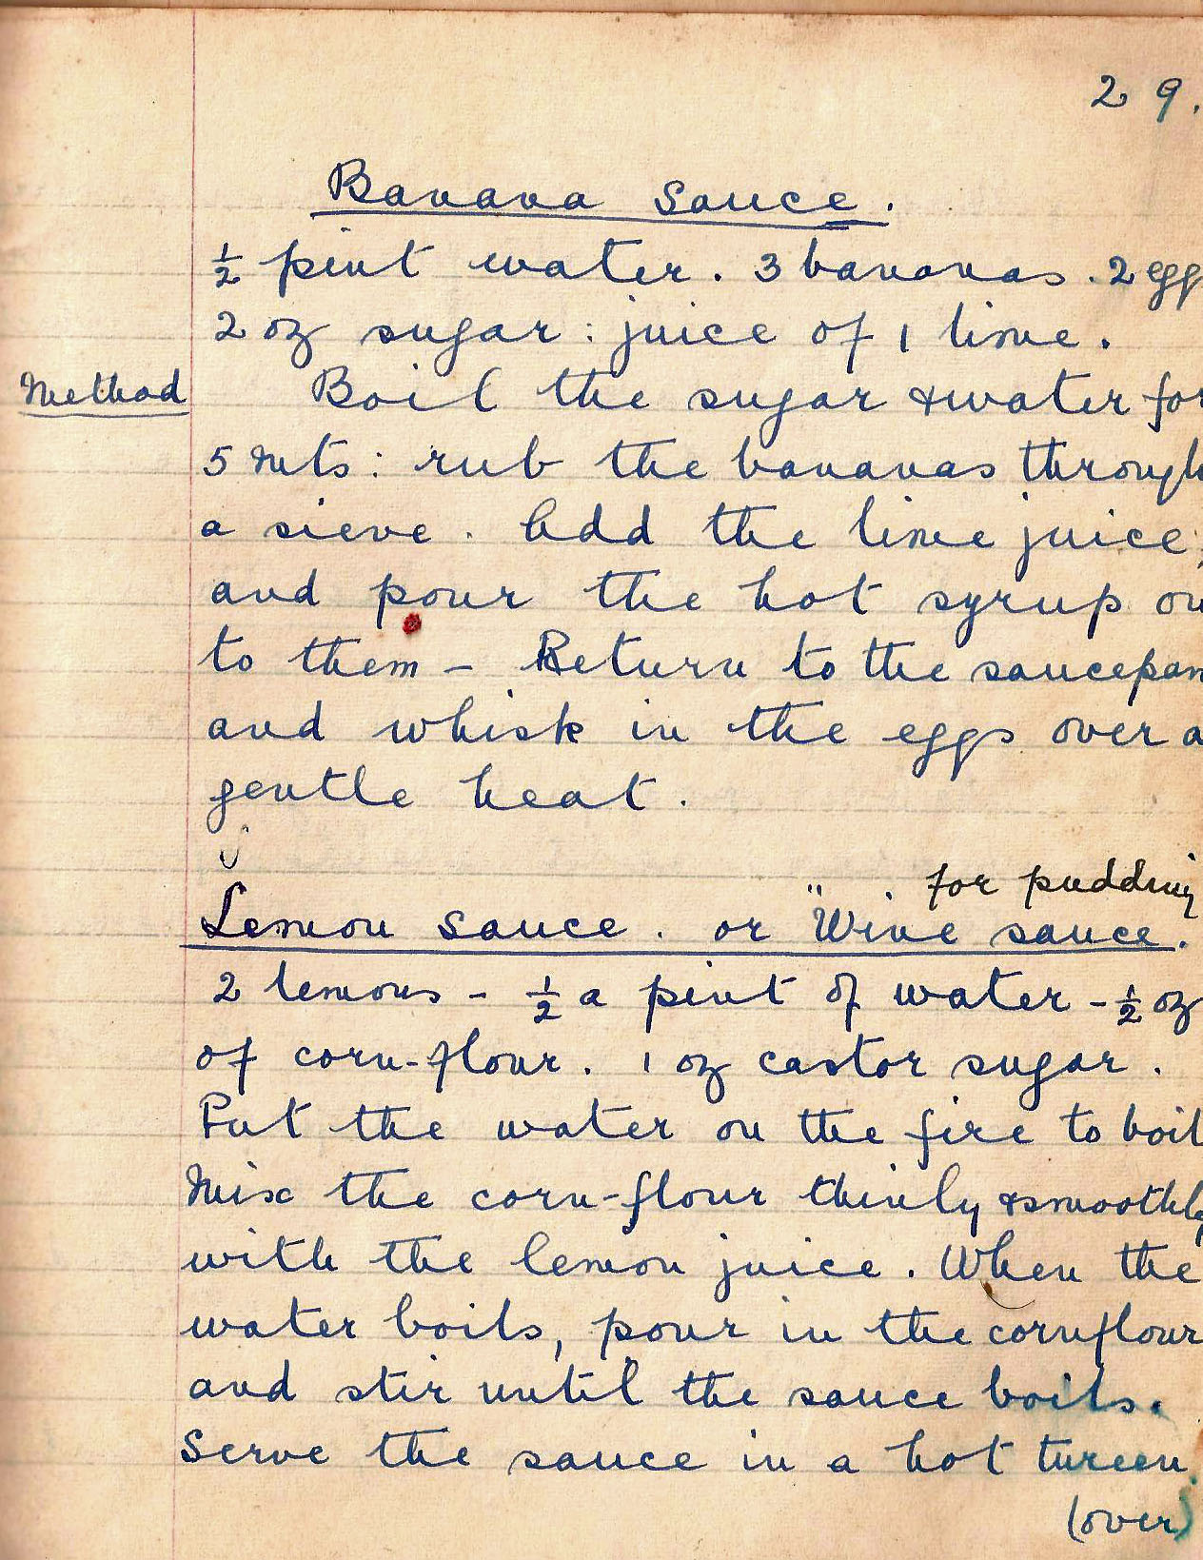

Banana sauce
½ pint water. 3 bananas. 2 eggs. 2 oz sugar
juice of 1 lime.

Method. Boil the sugar and water for 5 mins: rub the bananas through a sieve. Add the lime juice, and pour the hot syrup on to them. Return to the saucepan and whisk in the eggs over a gentle heat.

Lemon sauce or wine sauce for pudding
2 lemons - ½ a pint of water - ½ oz of corn-flour.
1 oz caster sugar.

Put the water on the fire to boil. Mix the cornflour thinly and smoothly with the lemon juice. When the water boils, pour in the cornflour and stir until the sauce boils. Serve the sauce in a hot tureen.

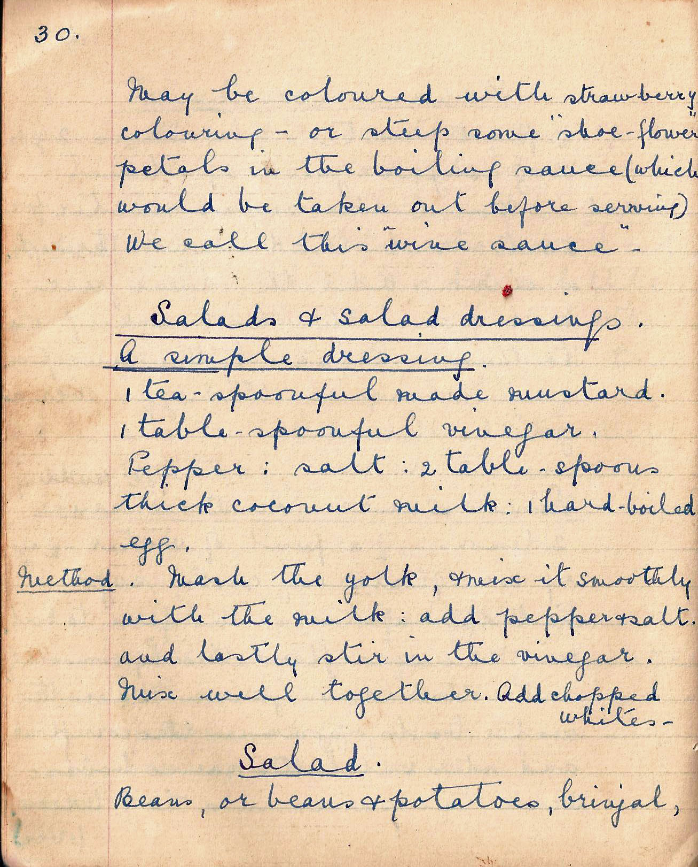

May be coloured with strawberry colouring – or steep some “shoe flowers” petals in the boiling sauce (which would be taken out before serving). We call this “wine sauce”.

SALADS AND SALAD DRESSINGS

A simple salad dressing
1 teaspoonful made mustard. 1 tablespoonful vinegar. Pepper. salt. 2 tablespoons thick coconut milk. 1 hard boiledegg.

Method. Mash the yolk of the egg. Mix it smoothly with the coconut milk. Add pepper and salt to taste. Stir in the vinegar. Mix well together. Add the chopped whites.

Salad
Beans, or beans and potatoes, brinjal,

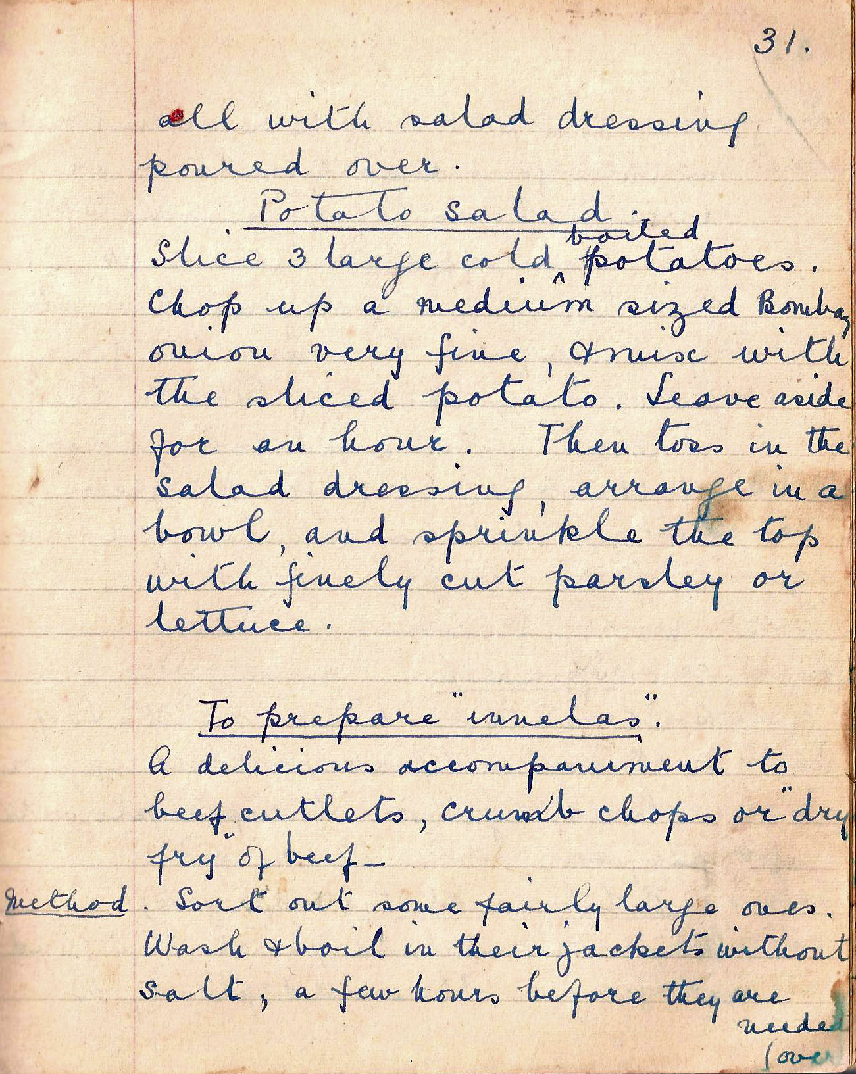

all with salad dressing poured over.

Potato salad
Slice 3 large cold boiled potatoes. Chop up a medium sized Bombay onion very fine, and mix with the sliced potato. Leave aside for an hour. Then toss in the salad dressing, arrange in a bowl and sprinkle top with finely cut parsley or lettuce.

To prepare “innelas”
A delicious accompaniment to beef cutlets, crumb chops or ‘dry fry’ of beef.

Method: Sort out some fairly large ones. Wash and boil in their jackets without salt, a few hours before they are needed.

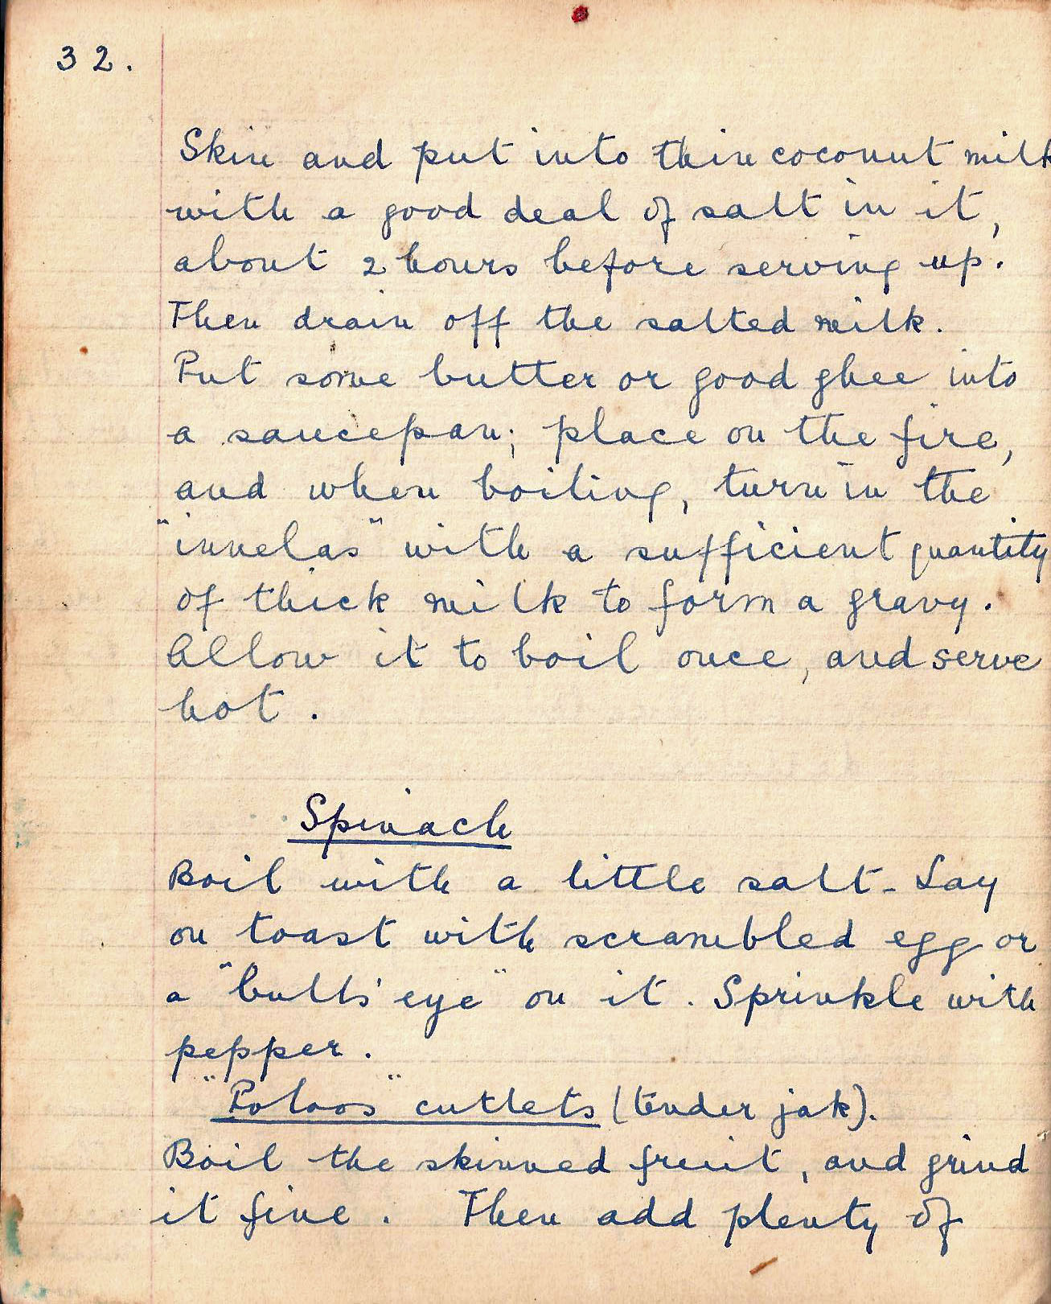

Skin and put into thin coconut milk with a good deal of salt in it, about 2 hours before serving up! Then drain off the salted milk. Put some butter or good ghee into a saucepan: place on the fire, and when boiling, turn in the “innelas” with a sufficient quantity of thick milk to form a gravy. Allow it to boil once, and serve hot.

Spinach
Boil with a little salt. Lay on toast with scrambled eggs or a ‘bulls eye” on it. Sprinkle with pepper.

Polos cutlets (tender jak)
Boil the skinned fruit, and grind it fine. Then add plenty of

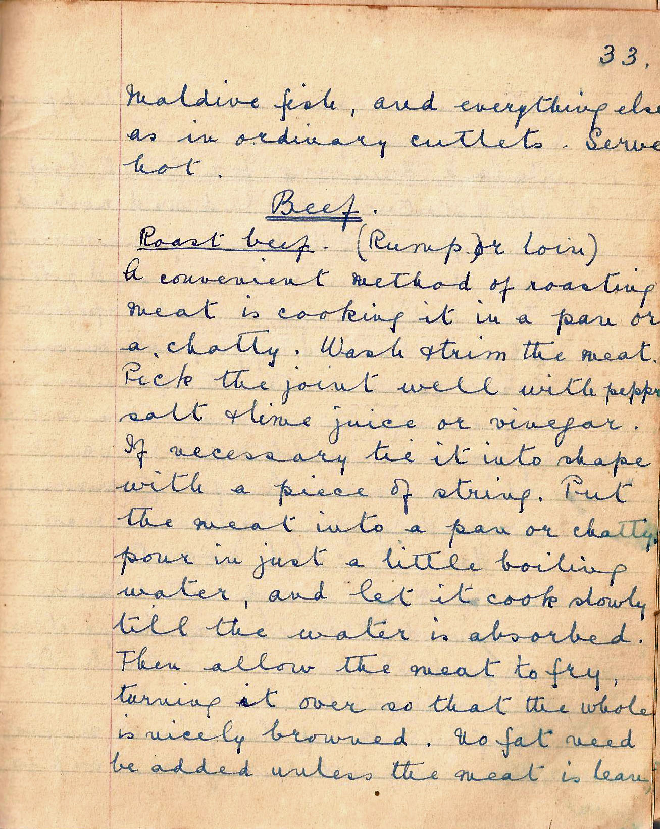

Maldive fish, and everything else as in ordinary cutlets. Serve hot.

BEEF
Roast Beef .(Rump or loin)
A convenient method of roasting meat is cooking it in a pan or a chatty. Wash and trim the meat. Pick the joint well with pepper, salt and lime juice or vinegar. If necessary tie it into shape with a piece of string. Put the meat into a pan or chatty, pour in just a little boiling water, and let it cook slowly till the water is absorbed. Then allow the meat to fry, turning it over so that the whole is nicely browned. No fat need be added unless the meat is lean,

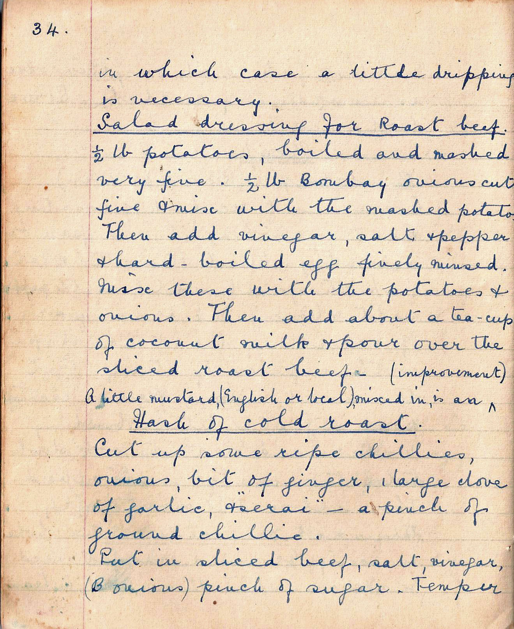

in which case a little dripping is necessary.

Salad dressing for Roast beef
½ lb potatoes, boiled and mashed very fine. ½ lb Bombay onions cut fine and mixed with the mashed potato. Then add vinegar, salt and pepper and hard boiled eggs finely minced.
The add about a tea-cup to coconut milk
and pour over the sliced roast beef. A little mustard (English or local) mixed in is an improvement.

Hash of cold roast
Cut up some ripe chillies, onions, a bit of ginger, 1 large clove of garlic, and serai - a pinch of ground chilli.

Put in sliced beef, salt, vinegar, Bombay onions, a pinch of sugar. Temper

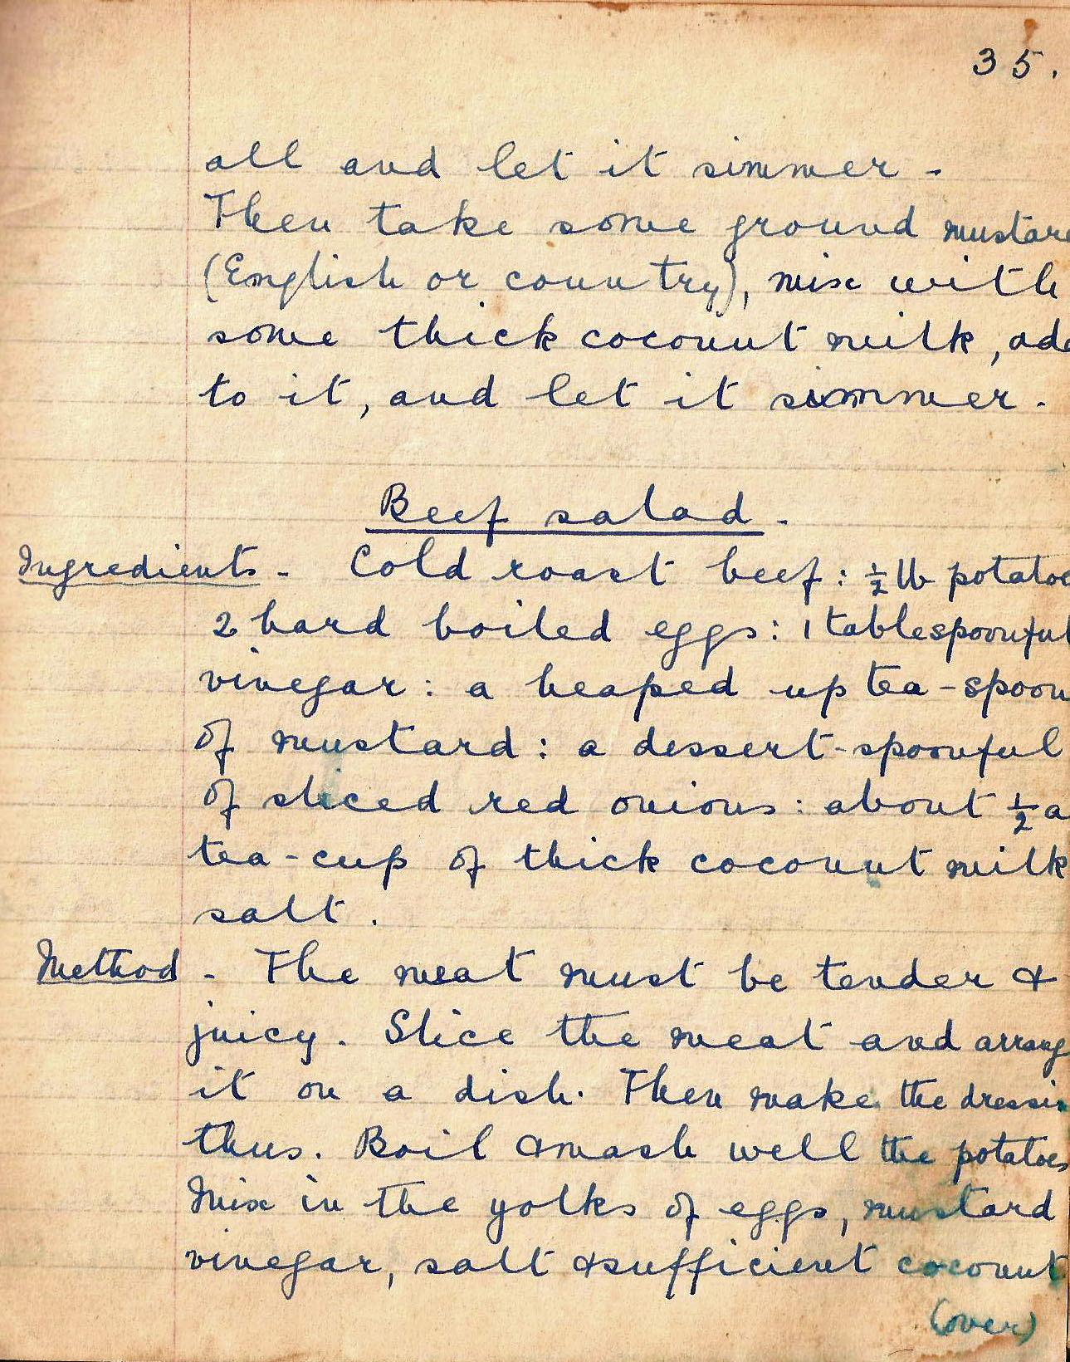

all and let it simmer. Then take some ground mustard (English or country), mix with some thick coconut milk, add to it and let it simmer.

Beef salad
Ingredients. Cold roast beef :½ lb potatoes: 2 hard boiled eggs: 1 tablespoonful vinegar: a heaped up teaspoon of mustard; 1 dessertspoonful of sliced red onions: about ½ a tea-cup of thick coconut milk: salt

The meat must be tender and juicy. Slice the meat and arrange it on a dish. Then make the dressing thus. Boil and mash well the potatoes. Mix in the yolks of eggs, mustard, vinegar, salt and sufficient
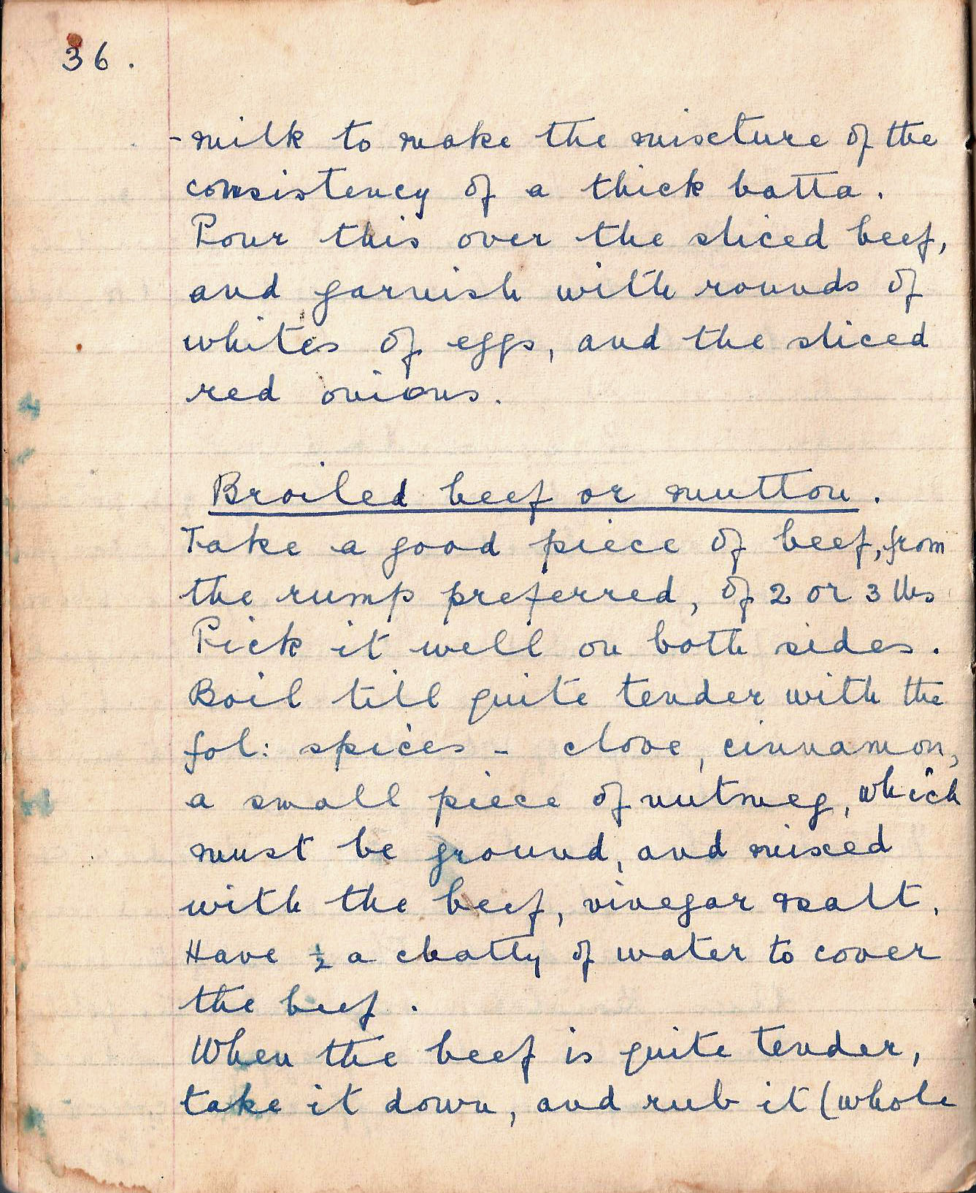

milk to make the mixture of the consistency of a thick batter. Pour this over the sliced beef, and garnish with rounds of whites of eggs, and the sliced red onions.

Broiled beef or mutton
Take a good piece of beef, from the rump preferred, of 2 or 3 lbs. Prick it well on both sides. Boil till quite tender with the fol: spices – clove, cinnamon, a small piece of nutmeg, which must be ground, and mixed with the beef, vinegar and salt. Have ½ chatty of water to cover the beef.

When the beef is quite tender, take it down and rub it (whole

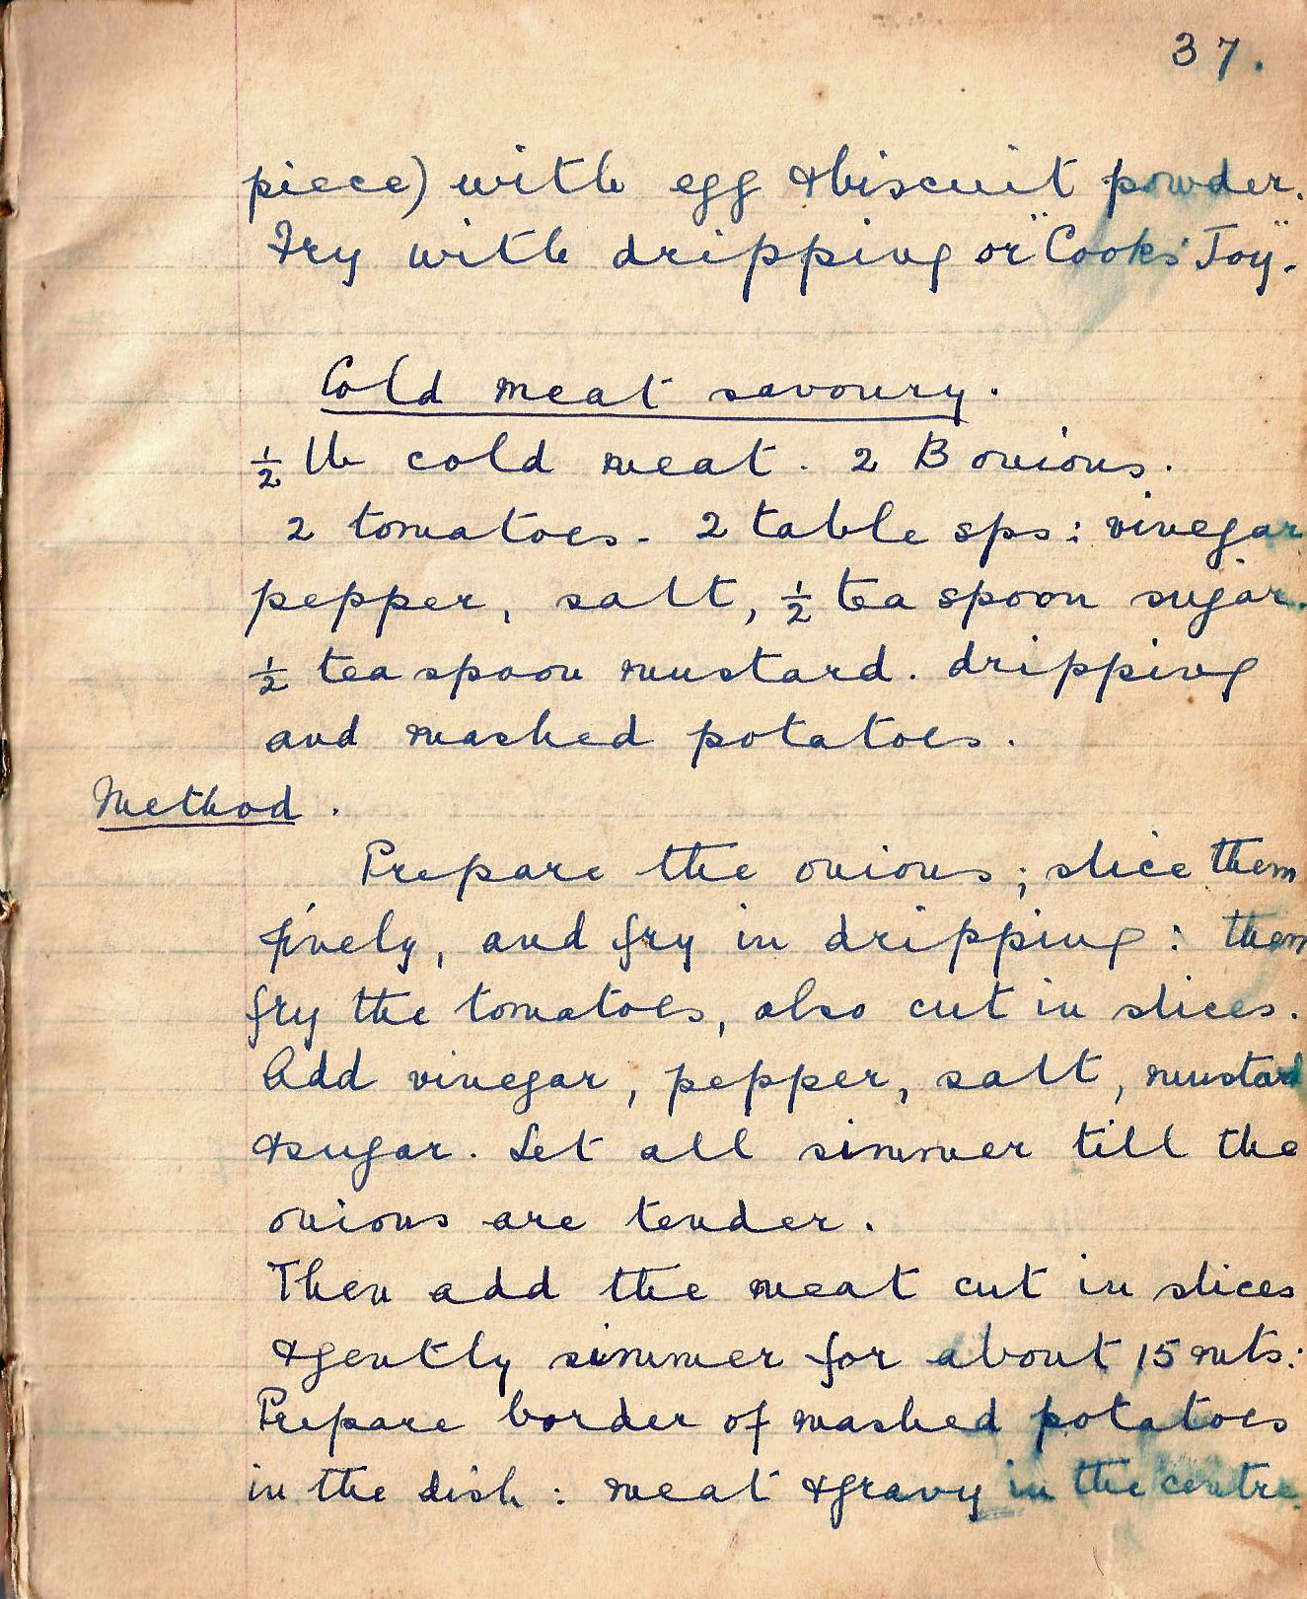

piece) with egg and biscuit powder. Fry with dripping or “ Cook’s Joy”.

Cold meat savoury
½ lb cold meat. 2 B onions. 2 tomatoes. 2 tablespoons: vinegar, pepper, salt, ½ teaspoon sugar. ½ teaspoon mustard. dripping and mashed potatoes.

Method. Prepare the onions: slice them finely, and fry in dripping: then fry the tomatoes, also cut in slices. Add vinegar, pepper, salt, mustard, and sugar. Let all simmer till the onions are tender.

Then add the meat cut in slices and gently simmer for about 15 mins. Prepare border of mashed potatoes in the dish: meat and gravy in the centre.

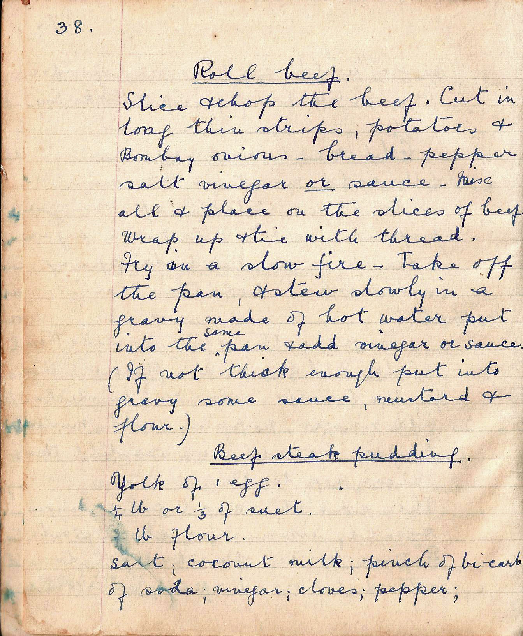

Roll beef
Slice and chop the beef. Cut it in long thin strips, potatoes and Bombay onions – bread – pepper, salt, vinegar or sauce.

Mix all and place on the slices of beef. Wrap up and tie with thread. Fry on a slow fire – Take off the pan, and stew slowly in a gravy made of hot water put into the same pan and add vinegar or sauce. (If not thick enough put into gravy some sauce, mustard and flour).

Beef steak pudding
Yolk of 1 egg. ¼ lb or 1/3 of suet’. ¾ lb flour.
salt; coconut milk; pinch of bicarb of soda; vinegar; cloves; pepper

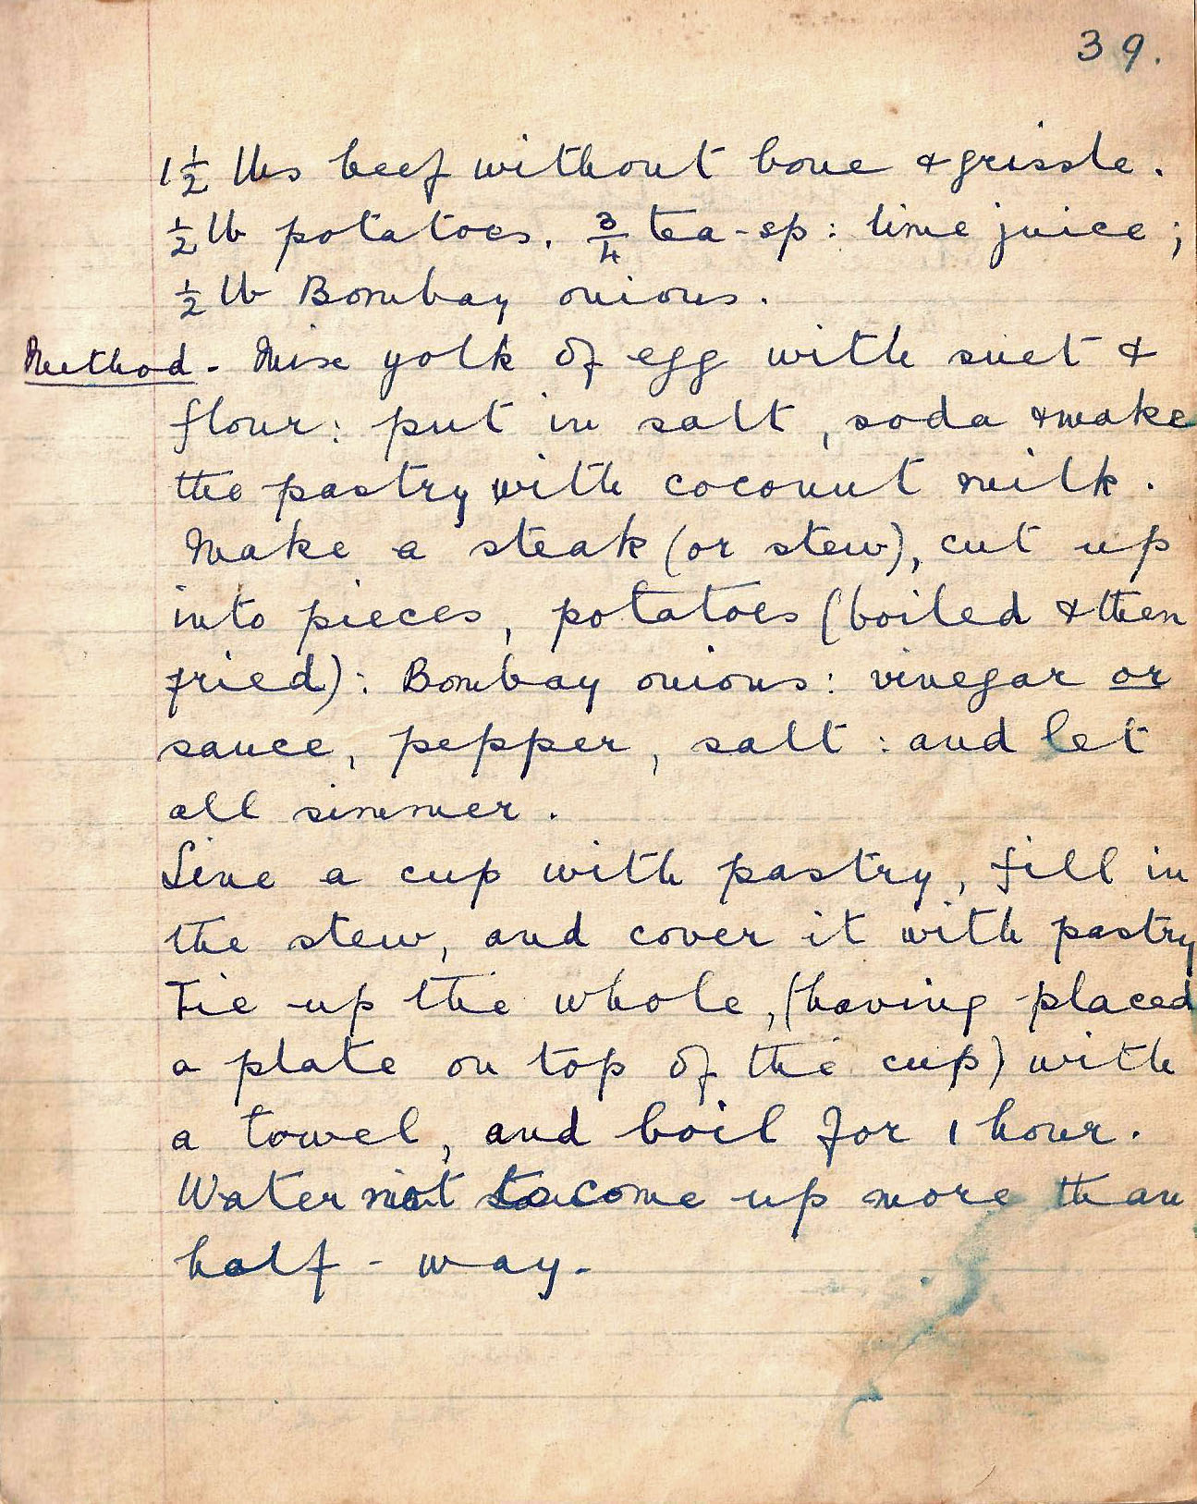

1 ½ lbs beef without bone and gristle. ½ lb potatoes. ¾ teaspoon lime juice; ½ lb Bombay onions

Method. Mix yolk of egg with suet and flour: put in salt, soda and make the pastry with coconut milk. Make a steak (or stew), cut up into pieces, potatoes (boiled and then fried): Bombay onions: vinegar or sauce, pepper, salt: and let all simmer.

Line a cup with pastry, fill in the stew, and cover it with pastry. Tie up the whole (having placed a plate on top of the cup) with a towel and boil for 1 hour. Water not to come up more than half-way.

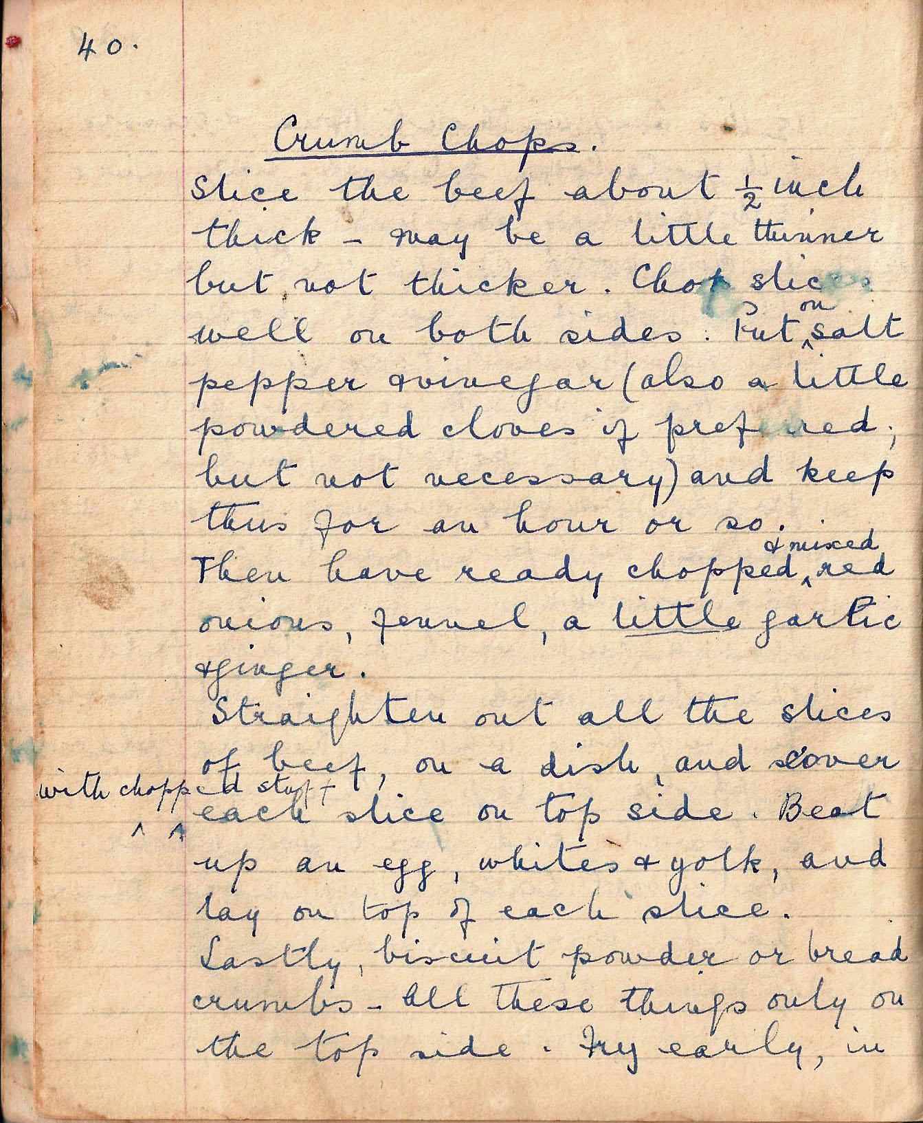

Crumb chops
Slice the beef about ½ inch thick – may be a little thinner but not thicker. Clean slices well on both sides. Put on salt, pepper, and vinegar (also a little powdered cloves if preferred but not necessary) and keep this for an hour or so.

Then have ready chopped and mixed red onions, fennel, a little garlic and vinegar.

Straighten out all the slices of beef, on a dish, and cover with chopped stuff each slice on top side. Beat up an egg, whites and yolk, and lay on top of each slice.

Lastly, biscuit powder or bread crumbs – all these things only on the top side. Fry early, in

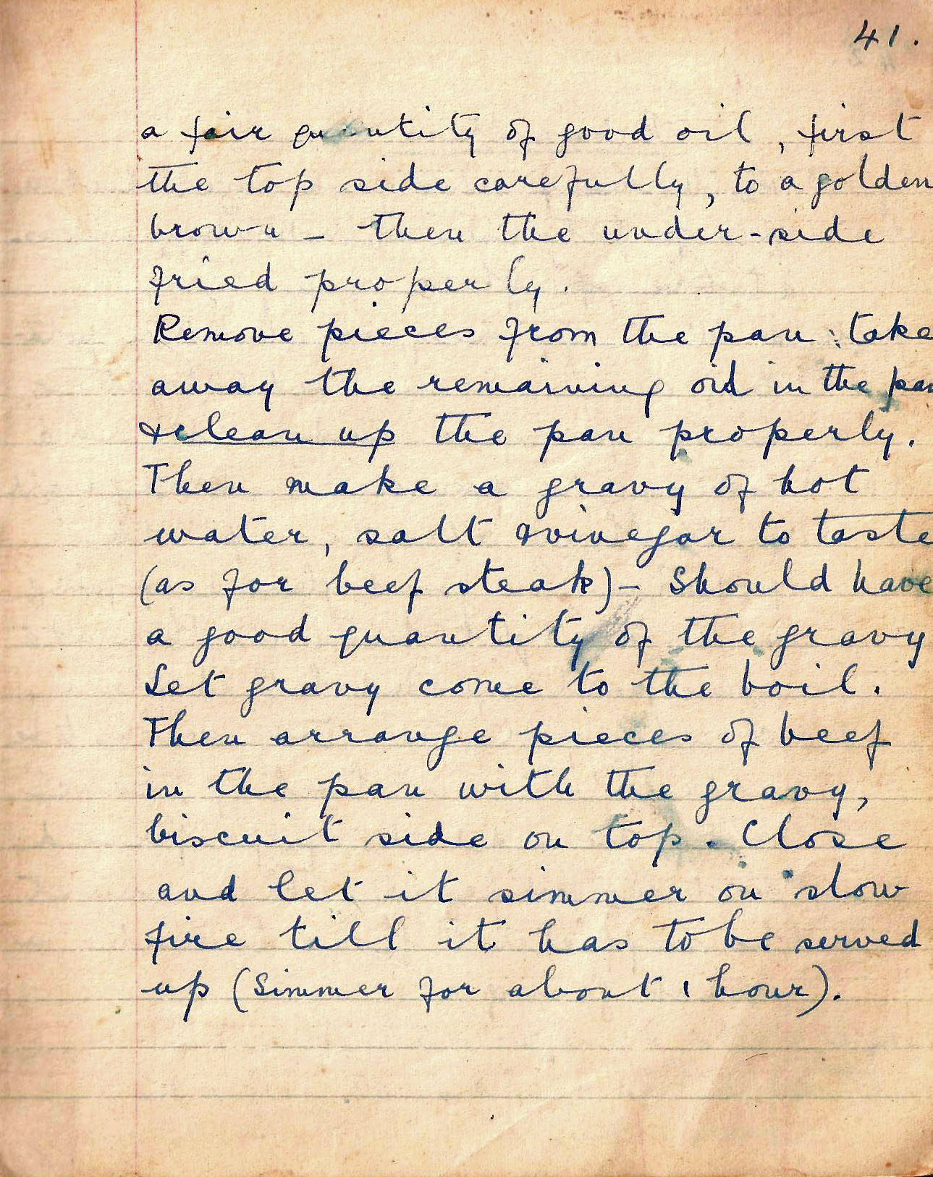

a fair quantity of good oil, first the top side carefully, to a golden brown – then the under-side fried properly.

Remove pieces from the pan: take away the remaining oil in the pan and clean up the pan properly. Then make a gravy of hot water, salt and vinegar to taste (as for beef steak) – Should have a good quantity of the gravy. Let gravy come to the boil.

Then arrange pieces of beef in the pan with the gravy, biscuit side on top. Close and let it simmer on slow fire till it has to be served up (Simmer for about 1 hour).

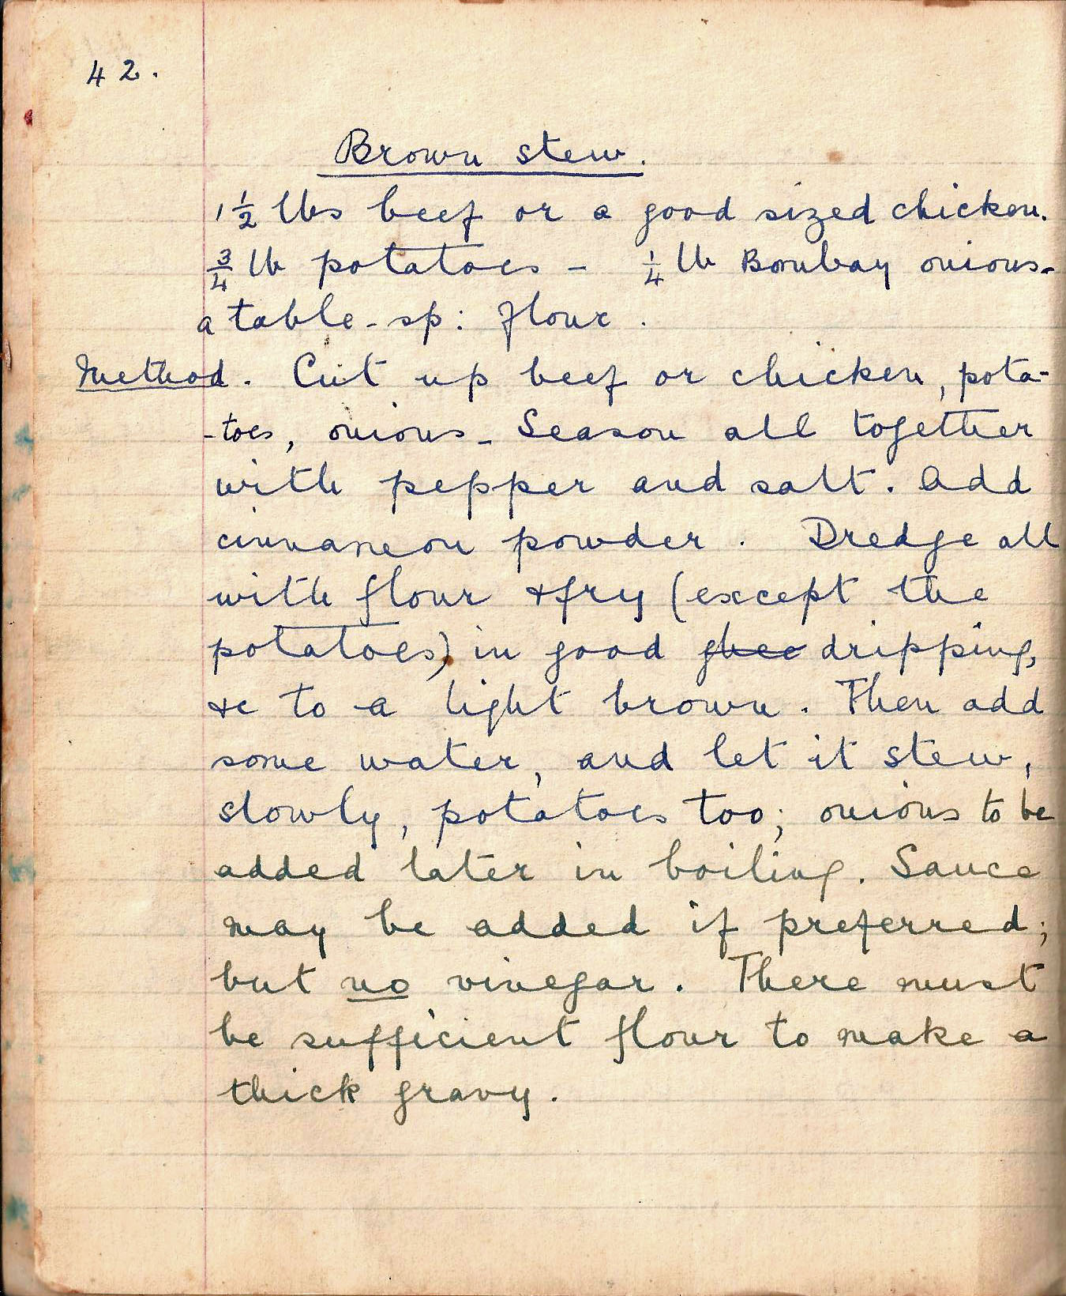

Brown stew
1 ½ lbs beef or a good sized chicken. ¾ lb potatoes – ¼ lb Bombay onions. a tablespoon flour.

Method Cut up beef or chicken, potatoes, onions. Season all together with pepper and salt. Add cinnamon powder. Dredge all with flour and fry (except the potatoes) in good dripping, to a light brown. Then add some water, and let it stew slowly, potatoes too: onions to be added later in the boiling. Sauce may be added if preferred, but no vinegar. There must be sufficient flour to make a thick gravy.

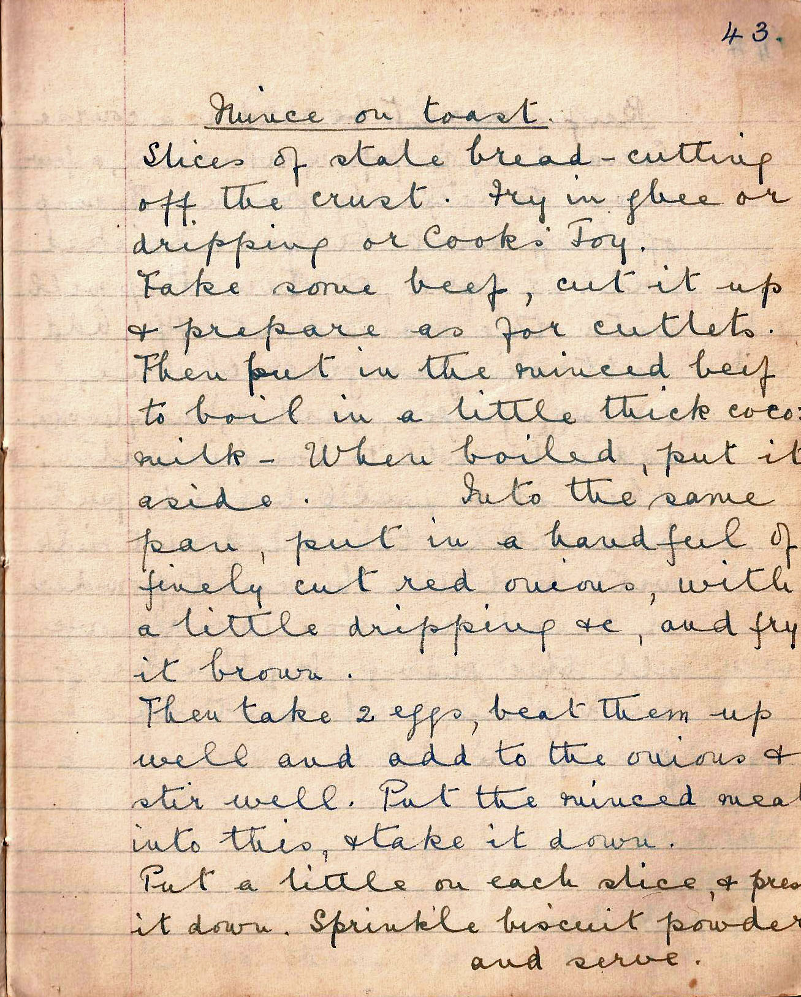

Mince on toast
Slices of stale bread – cutting off the crust. Fry in ghee or dripping or Cook’s Joy.

Take some beef, cut it up and prepare as for cutlets. Then put in the minced beef to boil in a little thick coco milk. When boiled, put it aside. Into the same pan, put in a handful of finely cut red onions, with a little dripping etc. and fry it brown.

Then take 2 eggs, beat them up well and add to the onions and stir well. Put the minced meat into this, and take it down.

Put a little on each slice, and press it down. Sprinkle biscuit powder and serve.

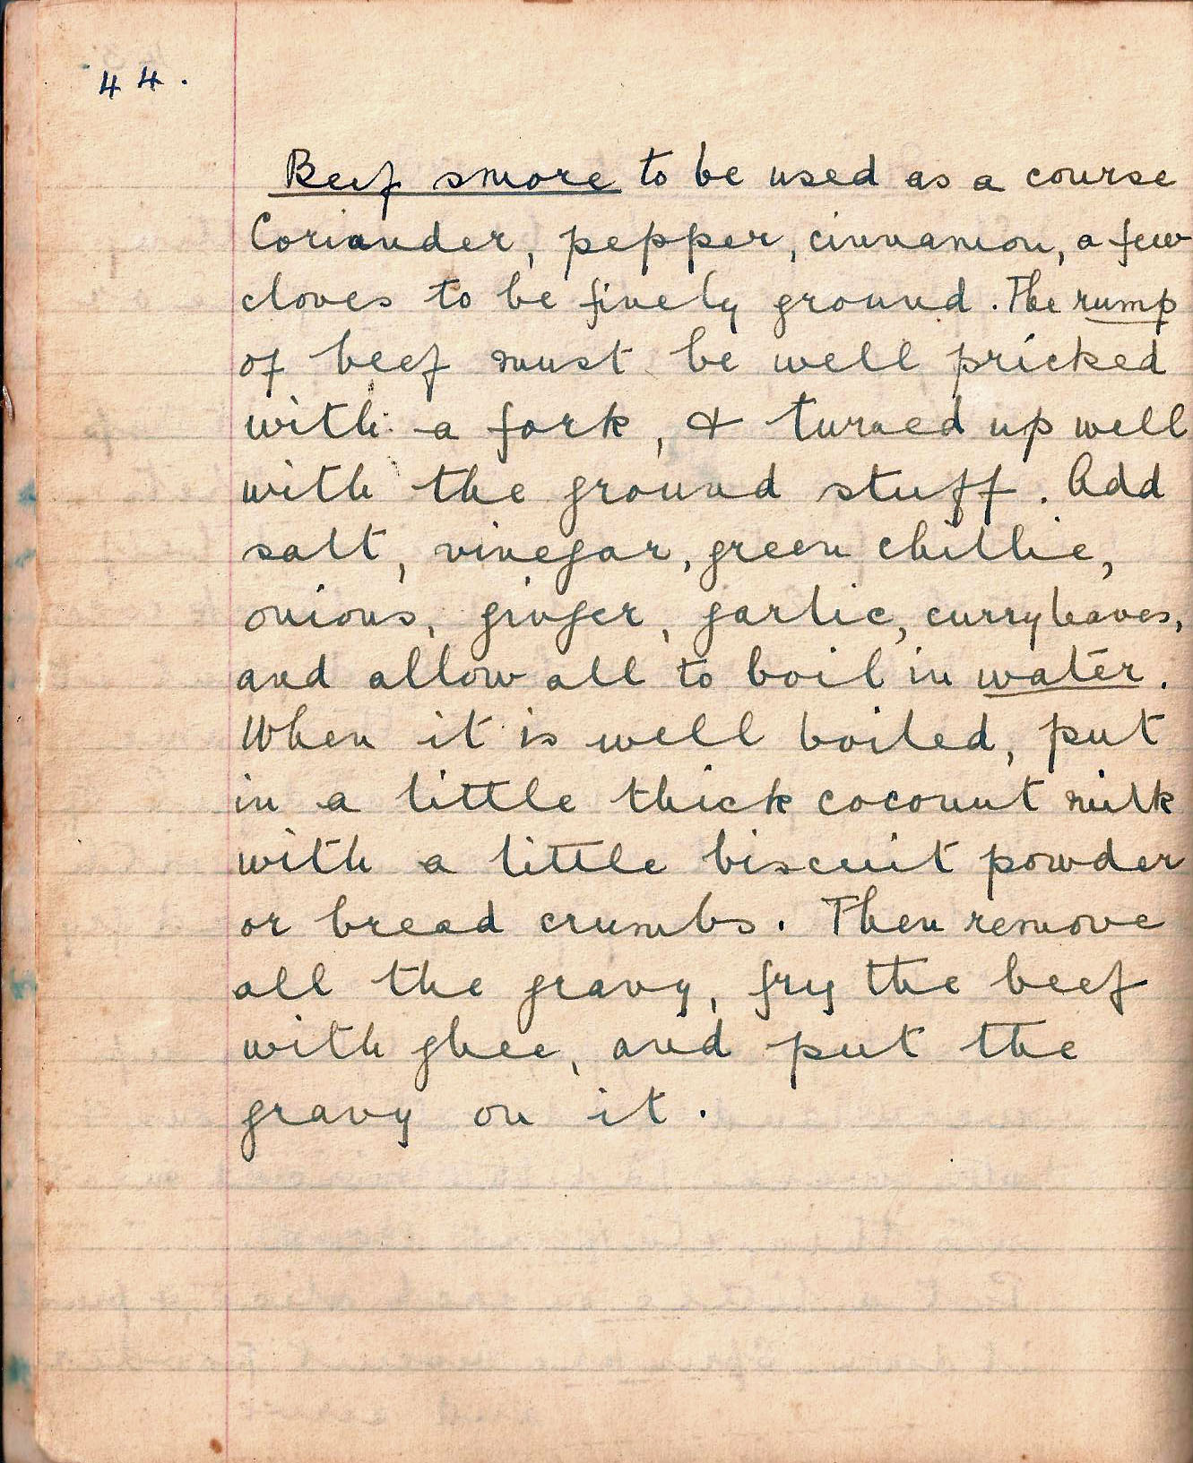

Beef smore to be used as a course
Coriander, pepper, cinnamon, a few cloves to be finely ground. The rump of beef must be well pricked with a fork, and turned up well with the ground stuff. Add salt, vinegar, green chilli, onions, ginger, garlic, curry leaves, and allow all to boil in water.

When it is well boiled, put in a little thick coconut milk with a little biscuit powder or bread crumbs. Then remove all the gravy, fry the beef with ghee, and put the gravy on it.

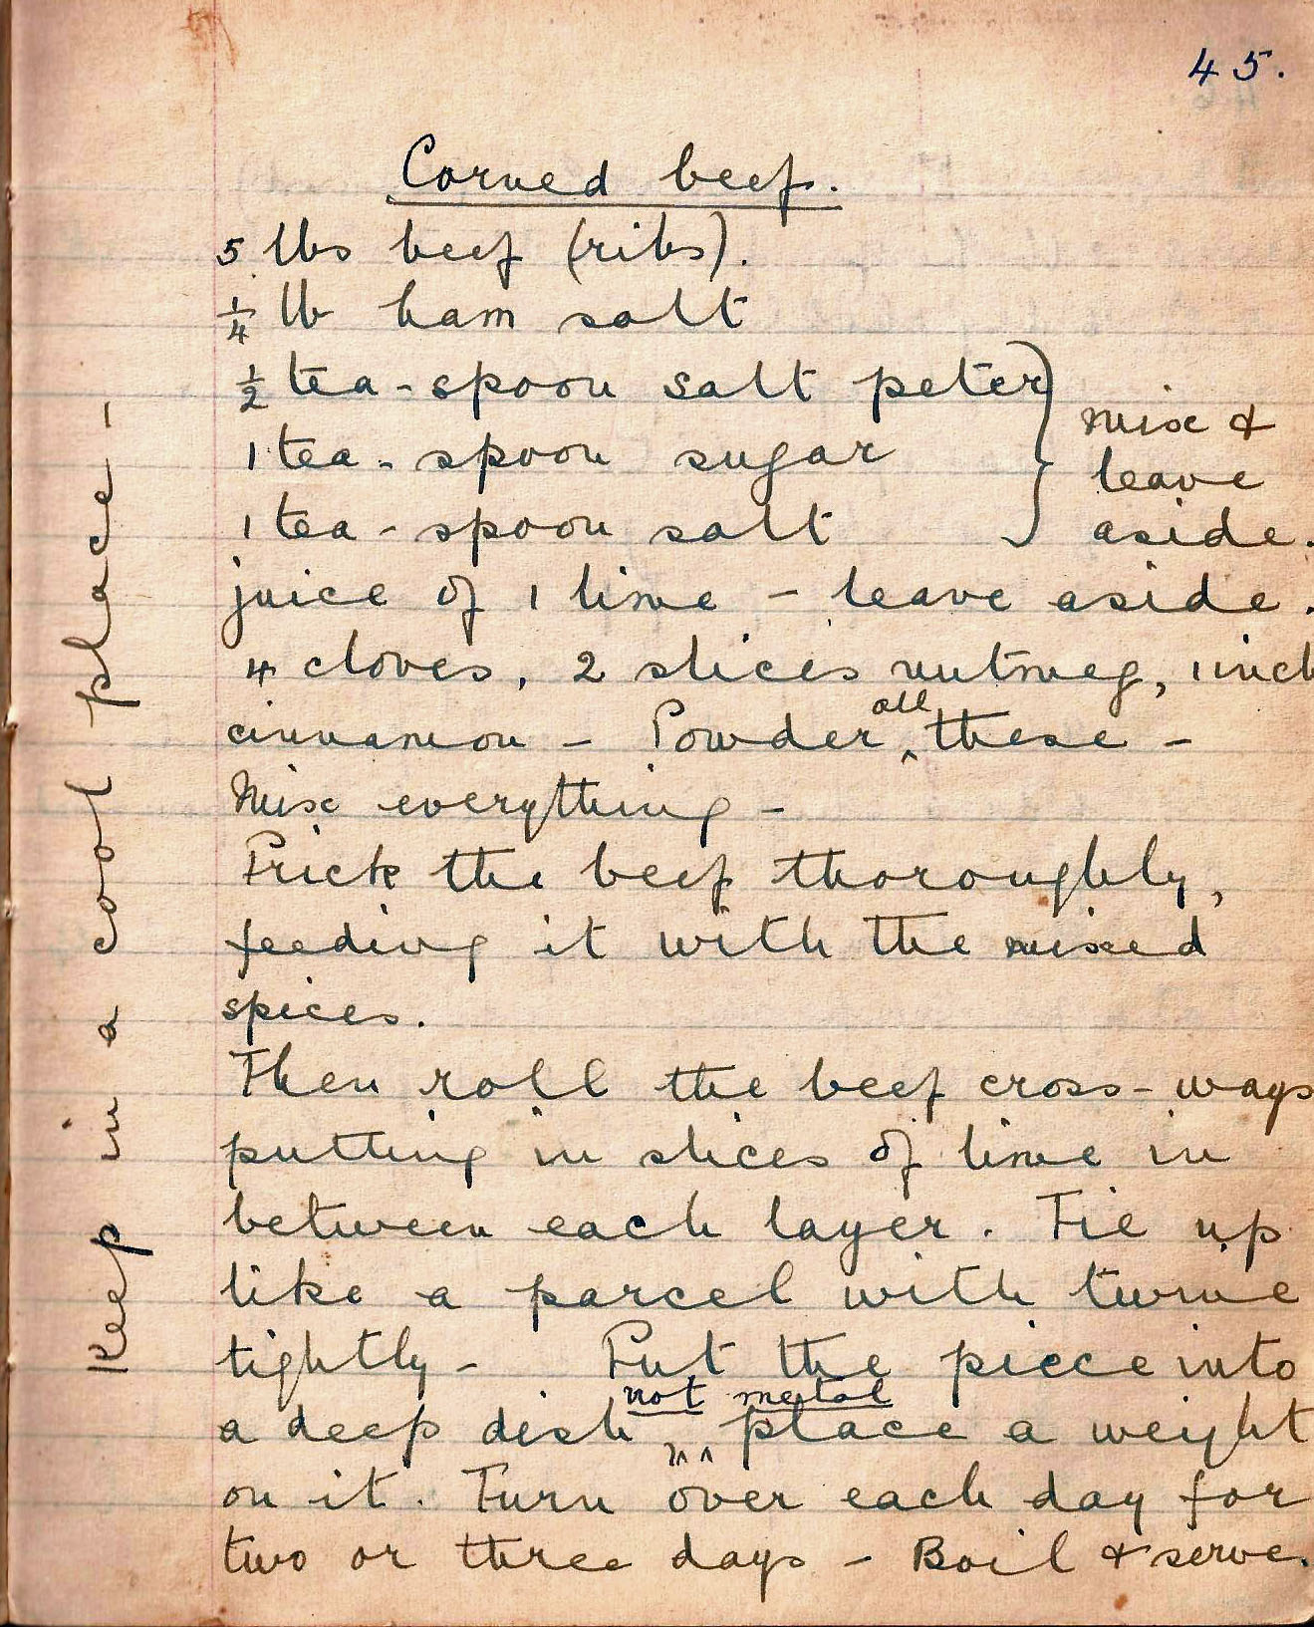

Corned beef
5 lbs beef (ribs)
¼ lb ham salt
½ teaspoon saltpetre, 1 teaspoon sugar, 1 teaspoon salt - mix these three and leave aside
juice of 1 lime – leave aside
4 cloves, 2 slices nutmeg, 1 inch cinnamon – powder all these

Mix everything

Prick the beef thoroughly, feeding it with the mixed spices.

Then roll the beef cross-ways putting slices of lime in between each layer. Tie up like a parcel with twine tightly. Put the piece into a deep dish not metal, place a weight on it. Keep in a cool place. Turn over each day for two or three days. Boil and serve.

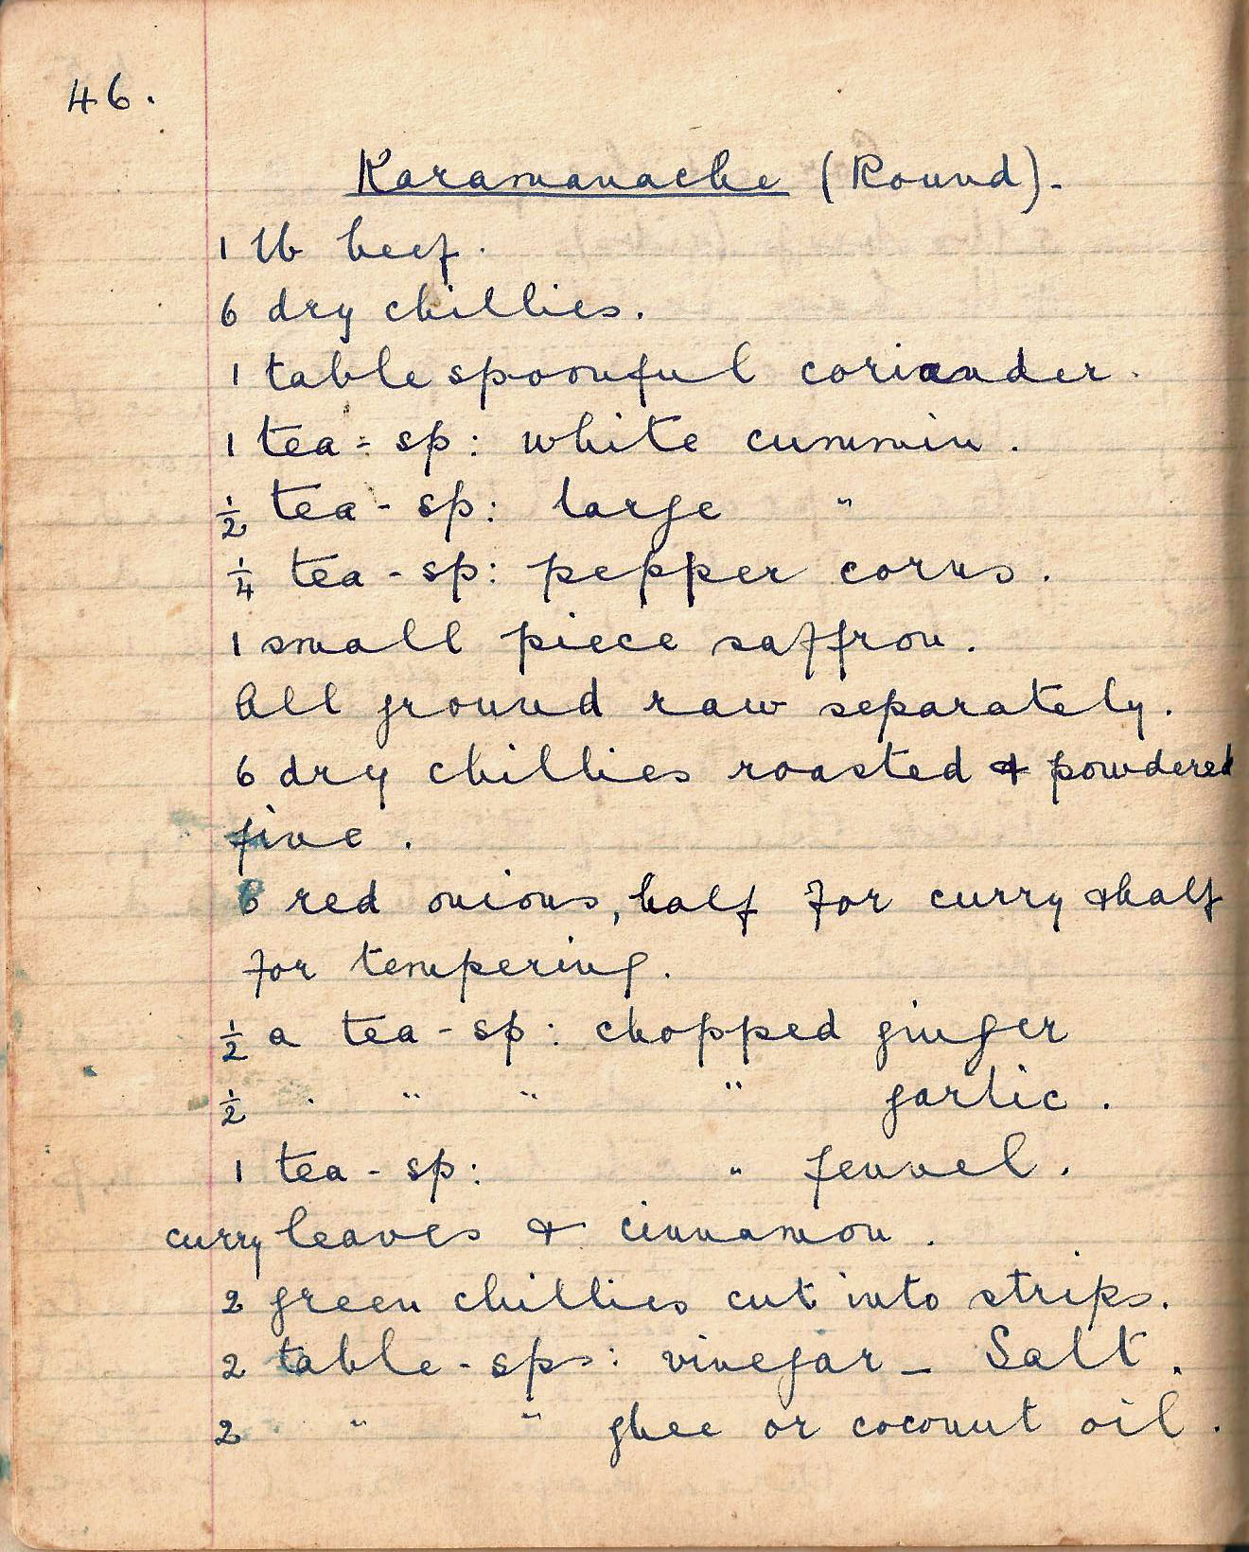

Karamanache (Round)
1 lb beef
6 dry chillies
1 tablespoonful coriander
1 tea-spoon white cumin
½ tsp large cumin
¼ tsp pepper corns
1 small piece saffron
All ground raw separately
6 dry chillies roasted and powdered fine
6 red onions, half for curry and half for tempering
½ a tea spoon chopped ginger
½ a tea spoon chopped garlic
1 tea spoon chopped fennel
curry leaves and cinnamon
2 green chillies cut into strips
2 tablespoons vinegar
salt
2 tablespoons ghee or coconut oil

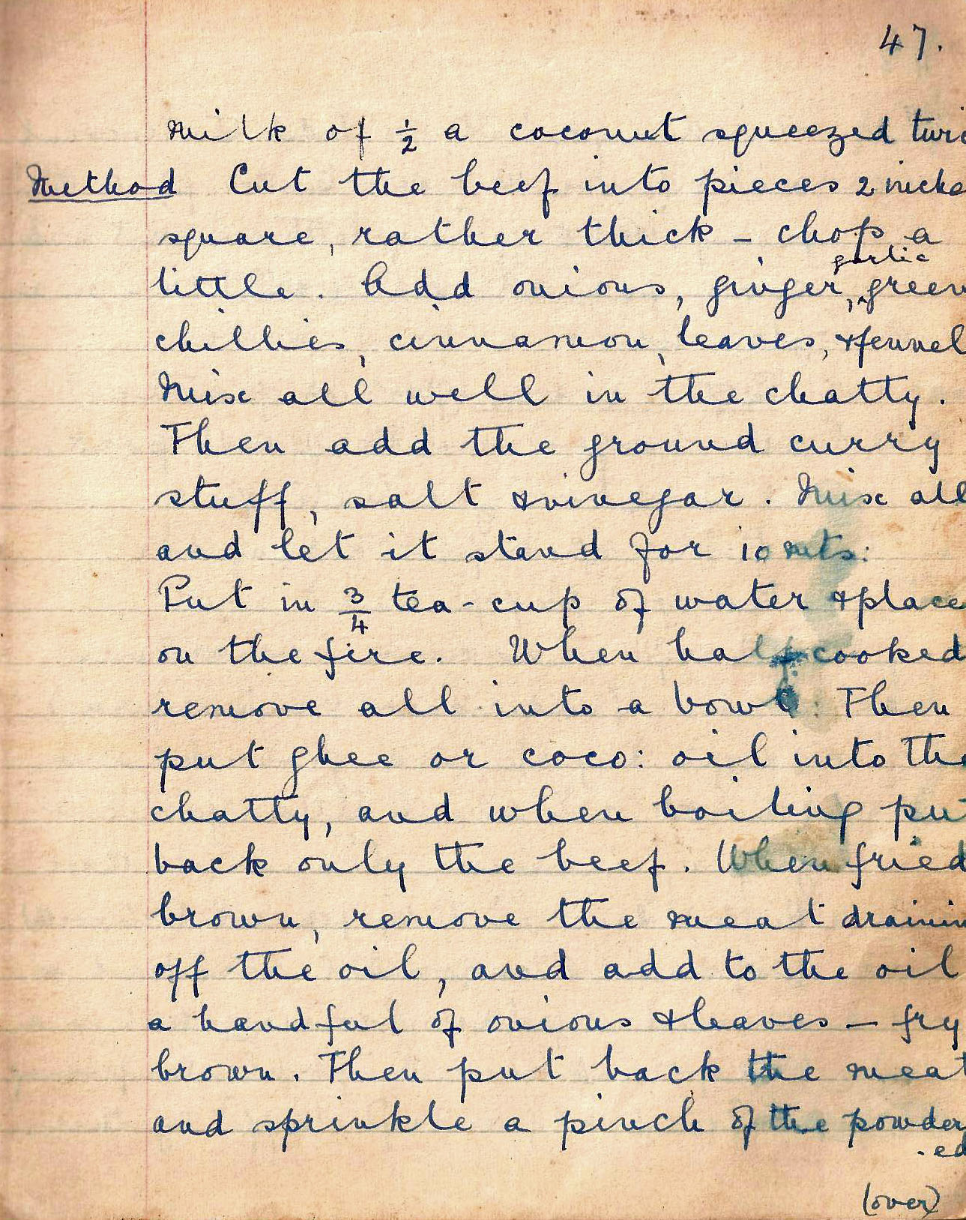

milk of ½ a coconut squeezed twice

Method Cut the beef into pieces 2 inches square. Add onions, ginger, garlic, green chillies, cinnamon, leaves and fennel. Mix all well in the chatty. Then add the ground curry stuff, salt, vinegar. Mix all and let it stand for 10 minutes. Put in ¾ tea cups of water and place on the fire. When half cooked remove all into a bowl. Then put ghee or coco oil into the chatty, and when boiling put back only the beef. When fried brown, remove the meat draining off the oil, and add to the oil a handful of onions and leaves – fry brown. Then put back the meat and sprinkle a pinch of the powdered

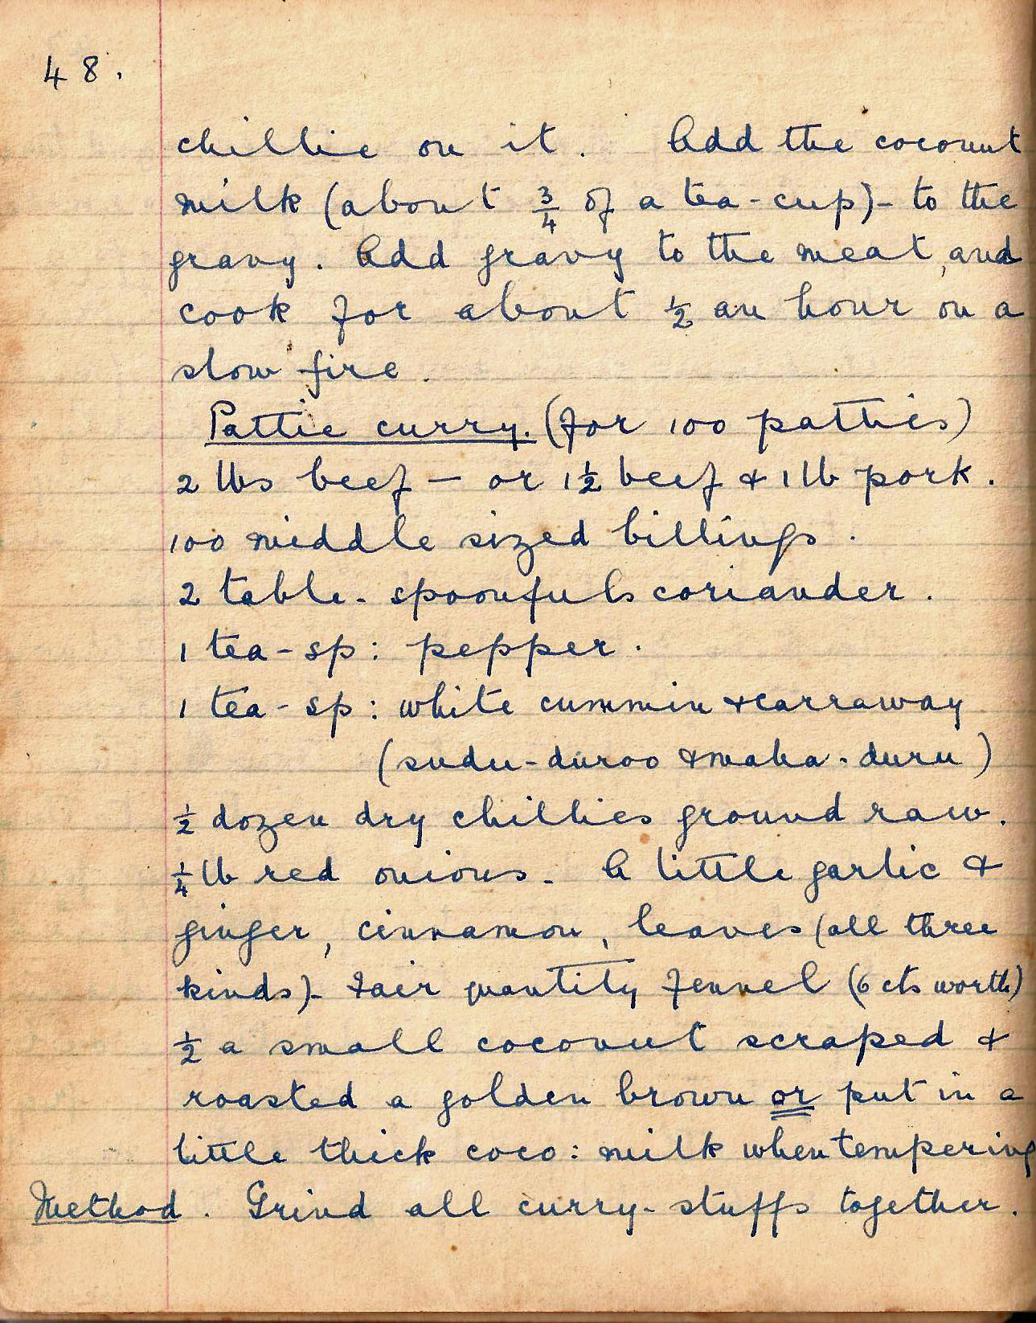

chilli on it. Add the coconut milk (about ¾ of a tea-cup) – to the gravy. Add gravy to the meat and cook for about ½ an hour on a slow fire.

Pattie Curry (for 100 patties)
2 lbs beef – or 11 beef and 1lb pork
10o middle size billings
2 tbsp coriander
1 tsp pepper
1 tsp white cumin and caraway (sudu-duroo and maha-duru)
½ dozen dry chillies ground raw
¼ lb red onions
a little garlic, ginger, cinnamon, leaves (all three kinds)
Fair quantity of fennel (6cts worth)
½ small coconut scraped and roasted a golden brown or put in a little thick coconut milk when tempering

Method Grind all curry stuffs together.

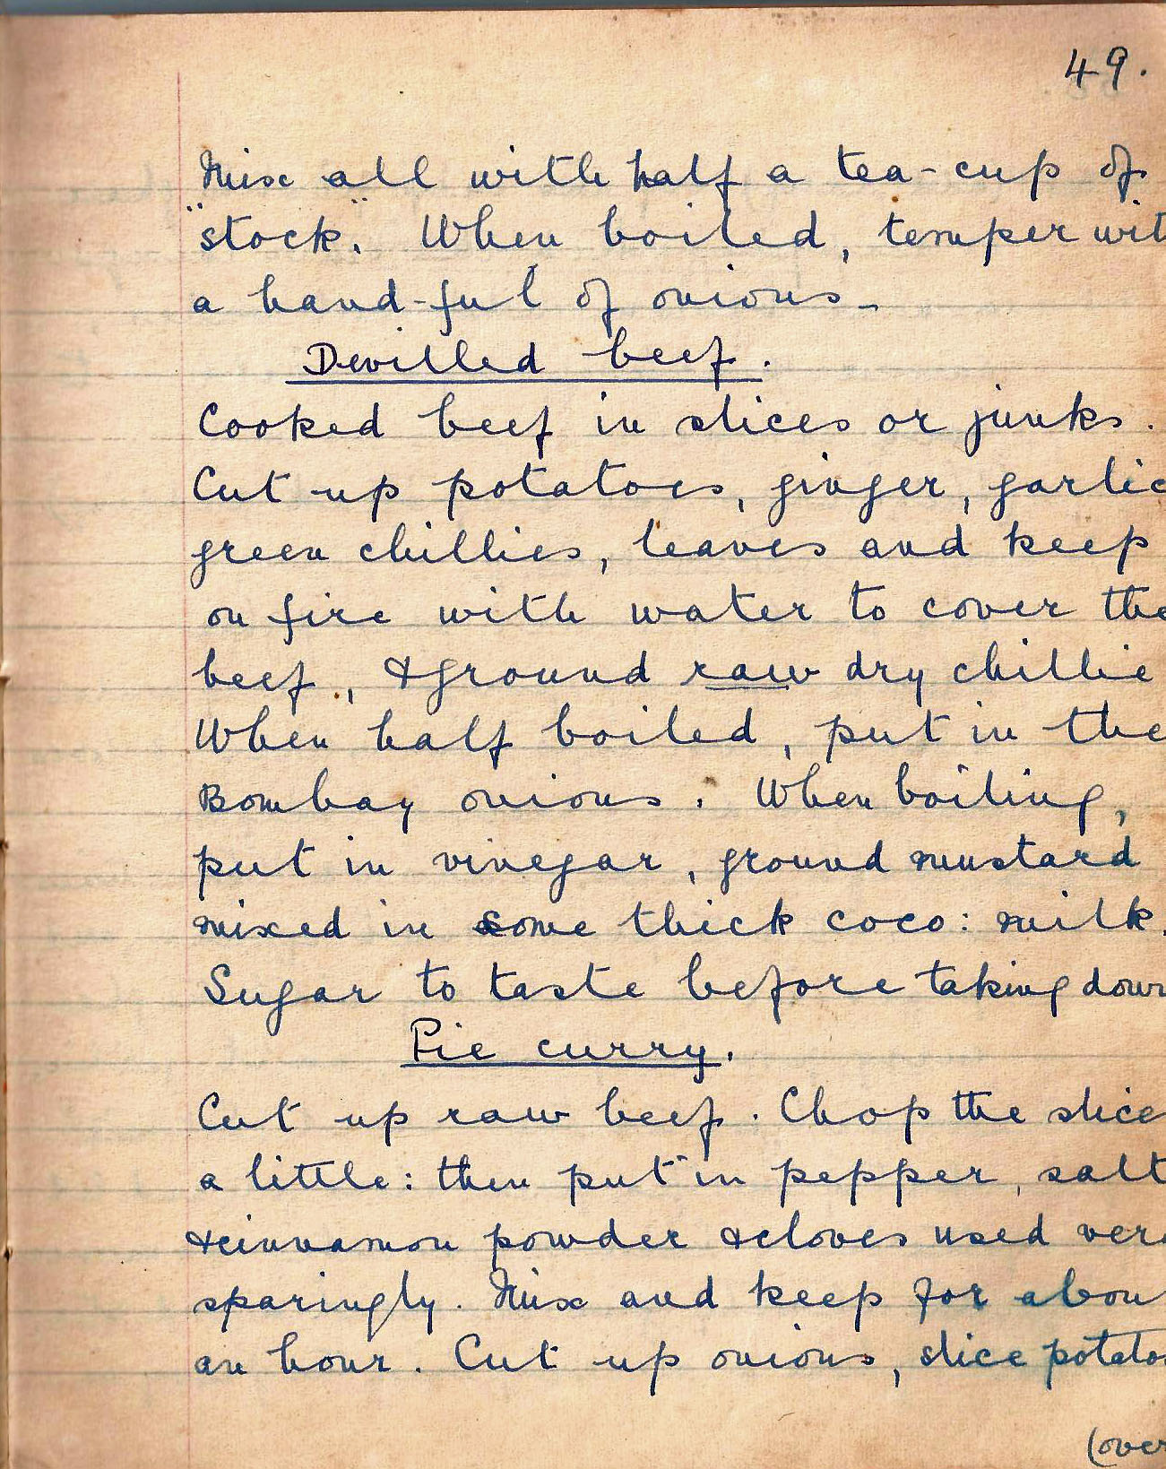

Mix all with half tea cup of ‘stock’. When boiled, temper with a handful of onions.

Devilled Beef
Cooked beef in slices or junks. Cut up potatoes, ginger, garlic , green chillies, leaves and keep on fire with water to cover the beef, ground raw
dry chillie.
When half boiled, put in the Bombay onions. When boiling, put in vinegar, ground mustard mixed in some thick coco milk. Sugar to taste before taking down.

Pie curry
Cut up raw beef. Chop the slices a little, then put in pepper, salt, cinnamon powder and cloves used vary sparingly. Mix and keep for about an hour. Cut up onions, slice potatoes

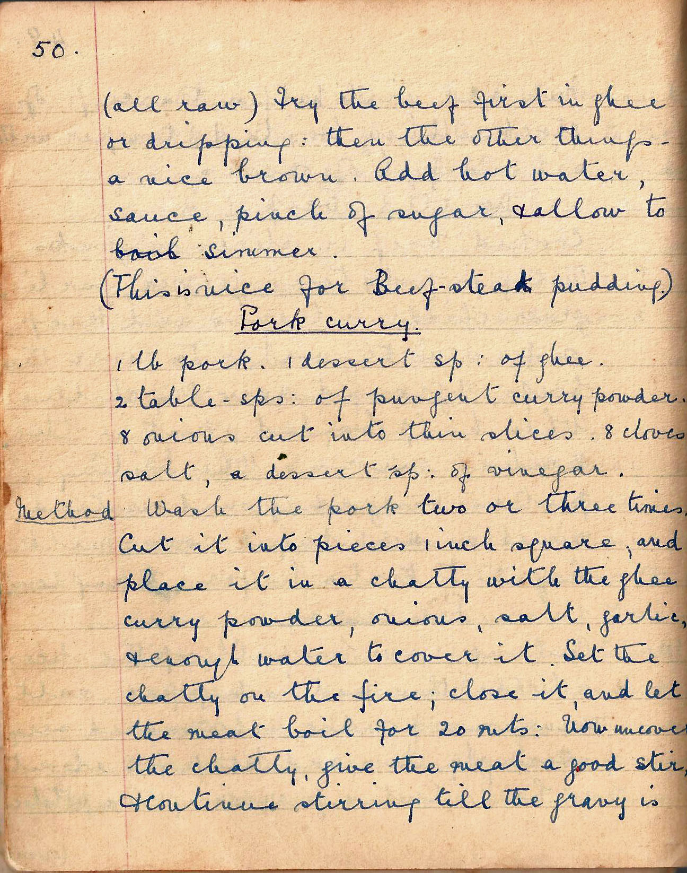

(all raw). Fry the beef first in ghee or dripping: then the other things – a nice brown. Add hot water, sauce, pinch of sugar and allow to simmer. (This is nice for beefsteak pudding).
(This is nice for Beef-steak pudding)

Pork Curry
1 lb pork. 1dessert spoon of ghee. 2 tablesp of pungent curry powder, 8 onions cut into thin slices, 8 cloves, salt, a dessert spoon of vinegar

Method Wash the pork two or three times. Cut it into pieces 1 inch square, and place it in a chatty with the ghee, curry powder, onions, salt, garlic, and enough water to cover it. Set the chatty on the fire, close it and let the meal boil for 20 minutes. Now uncover the chatty, give the meat a good stir, and continue stirring till the gravy is

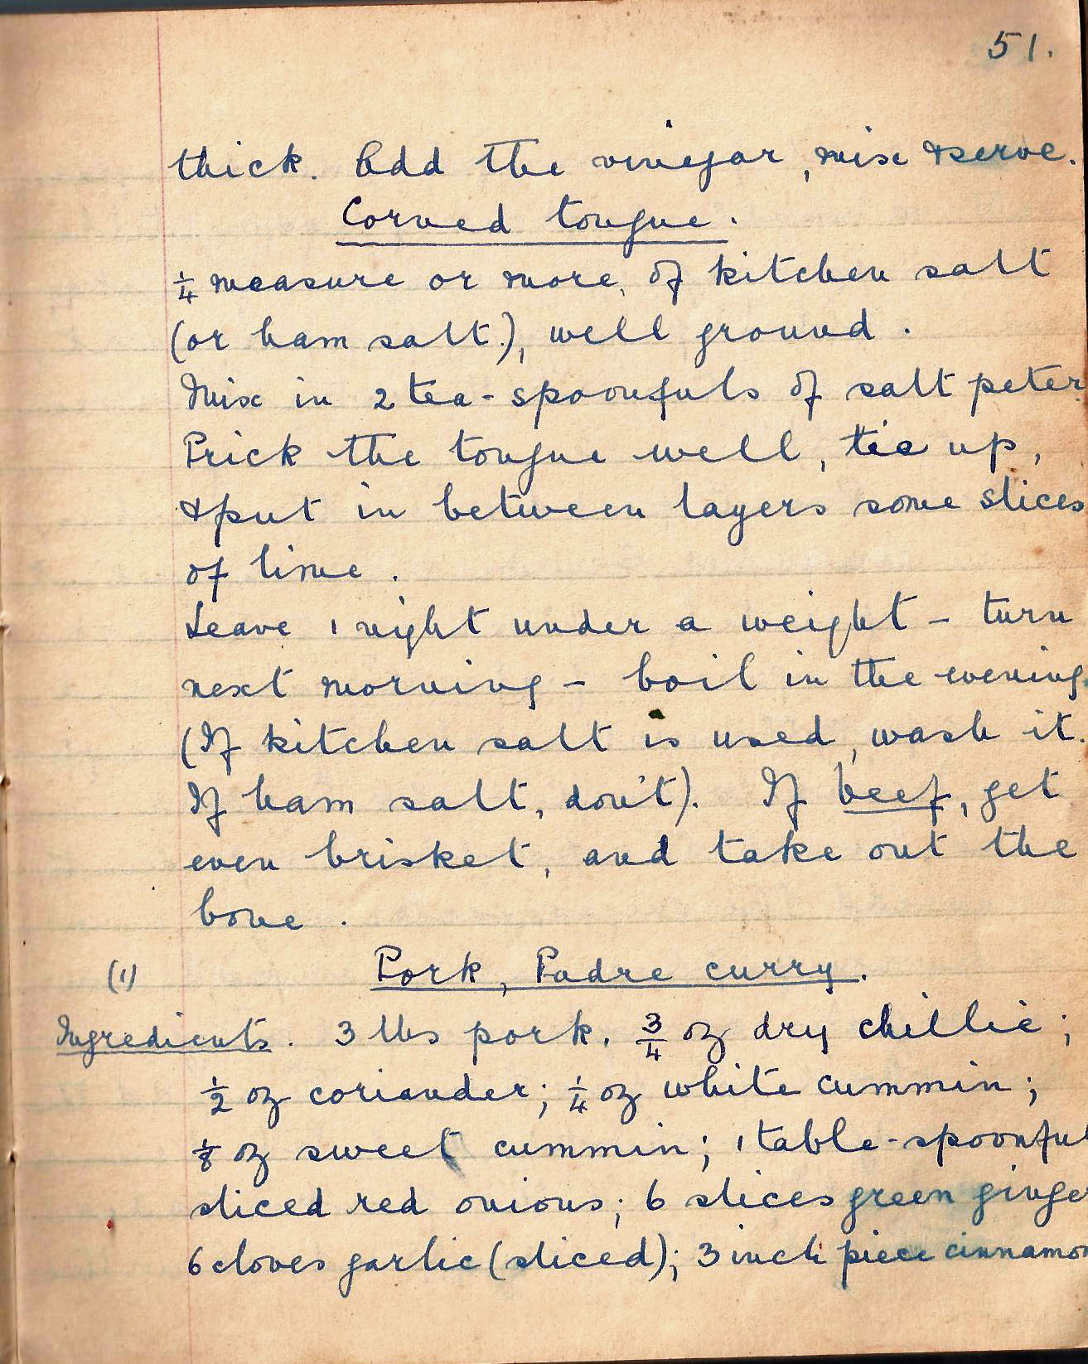

thick. Add the vinegar, mix and serve.

Corned Tongue
¼ measure or more of kitchen salt (or ham salt) well ground.

Mix in 2 tea-spoonfuls of saltpetre. Prick the tongue well, tie up, and put in between layers some slices of lime.

Leave one night under weight – turn next morning – boil in the evening. (If kitchen salt is used, wash it. If ham salt, don’t). If beef, get even brisket and take out the bone.

(1) Pork Padre Curry
Ingredients. 3 lbs pork, ¾ oz dry chillies; ½ oz coriander; ¼ oz white cumin; 1/8 oz sweet cumin; 1 table-spoonful sliced red onions; 6 slices green ginger; 6 cloves garlic (sliced); 3 inch piece of cinnamon;

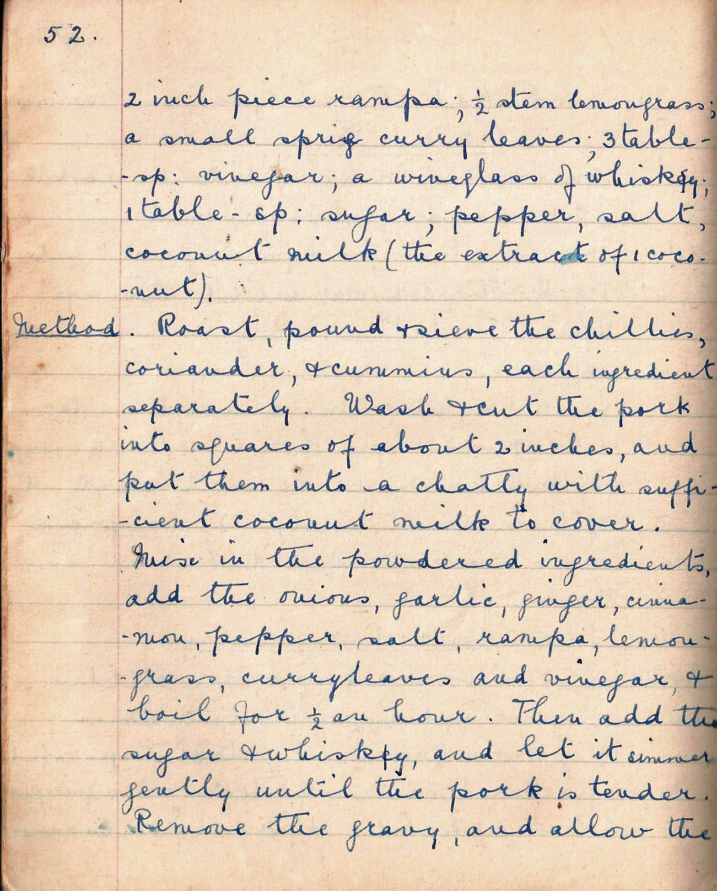

2 inch piece rampa; ½ stem lemongrass; a small sprig curry leaves; 3 tablespoons vinegar; a wineglass of whisky 1 table-sp sugar; pepper
salt, coconut milk (the extract of 1 coconut)

Method Roast, pound and sieve the chillies, coriander and cumin, each ingredient separately. Wash and cut the pork into squares of about 2 inches, and put them into a chatty with sufficient coconut milk to cover. Mix in the powdered ingredients, add the onions, garlic, ginger, cinnamon, pepper, salt, rampa, lemon-grass, curry leaves and vinegar and boil for ½ an hour. Then add the sugar and whisky and let it simmer gently until the pork is tender. Remove the gravy, and allow the

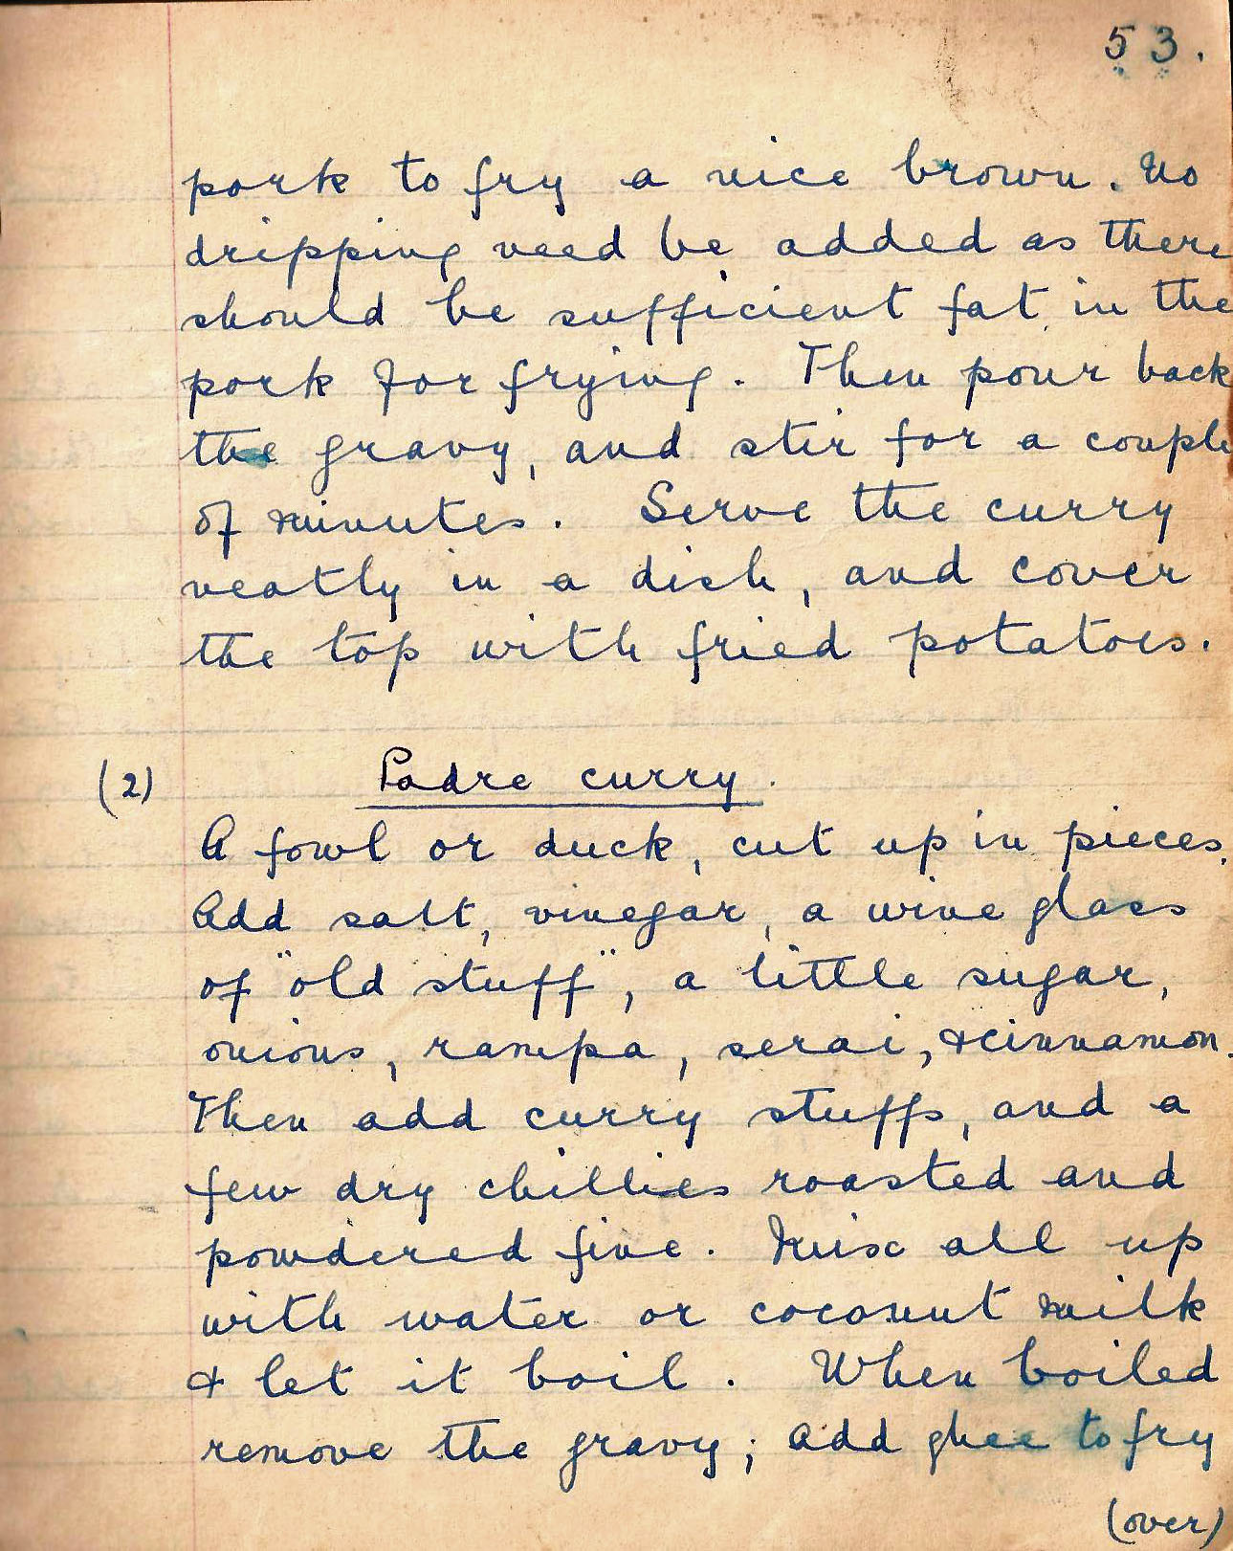

pork to fry a nice brown. No dripping need be added as there should be sufficient fat in the pork for frying. Then pour back the gravy, and stir for a couple of minutes. Serve the curry neatly in a dish, and cover the top with fried potatoes.

(2) Padre Curry
A fowl or duck, cut up in pieces. Add salt, vinegar, a wineglass of ‘old stuff’, a little sugar, onions, rampa, serai, and cinnamon. Then add curry stuffs and a few dry chillies roasted and powdered fine. Mix all up with water or coconut milk and let it boil. When boiled remove the gravy; add ghee to fry

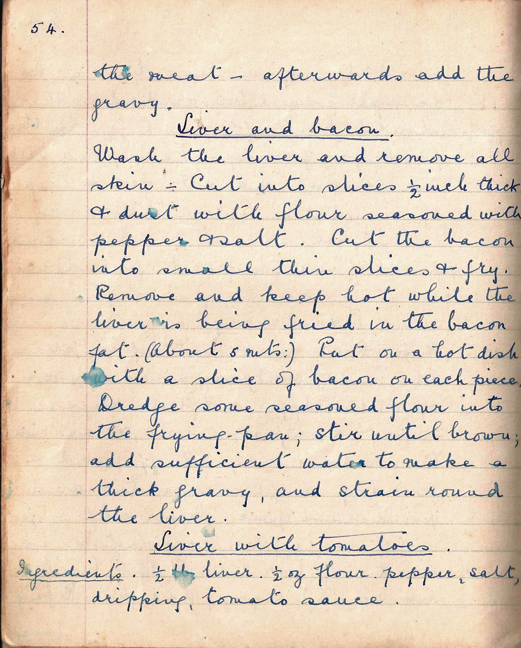

the meat – afterwards add the gravy.

Liver and bacon
Wash the liver and remove all skin –Cut into slices ½ inch thick and dust with flour seasoned with pepper and salt. Cut the bacon into small thin slices and fry. Remove and keep hot while the liver is being fried in the bacon fat. (About 5 mins.) Put on a hot dish with a slice of bacon on each piece. Dredge some seasoned flour into the frying pan; stir until brown; add sufficient water to make a thick gravy, and strain round the liver.

Liver with tomatoes
Ingredients. ½ lb liver. ½ oz flour. Pepper, salt, dripping, tomato sauce.

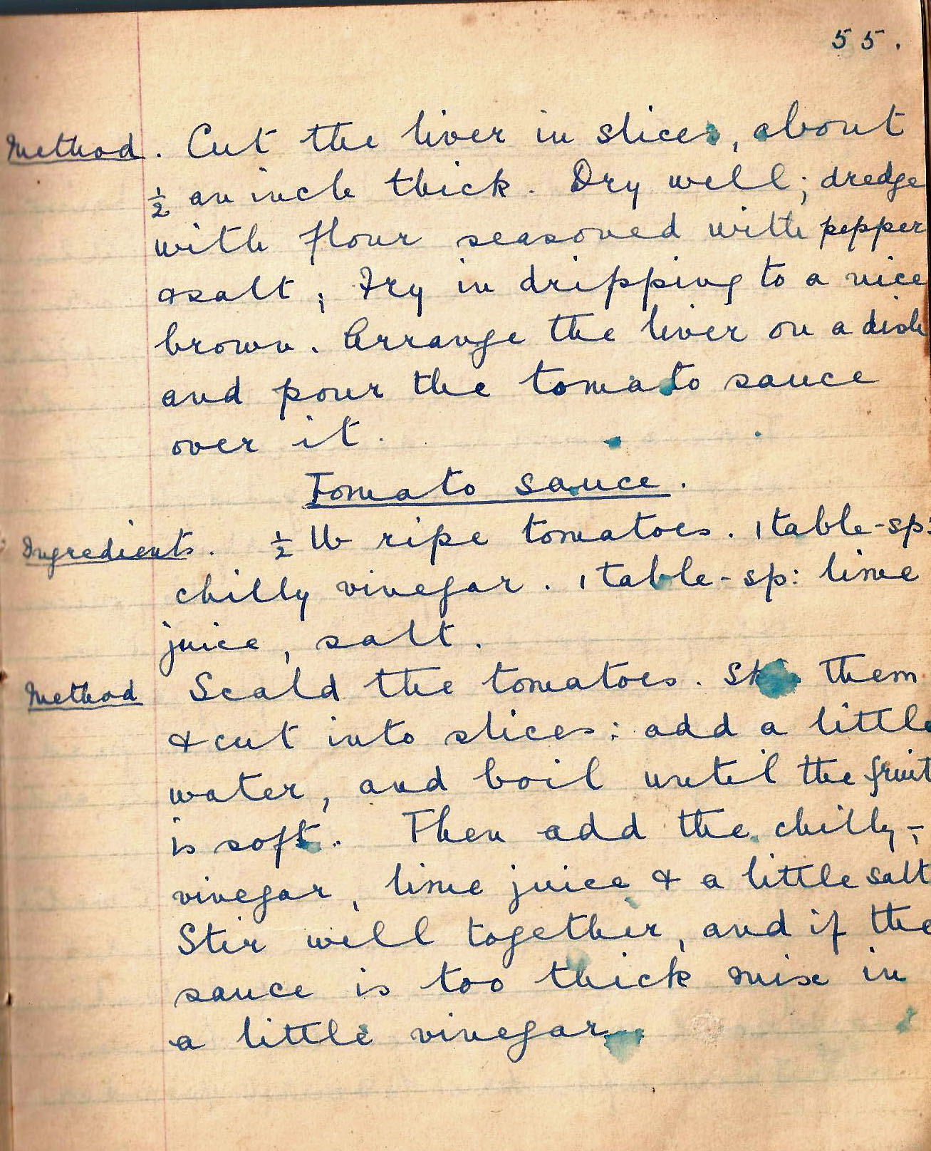

Method. Cut the liver in slices, about ½ an inch thick. Dry well; dredge with flour seasoned with pepper and salt, fry in dripping to a nice brown. Arrange the liver on a dish and pour tomato sauce over it.

Tomato Sauce
Ingredients. ½ lb ripe tomatoes. 1 table-spoon chilli vinegar. 1 table-spoon lime juice, salt.

Method Scald the tomatoes. Skin them and cut into slices; add a little water, and boil until the fruit is soft. Then add the chilly vinegar, lime juice and a little salt. Stir well together, and if the sauce is too thick mix in a little vinegar.

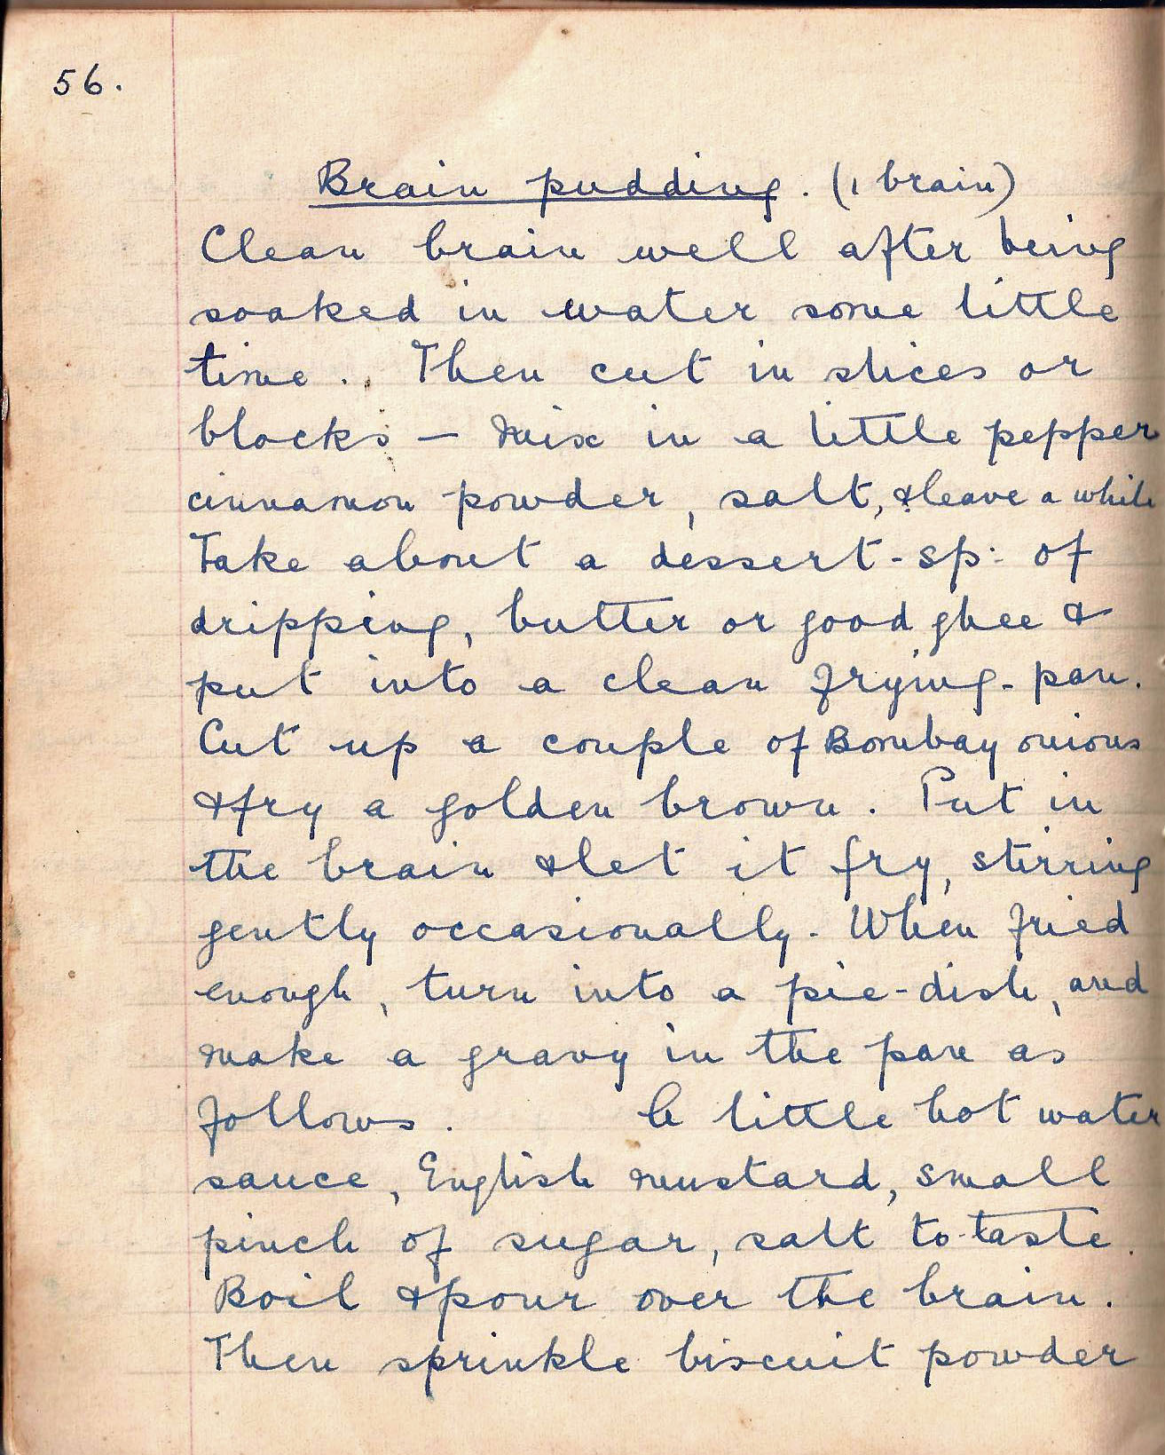

Brain Pudding (1 brain)
Clean the brain well after soaking it in water a for 10 – 15 minutes. Then cut in slices or blocks – mix in a little pepper, cinnamon powder, salt, and leave for 10 – 15 minutes for the brain to absorb the flavours. Take about a dessert-spoon of dripping, butter or good ghee and put into a clean frying pan. Slice thinly the Bombay onions and fry a golden brown. Put in the brain and let it fry, stirring gently occasionally. When fried till just firm to the touch put it into a pie-dish just big enough to hold the mixture. Now make a gravy in the frying pan as follows. Put in a little hot water (1 or 2 tablespoons should do, English mustard to taste, small pinch of sugar, salt to taste. Boil and pour over the brain. Then sprinkle biscuit powder

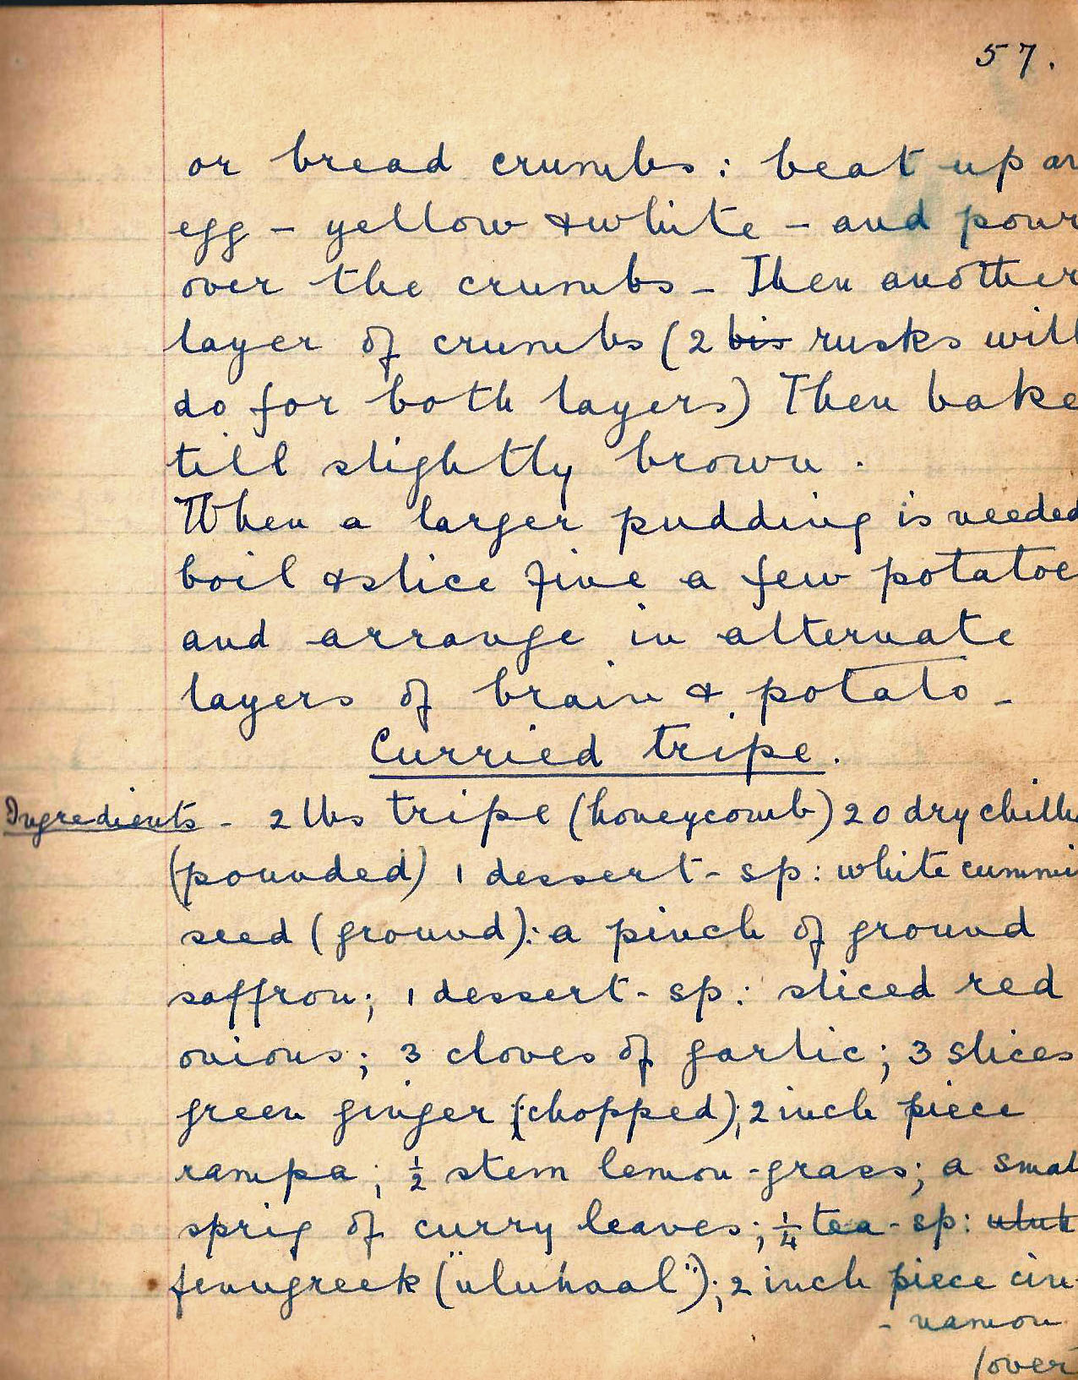

or bread crumbs over this. Beat the egg and pour over the crumbs. Then add another layer of crumbs. ( 2 rusks will do for both layers). Then bake till slightly brown.

When a larger pudding is needed boil and slice fine a few potatoes and arrange in alternate layers of brain and potato.

Curried Tripe
Ingredients . 2 lbs tripe (honeycomb), 20 dry chillies, (powdered) 1 dessert spoon white cumin seed (ground), a pinch of ground saffron; 1 desert spoon sliced red onions; 3 cloves of garlic; 3 slices green ginger (chopped); 2 inch rampa; 1 ½ stem lemon-grass; a small sprig of curry leaves; ¼ tea-cup fenugreek (“uluhaal”); 2 inch piece cinnamon;

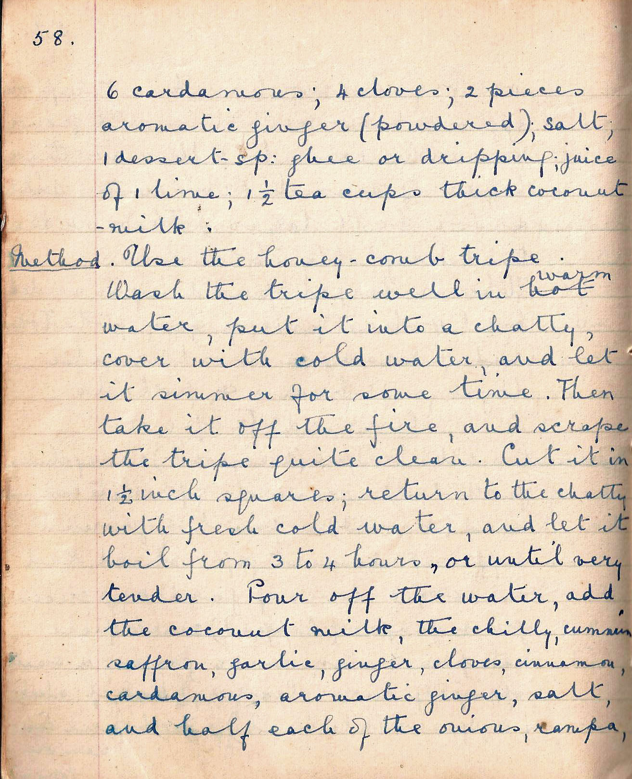

6 cardamoms; 4 cloves; 2 pieces aromatic ginger (powdered); salt, 1 dessert-spoon; ghee or dripping; juice of 1 lime; 1 ½ tea cups thick coconut milk.

Method Use the honeycomb tripe. Wash the tripe well in warm water, put it into a chatty, cover with cold water, and let it simmer for some time. Then take it off the fire, and scrape the tripe quite clean. Cut it in 1 ½ inch squares; return to the chatty with fresh cold water, and let it boil from 3 to 4 hours, or until very tender. Pour off the water, add the coconut milk, the chilly, cumin, saffron, garlic, ginger, cloves, cinnamon, cardamoms, aromatic ginger, salt and half each of the onions, rampa

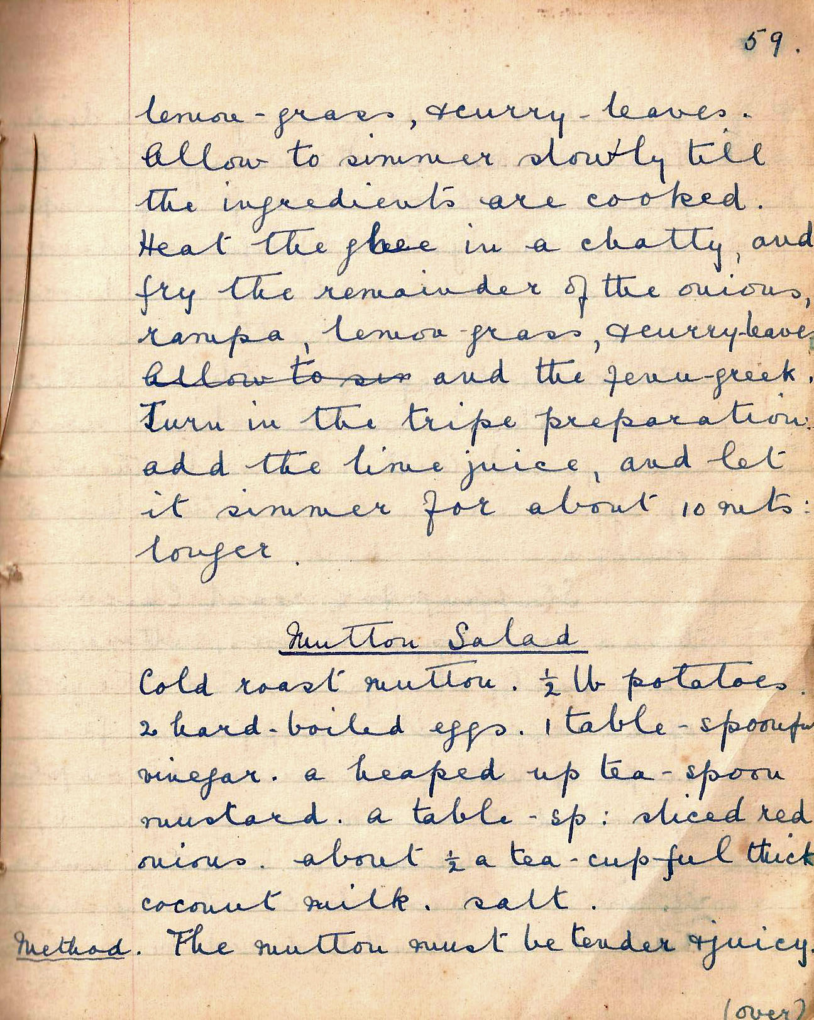

lemon-grass, and curry leaves. Allow to simmer slowly till the ingredients are cooked. Heat the ghee in a chatty, and fry the remainder of the onions, rampa, lemon-grass, and curry leaves and the fenugreek. Turn in the tripe preparation add the lime juice, and let it simmer for about 10 mins. longer.

Mutton Salad
Cold roast mutton. ½ lb potatoes. 2 hard-boiled eggs. 1 table-spoonful vinegar. A heaped-up tea-spoon of mustard. A table-spoon sliced red onions. About ½ teacupful thick coconut milk. Salt.
Method The mutton must be tender and juicy.

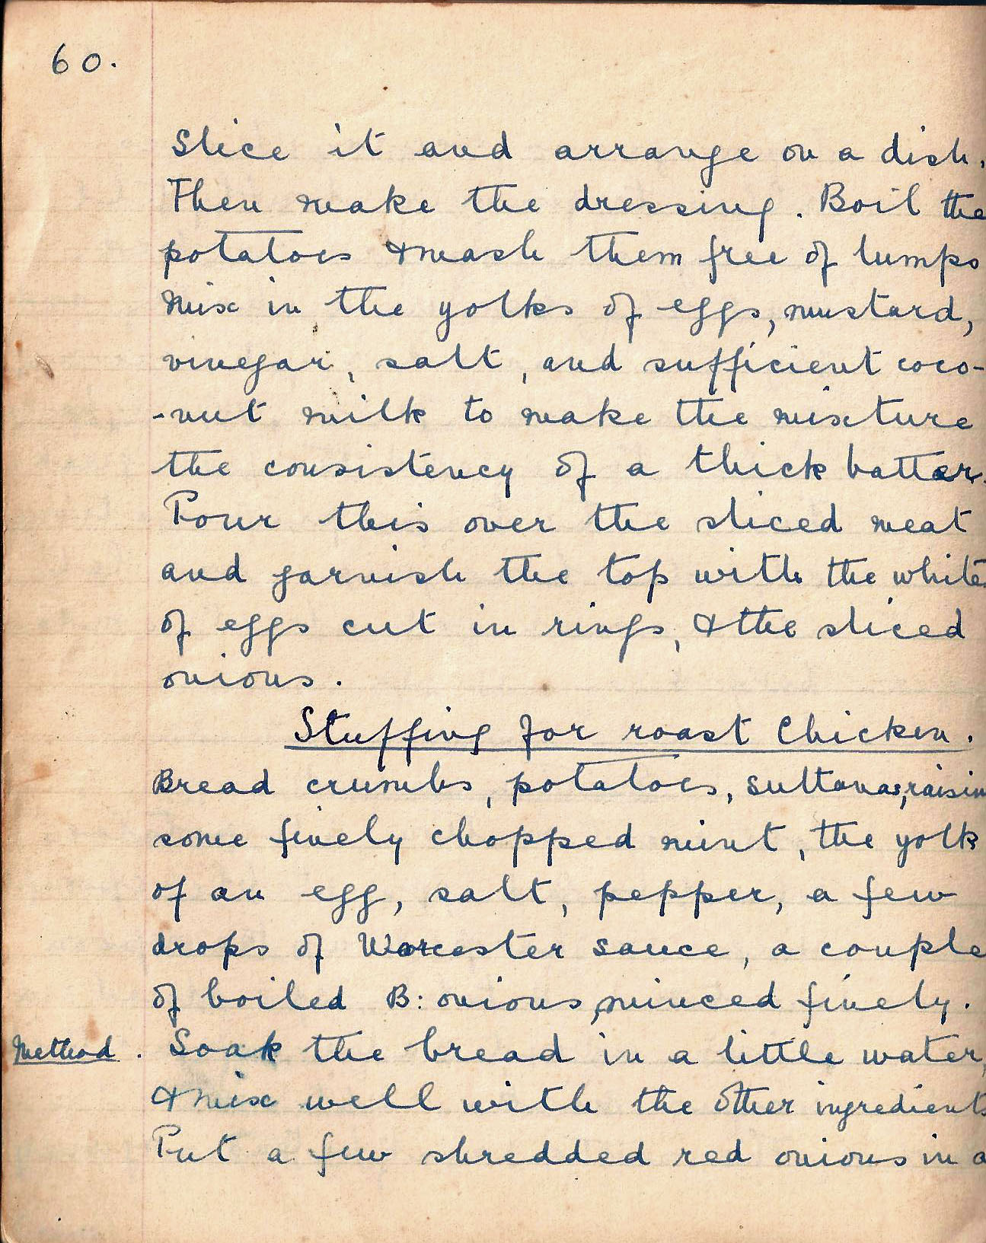

Slice it and arrange on a dish. Then make the dressing. Boil the potatoes and mash them free of lumps. Mix in yolks of eggs, mustard, vinegar, salt, and sufficient coconut milk to make the mixture the consistency of a thick batter. Pour this over the sliced meat and garnish the top with the whites of egg cut in rings, and the sliced onions.

Stuffing for Roast Chicken
Bread crumbs, potatoes, sultanas, raisins, some finely chopped mint, the yolk of an egg, salt, pepper, a few drops of Worcester sauce, a couple of boiled Bombay onions minced finely.

Method Soak the bread in a little water, and mix well with the other ingredients. Put a few shredded red onions in a

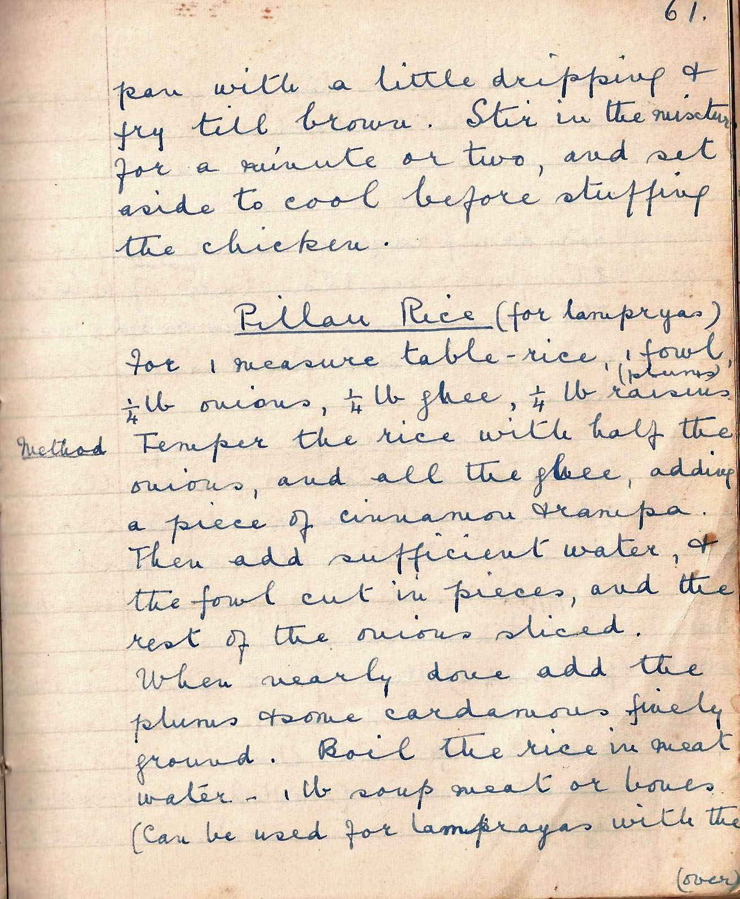

pan with a little dripping and fry till brown. Stir in the mixture for a minute or two, and set aside to cook before stuffing the chicken..

Pillau Rice (for lamprayas)
For 1 measure table-rice, I fowl, ¼ lb onions, ¼ lb ghee, ¼ lb raisins (plums).

Method Temper the rice with half the onions, and all the ghee, adding a piece of cinnamon and rampa. Then add sufficient water, and the fowl cut in pieces, and the rest of the onions, sliced. When nearly done, add the plums and some cardamoms finely ground. Boil the rice in meat water – 1lb soup meat or bones (Can be used for lamprayas with the

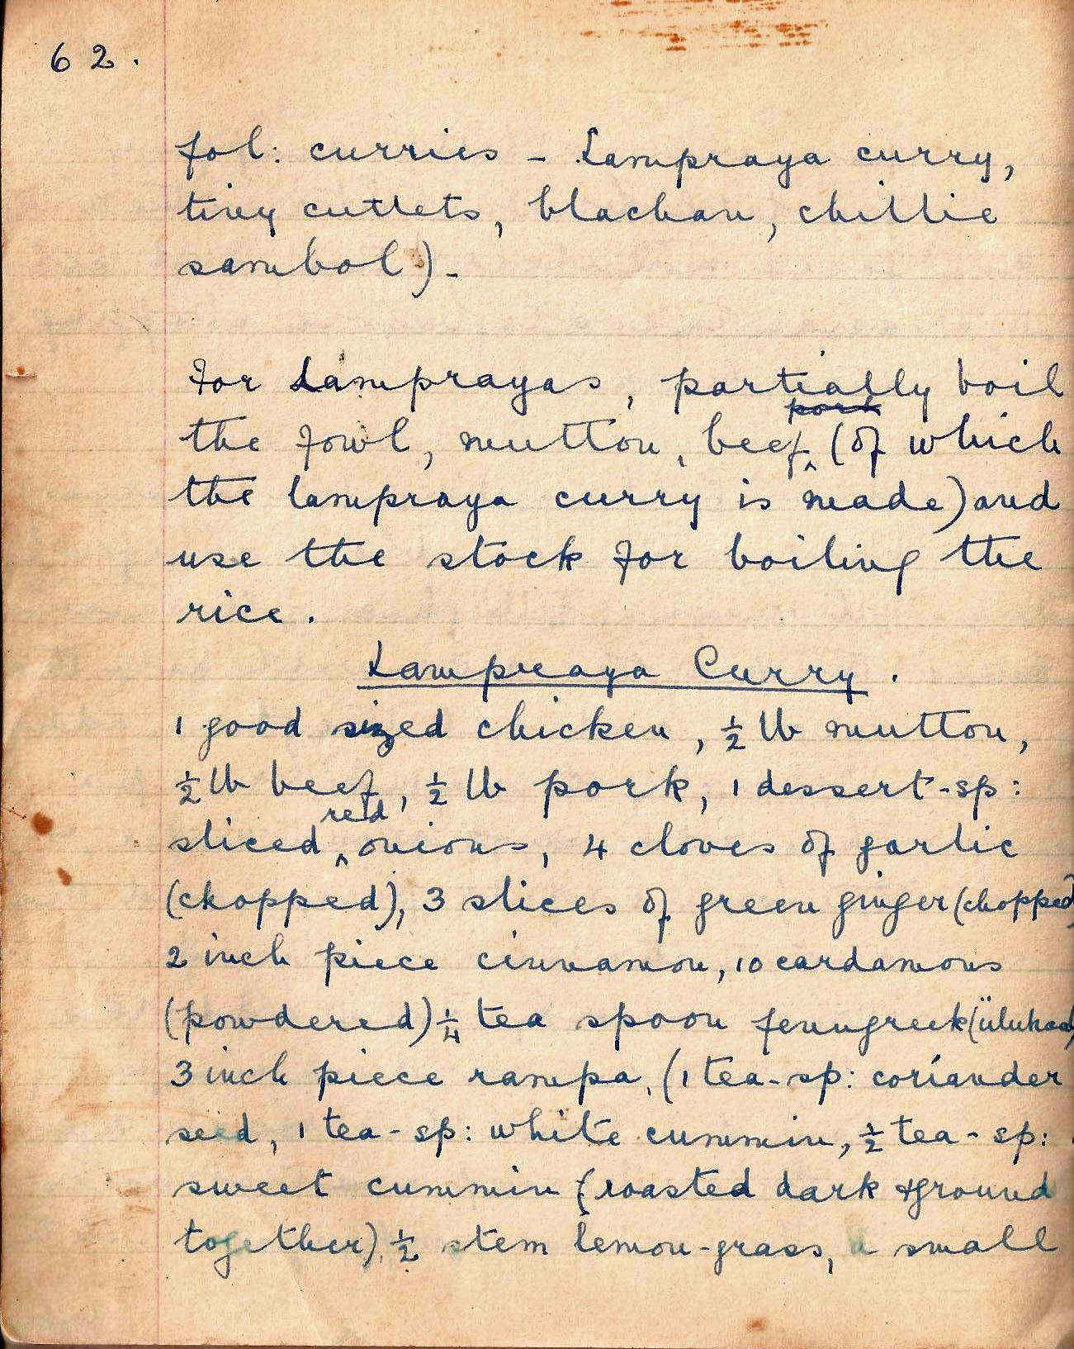

fol, curries – lampraya curry, tiny cutlets, blachan, chilli sambol)

For lamprayas, partially boil the fowl, mutton, beef (of which the lampraya curry is made) and use the stock for boiling the rice.

Lampraya Curry
1 good sized chicken, ½ lb mutton, ½ lb beef, ½ lb pork, 1 dessert spoon sliced red onions, 4 cloves of garlic (chopped), 3 slices of green ginger (chopped), 2 inch piece cinnamon, 10 cardamoms (powdered), ¼ teaspoon fenugreek, 3 inch piece rampa, 1 teaspoon coriander, I teaspoon white cumin, ½ tea spoon sweet cumin roasted dark and ground together, ½ stem lemon grass, a small

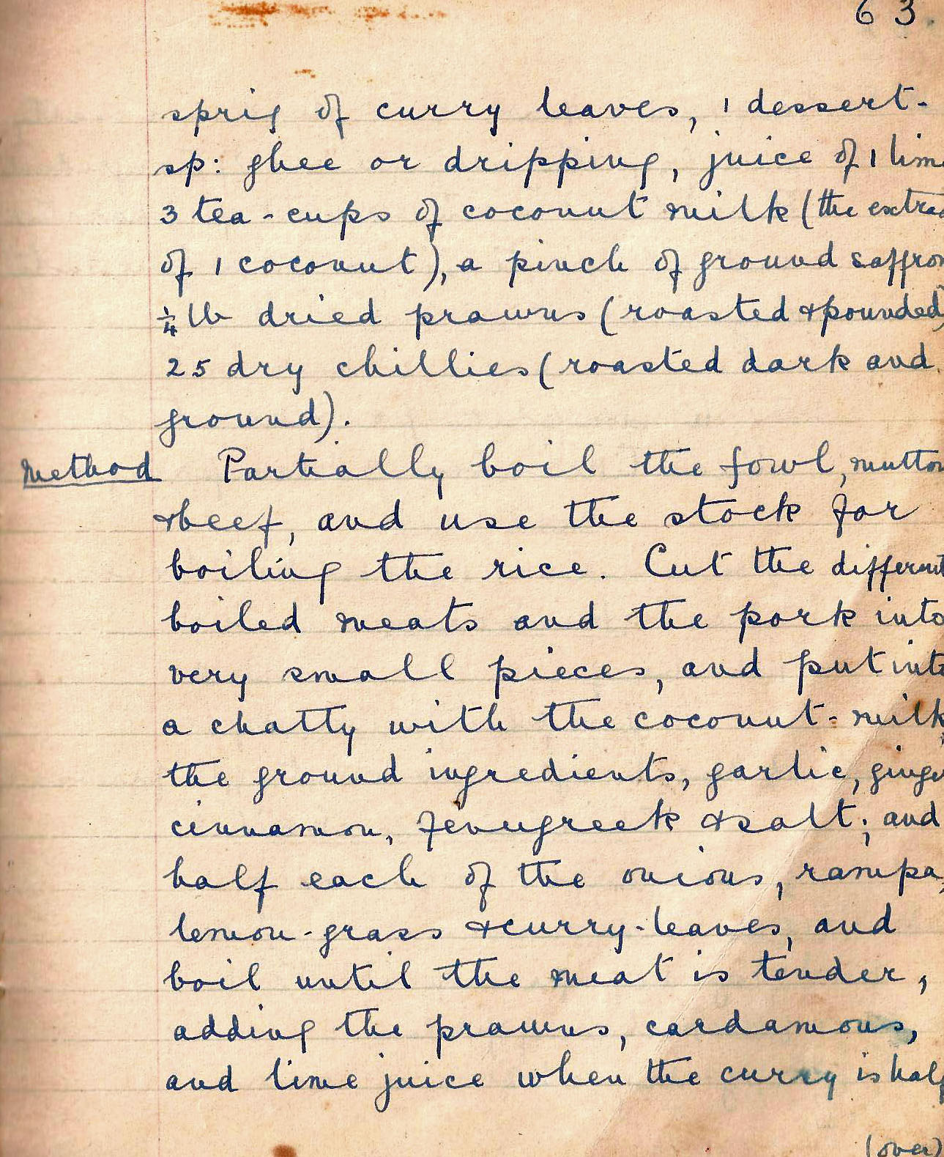

sprig of curry leaves, 1 dessertspoon ghee or dripping, juice of 1 lime, 3 teacups of coconut milk (the extract of 1 coconut), a pinch of ground saffron, 1/4 lb dried prawns (roasted and pounded), 25 dry chillies (roasted dark and ground).

Method Partially boil the fowl, mutton, and beef and use the stock for boiling the rice. Cut the different boiled meats and the pork into very small pieces, and put into a chatty with the coconut milk, the ground ingredients, garlic, ginger, cinnamon, fenugreek and salt and half each of the onions, rampa, lemongrass, and curry leaves, and boil until the meat is tender, adding the prawns, cardamoms and lime juice when the curry is half

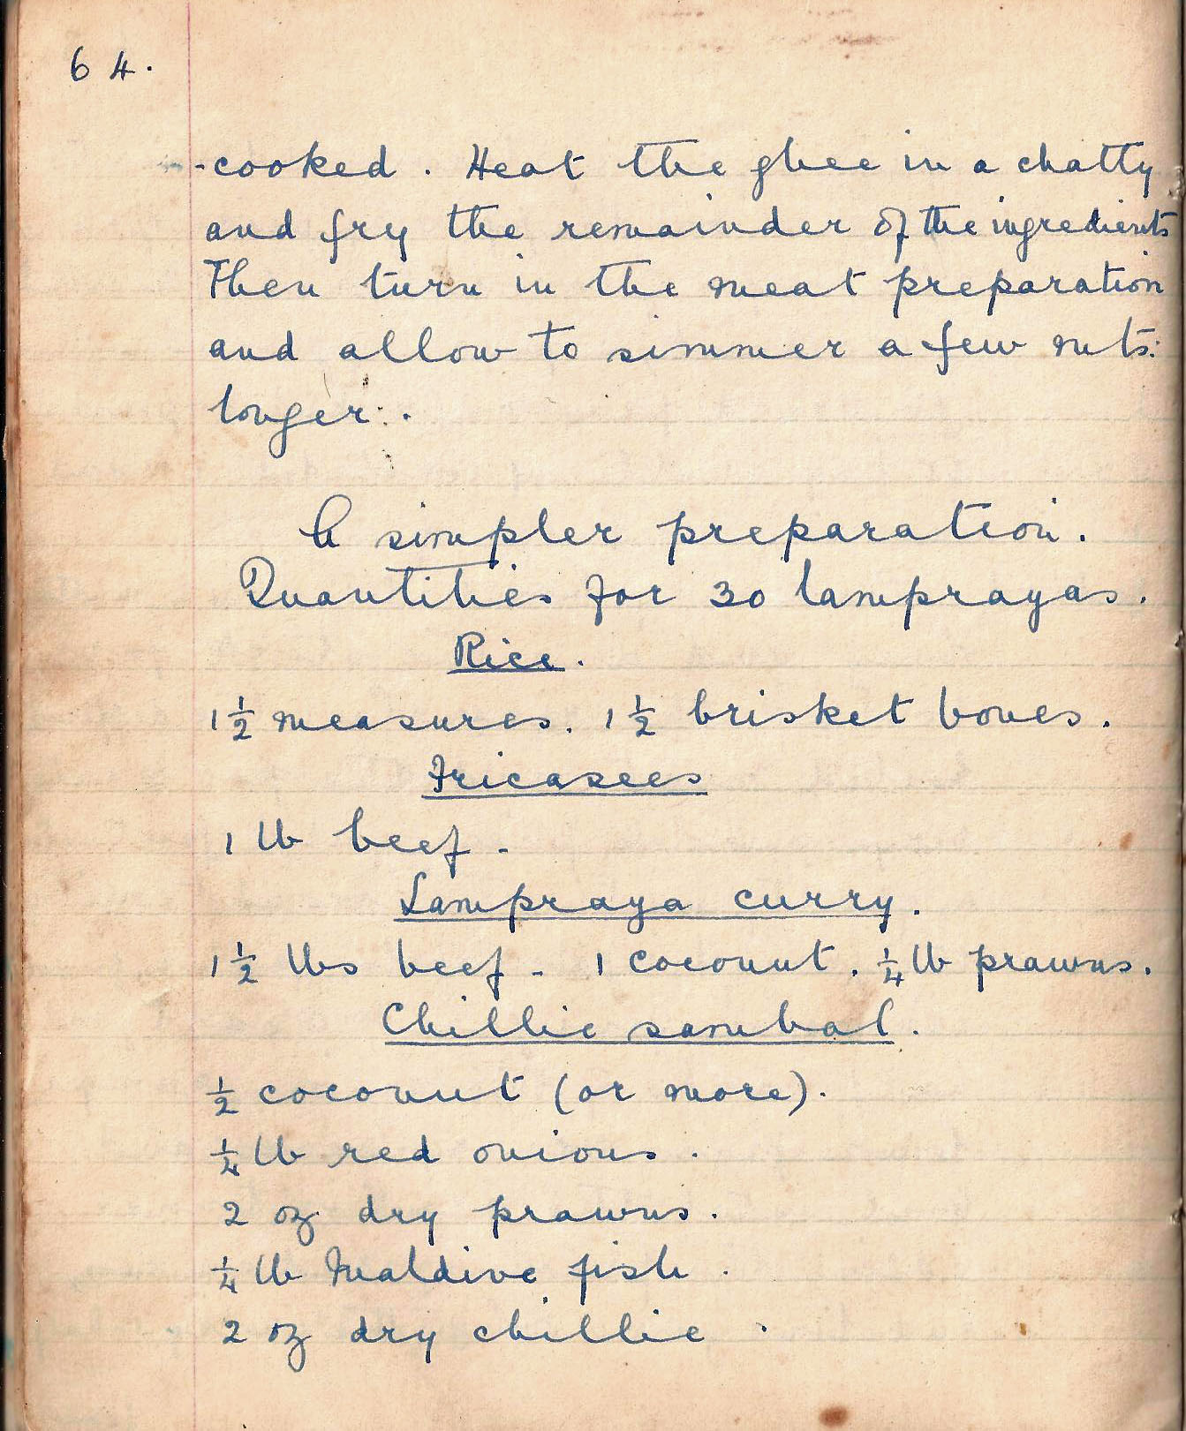

cooked. Heat the ghee in a chatty and fry the remainder of the ingredients. Then turn in the meat preparation and allow to simmer a few mins longer.

A simpler preparation.
Quantities for 30 lamprayas.
Rice 1 ½ measures. 1 ½ brisket bones
Fricassees 1 lb beef
Lampraya curry – 1 ½ lbs beef, 1 coconut. ¼ lb prawns
Chillie sambol
½ coconut (or more).
¼ lb red onions.
2 oz dry prawns.
¼ lb Maldive fish.
2 oz dry chilli

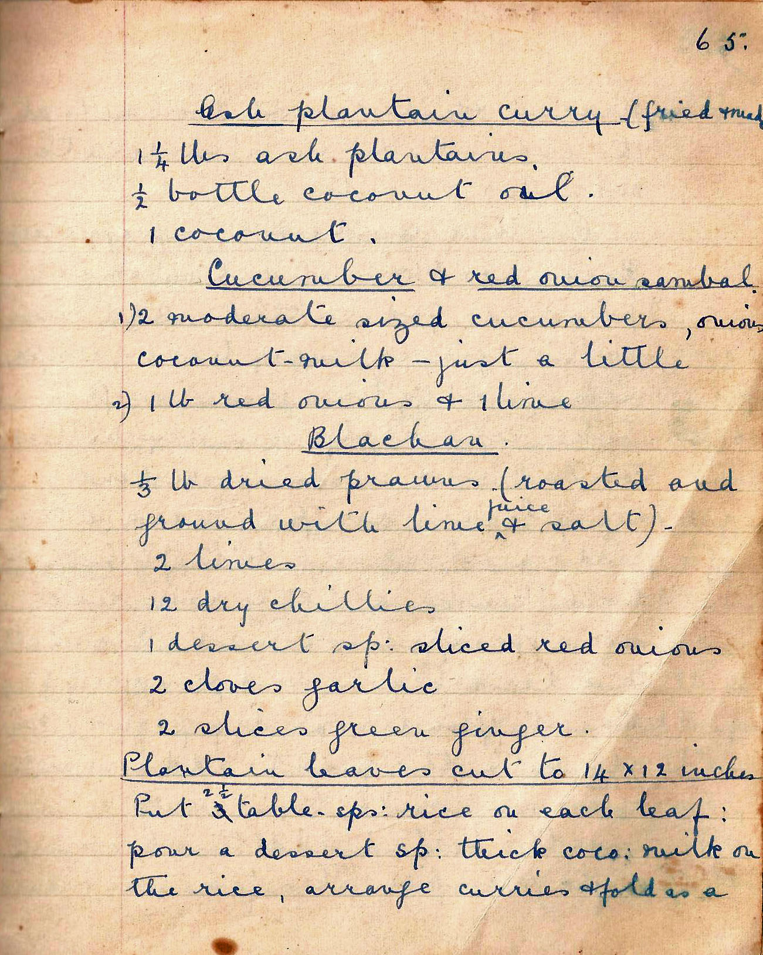

Ash plantain curry (fried) 1 ¼ lbs plantain. ½ bottle coconut oil. 1 coconut.

Cucumber and red onion sambol moderate sized cucumbers, onions, coconut milk – just a little. 1 lb red onions and 1 lime

Blachan
1/3 dried prawns (roasted and ground with lime juice and salt).
2 limes.
12 dry chillies.
1 dessert sp sliced red onions.
2 cloves garlic.
2 slices green ginger.

Plantain leaves cut to 14 x 12 inches. Put 2 ½ tablespoons rice on each leaf: pour a dessert spoon thick coconut milk on the rice, arrange curries and fold as a

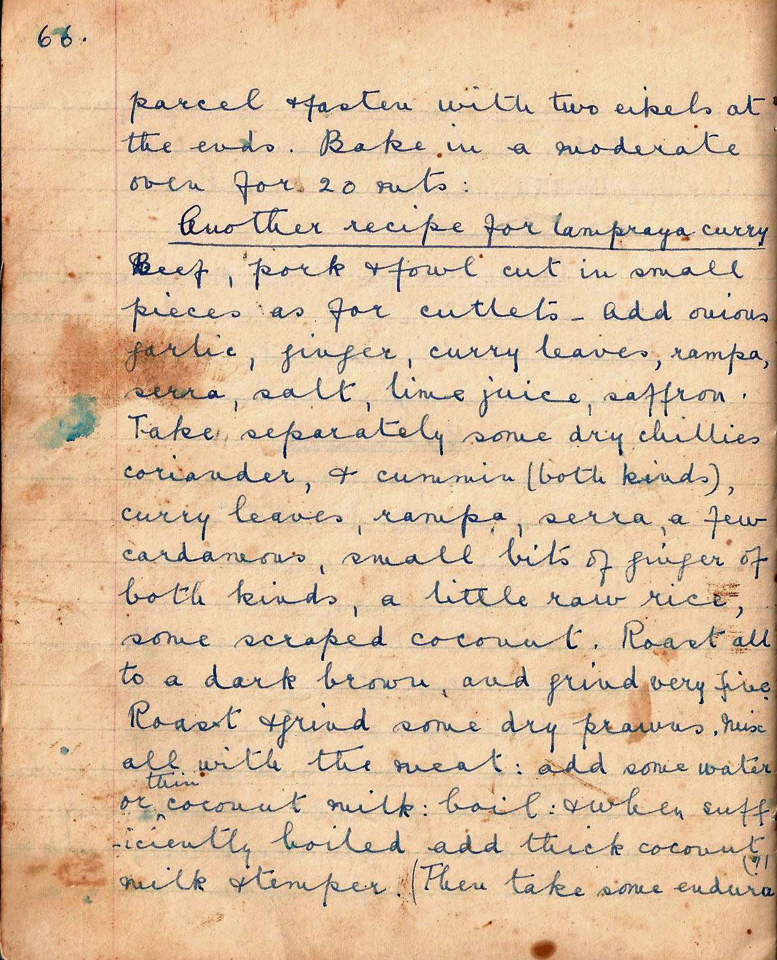

parcel and fasten with two ekels at the ends. Bake in a moderate over for 20 mins.

Another recipe for lampraya curry
Beef, pork and fowl cut in small pieces as for cutlets. Add onions, garlic, ginger, curry leaves, rampa, sera, salt, lime juice, saffron. Take separately some dry chillies, coriander, and cumin (both kinds), curry leaves, rampa, sera, a few cardamoms, small bits of ginger of both kinds, a little raw rice, some scraped coconut. Roast all to a dark brown, and grind very fine. Roast and grind some dry prawns. Mix all with the meat: add some water and thin coconut milk: boil: and when sufficiently boiled add thick coconut milk and temper (Then take some endura,

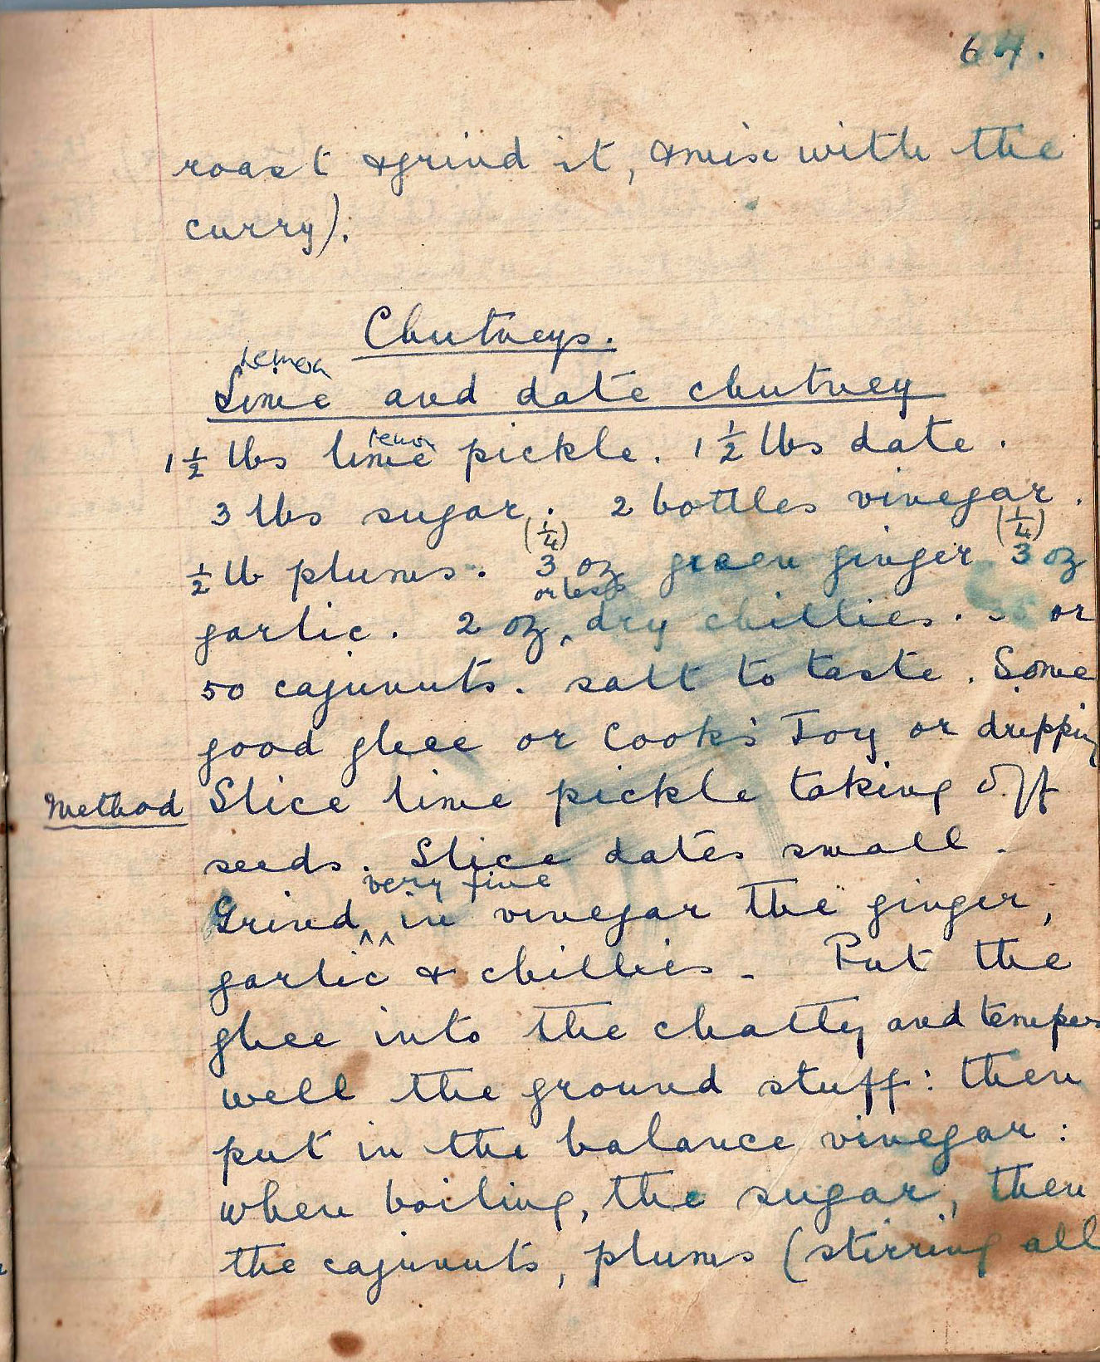

roast and grind it and mix with the curry).

Chutneys

Lime (lemon)and date chutney
1 ½ lbs lime pickle. 1 ½ lbs date. 3 lbs sugar. 2 bottles vinegar. ½ lb plums. 3 oz green ginger. 3 ozs garlic. 2 oz dry chillies. 30 or 50 cajunuts. salt to taste. Some good ghee or Cook’s Joy or dripping.

Method Slice lime pickle taking off seeds. Slice dates small. Grind in vinegar the ginger, garlic and chillies. Put the ghee into the chatty and temper well the ground stuff; then put in the balance vinegar: when boiling, the sugar, then the cajunuts, plums (stirring all

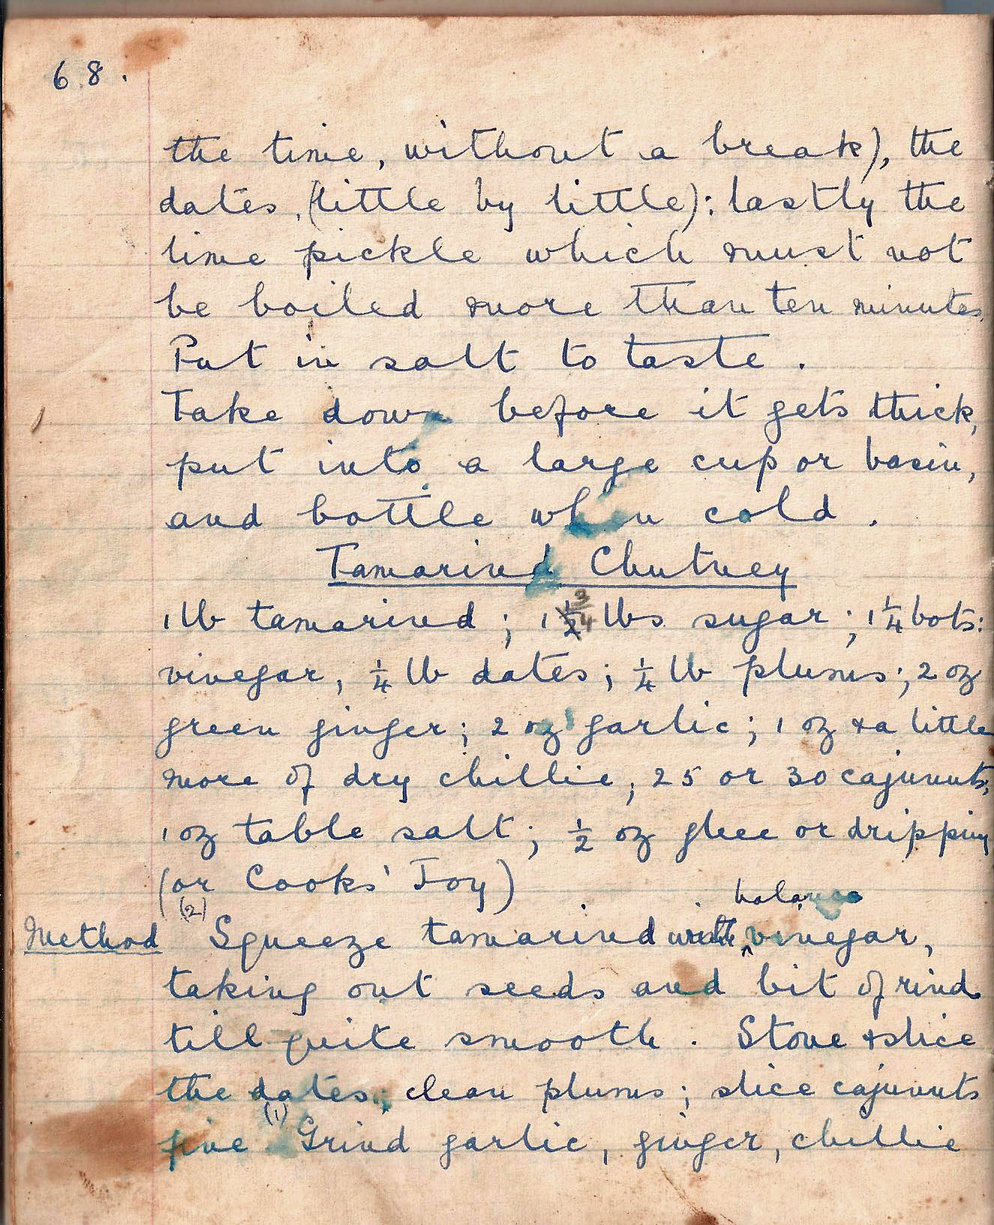

the time without a break), the dates (little by little): lastly the lime pickle which must not be
boiled more than ten minutes. Put in salt to taste.

Take down before it gets thick, put into a large cup or basin and bottle when cold.

Tamarind chutney
1 lb tamarind; 1 ½ lbs sugar; 1 ¼ bots vinegar, ¼ lb dates; ¼ lb plums; 2 oz green ginger; 2 oz garlic; 1 oz and a little more of dry chillies; 25 or 30 cajunuts, 1 oz table salt; ½ oz ghee or dripping (or Cook’s Joy)

Method Squeeze tamarind with vinegar, taking out seeds and bit of rind till quite smooth. Stone and slice the dates; clean plums; slice cajunuts fine. Grind garlic, ginger, chillie

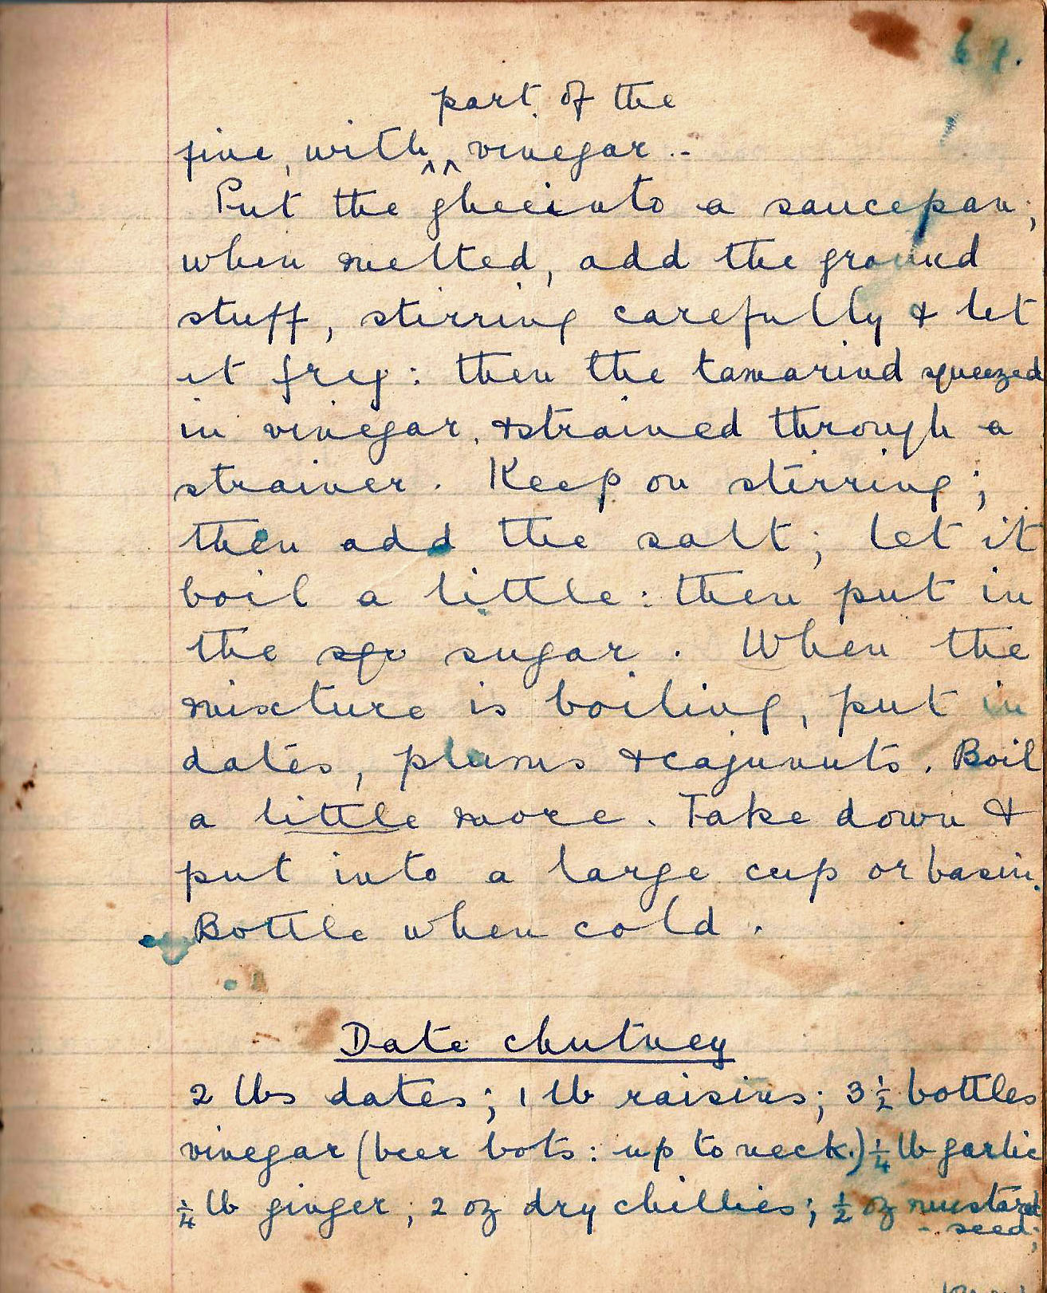

fine with part of the vinegar.

Put the ghee into a saucepan; when melted, add the ground stuff, stirring carefully and let it fry: then the tamarind squeezed in vinegar, and strained through a strainer. Keep on stirring: then add the salt; let in the sugar. When the mixture is boiling, put in dates, plums, and cajunuts. Boil a little more. Take down and put into a large cup or basin. Bottle when cold.

Date chutney
2 lbs dates; 1 lb raisins; 3 ½ bottles vinegar (beer bots: up to the neck) ¼ lb garlic. ¼ lb ginger; 2 oz dry chillies; ½ oz mustard seed;

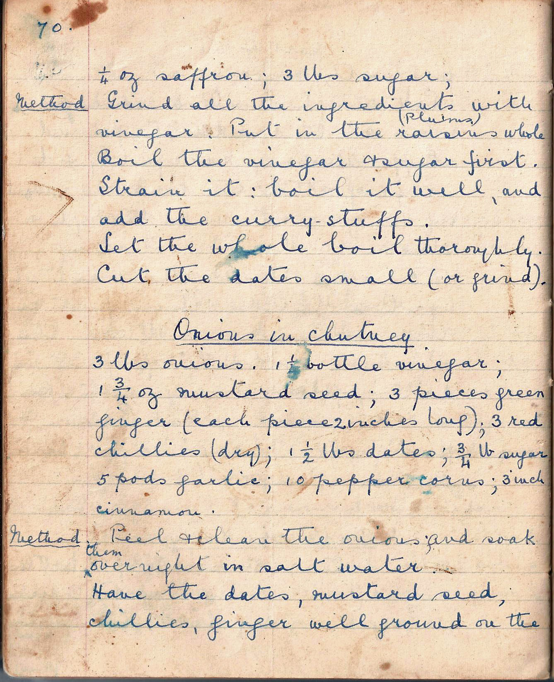

¼ oz saffron; 3 lbs sugar.

Method Grind all the ingredients with vinegar. Put in the raisins whole. Boil the vinegar and sugar first. Strain it: boil it well, and add the curry-stuffs. Let the whole boil thoroughly. Cut the dates small (or grind).

Onions in chutney
3 lbs onions. 1 ½ bottle vinegar; 1 ¾ oz mustard seed; 3 pieces green ginger (each piece 2 inches long); 3 red chillies (dry); 1 ½ lbs dates; ¾ lb sugar; 5 pods garlic; 10 peppercorns; 3 inch cinnamon.

Method . Peel and clean the onions, and soak them overnight in salt water. Have the dates, mustard seed, chillies, ginger well ground on the

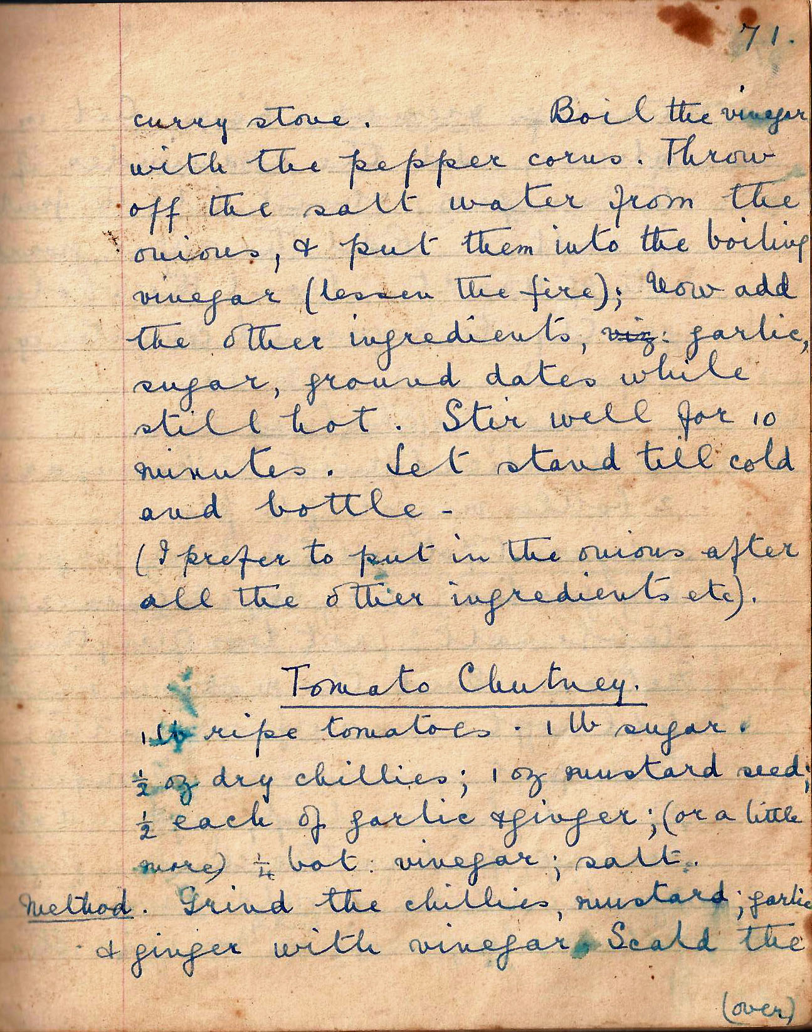

curry stone. Boil the vinegar with the pepper corns. Throw off the salt water from the onions, and put them into the boiling vinegar (lessen the fire); now add the other ingredients, garlic, sugar, ground dates while still hot. Stir well for 10 minutes. Let it stand till cold and bottle.

(I prefer to put in the onions after all the other ingredients etc.)

Tomato chutney
1 lb ripe tomatoes. 1 lb sugar. ½ oz dry chillies; 1 oz mustard seed; ½ each of garlic and ginger; (or a little more) ¼ bot vinegar; salt.

Method Grind the chillies, mustard, garlic and ginger with vinegar. Scald the

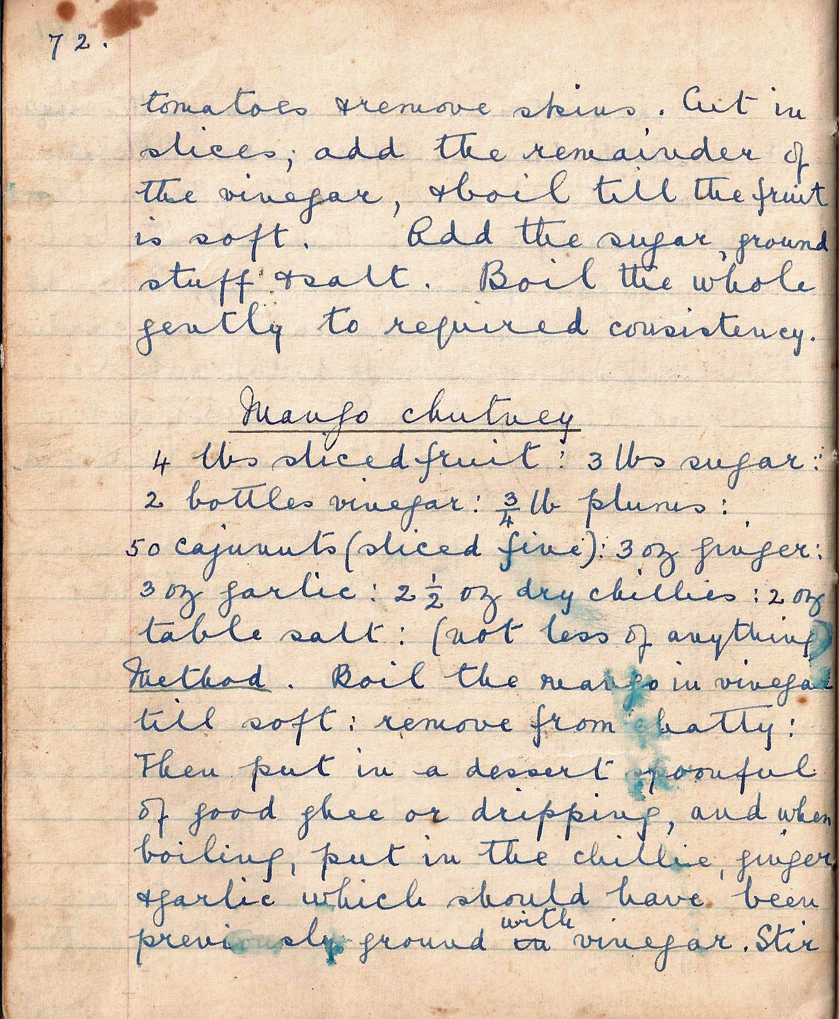

tomatoes and remove skins. Cut in slices and add the remainder of the vinegar and boil till the fruit is soft. Add the sugar, ground stuff and salt. Boil the whole gently to required consistency.

Mango chutney
4 lbs sliced fruit; 3 lbs sugar; 2 bottles vinegar; ¾ lbs plums; 50 cajunuts (sliced fine); 3 oz ginger; 3 oz garlic; 2 ½ oz dry chillies; 2 oz table salt; (not less of anything)

Method Boil the mango in vinegar till soft; remove from chatty. Then put in a dessert spoonful of good ghee or dripping, and when boiling, put in the chilli, ginger and garlic which should have been previously ground with vinegar. Stir

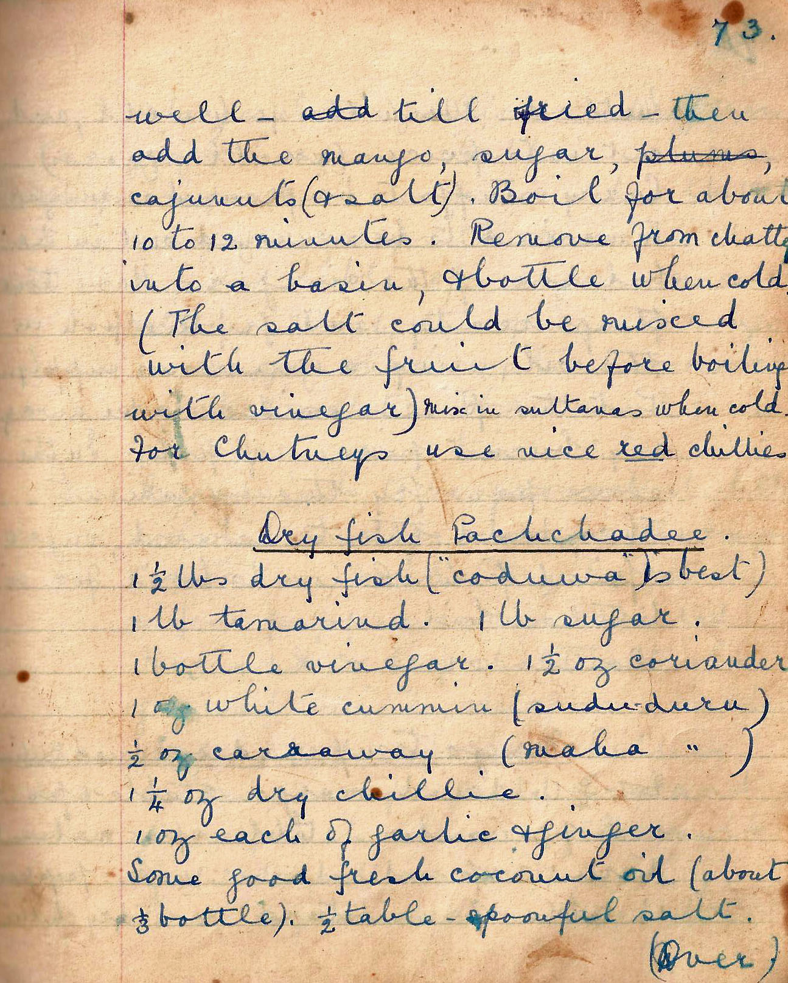

well – till fried – then add the mango, sugar, cajunuts (and salt). Boil for about 10 to 12 minutes. Remove from chatty into a basin, and bottle when cold. (The salt could be mixed with the fruit before boiling with vinegar) Mix in sultanas when cold. For chutneys use nice red chillies.

Dry fish Pachchadee
1 ½ lbs dry fish (“coduwa” is best)
1 lb tamarind. 1 lb sugar. 1 bottle vinegar. 1 ½ oz coriander. 1 oz white cumin (sudu-duru). ½ oz caraway (maha-duru). 1 ¼ oz dry chillies.
1 oz each of garlic and ginger.
Some good fresh coconut oil (about 1/3 bottle). ½ tablespoonful salt.

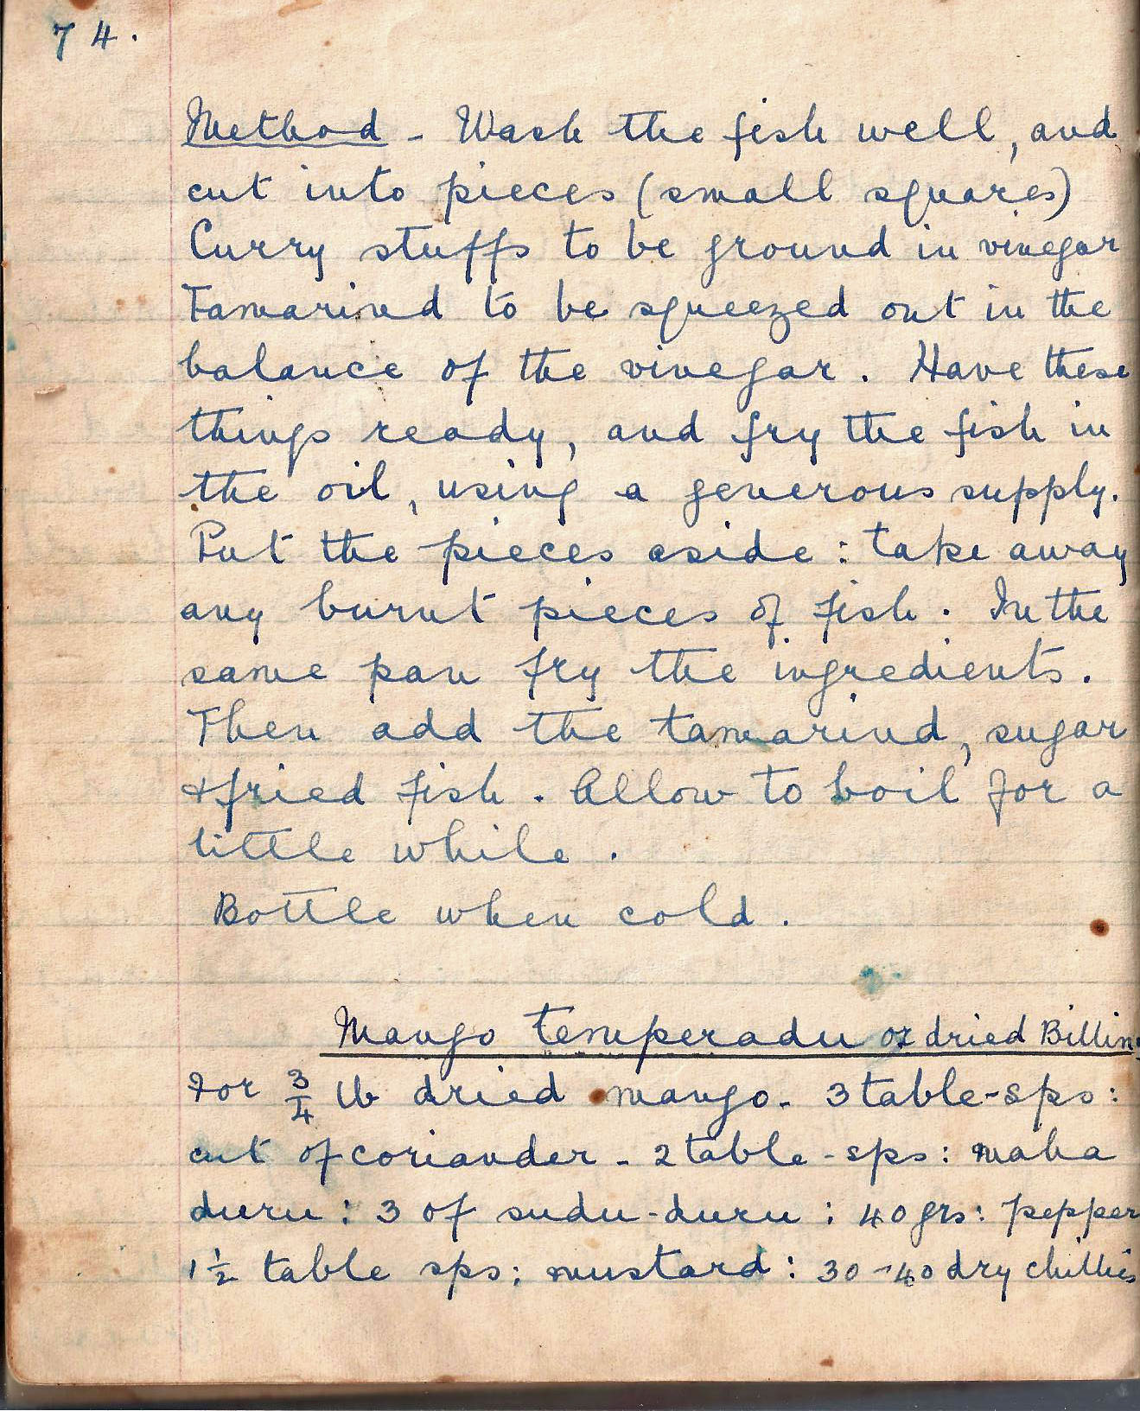

Method . Wash the fish well, and cut into pieces (small squares). Curry stuffs to be ground in vinegar. Tamarind to be squeezed out in the balance of the vinegar. Have these things ready, and fry the fish in the oil, using a generous supply. Put the pieces aside; take away any burnt pieces of fish. In the same pan fry the ingredients. Then add the tamarind, sugar and fish. Allow to boil for a little while. Bottle when cold.

Mango temperado
For ¾ lb dried mango. 3 tbsp cut of coriander. 2 tbsps maha duru: 3 of sudu duru. 40 grams pepper. 1 ½ tbsp mustard. 30 – 40 dry chillies.

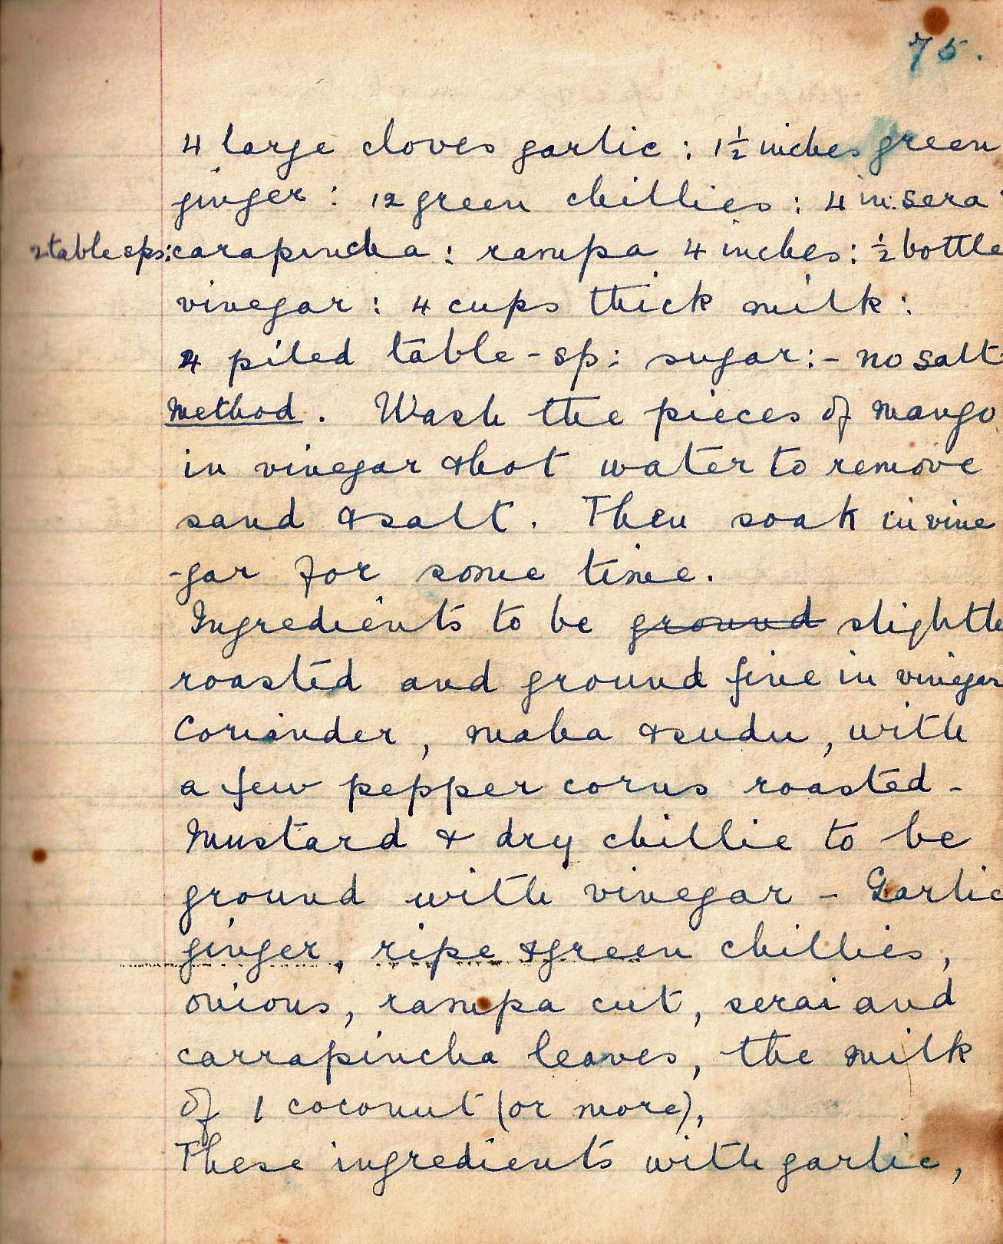

4 large cloves garlic. 1 ½ inches green ginger. 12 green chillies. 4 in sera. 2 tablespoons karapincha. rampa 4 inches. ½ bottle vinegar. 4 cups thick milk. 4 piled table-spoon sugar. no salt.

Method Wash the pieces of mango in vinegar and hot water to remove sand and salt. Then soak in vinegar for some time.

Ingredients to be slightly roasted and ground fine in vinegar, coriander, maha duru, with a few peppercorns roasted – mustard and dry chilli to be ground with vinegar – garlic, vinegar ripe and green chillies, onions, rampa cut, serai and karapincha leaves, the milk of 1 coconut (or more).

These ingredients with garlic,

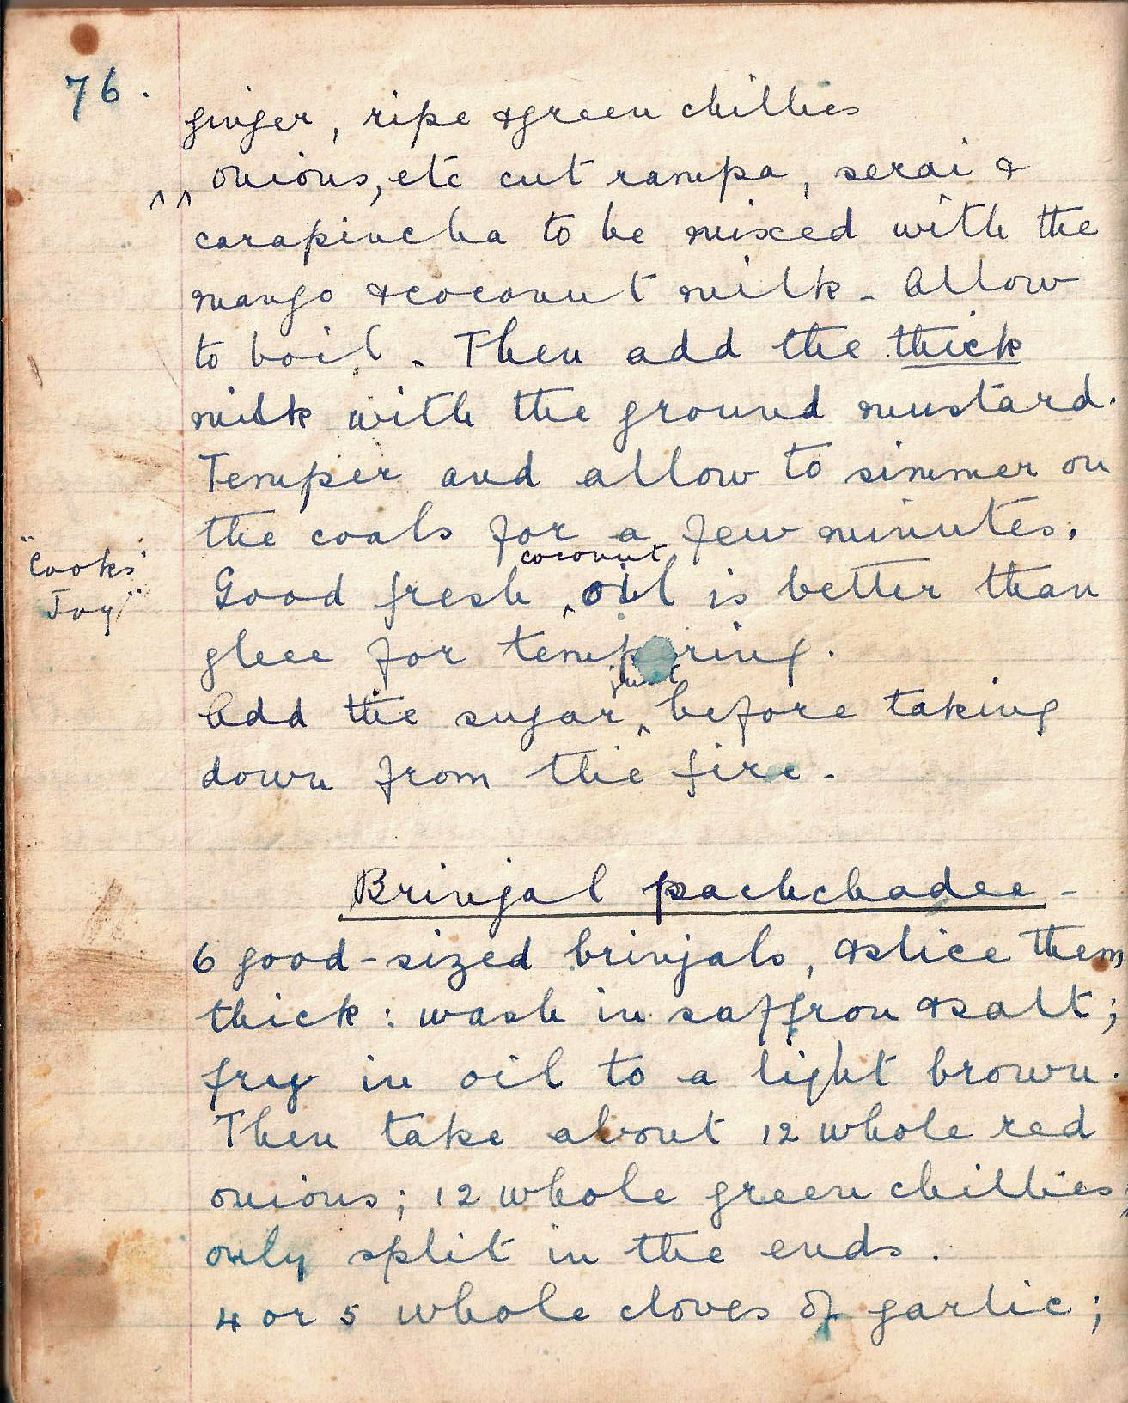

Ginger, ripe green chillies, onions, etc cut rampa, serai and carapincha to be mixed with the mango and coconut milk. Allow to boil. Then add the thick milk with the ground mustard. Temper and allow to simmer on the coals for a few minutes.

Good fresh coconut oil is better than ghee for tempering.

Add the sugar before taking down from the fire.

Brinjal pachchadee
6 good sized brinjals, and slice them thick: wash in saffron and salt; fry them in oil to a light brown.

Then take about 12 whole red onions; 12 whole green chillies, only split in the end; 4 or 5 whole cloves of garlic; 1 ¼ inch ginger sliced very fine.

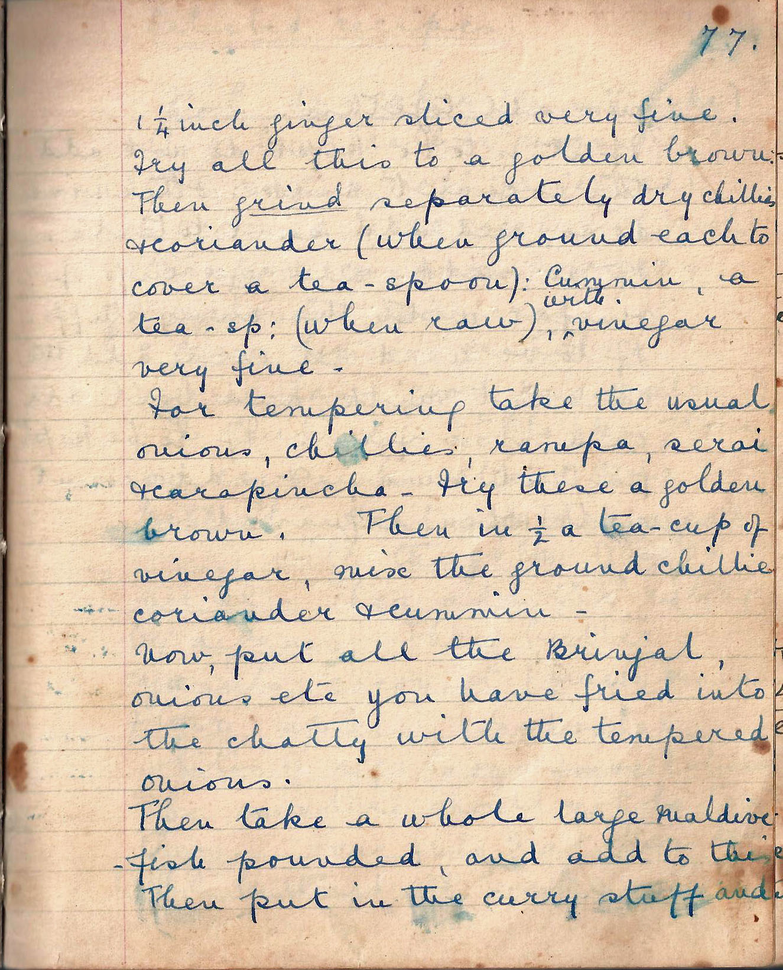

Fry all this to a golden brown. Then grind separately, dry chillies and coriander (when ground each to cover a teaspoon)’ cumin, a teaspoon (when raw) with vinegar very fine.

For tempering take the usual onions, chillies, rampa, serai, and karapincha. Fry these a golden brown. Then in ½ a tea-cup of vinegar, mix the ground chillies, coriander and cumin.

Now, put all the brinjal onions etc you have fried into the chatty with the tempered onions.

Then take a whole large Maldive fish pounded, and add to this.

Then put in the curry stuff and

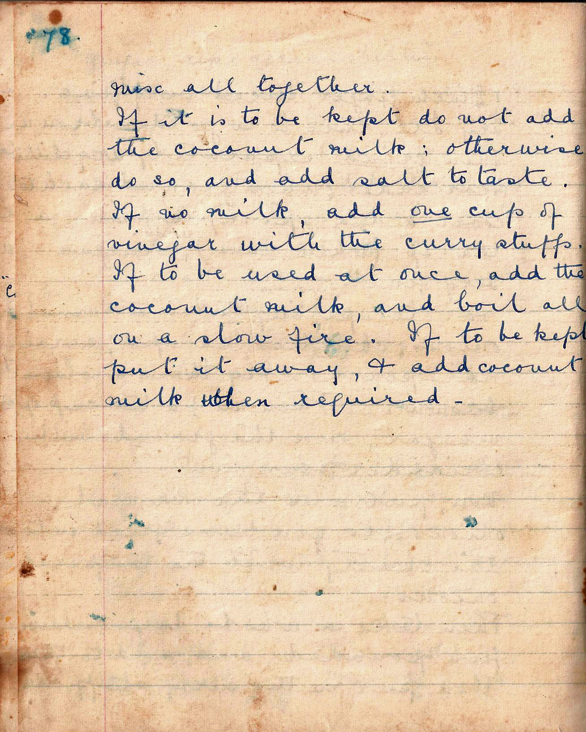

mix all together.

If it is to be kept do not add the coconut milk: otherwise do so, and add salt to taste.

If no milk, add one cup of vinegar with the curry stuffs. If to be used at once, add the coconut milk, and boil all on a slow fire. If to be kept put it away and add coconut milk when required.

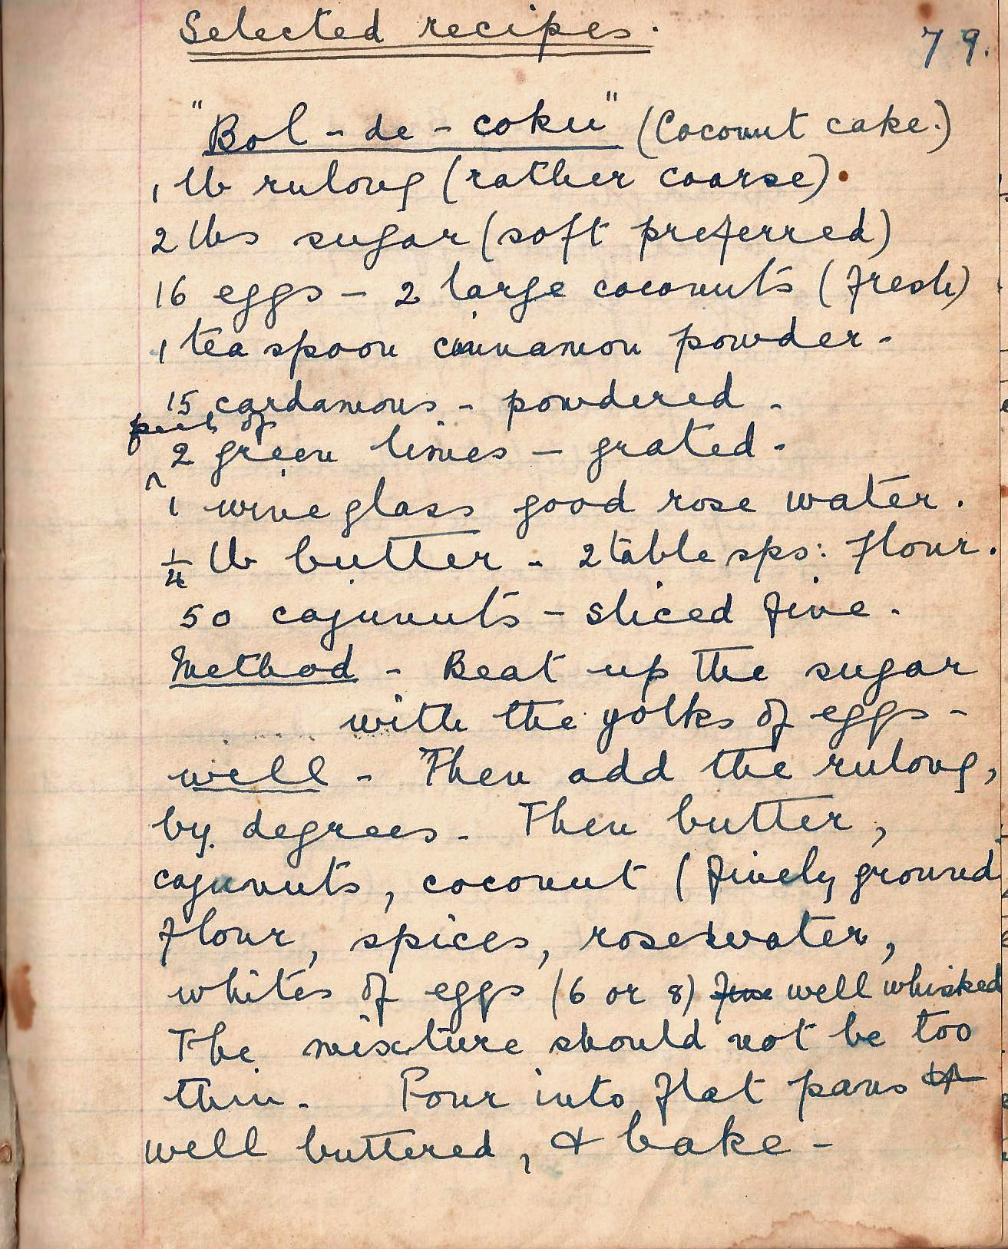

Selected Recipes

“Bol-de-coku” (Coconut cake)
1 lb rulang (rather coarse)
2 lbs sugar (soft preferred)
16 eggs - 2 large coconuts (fresh)
1 teaspoon cinnamon powder -
15 cardamoms – powdered -
peel of 2 green limes – grated -
1 wine glass good rose water.
¼ lb butter - 2 table sps: flour.
50 cajunuts sliced fine

Method Beat up the sugar with the yolks of eggs – well. Then add the rulang, by degrees - Then butter, cajujnuts, coconut (finely ground). flour, flour, spices, rosewater, whites of eggs (6 or 8) well whisked.

The mixture should not be too thin. Pour into flat pans, well buttered, and bake -

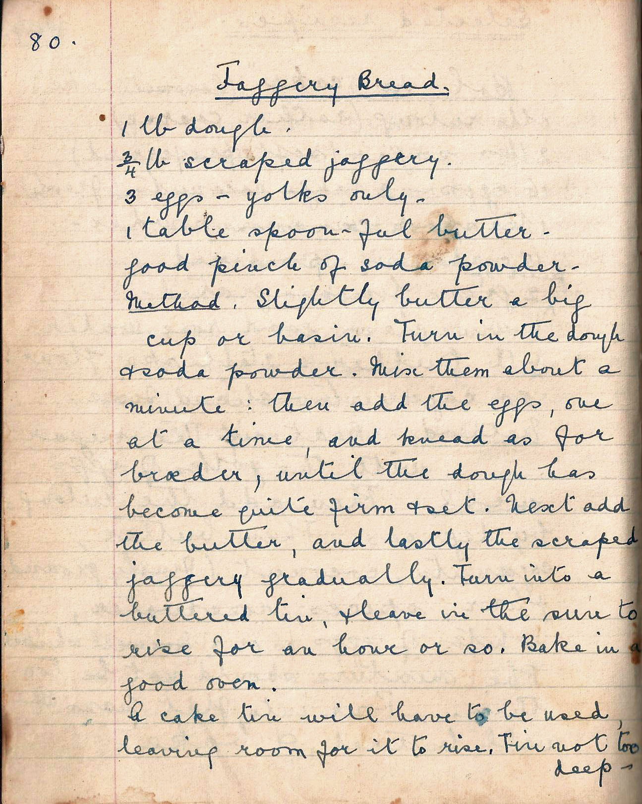

Jaggery Bread
1 lb dough.
¾ lb scraped jaggery.
3 eggs – yolk only -
1 table spoon-ful butter -
good pinch of soda powder -

Method Slightly butter a big cup or basin. Turn in the dough and soda powder. Mix them about a minute: then add the eggs, one at a time, and knead as for broeder, until the dough has become quite firm and set. Next add the butter, and lastly the scraped jaggery gradually. Turn into a buttered tin, and leave in the sun to rise for an hour or so. Bake in a good oven.

A cake tin will have to be used leaving room for it to rise. Tin not too deep -

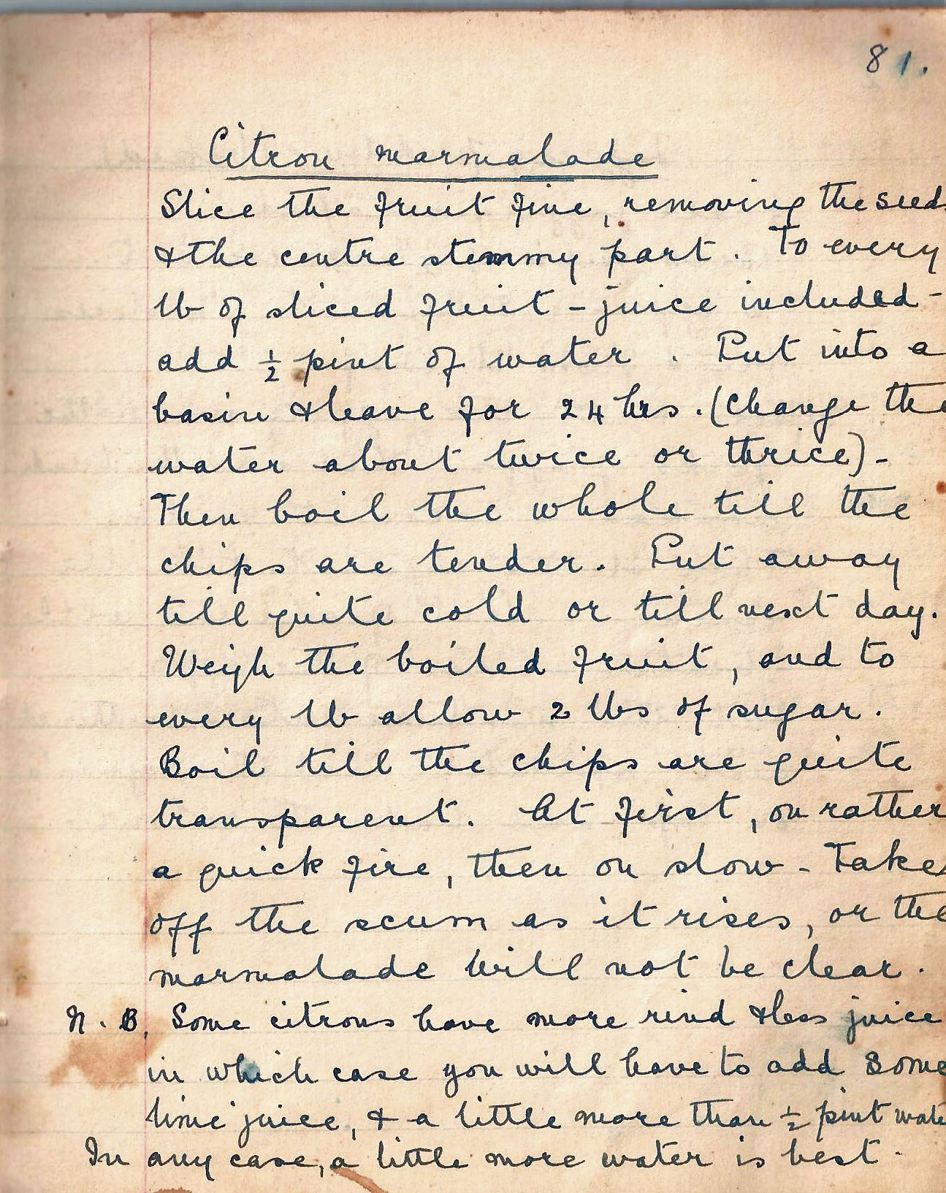

Citron marmalade
Slice the fruit, removing the seeds and the centre stemmy part. To every lb of sliced fruit – juice included – add ½ pint of water. Put into a basin and leave for 24 hours. (Change the water about twice or thrice).

Then boil the whole till the chips are tender. Put away till quite cold or till the next day. Weight the boiled fruit, and to every lb allow 2 lbs of sugar. Boil till the chips are quite transparent. At first, on rather a quick fire, then on slow. Take off the scum as it rises, or the marmalade will not be clear.

NB Some citrons have more rind and less juice, in which case you will have to add some lime juice and a little more than ½ pint water. In any case, a little more water is best.

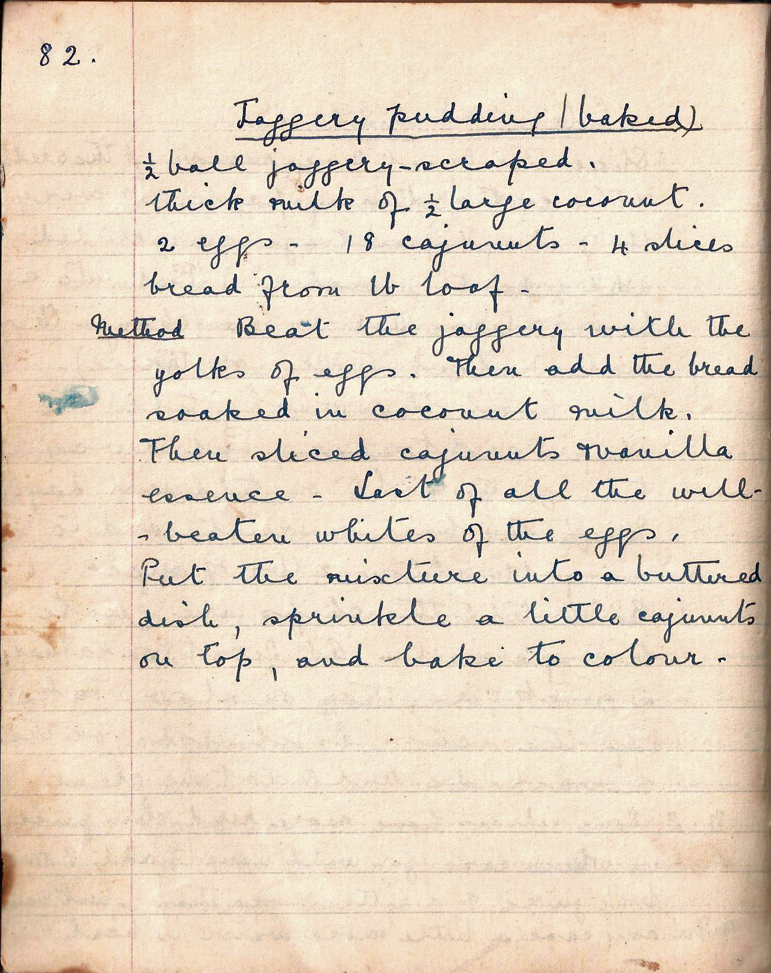

Jaggery pudding (baked)
½ ball of jaggery – scraped.
thick milk of ½ large coconut.
2 eggs - 18 cajunuts - 4 slices bread from lb loaf

Method Beat the jaggery with the yolk of eggs. Then add the bread soaked in coconut milk.

Then sliced cajunuts and vanilla essence - Last of all the well-beaten whites of the eggs.

Put the mixture into a buttered dish, sprinkle a little cajunuts on top, and bake to colour

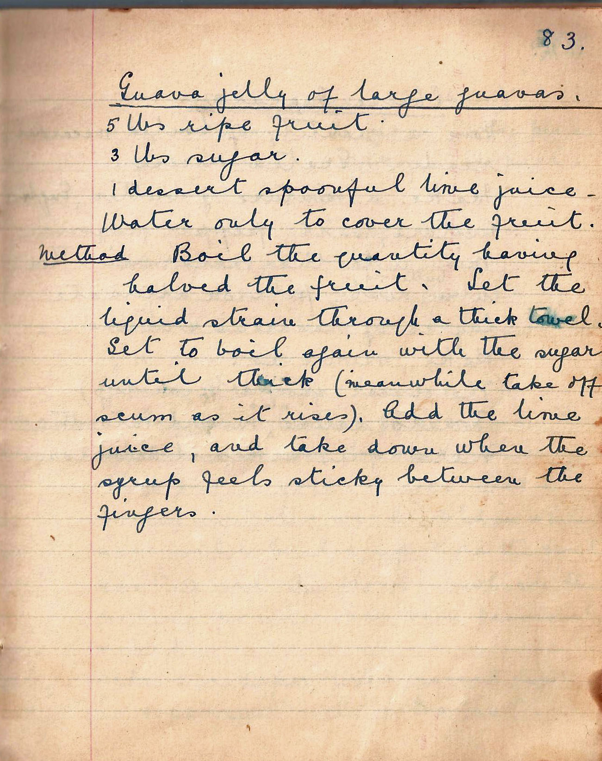

Guava jelly of large guavas
5lbs ripe fruit.
3 lbs sugar.
1 dessert spoonful lime juice -
Water only to cover the fruit.

Method Boil the quantity having halved the fruit. Let the liquid strain through a thick towel. Set to boil again with the vinegar until thick (meanwhile take off the scum as it rises). Add the lime juice, and take down when the syrup feels sticky between the fingers.

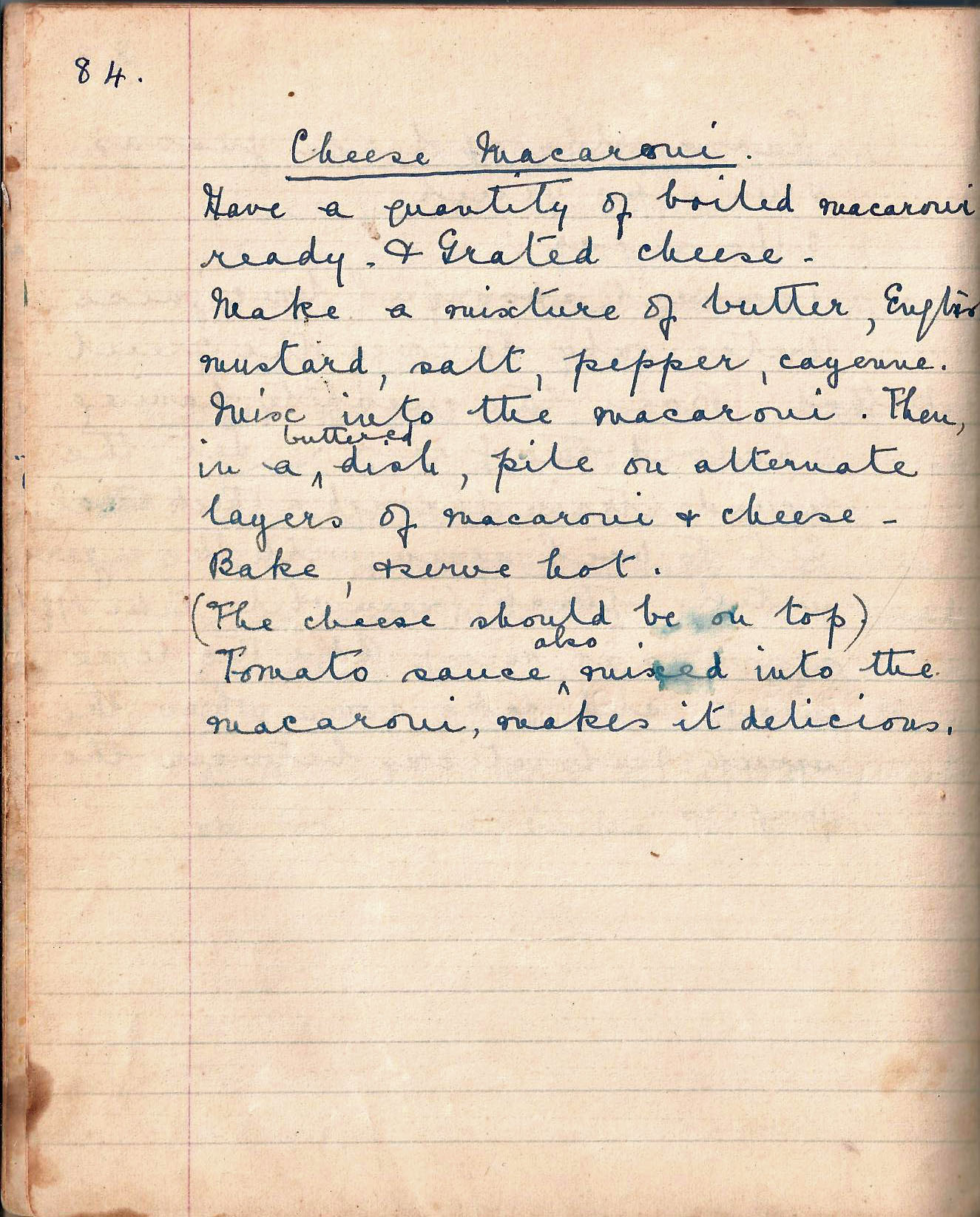

Cheese Macaroni
Have a quantity of boiled macaroni ready and grated cheese –
Make a mixture of butter, English mustard, salt, cayenne.
Mix into the macaroni. Then, in a buttered dish, pile on alternate layers of macaroni and cheese –
Bake, and serve hot.
(The cheese should be on top)
Tomato sauce also mixed into the macaroni, makes it delicious.

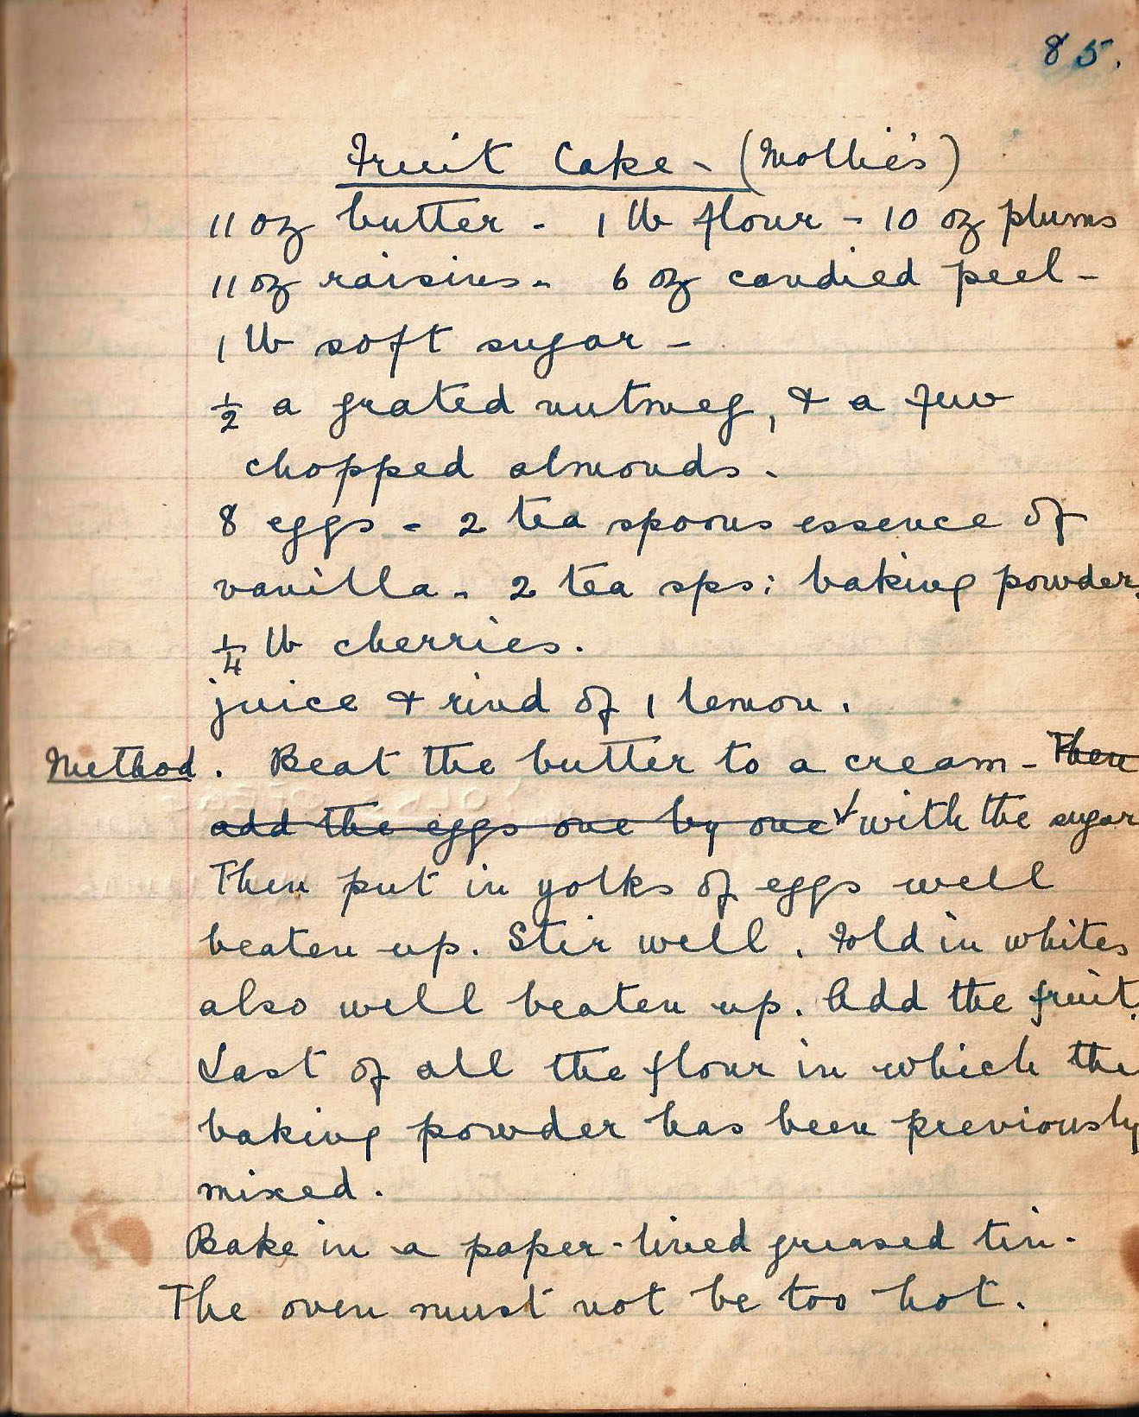

Fruit Cake – (Mollies_)
11 oz butter - 1 lb flour - 10 oz plums, 11 oz raisins - 6 oz candied peel - 1 lb soft sugar -
½ a grated nutmeg, and a few chopped almonds -
8 eggs - 2 tea spoons essence of vanilla - 2 tea sps: baking powder
¼ lb cherries.
juice and rind of 1 lemon.

Method Beat the butter to a cream with the sugar. Then put in yolks of eggs well beaten up. Stir well. Fold in whites also well beaten up. Add the fruit. Last of all the flour in which the baking powder has been previously mixed.

Bake in a paper-lined greased tin.

The oven must not be too hot.

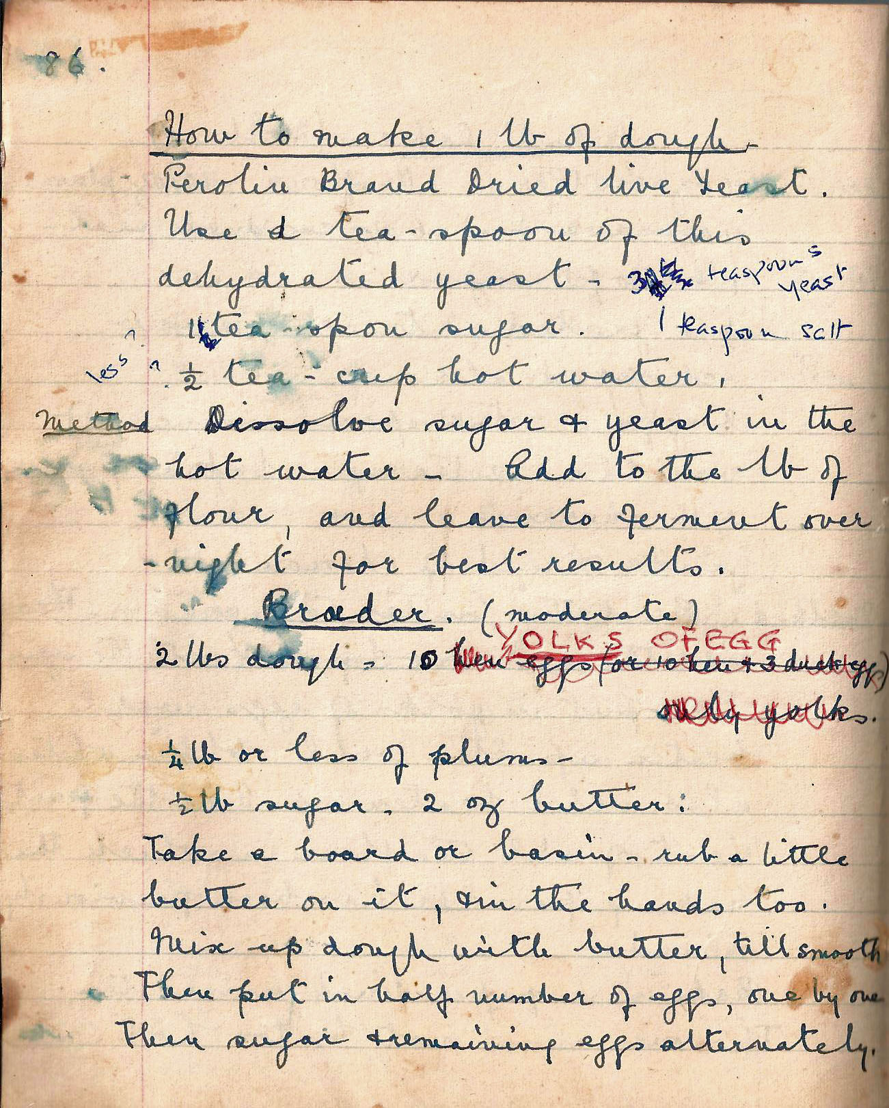

How to make 1 lb of dough
Peroline Brand dried live yeast.
Use a teaspoon of this dehydrated yeast -
1 teaspoon sugar.
½ teacup hot water

Method Dissolve sugar and yeast in the hot water - Add the lb of flour, and leave to ferment over-night for the best results.

‘Broder’ (moderate)
2 lbs dough - 10 hen eggs or 10 hen and 3 duck eggs, only yolks
¼ lb or less of plums -
½ lb sugar - 2 oz butter:

Take a board or basin - rub in a little butter on it, and in the hands, too. Mix up the dough with butter, till smooth. Then put in half number of eggs, one by one. Then sugar and remaining eggs alternately.

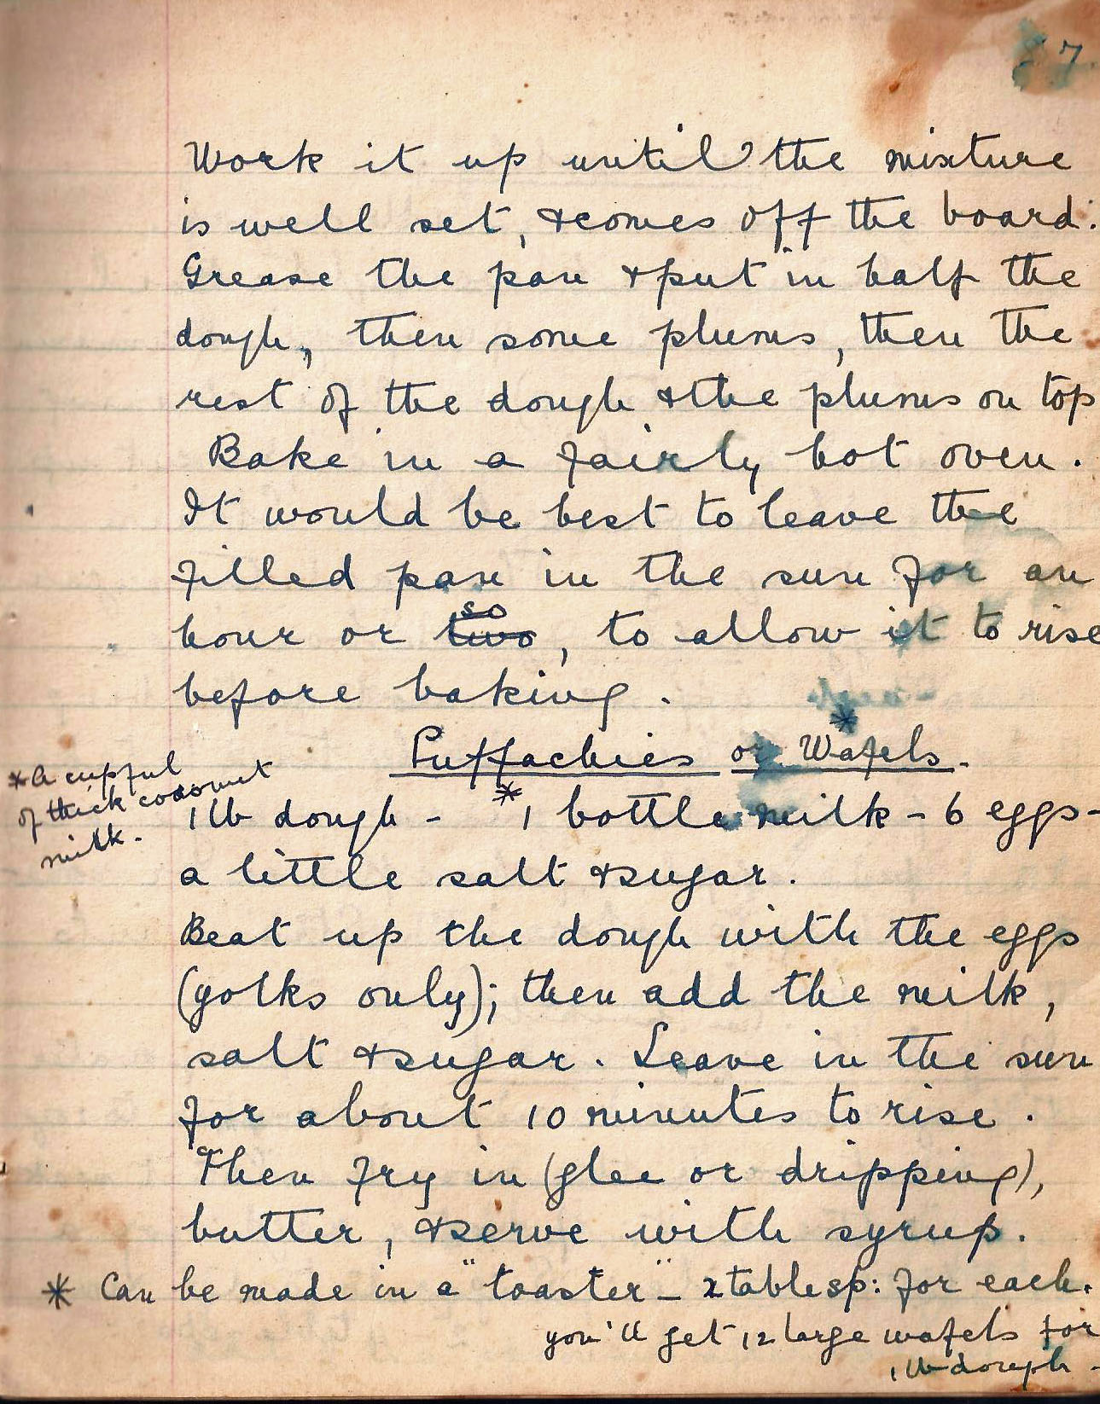

Work it up until the mixture is well set, and comes off the board.
Grease the pan and put in half the dough, then some plums, then the rest of the dough and the plums on top. Bake in a fairly hot oven.
It would be best to leave the filled pan in the sun for an hour or two to allow it to rise before baking.

Puffachies or Wafels
1 lb dough - *1 bottle of milk - 6 eggs - a little salt and sugar.
*a cupful of thick coconut milk

Beat up the dough with the eggs (yolk only); then add the milk, salt and sugar. Leave in the sun for about 10 minutes to rise.

Then fry in (ghee or dripping) butter, and serve with syrup,

*Can be made in a “toaster” – 2 tablesp: for each. you’ll get 12 large wafels from 1 lb dough.

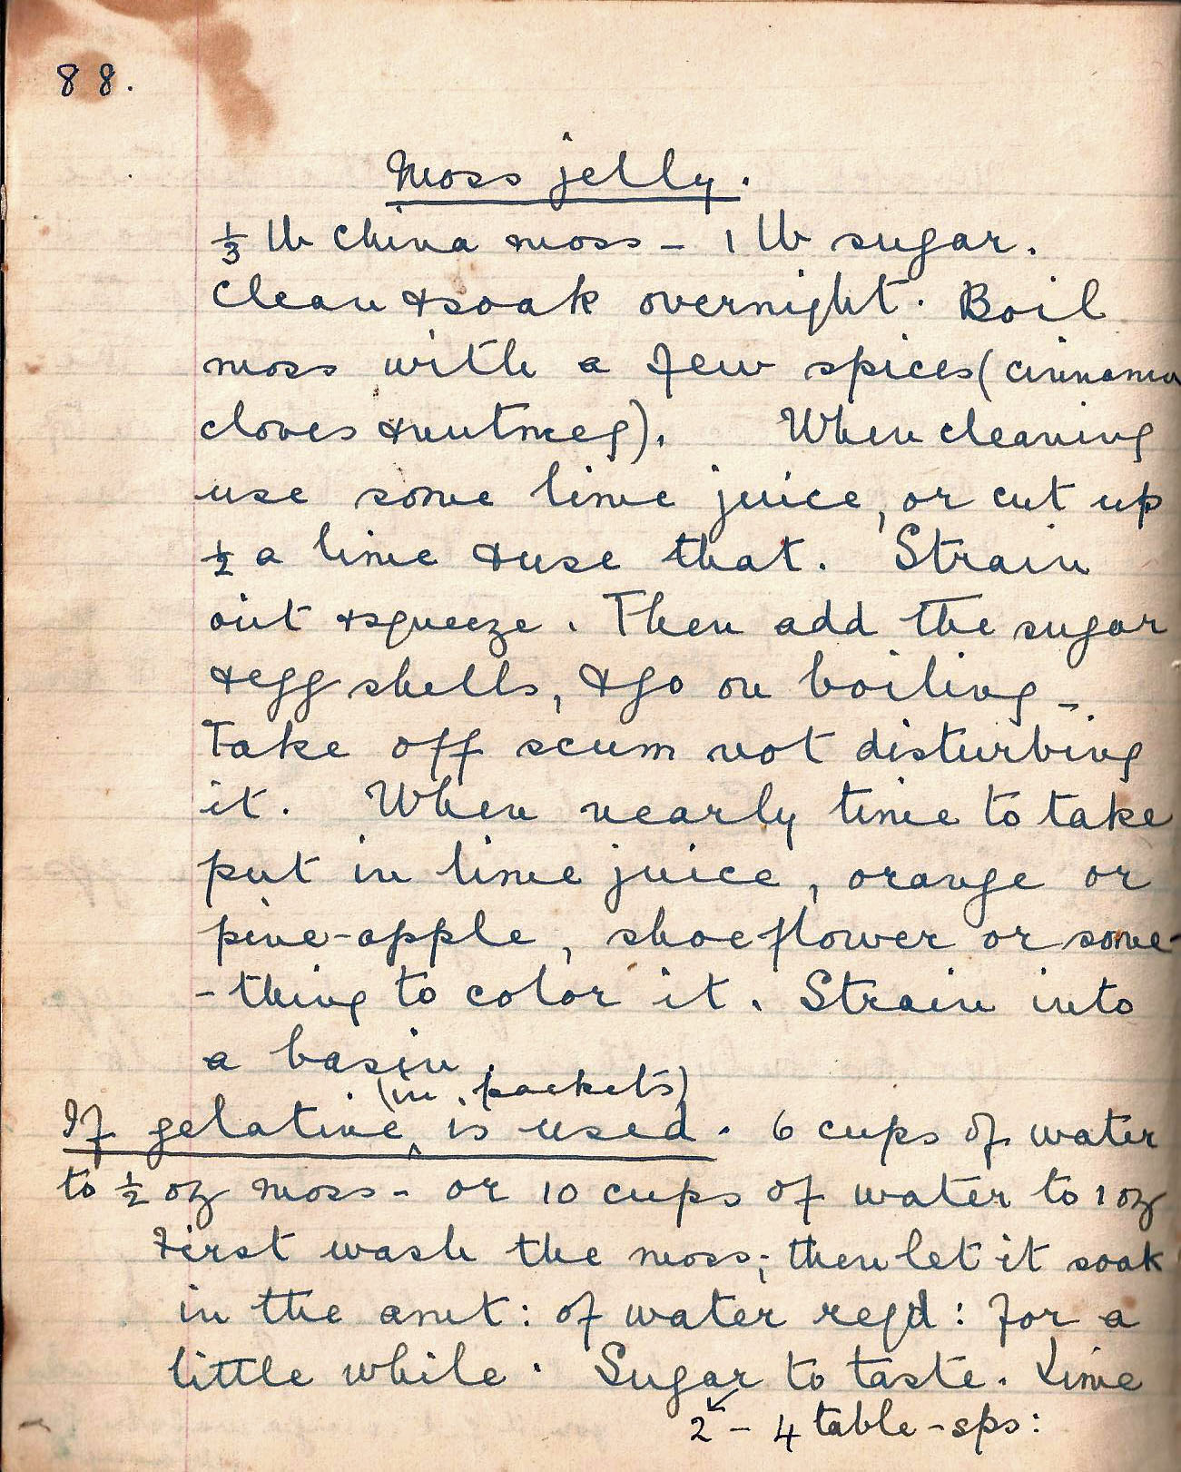

Moss Jelly
1/3 lb china moss - 1 lb sugar
Clean and soak overnight. Boil moss with a few spices (cinnamon, cloves and nutmeg). When cleaning use some lime juice, or cut up ½ a lime and use that. Strain out and squeeze. Then add the sugar and egg shells, and go on boiling. Take of the scum not disturbing it. When nearly time to take, put in lime juice, orange or pineapple, shoeflower or something to colour it. Strain into a basin.

If gelatine (in packets) is used - 6 cups of water to ½ oz moss - or 10 cups water to 1 oz.

First wash the moss, then let it soak in the amt: of water reqd: for a little while. Sugar 2 –4 table-sps: to taste. Lime

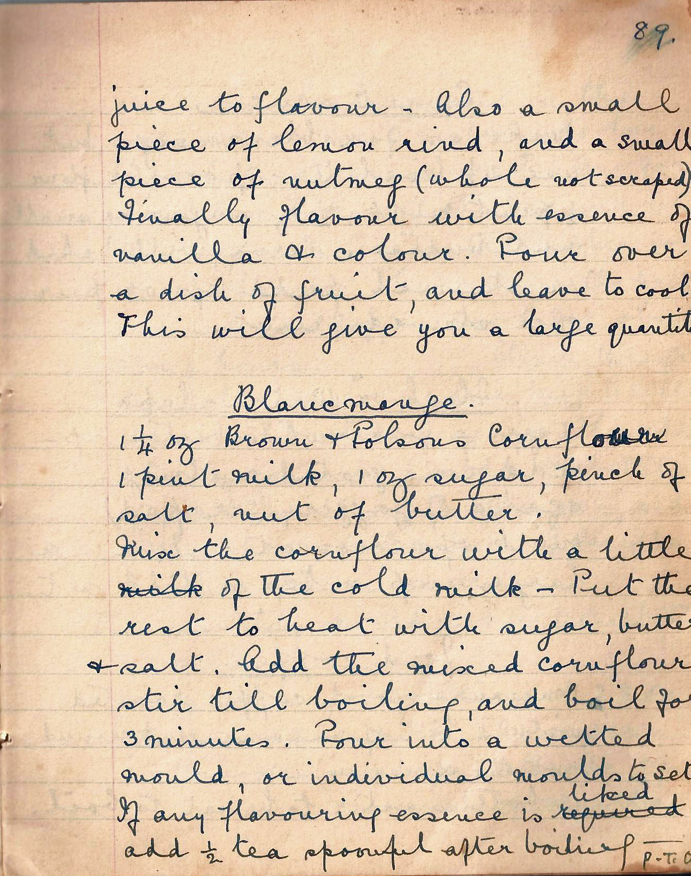

juice to flavour - Also a small piece of lemon rind, and a small piece of nutmeg (whole not scraped). Finally flavour with essence of vanilla and colour. Pour over a dish of fruit, and leave to cool.
This will give you a large quantity.

Blancmange
1¼ Brown and Polsons Cornflour
1 pint milk, 1 oz sugar, pinch of salt, nut of butter.

Mix the cornflour with a little of the cold milk - Put the rest to heat with sugar, butter and salt. Add the mixed cornflour, stir till boiling, and boil for 3 minutes. Pour into a wetted mould, or individual moulds to set. If any flavouring essence is liked add ½ teaspoonful after boiling.

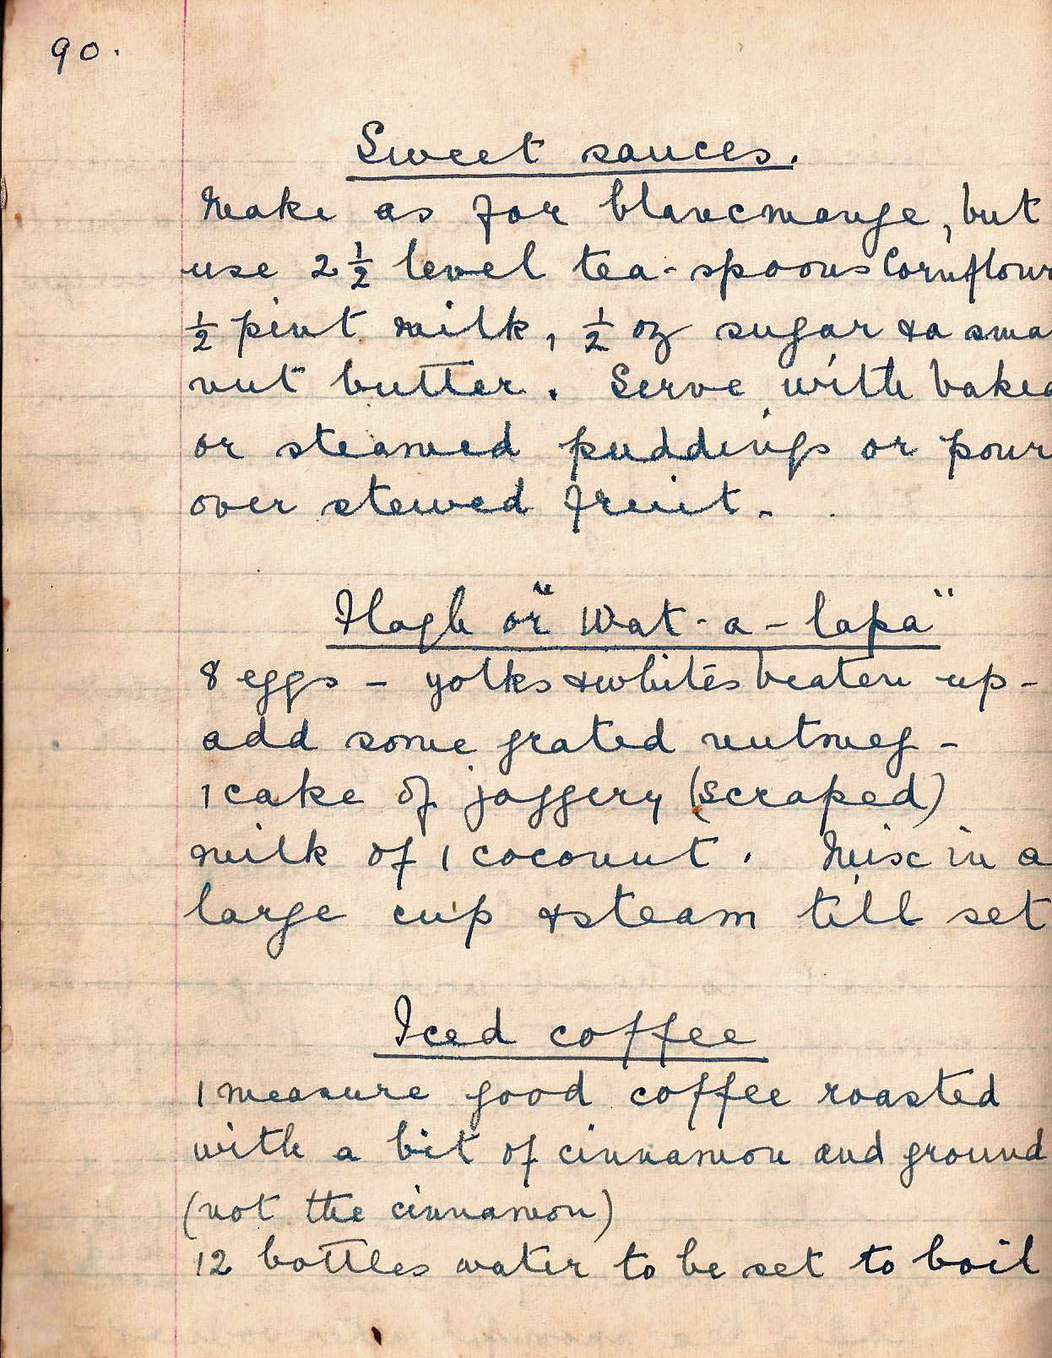

Sweet sauces
Make as for blancmange, but use 2½ level teaspoons cornflour, ½ pint milk, ½ oz sugar and a small nut butter. Serve with baked or steamed puddings or pour over stewed fruit.

Flagh or “Wat-a-lapa”
8 eggs, yolks and whites beaten up - add some grated nutmeg - 1 cake of jaggery (scraped) milk of 1 coconut. Mix in a large cup and steam till set.

Iced Coffee
1 measure good coffee roasted with a bit of cinnamon and ground (not the cinnamon)

12 bottles water to be set to boil,

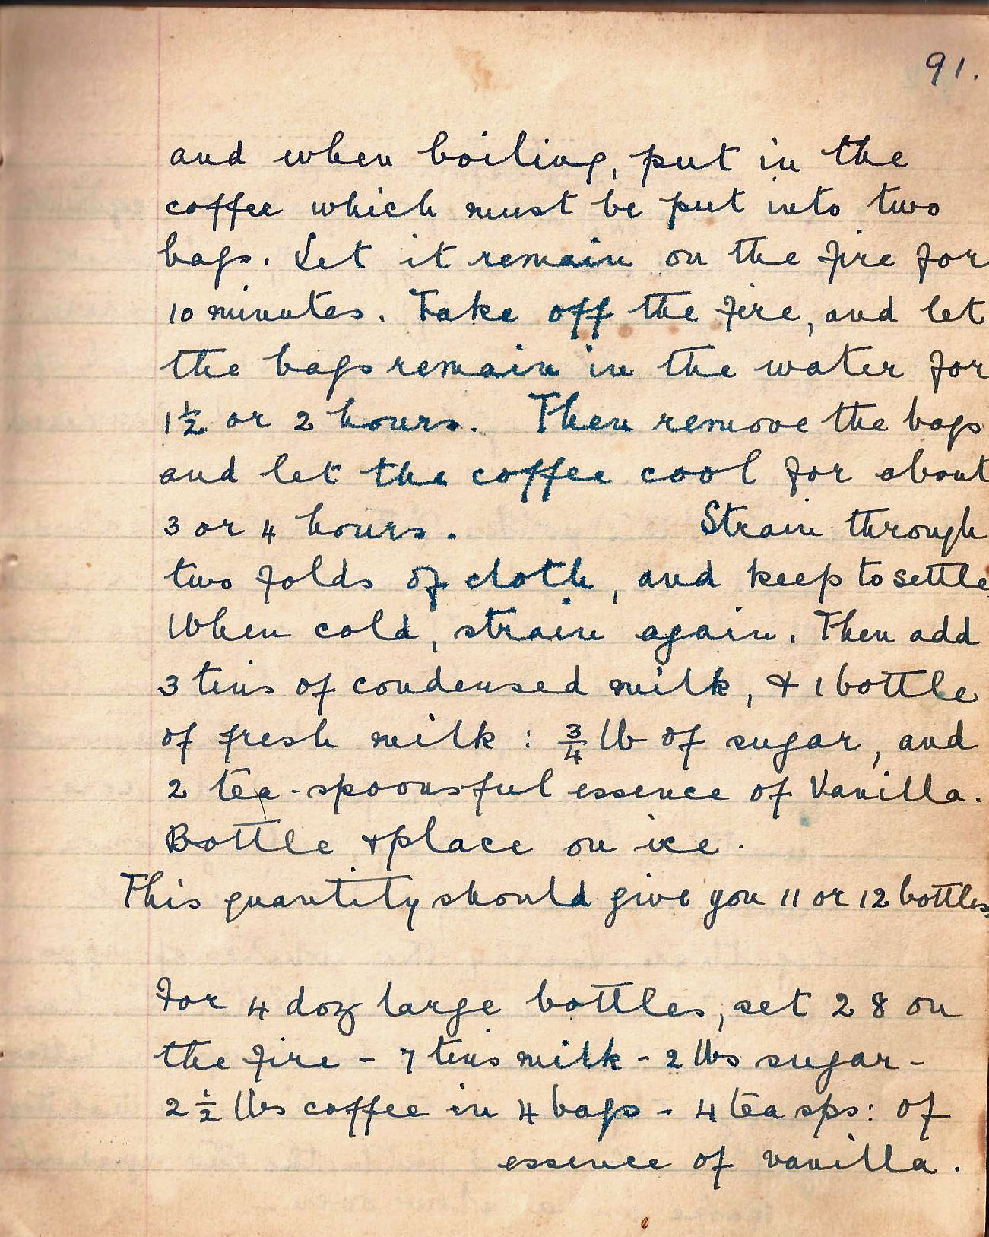

and when boiling, put in the coffee which must be put into two bags. Let remain on the fire for 10 minutes. Take off the fire, and let the bags remain in the water for 1½ or 2 hours. Then remove the bags and let the coffee cool for about 3 or 4 hours. Strain through two folds of cloth, and keep to settle. When cold, strain again. Then add 3 tins of condensed milk, and 1 bottle of fresh milk: ¾ lb sugar, and 2 tea-spoonful essence of Vanilla.

Bottle and place on ice.

This quantity should give you 11 or 12 bottles.

For 4 doz large bottles, set 28 on the fire – 7 tins of milk – 2 lbs sugar – 2½ lbs coffee in 4 bags – 4 teasps: of essence of vanilla.

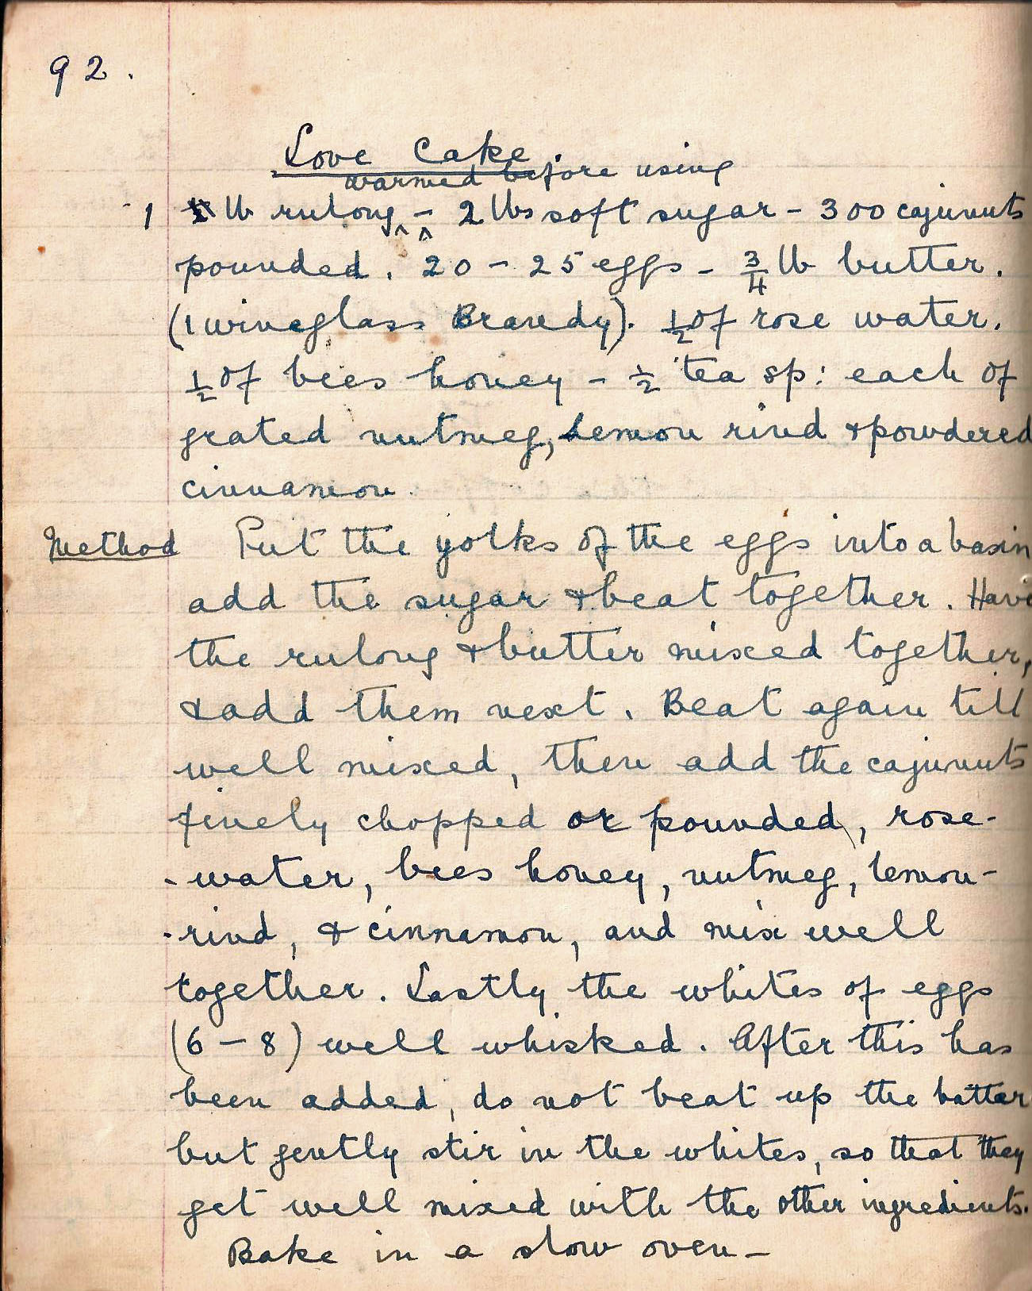

Love Cake
1 lb rulang warmed before using - 2 lbs soft sugar - 300 cajunuts pounded. 20 - 25 eggs – ¾ lb butter. (1 wineglass Brandy). ½ of rose water. ½ of bees honey - ½ tea sp: each of grated nutmeg, lemon rind and powdered cinnamon

Method Put the yolks of the eggs into a basin add the sugar and beat together. Have the rulang and butter mixed together, add them next. Beat again till well mixed, then add the cajunuts finely chopped or pounded, rose water, bees honey, nutmeg, lemon rind, and cinnamon and mix well together. Lastly the whites of eggs (6-8) well whisked. After this has been added, do not beat up the batter but gently stir in the whites, so that they get well mixed with the other ingredients.

Bake in a slow oven -

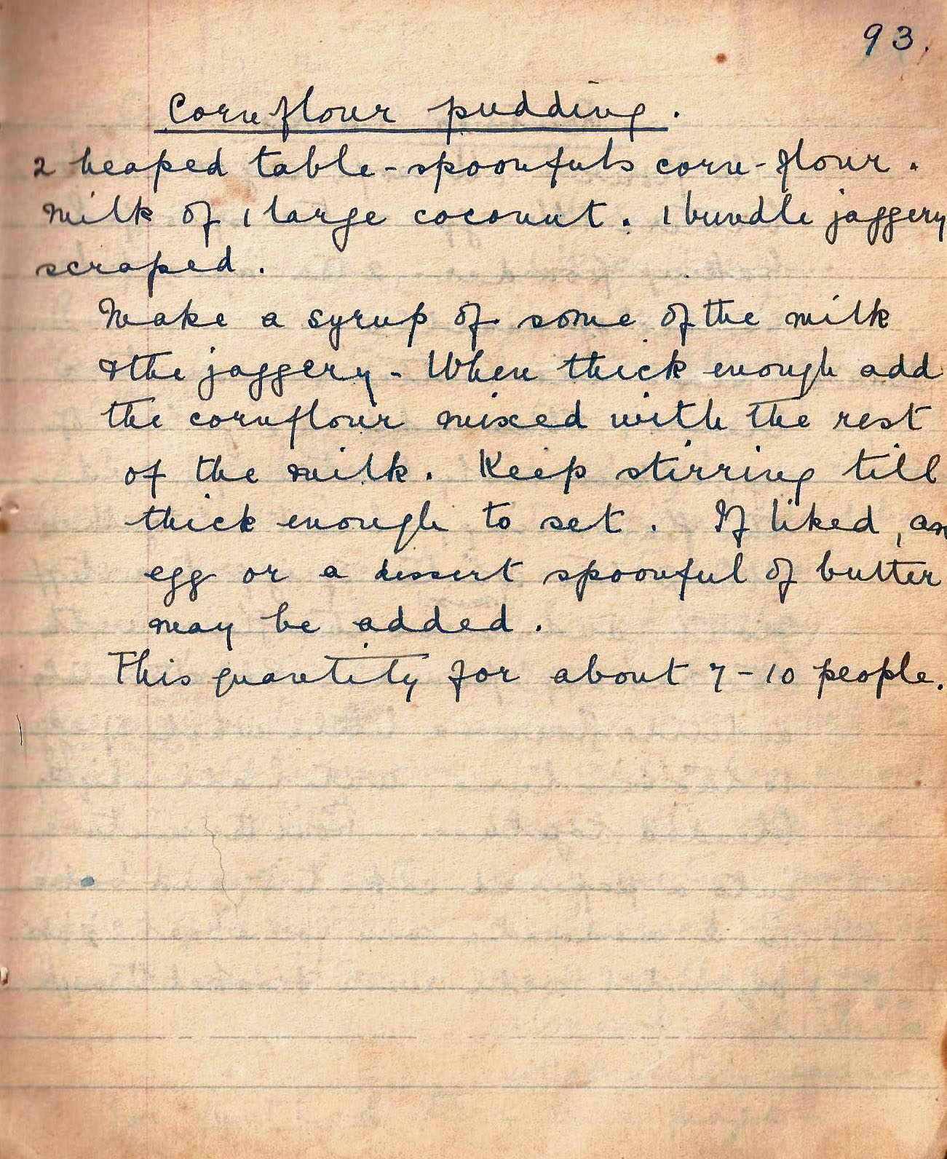

Cornflour pudding
2 heaped tablespoonfuls cornflour. milk of 1 large coconut.1 bundle jaggery scraped.

Make a syrup of some of the milk and the jaggery - When thick enough add the cornflour mixed with the rest of the milk. Keep stirring till thick enough to set. If liked, an egg or a dessert spoonful of butter may be added.

This quantity for about 7 – 10 people.

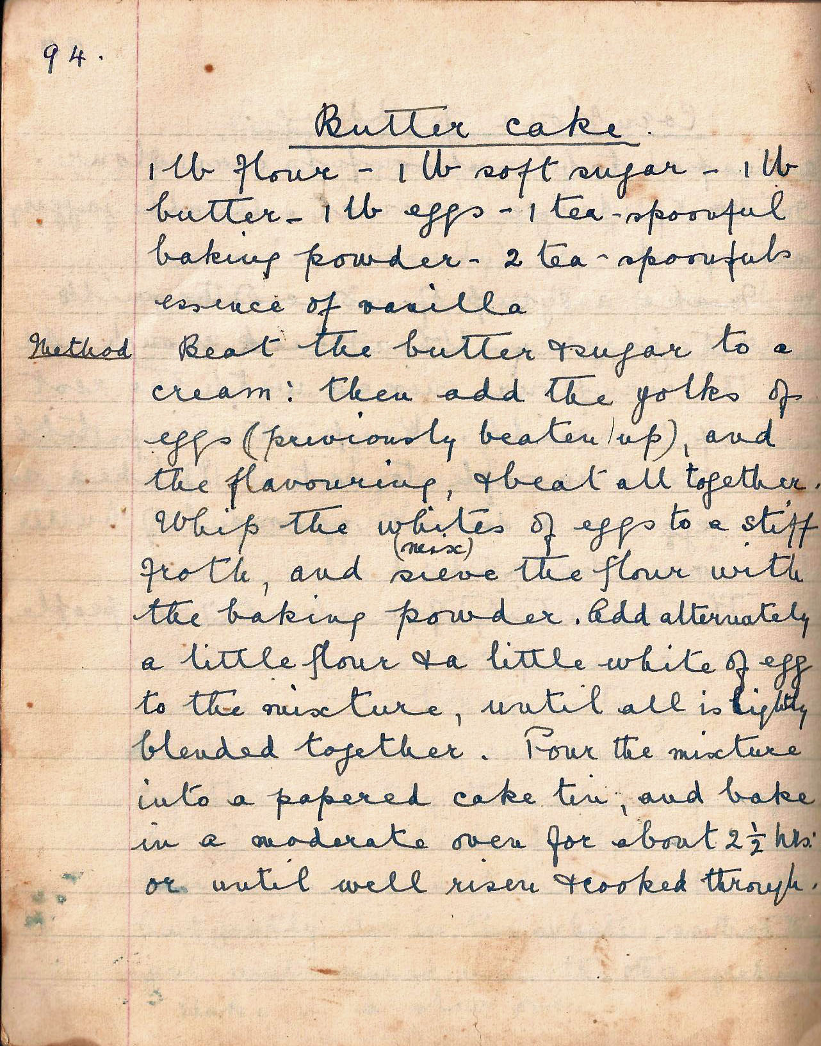

Butter Cake
1 lb flour - 1 lb soft sugar - 1 lb butter - 1 lb eggs - 1 tea-spoonful baking powder - 2 tea-spoonfuls essence of vanilla

Method Beat the butter and sugar to a cream: then add the yolks of eggs (previously beaten up) and the flavouring, and beat all together. Whip the whites of eggs to a stiff froth, and sieve (mix) the flour with the baking powder. Add alternately a little flour and a little white of egg to the mixture. Pour the mixture into a papered cake tin, and bake in a moderate oven for about 2½ hours or until well risen and cooked through.

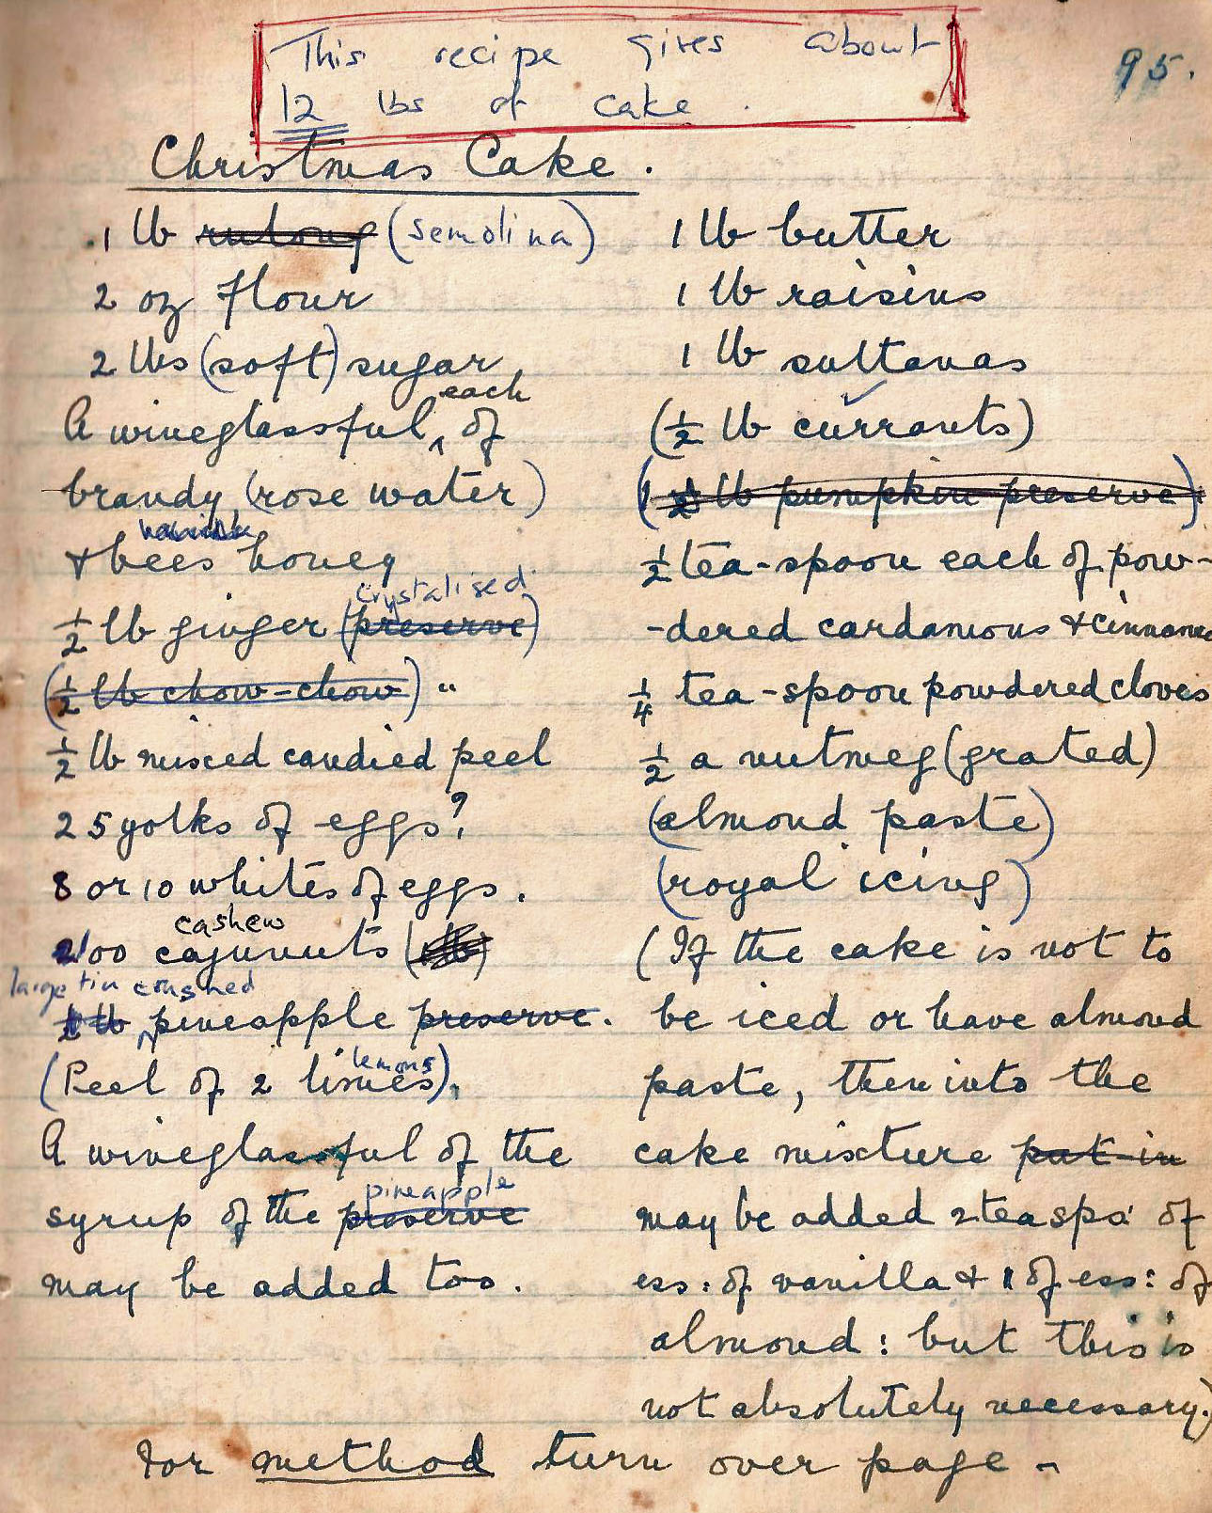

Christmas Cake
1 lb rulang (semolina)
1 lb butter
2 oz flour
1 lb raisins
2 lbs (soft) sugar
1 lb sultanas
A wineglassful each of brandy (rose water) and bees honey
1½ lb pumpkin preserve)
½ teaspoon each of powdered cardamom and cinnamon
½ lb ginger preserve
(½ lb chow chow)
¼ tea-spoon powdered cloves
½ lb mixed candied peel
½ a nutmeg (grated)
25 yolks of eggs
(almond paste)
8 or 10 whites of eggs
(royal icing)
100 cajunuts
½ lb pineapple preserve
(Peel of two limes)
A wineglass full of the syrup of the preserve

may be added
If the cake is not to be iced or have almond paste, then into the cake mixture may be added 2 teaspoons of ess of vanilla and 1 of ess. of
almond: but this is not absolutely necessary.

For method turn over page

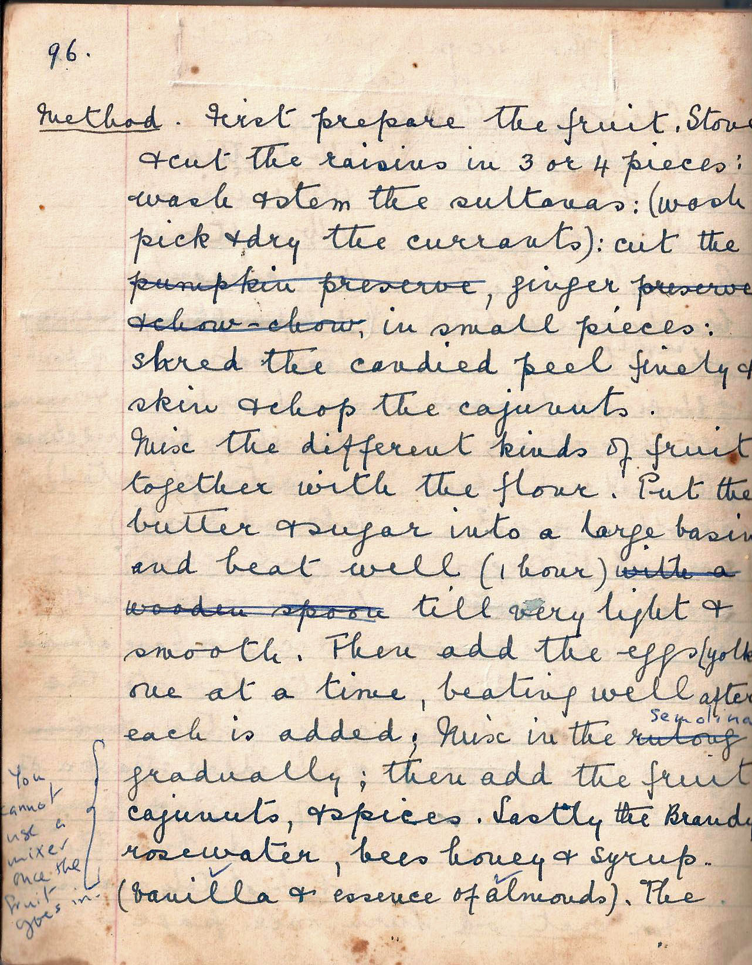

Method First prepare the fruit. Stone and cut the raisins in 3 or 4 pieces: wash and stem the sultanas: (wash pick and dry the currants): cut the pumpkin preserve, ginger preserve, and chow chow into small pieces: shred the candied peel finely and skin chop the cajunuts.

Mix the different kinds of fruit together with the flour. Put the butter and sugar into a large basin and beat well (1 hour) with a wooden spoon till very light and smooth. Then add the egg yolks one at a time, beating well after each is added. Mix in the rulang gradually; then add the fruit, cajunuts, and spices. Lastly the Brandy, rosewater, bees hone and syrup (vanilla and essence of almonds). The

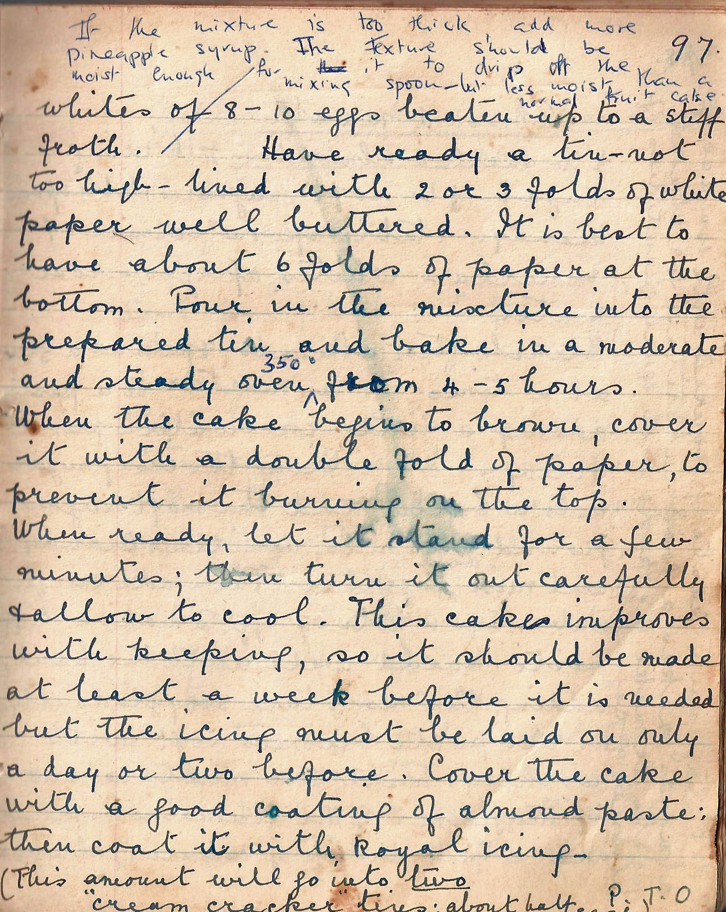

whites of 8 – 10 eggs beaten up to a stiff froth. Have ready a tin – not too high – lined with 2 or 3 folds of white paper well buttered. It is best to have about 6 folds of paper at the bottom. Pour in the mixture into the prepared tin and bake in a moderate and steady oven from 4 – 5 hours.

When the cake begins to brown, cover it with a double fold of paper, to prevent it burning on the top.

When ready, let it stand for a few minutes; then turn it out carefully and allow to cool. This cake improves with keeping, so it should be made at least a week before it is needed, but the icing must be laid on only a day or two before. Cover the cake with a good coating of almond paste then coat it with royal icing.

(This amount will go into two “cream cracker” tins: about half each)

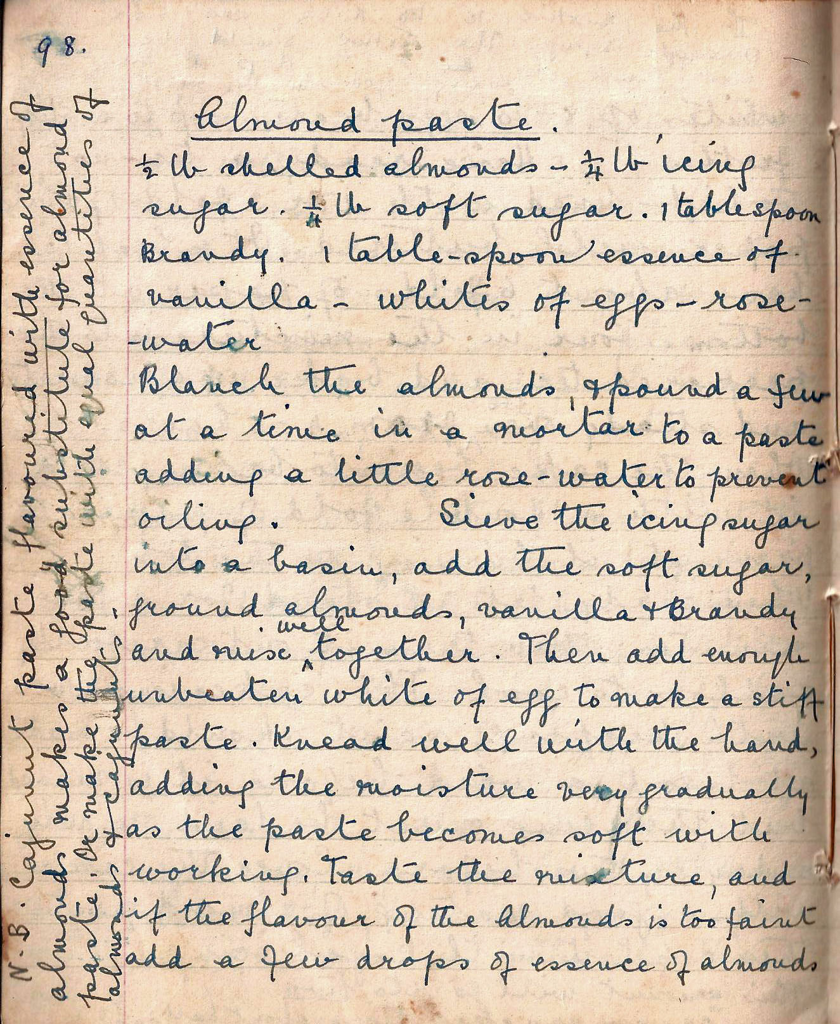

Almond Paste
½ lb shelled almonds - ¼ lb icing sugar. ¼ lb soft sugar. 1 tablespoon Brandy. 1 table-spoon essence of vanilla - whites of eggs – rose-water

Blanch the almonds and pound a few at a time in a mortar to a paste, adding a little rose-water to prevent oiling. Sieve the icing sugar into a basin, add the soft sugar, ground almonds, vanilla and Brandy and mix well together. Then add enough unbeaten white of egg to make a stiff paste. Knead well with the hand, adding moisture very gradually as the past become soft with working. Taste the mixture, and if the flavour of the almonds is too faint add a few drops of essence of almonds.

N.B. Cajunut paste flavoured with essence of almonds makes a good substitute for almond paste. Or make the paste with equal quantities of almonds and cajunuts.

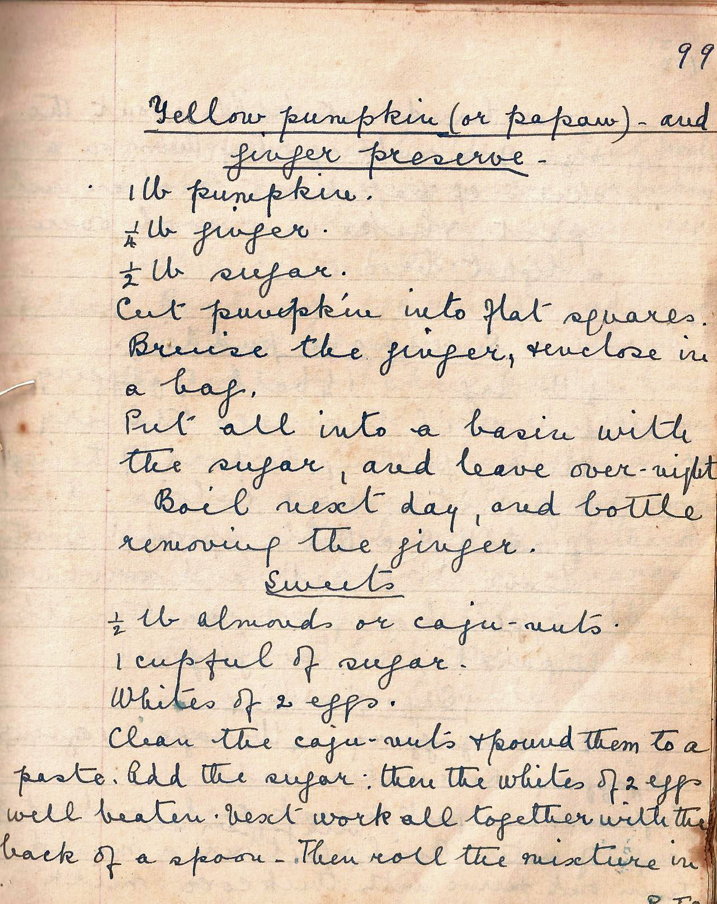

Yellow Pumpkin (or pawpaw) – and ginger preserve
1 lb pumpkin.
¼ lb ginger.
½ lb sugar.
Cut pumpkin into flat squares. Bruise the ginger, and enclose in a bag..

Put all into a basin with the sugar, and leave over-night.

Boil next day, and bottle removing the ginger.

Sweets
½ lb almonds or caju-nuts.
I cupful of sugar.
Whites of 2 eggs.

Clean the caju-nuts and pound them to a paste. Add the sugar: then the whites of 2 eggs well beaten. Next work all together with the back of a spoon. Then roll the mixture in

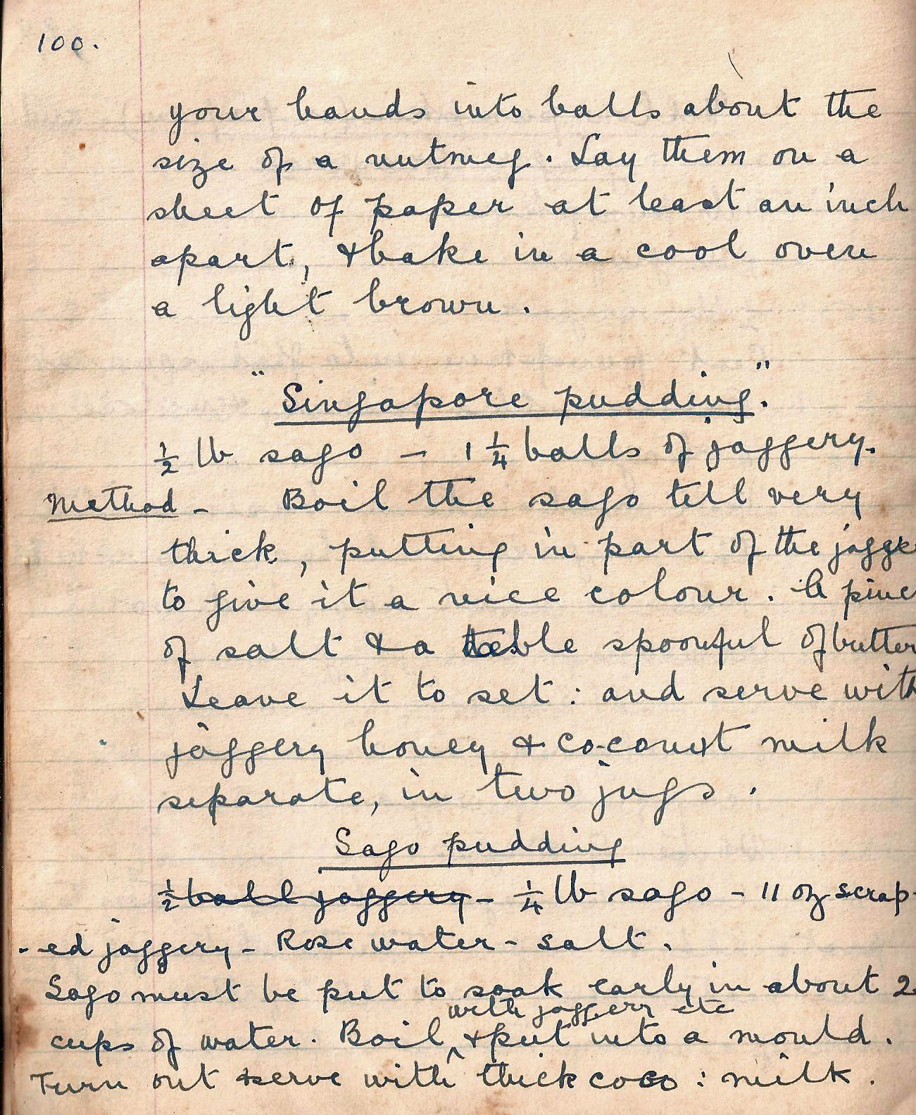

your hands into balls about the size of a nutmeg. Lay them on a sheet of paper at least and inch apart, and bake in a cool oven a light brown.

“Singapore pudding”
½ lb sago – 1¼ balls jaggery.
Method Boil the sago till very thick, putting in part of the jaggery to give it a nice colour. A pinch of salt and a table spoonful of butter.

Leave it to set: and serve with jaggery honey and coconut milk separate, in two jugs.

Sago pudding
¼ lb sago – 11 oz scraped jaggery – Rose water – salt.
Sago must be put to soak early in about 2 cups of water. Boil with jaggery etc and put into a mould. Turn out and serve with thick coco: milk.

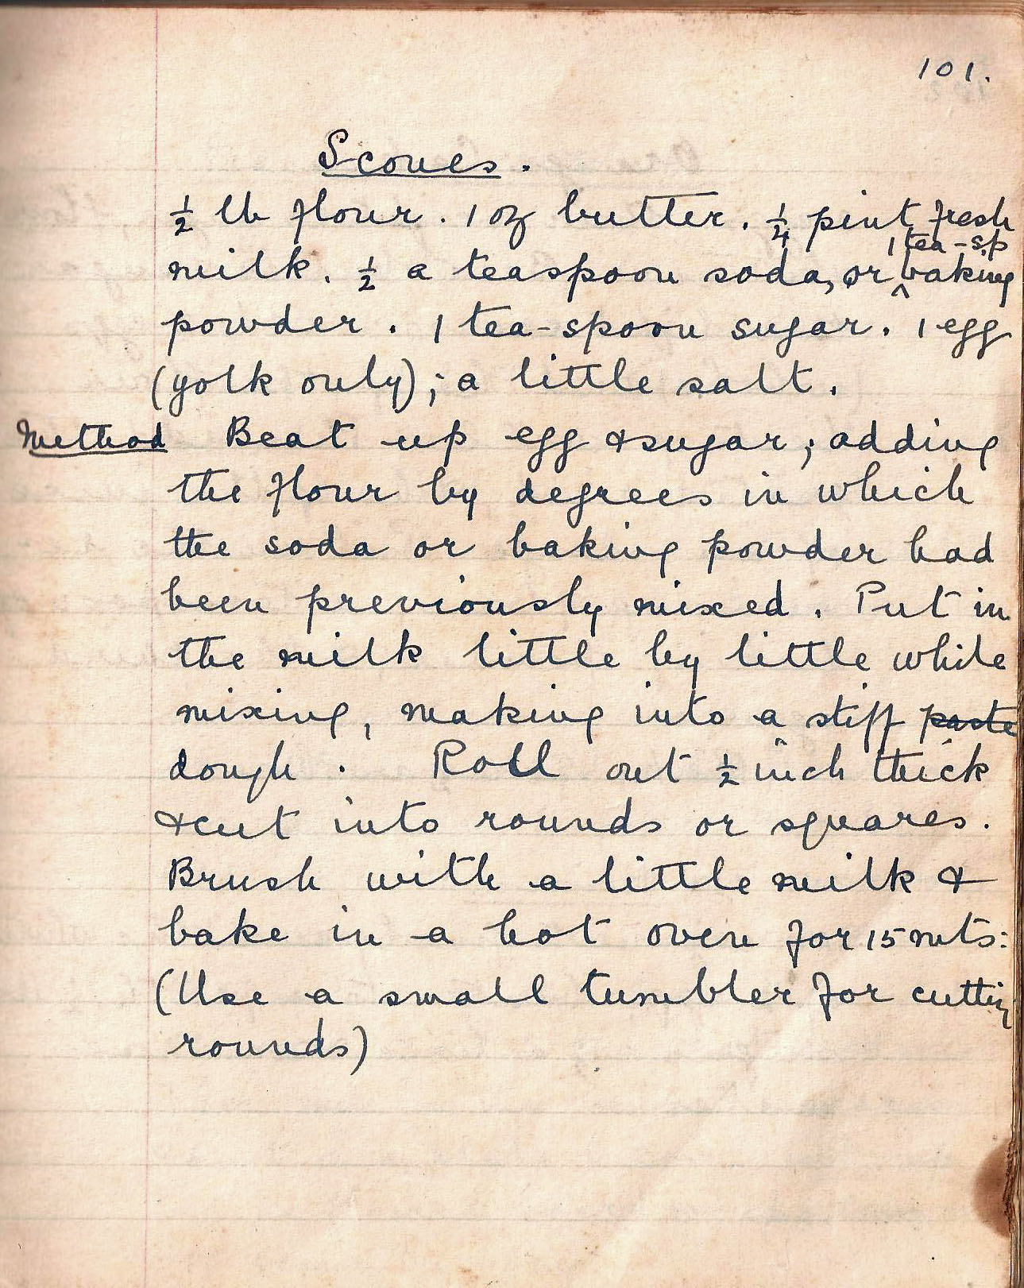

Scones
½ lb flour. 1 oz butter. ¼ pint fresh milk. ½ a teaspoon soda or 1 tea-sp baking powder. 1 tea-spoon sugar. 1 egg (yolk only); a little salt.
Method Beat up egg and sugar, adding the flour by degrees in which the soda or baking powder had been previously mixed. Put in the milk little by little while mixing, making into a stiff dough. Roll out ½ inch thick and cut into rounds or square. Brush with a little milk and bake in a hot over for 15 mts:
(Use a small tumbler for cutting rounds)

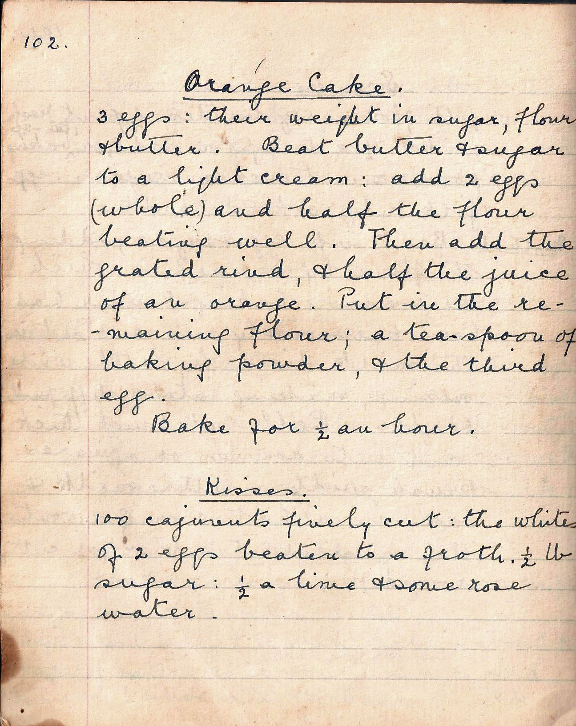

Orange Cake
3 eggs: their weight in sugar, flour and butter.
Beat butter and sugar to a light cream: add 2 eggs (whole) and half the flour beating well. Then add the grated rind, and half the juice of an orange. Put in the remaining flour; a teaspoon of baking powder, and the third egg.

Bake for ½ an hour.

Kisses
100 cajunuts finely cut; the whites of two eggs beaten to a froth. ½ lb sugar; ½ a lime and some rose water.

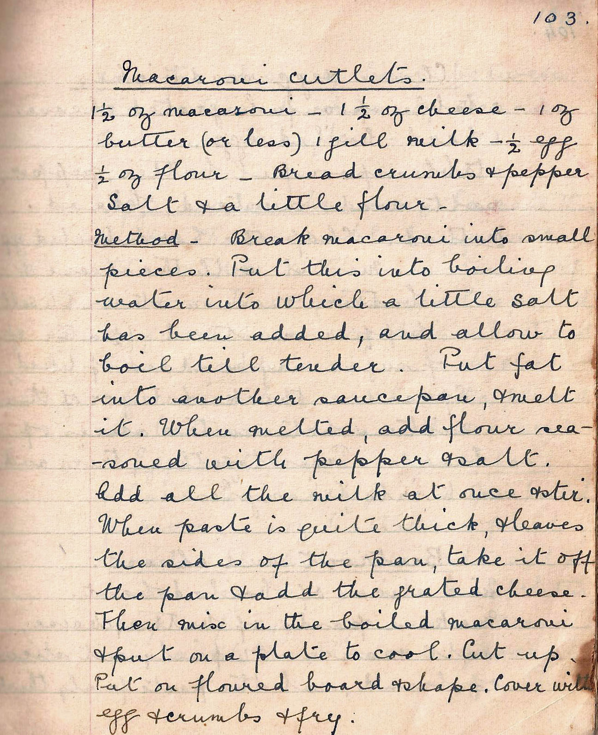

Macaroni cutlets
1½ oz macaroni – 1½ oz cheese – 1 oz butter (or less) – 1 gill milk – ½ egg – ½ oz flour – breadcrumbs and pepper, salt and a little flour.

Method Break macaroni into small pieces. Put this into boiling water into which a little salt has been added, and allow to boil till tender. Put fat into other saucepan, and melt it. When melted, add flour seasoned with pepper and salt. Add all the milk at once and stir. When paste is quite thick and leaves the sides of the pan, take it off the pan and add the grated cheese.

Then mix in the boiled macaroni and put on a plate to cool. Cut up. Put on a floured board and shape. Cover with egg and crumbs and fry.

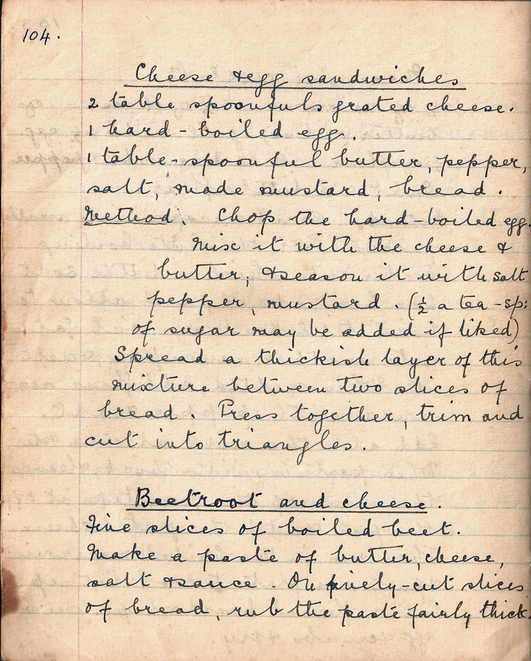

Cheese egg sandwiches
2 table spoonfuls grated cheese.
1 hard-boiled egg.
1 table spoonful butter, pepper, salt, made mustard, bread.

Method Chop the hard-boiled egg. Mix it with the cheese and butter, and season it with salt, pepper, mustard. (½ tea-sp: of sugar may be added if liked). Spread a thickish layer of this mixture between two slices of bread. Press together, trim and cut into triangles.

Beetroot and cheese
Fine slices of boiled beet.

Make a paste of butter, cheese, salt and sauce. On finely-cut slices of bread, rub the paste fairly thick.

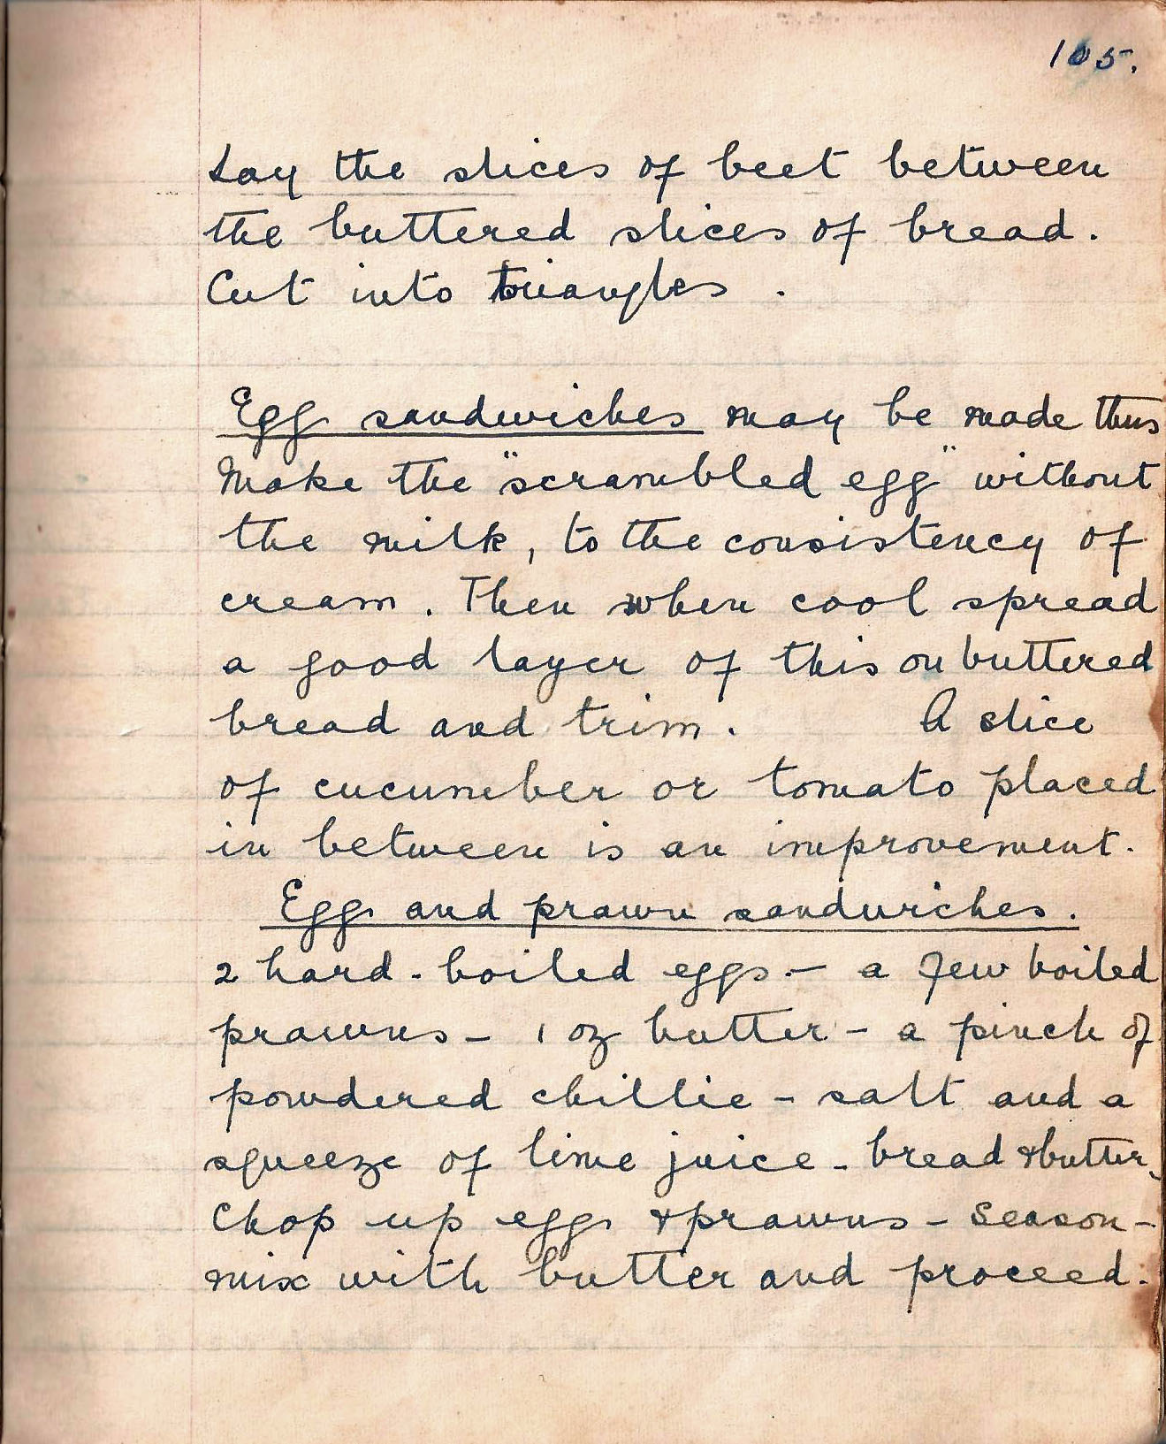

Lay the slices of beet between the buttered slices of bread. Cut into triangles.

Egg sandwiches may be made thus

Make the “scrambled egg” without the milk, to the consistency of cream. Then when cool spread a good layer of this on buttered bread and trim. A slice of cucumber or tomato placed in between is an improvement.

Egg and prawn sandwiches
2 hard-boiled eggs - a few boiled prawns - 1 oz butter - a pinch of powdered chillie - salt and a squeeze of lime juice -
bread and butter.

Chop up eggs and prawns. Season. Mix with butter and proceed.

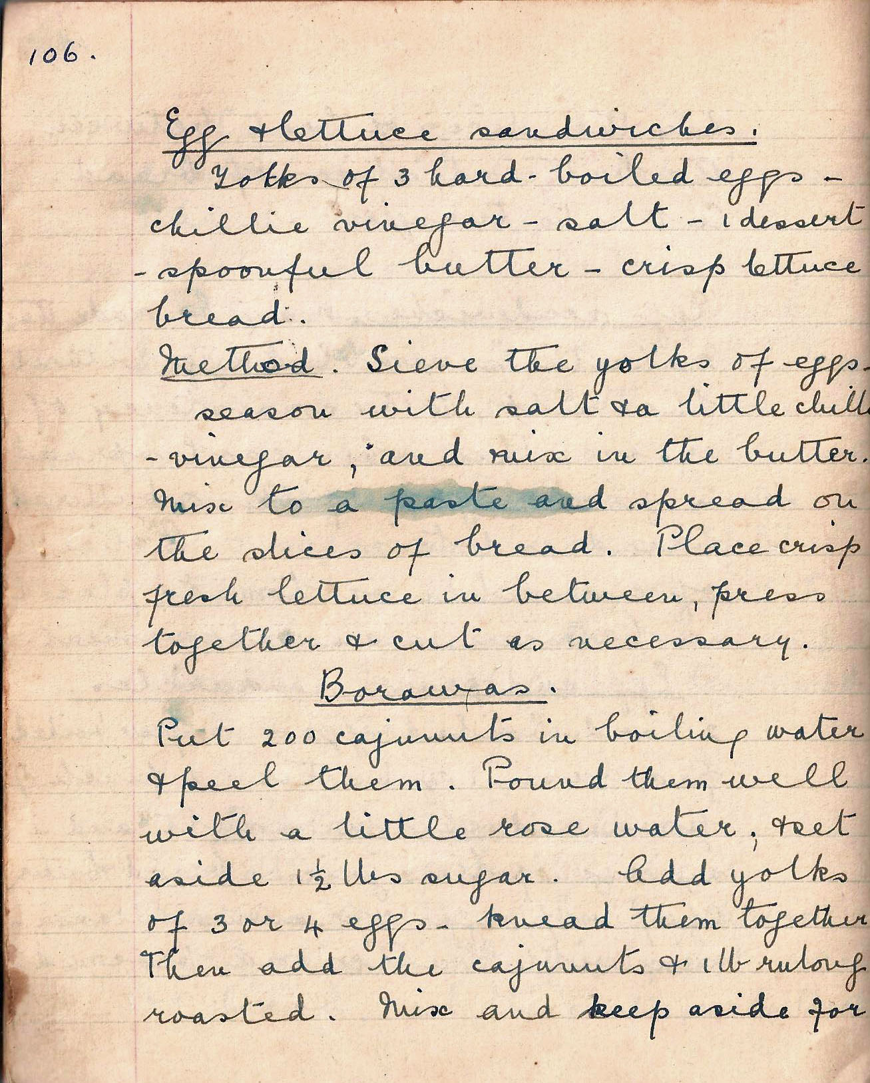

Egg and lettuce sandwiches
Yolks of 3 hard-boiled eggs - chillie vinegar – salt - 1 dessert-spoonful butter - crisp lettuce bread.

Method Sieve the yolks of eggs. Season with salt and a little chillie vinegar, and mix in the butter. Mix to a paste and spread on the slices of bread. Place crisp fresh lettuce in between, press together and cut as necessary.

Borawas
Put 200 cajunuts in boiling water and peel them. Pound them well with a little rose water, and set aside 1½ lbs sugar. Add yolks of 3 or 4 eggs – knead them together. Then add the cajunuts and 1lb rulang roasted. Mix and keep aside for

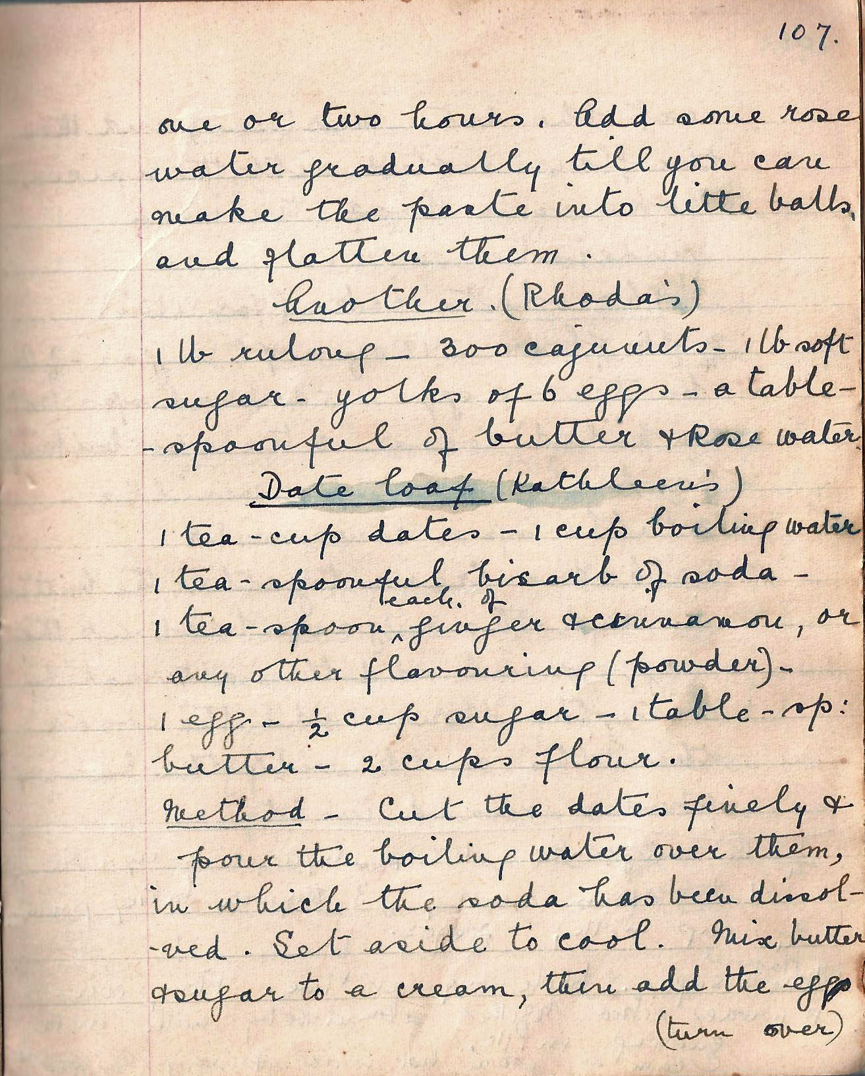

one or two hours. Add some rose water gradually till you can make the paste into little balls and flatten them.

Another (Rhoda’s)
1 lb rulang – 300 cajunuts – 1 lb soft sugar – yolks of 6 eggs – a table-spoonful of butter and Rose water.

Date loaf (Kathleen’s)
1 tea-cup dates - 1 cup boiling water
1 tea-spoonful bicarb of soda -
1 tea-spoon each of ginger and cinnamon, or any other flavouring (powder)
1 egg - ½ cup sugar - 1 table-sp: butter - 2 cups flour.

Method Cut the dates finely and pour boiling water over them, in which the soda has been dissolved. Set aside and cool. Mix butter and sugar to a cream, then add the eggs

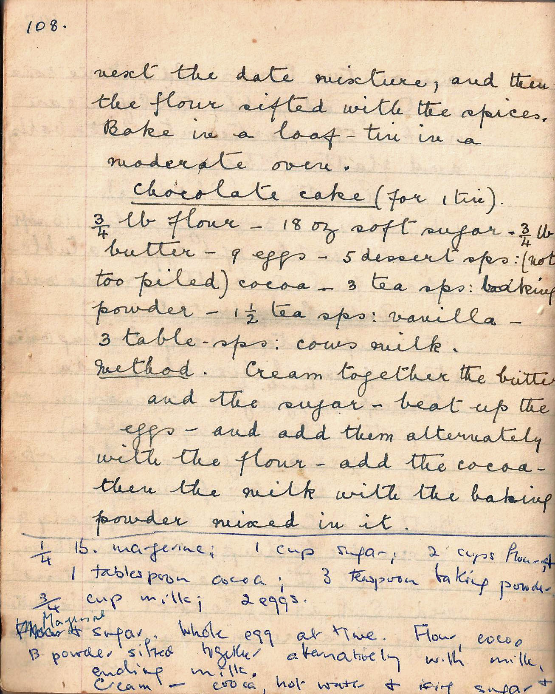

next the date mixture, and then the flour sifted with the spices.
Bake in a loaf tin in a moderate oven.

Chocolate cake (for 1 tin)
¾ lb flour - 18 oz soft sugar - ¾ lb butter - 9 eggs - 5 dessert sps: (not too piled) cocoa - 3 tea sps: baking powder 1½ teaspoons vanilla - 3 table sps: cows milk.

Method Cream together the butter and the sugar – beat up the eggs – and add them alternatively with the flour – add the cocoa – then the milk with the baking powder mixed in it.

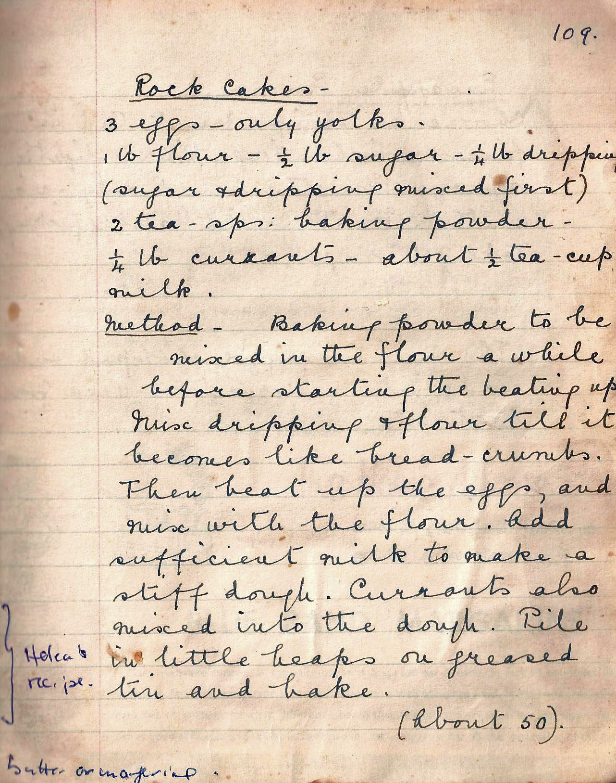

Rock cakes
3 eggs – only yolks.
1 lb flour - ½ lb sugar - ¼ lb dripping (sugar and ripping mixed first)
2 tea-sps: baking powder - ¼ lb currants - about ½ tea-cup milk

Method Baking powder to be mixed in the flour a while before starting the beating up. Mix dripping and flour till it becomes like bread-crumbs. Then beat up the eggs, and mix with the flour. Add sufficient milk to make a stiff dough. Currants also mixed into the dough. Pile in little heaps on greased tin and bake.

(About 50)

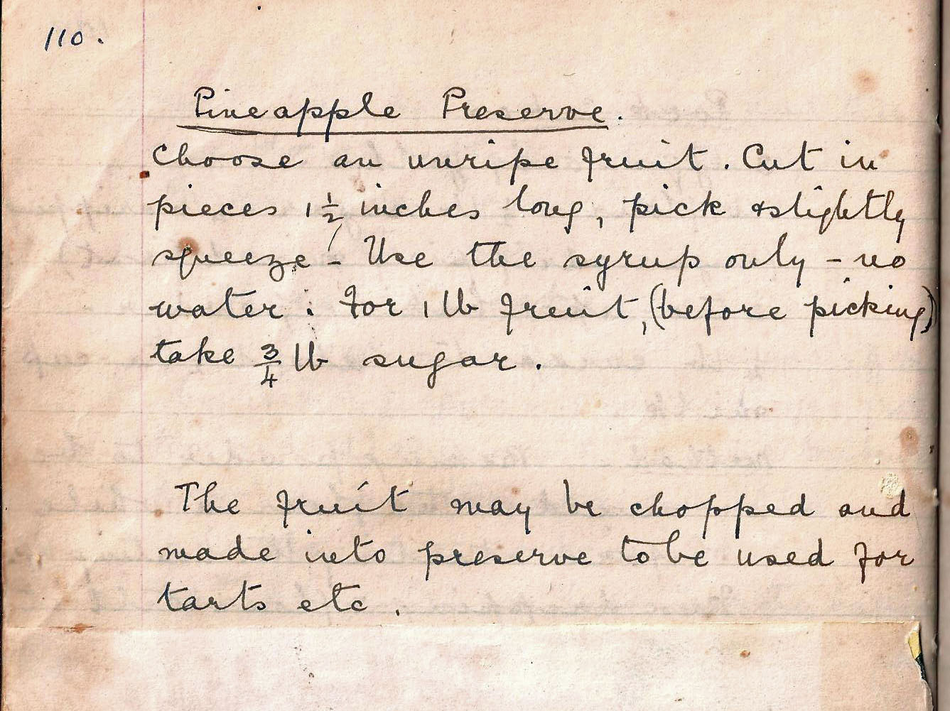

Pineapple Preserve
Choose an unripe fruit. Cut in pieces 1 ½ inches long, pick and slightly squeeze - Use the syrup only – no water. For 1 lb fruit (before picking) take ¾ lb sugar.

The fruit may be chopped and made into preserve to be used for tarts etc.

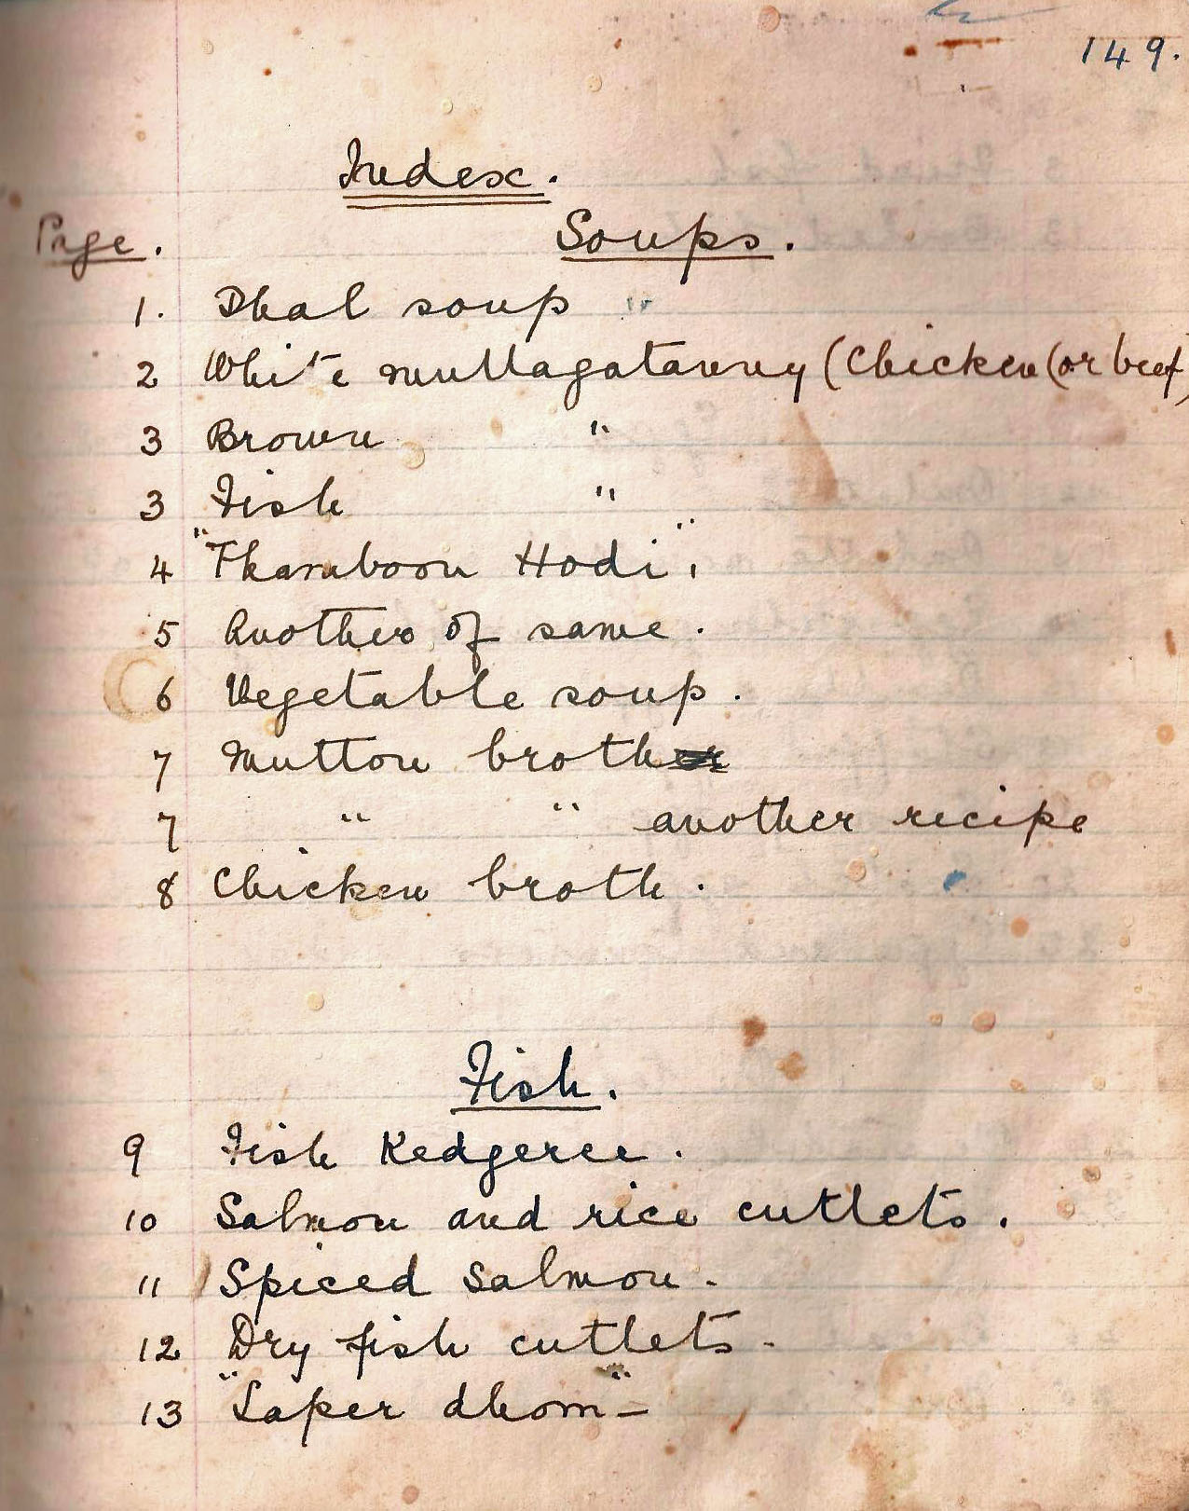

Index
Page. Soups.
1. Dhal soup
2 White mullagatanny (Chicken (or beef)
3 Brown “
3 Fish “
4 “Thamboom Hodi”.
5 Another of the same.
6 Vegetable soup.
7 Mutton broth.
7 “ “ another recipe.
8 Chicken broth.

Fish.
9 Fish Kedgeree.
10 Salmon and rice cutlets.
11 Spiced salmon.
12 Dry fish cutlets.
13 “Saper dhom”-

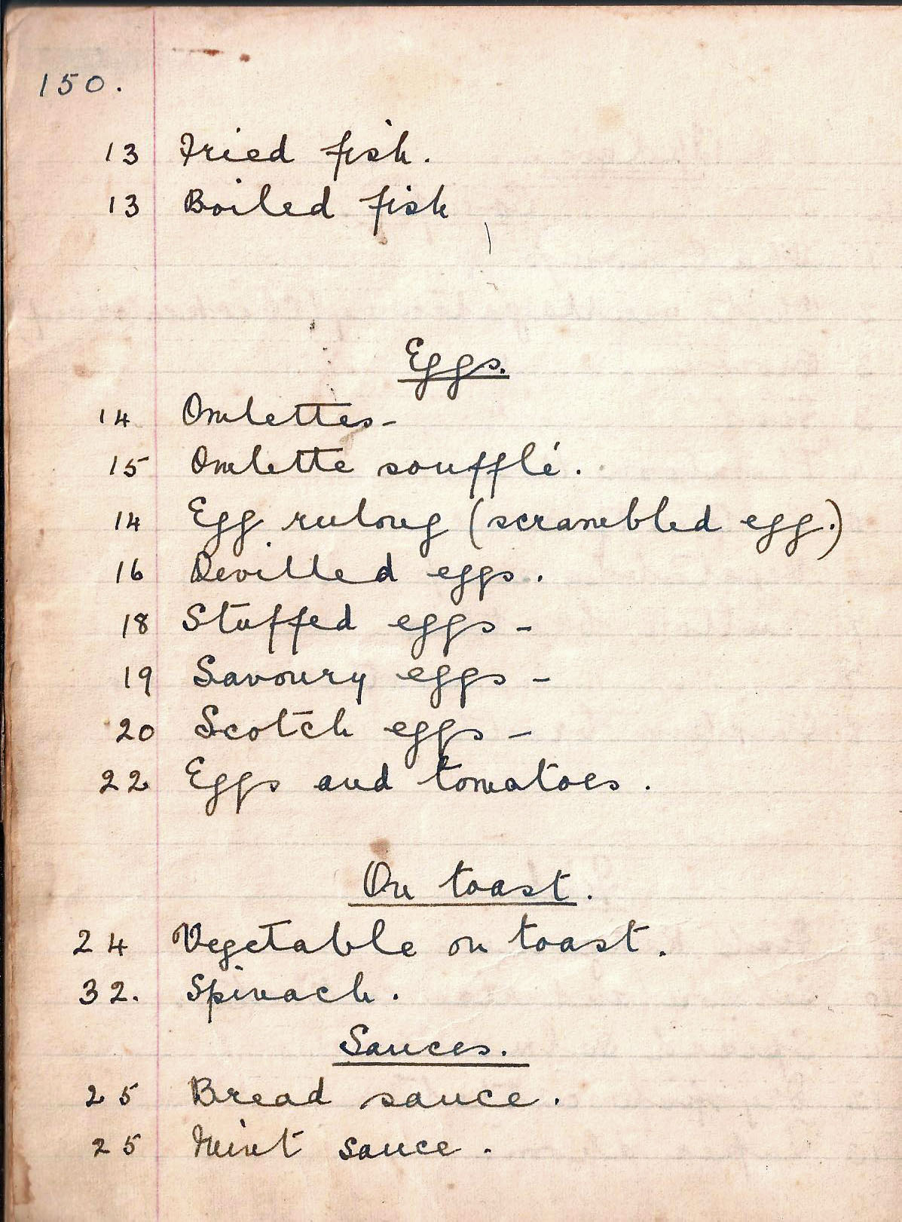

13 Fried fish.
13 Boiled fish

Eggs.
14 Omlettes –
15Omlette soufflé.
14 Egg ruling (scrambled egg.)
16 Devilled eggs.
18Stuffed eggs –
19. Savoury eggs –
20Scotch eggs –
22 Eggs and tomatoes.

On toast.
24 Vegetable on toast.
32. Spinach.

Sauces.
25 Bread sauce.
25 Mint sauce.

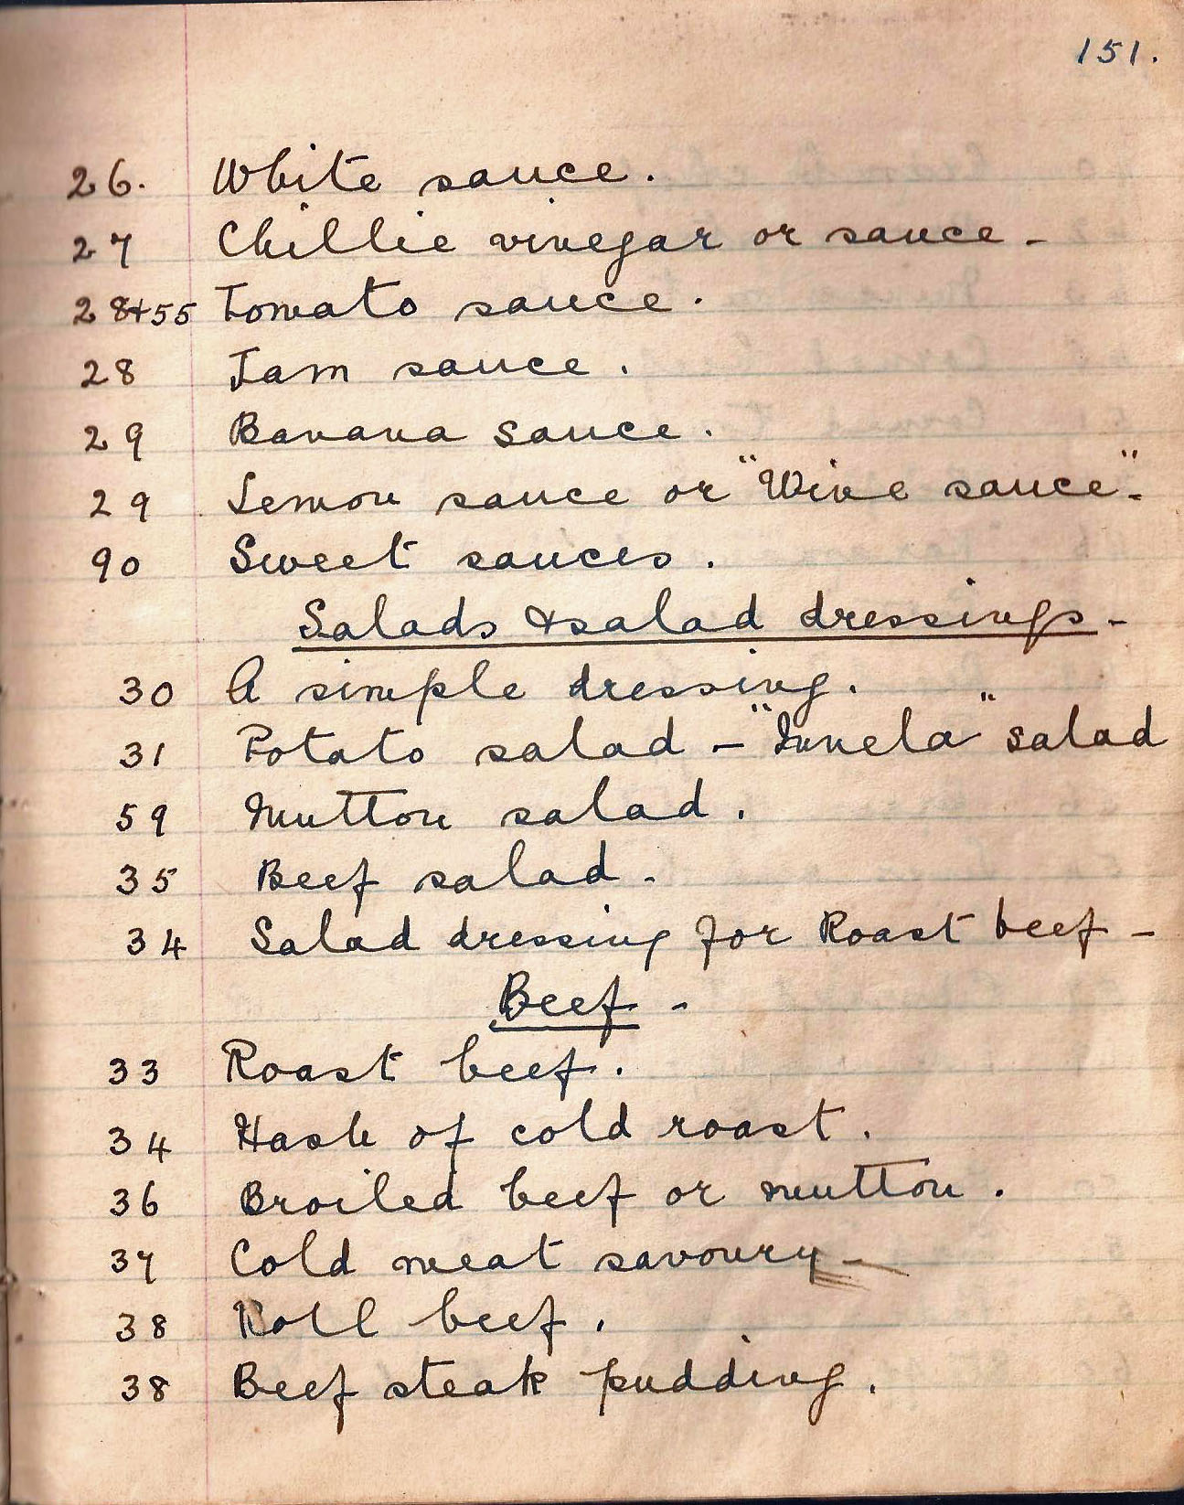

26 White sauce.
27 Chillie vinegar or sauce.
28 + 55 Tomato sauce.
29 Banana sauce.
29 Lemon sauce or “Wine sauce”.
90 Sweet sauces.

Salads and salad dressings
30 A simple dressing.
31 Potato salad – “Innela” salad.
59 Mutton salad.
35 Beef salad.
34 Salad dressing for Roast beef –

Beef
33 Roast beef.
34 Hash of cold roast.
36 Broiled beef or mutton.
37 Cold meat savoury.
38 Roll beef.
39 Beef steak pudding.

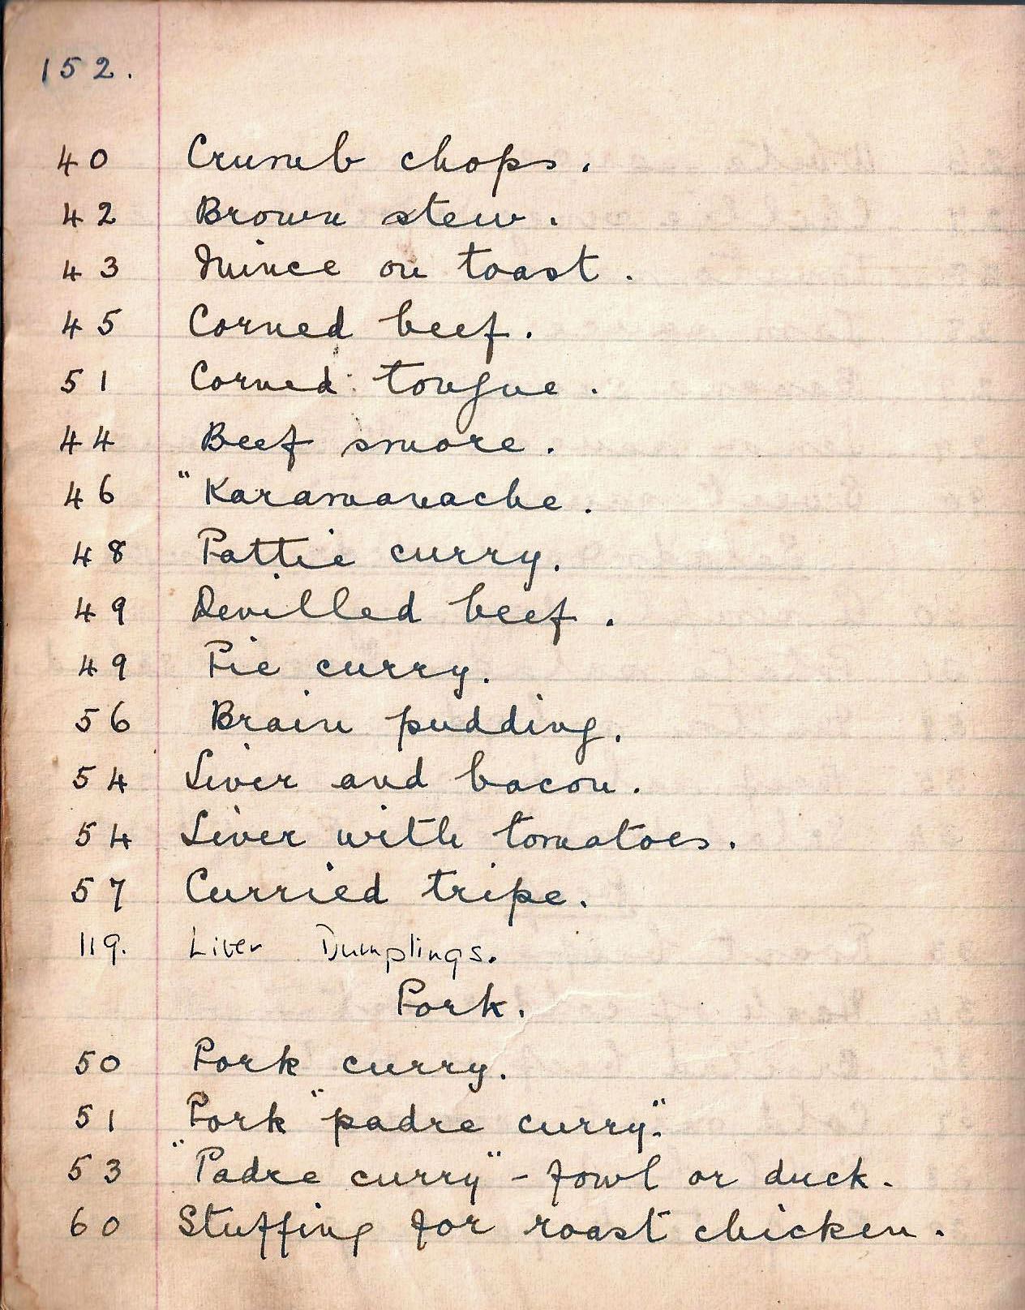

40 Crumb chops.
42 Brown stew.

43 Mince on toast.
45 Corned beef.
51 Corned tongue.
44 Beef smore.
46 ” Karamanache.
48 Pattie curry.
49 Devilled beef.
56 Brain pudding.
54 Liver and bacon.
57 Curried tripe.

Pork.
50 Pork curry.
51 Pork “padre curry”.
53 “Padre curry” – fowl or duck.
60 Stuffing for roast chicken.

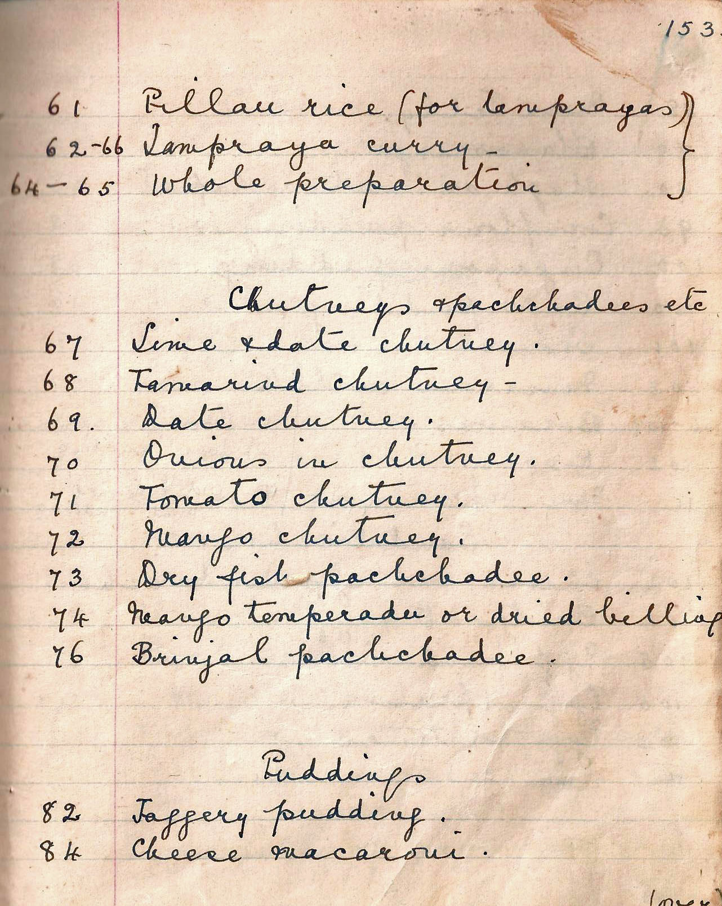

61 Pillau rice (for lamprayas)
62-66 Lampraya curry-
64-65 Whole preparation.

Chutneys and pachchadees etc
67. Lime and date chutney.
68 Tamarind chutney –
69. Date chutney.
70 Onions in chutney.
71 Tomato chutney.
72 Mango chutney.
73 Dry fish pachchadee
74 Mango temperado or dried billing
76 Brinjal pachchadee.

Puddings
82 Jaggery pudding.
84 Cheese macaroni.

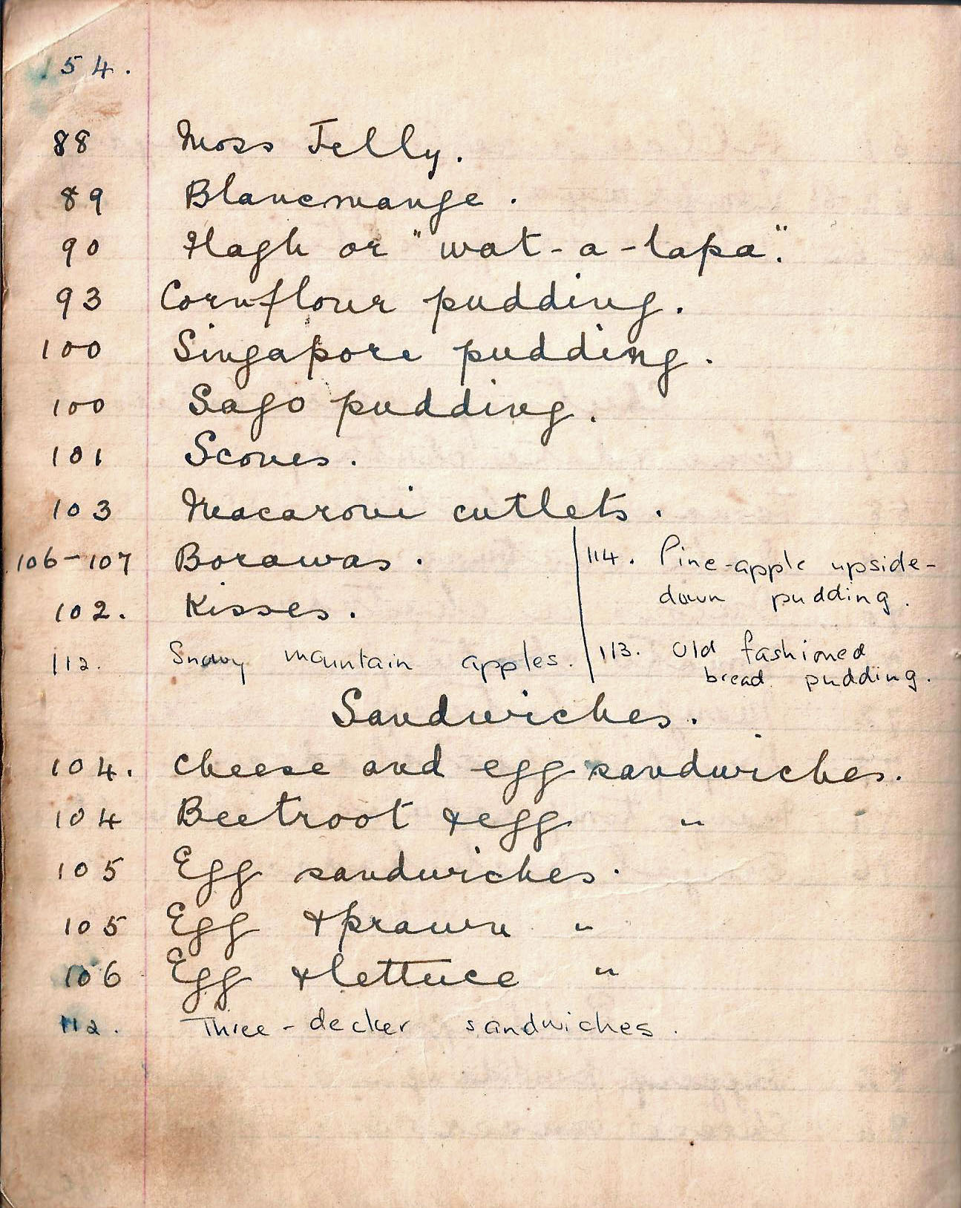

88 Moss Jelly.
89 Blancmange
90 Flagh or “wat-a-lapa”.
93 Cornflour pudding.
100 Singapore pudding.
100 Sago pudding.
101 Scones.
103 Macaroni cutlets.
106-107 Borawas.
102 Kisses.

Sandwiches
04 Cheese and egg sandwiches.
104 Beetroot and egg “
105 Egg sandwiches
105 Egg and prawn “
106 Egg and lettuce “

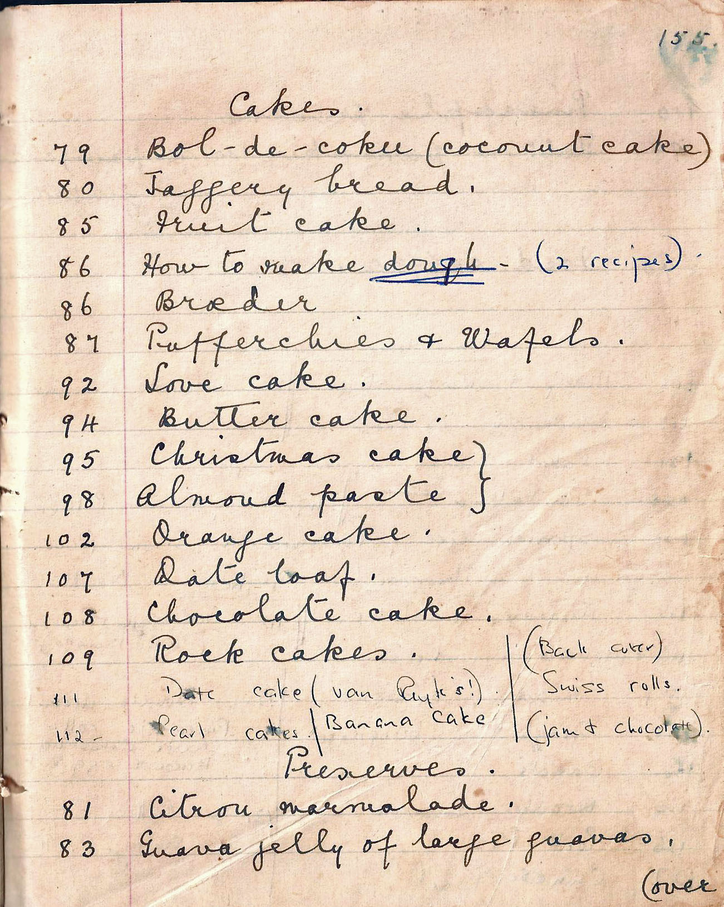

Cakes
79 Bol-de-coke (coconut cake).
80 Jaggery bread.
85 Fruit cake.
86 How to make dough
86 Broeder
87 Pufferchies and Wafe;s.
92 Love cake.
94 Butter cake.
95 Christmas cake
98 Almond paste.
102 Orange cake.
107 Date loaf.
108 Chocolate cake.
109 Rock cakes.

Preserves.
81 Citron marmalade.
83 Guava jelly of large guavas.

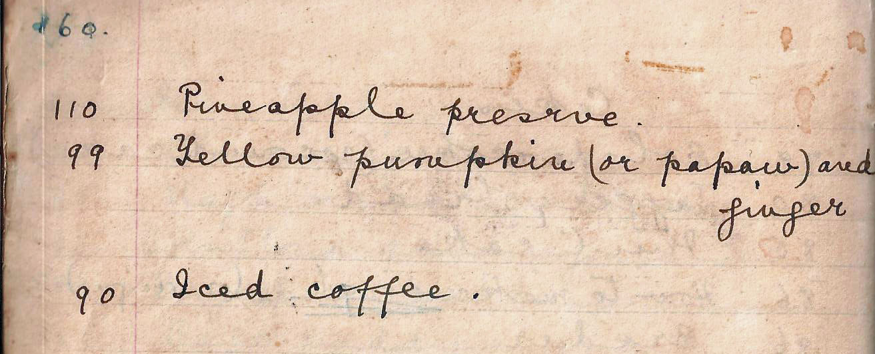

110 Pineapple preserve.
99 Yellow pumpkin (or pawpaw) and ginger

90 Iced coffee.

